MSAI 699 Capstone Project

Instructor: Dr. Gamini Bulumulle

Week 7: Final Report

TrustResume: Evidence-Based Resume Generation Using RAG, Multi-Agent AI, and Trust Verification

Peng Fei Xu

University of the Cumberlands

Submitted to the University of the Cumberlands
in Partial Fulfillment of the Requirements of the Degree of
Master of Science in Artificial Intelligence

Aug 11, 2026

Abstract
TrustResume checks every claim in a generated resume against a candidate's own evidence before showing it to anyone. This is a direct response to the risk that an unconstrained LLM embellishes a resume. This report covers a from-scratch reimplementation of an earlier pydantic-ai/Qdrant capstone on LangChain, LangGraph, and ChromaDB: six agents coordinated by a quality loop that rewrites a draft up to three times against a Trust gate and an ATS gate. An offline evaluation harness scores the system itself: hybrid retrieval reaches recall@8 1.000/MRR 0.938, and the Trust Harness, after a calibration fix documented here, classifies claims at accuracy/macro-F1 0.833 (up from 0.500/0.489) with zero dangerous false-pass errors either way. A 482-test suite holds 99.3% coverage, and four real Bedrock-hosted runs show the thesis directly: the system would rather fail a candidate than invent experience they lack. The report closes with the challenges this build surfaced and the work still open.
1. Introduction
Resume writing is adversarial-by-default for a language model: the easiest way to make a draft look stronger is to overstate scope, seniority, or a metric the evidence doesn't support. TrustResume's answer is architectural: generation and verification run as separate agents, so the writer never grades its own work, and every claim it produces is checked against retrieved evidence by an independent Trust Harness before any score reaches a user. This system is a from-scratch reimplementation of an earlier MSAI-699 capstone (a RAG and multi-agent pipeline on pydantic-ai and Qdrant) on LangChain, LangGraph, and ChromaDB, a deliberate learning exercise in the field's dominant agent framework rather than a redesign; the architecture, the SQLite storage layer, and the trust/ATS scoring logic carried over unchanged, while how agents are built and coordinated did not.
Earlier weeks of this course layered a measurement discipline on top of that port the original project never had: an offline evaluation harness, per-run cost/latency telemetry, role-tiered models, and a testable per-user identity model. This report synthesizes that work: methodology (§2), results (§3), challenges and ethics (§4), and open work (§5).
2. Methodology
2.1 System architecture
A run is driven by a single LangGraph StateGraph (Figure 1). Job Description and Evidence Retrieval (hybrid vector + SQLite-FTS5 keyword search, user-scoped) each run once; with a cached Candidate Profile, they feed a quality loop: the Resume Writer drafts, the Trust Harness classifies every claim as SUPPORTED, PARTIALLY_SUPPORTED, or UNSUPPORTED against the evidence, and ATS Evaluation scores keyword coverage. Trust ≥ 90 and ATS ≥ 85 passes; otherwise deterministic feedback drives a rewrite, up to three times, before the run exports its best attempt regardless of outcome.
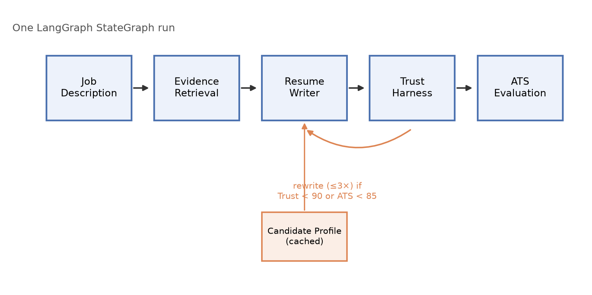
Figure 1. The generation pipeline: five sequential agents plus a cached sixth, orchestrated by a LangGraph quality loop.
2.2 Key design decisions
Storage stayed on SQLite plus ChromaDB rather than Qdrant (ADR-0001), every search scoped by a user_id filter. Retrieval is hybrid (ADR-0010): vector and keyword hits fuse by Reciprocal Rank Fusion, since cosine similarity and BM25 rank aren't comparable. One catches a paraphrase sharing no vocabulary with its evidence; the other catches an exact product name the embedder treats as interchangeable with a competitor. Temperature is pinned to 0 (ADR-0013), since the headline claim is a deterministic, code-computed Trust score; models are tiered by role (extraction/writer/verifier) so a cheap model fills a schema while a stronger one adjudicates trust. Every route resolves its caller from a request header (ADR-0014) instead of one hardcoded demo user, making the isolation boundary testable rather than merely asserted. An opt-in checkpointing layer (ADR-0015) demonstrates LangGraph's durable-execution capability: a crashed run resumes from its last completed node instead of re-paying for already-completed LLM calls, off by default so the pipeline above is unchanged unless a caller opts in.
2.3 Development process
Development proceeded as a module-by-module port checked against the original repository's behavior, with one exception: adopting LangChain-idiomatic constructs where they were a clear win. An AI coding assistant (Claude Code) was used throughout: for the port, the measurement layer, running evaluations, and drafting reports. Every change was reviewed against the running suite and real evaluation output before acceptance.
2.4 Testing and evaluation methodology
Correctness and quality are measured separately. Pytest runs entirely offline under a 95% coverage gate; a smaller live-marked slice exercises the real embedding model and a real HTTP server on demand. Neither tells you whether the system is getting better at its job, so a separate offline evaluation harness (ADR-0011) scores retrieval quality and Trust Harness accuracy against labeled ground truth. This is deliberately distinct from the product-facing evaluation package, which scores one resume at runtime and cannot detect that the grader itself has gone wrong.
3. Results
3.1 Automated test suite and CI
The suite holds 482 passing tests (9 live-marked tests deselected by default) at 99.3% coverage against a 95% gate. CI runs lint, a format check, strict mypy, and the full suite on Python 3.11 and 3.13 from a locked dependency file on every push and pull request.
3.2 Retrieval evaluation
Scored at k=8, the depth a real generation actually retrieves, hybrid retrieval reaches recall@8 1.000 and MRR 0.938 over a 10-document labeled corpus and 9 queries, including one query sharing no vocabulary with its answer and one naming an exact product the embedder treats as interchangeable with a competitor. Precision@8 is 0.156, expected rather than a weakness (most queries have one relevant document, capping precision at 0.125). The one deliberately unanswerable query still returns a full 8 results, since retrieval has no notion of “no good answer.” That's a weak spot discussed in Section 4.
Metric | Value | Corpus
Recall@8 | 1.000 | 10 documents / 9 queries
MRR | 0.938 | 10 documents / 9 queries
Precision@8 | 0.156 | capped by single-relevant-doc queries
Hit rate | 1.000 | N/A

3.3 Trust Harness evaluation and calibration fix
The Trust Harness's original prompt said only to “be strict... do not give the draft the benefit of the doubt,” without defining its three labels. Scored against a 12-case labeled dataset on a real Bedrock model, that prompt measured accuracy 0.500/macro-F1 0.489, with every error off by one severity step toward under-crediting. Even a claim restating its evidence verbatim was downgraded. Explicit label definitions plus a named asymmetry between error types (a false pass ships a fabrication; a false flag costs one rewrite) raised accuracy/macro-F1 to 0.833, reproduced identically on repeat runs, with dangerous errors held at zero throughout.
3.4 End-to-end generations against a real model
One synthetic candidate was run against four job postings, real Bedrock end to end. Three of four fail the quality gate. That's deliberate: a gate that never rejects anything is decoration. Scenario 4 is the clearest evidence for the project's design bet: given an iOS posting for a backend candidate, the writer refused to invent iOS experience, so every claim was supported (Trust 100) and the resume matched no required keyword (ATS 0). The system chose to fail the candidate rather than lie for them.
Scenario | Result | Trust /90 | ATS /85 | Drafts | LLM calls | Cost
1-strong-match | PASS | 94 | 90 | 1 | 4 | $0.32
2-partial-match | FAIL | 94 | 53 | 4 | 10 | $1.07
3-inflation-pressure | FAIL | 92 | 50 | 4 | 10 | $1.06
4-wrong-domain | FAIL | 100 | 0 | 4 | 10 | $0.87

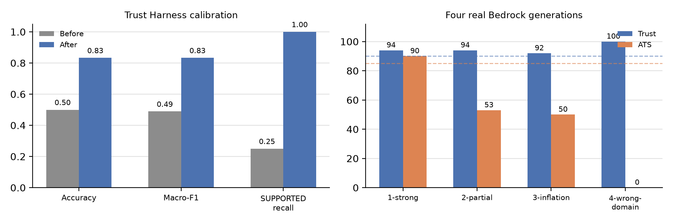
Figure 2. Trust Harness accuracy before/after the calibration fix (left) and Trust/ATS scores across four real Bedrock generations, dashed lines marking the quality gate (right).
Scenario 3 shows the checks working under pressure: asked for staff-level scope the evidence doesn't fully support, the writer produced plausible filler, and the Trust Harness flagged all three inflated claims PARTIALLY_SUPPORTED rather than letting them read as fact. A self-checking prompt would have passed its own prose. Per-run cost ranged from $0.32 to $1.07 across four to ten LLM calls, via per-node telemetry (ADR-0012) that attributes every call to its node and reports an honest null rather than a partial total for any unpriced model.
4. Discussion
4.1 What worked
Treating this as a faithful port kept every regression attributable to a specific decision. The offline-first test suite stayed fast enough to run on every change, catching most structural bugs before a real model call. Most importantly, separating generation from verification, and both from the harness grading the verifier itself, is what let §3.3's calibration bug be found at all. Nothing in the runtime pipeline could reveal it, since the Trust score is computed from whatever the harness reports.
4.2 Challenges encountered and how they were addressed
Several consequential bugs were invisible to static analysis and unit tests, surfacing only when the real system ran:
- Trust Harness miscalibration (§3.3): an undefined “be strict” instruction caused a uniform downgrade. Fixed with explicit label definitions, verified by an A/B comparison, not inspection.
- Token/cost invisibility: with_structured_output consumes the AIMessage before usage_metadata reaches the agent. Fixed with a LangGraph callback that sees every nested model call.
- Structured-output brittleness: an empty section heading failed the strict schema and crashed parsing, losing a paid-for draft. Fixed with a lenient private schema, relabeled in code.
- PDF export crashing on real prose: fpdf2's core font only encodes Latin-1, and an em dash in real Bedrock output destroyed an already-paid-for export. Fixed with transliteration and a degrade-to-‘?’ fallback.
- A silent 422 on every route: FastAPI couldn't resolve a type alias defined inside a function once `from __future__ import annotations` was active, and only booting the real app caught it. Fixed by moving it to module scope.
These are integration-boundary bugs, not logic errors inside one function. That's exactly the class an offline-first suite is weakest against and a real end-to-end run is strongest against, the argument for keeping live and manual smoke-test paths at all.
4.3 Ethical considerations
Security: externally sourced text, such as a posting, an uploaded document, or retrieved evidence, is wrapped and marked as data before reaching a prompt, so injection reads as content, not instruction. Fairness: the Trust Harness doubles as a fairness mechanism, since an ungrounded generator would favor candidates whose backgrounds happen to embellish well; the ATS score carries a smaller residual bias risk and is treated as candidate feedback, not a claim about a real employer's system. Privacy: every record and vector carries a user_id, filtered server-side. The API still resolves identity from a self-reported header with no authentication behind it: the clearest ethical gap carried into Section 5.
4.4 Limitations
Two PARTIALLY_SUPPORTED claims still misclassify as UNSUPPORTED. That's the safe direction, but not a solved problem. Retrieval always fills its configured depth even with nothing relevant, relying on the Trust Harness as the actual downstream safeguard. PDF export degrades any non-Latin-1 character to ‘?’, and the storage schema has no migration tool: a change is invisible to a database file created before it.
5. Future Work
- Real authentication and rate limiting, replacing the self-reported X-User-Id header. Every store call is already user-scoped.
- A relevance threshold on retrieval, so an unanswerable query returns fewer chunks instead of always filling top-k.
- A larger labeled Trust Harness dataset targeting compound and seniority-inflation claims, the two remaining failure modes.
- Unicode-capable PDF export (a bundled TTF) instead of degrading non-Latin-1 characters to ‘?’.
- Real schema migration tooling, and an incremental scale path (Kubernetes or a managed service) if demand grows.
6. Conclusion
This reimplementation carries forward its predecessor's central bet: a resume generator is trustworthy only if something other than the generator checks its claims. The measurement layer built alongside it is what let that bet be verified rather than assumed. The evaluation harness caught a real regression in the one component the system's credibility rests on, and a real end-to-end run showed the resulting behavior directly: the system would rather fail an ATS check than fabricate experience. What remains open is documented, not hidden: authentication, a retrieval-side relevance floor, and a dataset gap around two claim types the harness still gets wrong.
AI Disclosure Statement
Throughout this project, an AI coding assistant (Claude Code) was used to implement the LangChain/LangGraph/ChromaDB port, build and run the evaluation harness and telemetry layer, diagnose and fix the bugs in Section 4.2, generate the sample runs in Section 3.4, and draft this report and its figures. All numeric results came from actually running the project's code: the test suite, the evals CLI, or a real Bedrock-hosted model. None were estimated. All findings and this report's final text were reviewed and confirmed by the author.

