MSAI 699 Capstone Project

Instructor: Dr. Gamini Bulumulle

Week 7: Final Report

TrustResume: Evidence-Based Resume Generation Using RAG, Multi-Agent AI, and Trust Verification

Peng Fei Xu

University of the Cumberlands

Submitted to the University of the Cumberlands
in Partial Fulfillment of the Requirements of the Degree of
Master of Science in Artificial Intelligence

Aug 15, 2026

Abstract
TrustResume checks every claim in a generated resume against a candidate's own evidence before showing it to anyone. This is a direct response to the risk that an unconstrained LLM embellishes a resume. This report covers a from-scratch reimplementation of an earlier pydantic-ai/Qdrant capstone on LangChain, LangGraph, and ChromaDB: six agents coordinated by a quality loop that always rewrites a draft a configurable number of times against a Trust gate and an ATS gate, regardless of whether an earlier draft already passed, then ships whichever draft actually scored best. An offline evaluation harness scores the system itself: hybrid retrieval reaches recall@8 1.000/MRR 0.938, and the Trust Harness, after a calibration fix documented here, classifies claims at accuracy/macro-F1 0.833 (up from 0.500/0.489) with zero dangerous false-pass errors either way. A 500-test suite holds 99.2% coverage, and four real Bedrock-hosted runs show the thesis directly: the system would rather fail a candidate than invent experience they lack. The report closes with the challenges this build surfaced and the work still open.

1. Introduction
Resume writing is adversarial-by-default for a language model: the easiest way to make a draft look stronger is to overstate scope, seniority, or a metric the evidence doesn't support. TrustResume's answer is architectural: generation and verification run as separate agents, so the writer never grades its own work, and every claim it produces is checked against retrieved evidence by an independent Trust Harness before any score reaches a user.

This project was originally implemented using pydantic-ai and Qdrant and was later reimplemented from scratch using LangChain, LangGraph, and ChromaDB. The migration was driven by two considerations. First, it provided hands-on experience with LangGraph, one of the most widely adopted agent orchestration frameworks. Second, as the project evolved, it became clear that many capabilities such as text splitting, memory management, retrieval tooling, and workflow orchestration would require significant custom implementation in pydantic-ai, whereas the LangChain ecosystem already provides mature, well-integrated solutions for these needs.

Consequently, the system's architecture, SQLite storage layer, and Trust/ATS scoring methodology were preserved, while the agent implementation and orchestration mechanisms were rebuilt on the new framework stack.

In addition to the migration, this project introduced an offline evaluation harness, cost and latency telemetry, role-specific model selection, and a testable multi-user identity model. These additions made the system more measurable, testable, and easier to evaluate objectively. This report presents the methodology (Section 2), results (Section 3), discussion (Section 4), future work (Section 5), and conclusions (Section 6).
2. Methodology
2.1 System architecture
A run is orchestrated by a single LangGraph StateGraph (Figure 1). Job Description analysis and Evidence Retrieval execute once at the start of the workflow. Retrieval combines vector search and SQLite-FTS5 keyword search, while a cached Candidate Profile provides additional context for downstream agents.
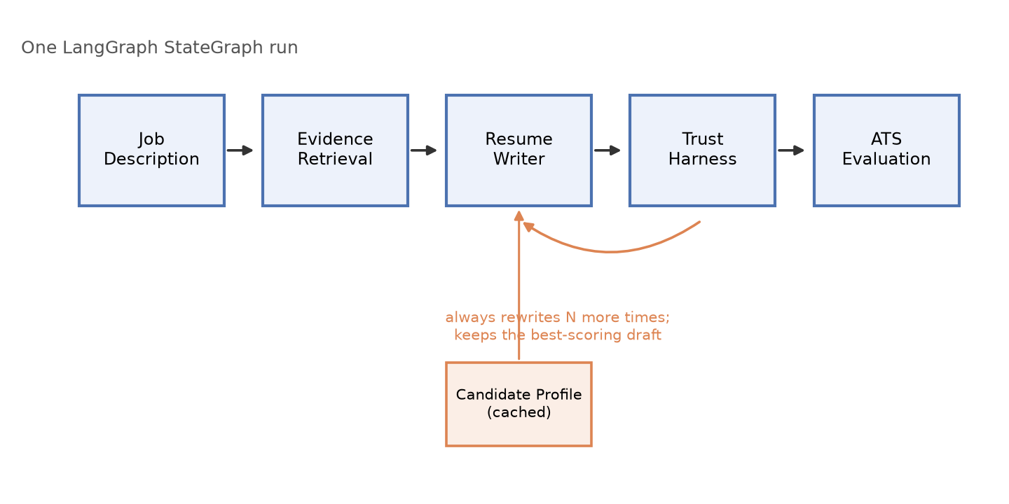
Figure 1. The generation pipeline: five sequential agents plus a cached sixth, orchestrated by a LangGraph quality loop.
The workflow then enters a quality loop. The Resume Writer generates a draft, the Trust Harness classifies each claim as SUPPORTED, PARTIALLY_SUPPORTED, or UNSUPPORTED based on retrieved evidence, and the ATS Evaluation agent measures alignment with the target job description. Drafts are evaluated against the project's quality thresholds of Trust ≥ 90 and ATS ≥ 85.
Unlike the original implementation, the loop does not stop when the first passing draft is found. Instead, it performs a configurable number of rewrite iterations (currently one) using deterministic feedback. After all iterations are complete, the system selects the highest-scoring draft for export. Passing drafts are always preferred over failing drafts, and ties are resolved by ATS score.
2.2 Key design decisions
- Storage: SQLite and ChromaDB were used instead of Qdrant. ChromaDB simplified local development and deployment while providing sufficient functionality for the scale of this project. All retrieval operations are scoped by a user_id filter to enforce user-level data isolation.
- Retrieval: A hybrid retrieval strategy combines vector search and keyword search using Reciprocal Rank Fusion. Vector retrieval helps find semantic matches and paraphrases, while keyword retrieval captures exact technology names and other important terms.
- Model Configuration: Temperature is fixed at 0 because the Trust score is a deterministic value computed in code. Models are assigned by role, allowing lightweight models to handle structured extraction while stronger models perform resume generation and trust verification.
- Multi-User Support and Resilience: API routes resolve the current user from a request header rather than relying on a hardcoded user. An optional checkpointing layer allows interrupted workflows to resume from the last completed node instead of repeating completed LLM calls.
- Quality Loop: The workflow does not stop after the first passing draft. Instead, it performs a configurable number of rewrite iterations and selects the highest-scoring draft at the end of the process, enabling improvements in ATS alignment without sacrificing trustworthiness.
2.3 Development process
Development began with an implementation based on pydantic-ai and Qdrant and later transitioned to LangChain, LangGraph, and ChromaDB. The migration provided hands-on experience with modern agent orchestration while reducing the need for custom implementations of capabilities such as text splitting, memory management, and workflow coordination. Development then proceeded as a module-by-module port validated against the original system's behavior.

2.4 Testing and evaluation methodology
Correctness and quality are measured separately. Automated testing combines an offline Pytest suite with a smaller set of live integration tests that exercise the real embedding model and HTTP API. Code coverage is enforced through a minimum coverage threshold in CI.

To measure system quality rather than implementation correctness, a separate offline evaluation harness evaluates retrieval performance and Trust Harness accuracy against labeled ground truth data. This is intentionally separate from the product-facing evaluation package, which scores individual resumes at runtime but cannot detect regressions in the evaluator itself.
3. Results
3.1 Automated test suite and CI
The automated test suite contains 500 passing tests with 99.2% code coverage, exceeding the project's 95% coverage requirement. CI runs linting, formatting checks, strict mypy validation, and the full test suite on Python 3.11 and 3.13 for every push and pull request.

3.2 Retrieval evaluation
The retrieval evaluation used a manually labeled dataset consisting of 10 evidence documents and 9 representative queries. For each query, one or more relevant documents were identified as ground truth. Retrieval was evaluated using the top 8 retrieved results for each query, matching the configuration used during normal resume generation.
Results are summarized in Table 1. Overall, the hybrid retrieval approach consistently returned relevant evidence and ranked it near the top of the results. The evaluation also included a paraphrased query and a product-specific query, demonstrating the complementary strengths of vector and keyword search. One intentionally unanswerable query still returned eight results because the retrieval layer always returns the top-k matches, even when none are truly relevant. This limitation is discussed further in Section 4.
Metric | What It Measures | Value | Interpretation
Recall@8 | Ability to find relevant evidence | 1.000 | No relevant documents were missed.
MRR | Ranking quality | 0.938 | Relevant evidence usually appeared first.
Precision@8 | Relevance of returned results | 0.156 | Limited by the evaluation dataset design.
Hit Rate | Success rate of retrieval | 1.000 | Every query returned at least one relevant result.

3.3 Trust Harness Evaluation
The original Trust Harness prompt instructed the model to “be strict” but did not clearly define the meanings of SUPPORTED, PARTIALLY_SUPPORTED, and UNSUPPORTED. When evaluated on a 12-case labeled dataset using a real Bedrock model, it achieved only 0.500 accuracy and 0.489 macro-F1, with the model consistently judging claims too harshly.
The prompt was then updated with explicit label definitions and guidance on error severity. This improved both accuracy and macro-F1 to 0.833, while maintaining zero false-pass errors, meaning unsupported claims were never incorrectly approved.
3.4 End-to-End Evaluation
To evaluate the complete system, a synthetic candidate was tested against four job postings using a real Bedrock model. Each scenario generated two resume drafts and selected the highest-scoring result based on the project's Trust and ATS criteria.
As shown in Table 2, only the strong-match scenario passed the quality gate. The remaining three scenarios failed because the candidate's documented experience did not sufficiently match the target role. These failures were expected and demonstrate that the system does not automatically optimize for passing scores.
Scenario 4 provides the clearest example. When presented with an iOS developer position for a backend-focused candidate, the system did not invent iOS experience. As a result, the resume achieved a Trust score of 100 but an ATS score of 0. This behavior reflects the project's primary goal: prioritizing evidence-supported content over resume optimization.
Scenario | Result | Trust /90 | ATS /85 | Drafts | LLM calls | Cost
1-strong-match | PASS | 93 | 95 | 2 | 6 | $0.53
2-partial-match | FAIL | 81 | 63 | 2 | 6 | $0.56
3-inflation-pressure | FAIL | 83 | 42 | 2 | 6 | $0.60
4-wrong-domain | FAIL | 100 | 0 | 2 | 6 | $0.51

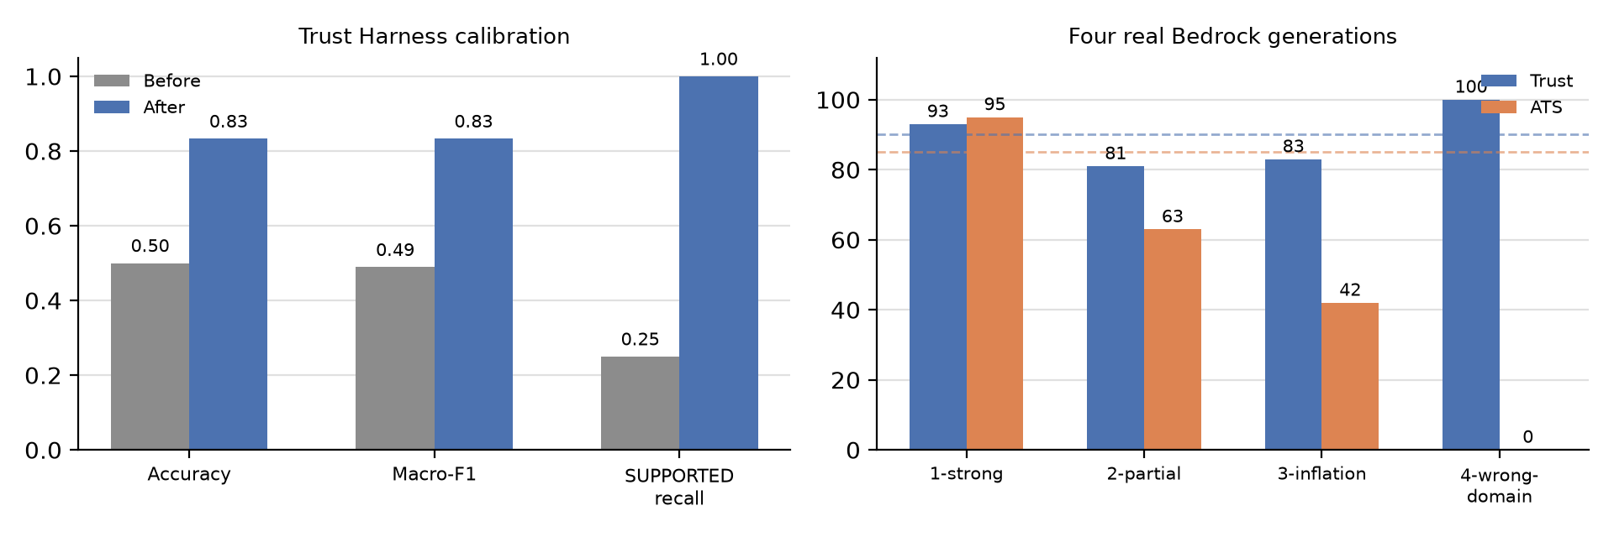
Figure 2. Trust Harness accuracy before/after the calibration fix (left) and Trust/ATS scores across four real Bedrock generations, dashed lines marking the quality gate (right).

4. Discussion

4.1 What Worked Well
The project's core design worked as intended. Separating resume generation from verification helped prevent unsupported claims from appearing in final resumes. Hybrid retrieval also performed well, consistently finding relevant evidence during evaluation. In addition, the testing and evaluation framework provided objective measurements of system quality rather than relying on subjective judgment.

4.2 Challenges and Lessons Learned
The most significant challenge was Trust Harness calibration. The original prompt did not clearly define its classification labels, leading to overly strict evaluations. Adding explicit label definitions substantially improved performance.
Several additional issues related to cost tracking, structured outputs, PDF export, and API validation were only discovered through real end-to-end testing. These experiences highlighted the importance of evaluating AI systems in realistic environments, not just through unit tests.

4.3 Ethical Considerations
TrustResume prioritizes factual accuracy over resume optimization by verifying claims against user-provided evidence. Basic protections against prompt injection and user-level data isolation are also included. However, the current system relies on a self-reported user identifier and lacks production-grade authentication.

4.4 Limitations
Some partially supported claims are still classified as unsupported. The retrieval layer also always returns a fixed number of results, even when no strong evidence exists. In addition, the system currently has limited Unicode PDF support and no formal database migration mechanism.

5. Future Work
- Replace the self-reported X-User-Id header with proper authentication and rate limiting.
- Introduce a retrieval relevance threshold so unanswerable queries do not always return the full top-k results.
- Expand the labeled Trust Harness dataset, with particular focus on compound claims and seniority-inflation claims.
- Improve PDF export by adding full Unicode support instead of degrading unsupported characters.
- Add database schema migration tooling and a scalable deployment path, such as Kubernetes or a managed cloud service.

6. Conclusion
This project demonstrates that a resume generator is trustworthy only when its claims are independently verified against evidence. Reimplementing the system on LangChain, LangGraph, and ChromaDB provided a modern agent framework while preserving the project's core trust-verification design.
The evaluation framework made it possible to measure system quality objectively rather than relying on assumptions. Retrieval evaluation, Trust Harness testing, and end-to-end experiments showed that the system consistently favors evidence-supported content over resume optimization.
Several limitations remain, including authentication, retrieval relevance filtering, and additional Trust Harness training data. However, the results show that combining RAG, multi-agent workflows, and trust verification can significantly reduce the risk of AI-generated resume fabrication.
Overall, the project successfully achieved its goal of generating evidence-based resumes while minimizing the risk of AI-generated fabrication.

AI Disclosure Statement
AI-assisted development tools, primarily Claude Code and Microsoft Copilot, were used throughout this project to support implementation, testing, debugging, evaluation, and report drafting. All reported results were generated by executing the project's code, and all findings, analysis, and conclusions were reviewed and verified by the author.

