Text File

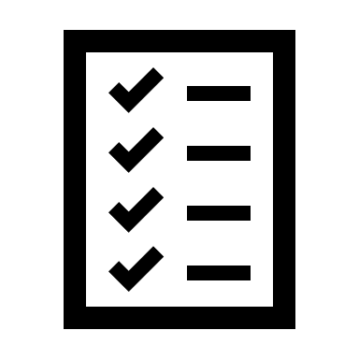

This will be the reference to all the tasks

**Python Tasks Assistant**

ERROR HANDLER

e.i: enter the error msg you’re getting  
  
this error is due to …

Provide the appropriate course materials

Details and Faq

Show A Demo of the program the student is expected to build

Dial a Mentor



If the robot cannot help the student, the student now can seek Human resources (this means more update)

Folder of Tasks



This is main folder where all the tasks and their details are stored

Chatbot



This chat bot will be the middleman between the computer and the application

**– 1 –**

**Computer**

**Web-app or desktop app**