PYAAS DAIRY
Know your milk.
CAMPAIGN PLAYBOOK — FULL EDITION
Pyaas Founding Families
Chandra Panorama, Lucknow
v2.0 — Two-Model Edition · aligned to “Two Models, Two Strategies” · Morning Delivery + Quick Pyaas

Pilot launch: Saturday, 15 August 2026 (Independence Day)
Goal: acquire genuine households → convert to paid milk subscriptions → retain through reliable daily delivery; then add on-demand Quick Pyaas on the same route.
An execution-ready, society-led BTL & WhatsApp campaign — built for a small team and a ₹4.70/litre milk margin.

Prepared as | Senior consumer-growth & BTL launch strategy — resident acquisition, conversion & retention, across two models
For | Pyaas Dairy Private Limited — founding & pilot team
Scope | Single society (Chandra Panorama). Low-cost, high-conversion BTL. Quick Pyaas added on the same riders after density is proven.
Commercial frame | Milk distribution margin ₹4.70 / litre (LMU Work Order 06.08.2026). No unsustainable discounts, blanket free milk, cashback or paid digital ads.
Status | Confidential working prototype — adapt bracketed [ ] figures to operations-verified values before publishing.

Contents

Right-click → “Update field” in Word to populate page numbers.

How to use this playbook
This is a ready-to-run plan, not a theory deck. Every section can be handed to a named owner tomorrow morning. Three rules govern it — and one edition note.
- Claims discipline. No asset or message makes unverified claims about purity, testing, delivery time, pricing or health. Product facts are only the pack specifications supplied (e.g. A2 beta-casein, 3.5% fat; Toned 3% fat, 8.5% SNF).
- Fill the brackets. [ ] marks a number the team must confirm from live operations (occupied-flat count, rider cost per route, exact cut-off time) before it is printed or committed.
- Margin first. At ₹4.70/litre, the campaign sells status, reliability and control — never cheap milk. Any “free milk” offer is clearly flagged as needing Parag/LMU promotional stock or written co-funding, and must never run on Pyaas margin.
Two-Model edition note
This edition folds the campaign into the “Two Models, Two Strategies” framework. This playbook executes Model 1 — Morning Delivery (the milk subscription). Model 2 — Quick Pyaas (on-demand) is added in §17, switched on later in the same society using the same riders. Two corrections are baked in throughout: the margin is ₹4.70/L (not ₹5.70), and the route-economic density gate is ≥120 paying litres/day (not 70 flats).

1. Campaign name, core idea & consumer promise
Core idea
The first households to join in Chandra Panorama are not merely “early customers” — they are Founding Families: a recognised, honoured inaugural cohort who help shape the service and keep founding privileges for as long as they stay subscribed. Launching on 15 August frames it as “Azadi from the daily-milk hassle” — freedom from unreliable milkmen, cash tabs and morning shop runs — and a chance to be a founder of something in your own building.
Why this is right for a ₹4.70/litre business: status, belonging and reliable service cost almost nothing to give, are impossible for a milkman or a quick-commerce app to copy quickly, and attract genuine households rather than freebie-seekers. We win on trust and control, not on price.
One-line consumer promise
Primary promise (matches the printed door hanger & flyer)
हिन्दी: रोज़ का दूध, अब ऐप पर — सीधे आपके दरवाज़े। पराग का भरोसा, अब आपकी हथेली में — बनिए Chandra Panorama की Founding Family।
English: Your daily milk, now on the app — straight to your door. Parag’s trust, now in your palm — become a Founding Family of Chandra Panorama.
Three things carry through every asset: (1) Parag × Pyaas trust transfer — पराग का भरोसा (1962 सहकारी) + Pyaas की सुविधा; (2) the Pyaas Wallet — recharge once, morning delivery never fails; and (3) a farmer-first close — “आपका हर ऑर्डर, किसान की मुस्कान”. Consumer brand colour is magenta/pink; co-brand lockup is Pyaas × पराग with the PCDF / P-DAN partner line. WhatsApp on all consumer assets: +91 96672 60050.

2. Pilot objective — first 30 days
Sizing assumption (confirm before publishing targets)
Chandra Panorama is modelled at ~[400] occupied flats. Insert the verified occupied-flat count from society mapping; the conversion ratios below matter more than the absolute numbers.
The one number the pilot is judged on: active subscriptions × Day-30 repeat = profitable delivery density. Downloads are a vanity input, not the goal.
Objective (30-day) | Definition | Target | Stretch | % occupied
App downloads | App installed from a society QR / short link | 160 | 200 | ≈40%
Verified households | Tower + flat confirmed, OTP login, address bound | 130 | 165 | ≈33%
First paid orders | At least one completed prepaid (UPI) order | 95 | 120 | ≈24%
Active subscriptions | On a recurring daily / alternate-day plan | ~100 | ~120 | ≈25–30%
Repeat rate (Day 30) | Subscribers still receiving & paying at day 30 | ≥75% | ≥85% | —
Amended density target (₹4.70/L)
The route-economic gate is ≥ 120 paying litres/day per morning route (≈120 subscribers at ~1 L/day) — the point at which delivery cost falls below ₹4.70/L (see §18). The old “≥70 flats” target is below break-even. Treat ~75–95 active subs as a demand milestone, and ~100–120 (≥120 L/day) as the gate to declare the model economic and replicate it. Push ≥1 L/home via minimum quantity and bundling. Supporting targets: first-delivery success ≥97% · complaint resolution < 24h · Founding-Family sign-ups: first 100 verified households.

3. Target segments & best product / offer for each
Chandra Panorama is not one audience. Match the product and the founding hook to the household so the first order feels obviously right.
Segment | Who they are / signals | Primary product & price | Founding hook
Young families with children | Highest daily volume; trust- and value-sensitive | Toned Milk 1 L ₹99 daily; A2 Cow 1 L ₹139 upgrade | Welcome kit + Pyaas recipe booklet; free delivery 30 days; kids’ milk-moustache sticker
Working / dual-income couples | Time-poor, travel often, want zero phone calls | A2 Cow 500 ml ₹79 or Toned 1 L ₹99, daily/alt-day | Auto-pilot subscription + pause/resume; free delivery + 21-day streak thank-you; Pyaas Plus for on-demand
Senior citizens | Fixed morning routine; may find apps hard | Toned Milk 500 ml ₹55 / 1 L ₹99 (lighter) | Assisted setup, large-print step card, priority support, family-managed account
Existing daily-milk households | Already buy from a milkman/shop — the switch target | Match the habit: Toned 1 L ₹99 or A2 1 L ₹139 | “No-risk switch” — keep your milkman for week 1 if you wish, then decide
Add-on (active subs) | Any household already receiving milk | Pure Cow A2 Bilona Ghee 500 ml ₹1,499 | Founding Families get first access — a basket-builder, NOT the trial product
Strategist note on the ghee
Ghee carries a much higher ticket and only a 1.5% commission, so it is an add-on to a trusted, already-active subscriber — never the first thing you sell. Introduce it in week 2–3 once daily delivery has proven itself. It is the margin engine of the whole model (see §18).

4. Three-phase execution plan
Calendar reality
Today is 9 Aug 2026 and launch is 15 Aug. The pre-launch window is tight and partly over a weekend — front-load every RWA/society approval and printing into 9–13 Aug. Deliveries begin the morning after first orders.
Phase 1 — Pre-launch (8–14 August)
Day | Focus | Key actions | Owner
Fri 8 | RWA / MC engagement | Present pilot to Management Committee; secure written permission for lobby desk, boards, door-hangers & early-AM delivery access | Founder
Sat 9 | Map & recruit | Map towers, occupied flats, lobby/board spots, WhatsApp admins. Recruit 2–4 resident champions. Agree gate / early-AM entry in writing | GTM
Sun 10 | Assets & app | Finalise & print top-up BTL; test app & payments (OTP, UPI, QR deep-link); pre-load Chandra Panorama towers/flats | BTL + Product
Mon 11 | Go visible | Seed resident WhatsApp groups with permission-approved intro + pinned FAQ; put up posters, notice-board flyer, lobby standee | Marketing
Tue 12 | Reach every door | Distribute door hangers flat-wise; publish launch-desk dates; configure offers in app (Founding welcome, free delivery, referral) | BTL
Wed 13 | Dry run | Operations dry run: morning route, gate access, test deliveries; cold-chain & crate check. Verify rider cost/route. Train desk team | Ops
Thu 14 | Go / No-Go | Go/No-Go review; set up desk with tricolour theme; stock & working-capital float top-up; confirm roster | Leadership
Phase 2 — Launch weekend (15–17 August)
Day | Focus | Key actions
Sat 15 — GO LIVE | “Pyaas Milk Morning” desk | Open lobby desk (tie in with RWA flag-hoisting if permitted). Assisted downloads + first orders; book subscriptions, not just installs. Sign up first 100 Founding Families. Champions visible at peak hours (7–10 AM, 6–8 PM)
Sun 16 | First deliveries | First doorstep deliveries to Day-1 subscribers. Team shadows the route; confirm gate access, flats, notifications. Fix issues live
Mon 17 | Feedback & convert | First-delivery feedback sweep with every new customer. Convert pre-registrations and trials to full subscriptions; close every open issue < 24h
Phase 3 — Retention & the second model (Day 4–30: 18 Aug – 13 Sep)
Window | Focus | Key actions
Day 4–7 | Welcome & first referrals | Complete the 7-day welcome journey (§8). Gentle referral asks to visibly happy customers. Publish a “we’re here, here’s our support number” update
Week 2 | Deepen, don’t spread | Streak-building nudges; pause/resume education; introduce A2 Bilona Ghee to active subs. First weekly review. Add depth in Chandra Panorama — do NOT open a new society
Week 3 | Referral engine + Quick Pyaas prep | Run the referral drive (21-day streak thank-you). IF Morning Delivery ≥120 L/day & on-time ≥97%, prepare Quick Pyaas soft-launch on idle mid-day riders (§17)
Week 4 | Retain & decide | Win back paused/lapsed; failed-payment recovery; Day-30 review against every metric; apply stop/scale rules (§13) to decide the next society

5. Exact BTL activities
Every activity names an audience, a creative, a channel, an owner, an indicative cost and a success metric. Most print assets already exist (see §16), so cost is largely top-up and distribution.
Activity | Audience | Creative | Channel | Owner | Cost | Success metric
RWA / MC engagement | Mgmt Committee | 1-pg summary + permission letter | In-person | Founder | ₹0 | Signed permission for desk/boards/AM access
Security-gate & lift comms | All residents | Lift poster (QR), gate banner | Lift lobby + gate | BTL | ₹2,500 | ≥40% downloads via in-society QR
Door hangers + QR | Every flat | Hanger: promise + 3 steps + QR | Flat door handles | BTL field | ₹1,500 | ≥25% of hung flats scan / pre-register
Lobby / clubhouse desk | Peak footfall | Roll-up standee, tent card, demo tablet | Main lobby | Desk lead | ₹5,000 | ≥15 assisted onboards/day at launch
WhatsApp resident-group plan | Opted-in residents | Pinned intro + FAQ; ≤1 update/day | Society groups | Marketing | ₹0 | ≥30% join broadcast; zero spam complaints
Sampling (permitted only) | Desk visitors | Milk-based tasting | Desk counter | Desk | If co-funded | Sample → same-day order ≥20%
Ambassador / referral | Active subs | Referral code/link, leaderboard | In-app + WhatsApp | Marketing | ₹1,500 | ≥0.4 paid referrals per active sub by D30
Rules that keep these honest
- WhatsApp: permission-based only, one clear message plus a pinned FAQ, never more than one update a day. No adding residents without consent.
- Sampling: run only where the society permits AND it is commercially/policy approved — otherwise skip it.
- Referral golden rule: a reward is issued ONLY after the new customer completes a paid order — never at install or sign-up.

6. Resident offer architecture

6A · Pyaas-funded, low-cost offer — the “Founding Family Charter”
The flagship offer, viable at ₹4.70/litre because it gives away no milk. It rewards subscribing and staying, using assets already paid for. First 100 verified households in Chandra Panorama receive:
- Founding Family status — a digital badge in the app and (with consent) their name on a “Founding Families” lobby wall.
- Free milk delivery for the first 30 days — time-boxed; near-zero marginal cost because it rides an existing morning route.
- A welcome kit — personalised Founding Family card (signed; see §16), recipe booklet, fridge magnet with reorder QR, large-print step card.
- Free Pyaas Plus for 90 days — free on-demand Quick Pyaas delivery once that model is live (§17). This bridges the two models and rewards the earliest homes.
- A one-time welcome credit of ₹[30] on the first paid order, per verified flat — fixed and capped.
- A 21-day streak thank-you of ₹[20] after 21 continuous delivery days — rewards retention.
Why it is sustainable (recomputed at ₹4.70/L)
No milk is given free. Free delivery uses a route that runs anyway; the kit reuses already-printed collateral; both credits are fixed and capped per flat. Fully-loaded cost per Founding Family ≈ ₹[50–90]. At ₹4.70 × 30 ≈ ₹141/month gross margin on a 1 L/day subscription, this is recovered in roughly 2–3 weeks — model the exact figure against your true last-mile cost before publishing.

6B · Optional Parag / LMU co-funded “milk-free” offer — “Azadi Free Trial”
DO NOT RUN ON PYAAS MARGIN
This offer is contingent on Parag/LMU providing promotional stock OR written co-funding. It activates only after that confirmation is received in writing; until then it stays off.
Mechanic (if funded): “Subscription लें और पाएं 2 दिन का दूध मुफ़्त*” — 2 days of milk free on a new eligible subscription. This is the offer already printed on the door hanger and flyer, with the eligibility line “यह ऑफ़र केवल Pyaas Pilot के दौरान नए और पात्र Subscription ग्राहकों के लिए है। नियम एवं शर्तें लागू।” Positioned as a Parag × Pyaas welcome, not a Pyaas discount.
Action before distributing the printed hangers
The printed door hanger LEADS with “2 din ka doodh muft*”. Because that free milk must come from Parag/LMU promotional stock or written co-funding, confirm the co-funding/stock in writing before the hangers go out. If not confirmed in time, lead distribution with the Founding Family Charter (6A) and hold the “2 days free” hangers until stock is secured.
Eligibility, limits, anti-misuse & expiry (both offers)
Control | Rule
Eligibility | One offer per verified flat — tower + flat + mobile-OTP + delivery to the registered address. Resident of Chandra Panorama only.
Requires a real subscription | Offer/credit unlocks only after a subscription is set, the Pyaas Wallet is recharged (UPI), and one completed paid order.
No cash-out | Credits apply to delivery/next order only — never refunded as cash, never stackable.
Founding cap | Founding Family Charter limited to first 100 verified households; “Azadi Free Trial” capped at the co-funded stock quantity.
Referral safeguard | Referral rewards issue only after the referred household’s first completed paid order; cap referrals per account per period.
Expiry & audit | Welcome credit expires 15 days after issue; free-delivery window is a fixed 30 days; streak thank-you needs 21 unbroken days. Redemptions reconciled daily against the advance→DI→sold ledger.

7. App onboarding journey & product catalogue
Frictionless for a busy 30-year-old and gentle enough for an 80-year-old. Every step has an assisted fallback so no willing household is lost to technology.
Step | What the resident does | What Pyaas ensures | Senior-friendly path
1 · QR → download | Scans the QR on a hanger/poster/standee | Deep link opens the right store; short URL backup | Desk installs it for them
2 · OTP login | Enters phone, receives OTP | Fast, reliable OTP; graceful retry | Team enters OTP together at desk
3 · Society & flat | Picks Chandra Panorama → tower → flat | Society & towers pre-loaded; address bound | Desk selects tower/flat with them
4 · Choose product | Selects an SKU (catalogue below) | Clear catalogue, quantities & prices | Desk recommends by segment
5 · Set subscription | Sets quantity, daily/alt-day, start date | Cut-off time for next-morning delivery shown | Family-managed account option
6 · Confirm address | Confirms tower + flat + landmark + gate note | Delivery instruction captured | Team verifies at door if needed
7 · Recharge Wallet | Recharges by UPI — “एक बार रिचार्ज, फिर बेफ़िक्र” | Auto-covers each morning; low-balance reminders | Desk helps recharge; family can top up
8 · Support | Saves WhatsApp +91 96672 60050 | Issue reaches a real person quickly | Large-print card + standing callback
Product catalogue to display (correct prices)
Product | 1 L | 500 ml | pouch | Spec (pack)
Pyaas A2 Cow Milk | ₹139 | ₹79 | ₹69 | A2 beta-casein; 3.5% fat
Pyaas Toned Milk | ₹99 | ₹59 | ₹55 | 3% fat; 8.5% SNF
Pure Cow A2 Bilona Ghee | 500 ml ₹1,499 | — | — | Add-on (pan-India)
Payment = Pyaas Wallet: recharge once by UPI → every morning’s delivery is auto-covered, no repeated payments. Fits the prepaid, no-credit supply terms. Display only these pack facts and prices; no purity/testing/health claims in Pyaas-authored copy.

8. Retention programme
First 7-day welcome journey
Day | Trigger / channel | Message intent
Day 0 | App + WhatsApp on sign-up | “Welcome to the Founding Families of Chandra Panorama.” Confirm tomorrow’s first delivery, cut-off, support number
Day 1 | After first delivery | “Your milk was delivered — here’s your delivery log.” Invite a quick thumbs-up/down
Day 2 | Feedback (call/WhatsApp) | “Did it arrive as expected? Anything to fix?” Log every response; fix same day
Day 3 | In-app tip | Teach pause / resume / skip — the #1 traveller trust feature. “Going away? Pause in two taps.”
Day 5 | In-app / WhatsApp | Introduce an add-on (A2 Bilona Ghee) to satisfied subscribers — soft, not pushy
Day 7 | WhatsApp + desk | Referral invite to happy customers (reward only after the friend’s first paid order)
Low-balance / failed-payment recovery (Pyaas Wallet)
- Low-balance alert (T−1): when the Wallet cannot cover tomorrow, send an in-app + WhatsApp nudge — “Wallet रिचार्ज करें ताकि कल की डिलीवरी न रुके।”
- At cut-off: one-tap recharge link; if still unrecharged, deliver the next morning within a capped grace so trust is protected, and flag for follow-up.
- Grace rule: never cut off a Founding Family on a single low balance — recover the relationship first, the rupee second, within a capped grace window.
Service recovery — late or missed delivery
Step | Action & SLA
Detect | Delivery associate flags any missed/late flat at route end; support logs complaints immediately
Acknowledge (<2h) | Proactive WhatsApp/call: apologise, state what happened plainly, confirm the fix
Make it right (same day) | Re-deliver if feasible that morning, or credit the day’s milk to the next order — resident’s choice
Close (<24h) | Confirm resolution; log root cause (gate access, wrong flat, stock, cold-chain)
Learn (weekly) | Cluster causes; fix the top reason each week. Rising complaints or slow fixes silently kill retention
Referral mechanism (only after a successful order)
- Golden rule: no reward before the referred household completes a paid order. Cap referrals per account per period.
- Track by tower: referrals → paid conversions → retained at Day-N, so you reward real density, not sign-up noise.

9. Daily operating checklist (Pyaas team)
Pre-dawn (before dispatch)
- Reconcile yesterday: advance paid → DI issued → sold → unsold; correct today’s indent from actual demand.
- Confirm stock received at hub; cold-chain temperature check; crate count and FEFO order.
- Print/queue today’s delivery run-sheet by tower & flat, including new subscribers and pauses/resumes.
Delivery window (early morning)
- Gate entry per agreed security protocol; carry rider ID.
- Deliver by tower; mark each flat delivered in the app so residents get the “delivered” notification + log.
- Flag any missed/late/wrong-flat case immediately for same-day service recovery.
Mid-morning to afternoon (desk, support & Quick Pyaas)
- Run the lobby desk at peak hours; assisted onboarding + first orders + subscriptions.
- Confirm mid-day Quick Pyaas capacity and the day’s served-order cap (once §17 is live) — riders freed after the morning route.
- Clear the support queue within the promised window; close every open complaint toward the <24h SLA.
- First-delivery feedback sweep for yesterday’s new customers; log responses.
End of day
- Update the dashboard: downloads, verified households, first orders, deliveries attempted/succeeded, complaints & resolution time; and (once live) Quick Pyaas orders, AOV & shared-route cost.
- Place/correct tomorrow’s advance indent; verify the working-capital float is sufficient (prepaid, no credit).
- Top up the desk and print stock; brief the team on tomorrow’s priorities in a 15-minute standup.

10. Responsibility matrix — Pyaas / Parag-LMU / RWA
Critical assumption
Do NOT assume Parag or LMU will fund marketing, provide free/promotional stock, grant society approvals, or execute any BTL unless separately confirmed in writing. Pyaas owns all customer-facing activity. Every Parag/LMU line marked “written confirmation” is a request, not a commitment.
Activity | Pyaas | Parag / LMU | RWA / Society
Society approvals & access | Requests & owns the relationship | — | Grants desk, boards, hanger & early-AM permission
BTL creative, print & execution | Owns fully (plan, cost, manpower) | Brand assets + written usage permission | Allows placement per society rules
Product supply & Distributor ID | Advance payment, indent, pickup | Supplies stock; issues DI; hub, gate pass, pricing/commission | —
“Free milk” promotional stock | Executes only if funded | Promotional stock OR co-funding (written) | —
App, delivery, support, both models | Owns fully | Quality-standards content (request) | Facilitates resident communication
Shared rider/hub base (both models) | Owns — Director, P-DAN Network | — | Enables gate/early-AM + mid-day access
Reconciliation & reporting | Owns (daily + weekly) | Receives POC review as agreed | Receives a light society-level summary

11. Minimum staffing & material checklist
Role | Count | When | Responsibility
Desk lead / society owner | 1 | Full pilot | Runs the desk, RWA/security liaison, owns the day’s numbers
Onboarding associates | 2 (1 for seniors) | Launch week, then taper | Assisted installs, first orders, subscription & UPI help
Delivery associate(s) | 1–2 | Daily | Morning route; reports gate/flat issues; mid-day Quick Pyaas once live
Support responder | 1 (can be remote) | Daily | Answers support number/WhatsApp within the promised window
Resident champions | 2–4 (volunteers) | Peak hours | Introductions, trust, senior help — not staff
Material checklist (★ = already in the Pyaas asset library)
★ Door hangers (F/B) · ★ Lift posters (A3) & lobby standee with QR · ★ Notice-board flyer · ★ Founding Family welcome card (A5, signed) · ★ Fridge magnet + recipe booklet · ★ Co-branded Parag tri-fold · Large-print senior step cards · Tricolour desk décor · Demo tablet/phone · Rider ID cards, insulated bags, crates · Printed support/complaint cards · NEW: Quick Pyaas fee card (add when §17 goes live).

12. Indicative pilot budget — three levels
Campaign / acquisition budget for one society over 30 days. Excludes core pilot operating costs (cold-chain, insulated vehicle, deep-freezer, delivery staff, stock float) which sit in the Go-Live plan — do not double-count.
Line item (₹) | Lean | Recommended | Expanded
BTL print top-up & distribution | 6,000 | 10,000 | 18,000
Launch desk setup & tricolour décor | 3,000 | 7,500 | 15,000
Welcome kits (already printed) | 2,000 (50) | 4,000 (100) | 8,000 (200)
Welcome credits (₹30 × first orders) | 1,500 | 2,850 | 4,500
21-day streak thank-you credits | 800 | 1,200 | 2,500
Champion & referral rewards | 1,000 | 1,500 | 4,000
Onboarding staffing (campaign-specific) | 0 | 10,000 | 30,000
Support responder (part-time) | 0 | 6,000 | 12,000
Contingency | 2,000 | 5,000 | 12,000
Indicative total | ≈ ₹16,300 | ≈ ₹48,050 | ≈ ₹1,06,000
CAC guardrail (recomputed at ₹4.70/L)
At the Recommended level (~₹48k) and ~100 active subscriptions, campaign cost per active sub ≈ ₹480. Gross margin on a 1 L/day sub is ≈ ₹141/month (₹4.70 × 30), so pilot payback is ~3.5 months — acceptable for a learning pilot. At scale, cost per active sub must fall below ~₹300 (≈ 2-month payback). Track it weekly and cut any activity whose cost-per-paid-order runs above target.

13. Dashboard — metrics, funnel & decision rules
Daily metrics
Metric | Why it matters / watch for
Deliveries attempted vs succeeded | First-delivery success ≥97%; every miss triggers recovery
Route litres/day (paying) | The core economic metric — must reach ≥120 L/day to clear ₹4.70/L
Complaints & resolution time | Trust signal; drive toward <24h
Advance → sold → unsold reconciliation | Inventory & cash discipline (prepaid, no returns)
Quick Pyaas: orders, AOV, shared-route cost/order | Once §17 live — AOV ≥₹220; marginal delivery cost ≤ ₹25/order
Weekly metrics & funnel
Funnel: Reached (BTL) → Downloads → Verified households → First paid order → Active subscription → Retained at D30. Read the biggest drop-off each week and fix that one step first — early on, the largest leak is “verified → first paid order”; close it with assisted onboarding and the Founding Family hook, not discounts. Track: install→activation, activation→first order, subscription rate, D7/D30 repeat, delivery density/tower, referral→paid conversion, churn by cause, CAC (< ₹300 at scale), and — once live — Quick Pyaas repeat & promo %.
Stop / scale decision rules (two-model)
Signal | Decision
SCALE | Route ≥120 L/day for 3 wks AND D7 repeat ≥70% AND sub-rate ≥50% AND first-delivery ≥97% AND complaints <24h → open next 1–2 contiguous societies; consider Quick Pyaas in the new society only after its Morning Delivery densifies
HOLD | Density or repeat within 10% of target but improving; complaints manageable → deepen Chandra Panorama; keep Quick Pyaas OFF; fix the top funnel leak
FIX / STOP | First-delivery failure >5%, or D7 repeat <50%, or route below break-even after 6 wks at target density, or any confirmed quality incident → pause acquisition & Quick Pyaas; fix before adding households

14. Risks & mitigations
Risk | Impact | Mitigation | Owner
Poor first delivery | Breaks trust on day 1; early churn | Mandatory dry run (13 Aug); over-staff the route on 16 Aug; strict <24h recovery; small first indents | Ops
Density mis-set / low density | Route below break-even; every litre loses | Gate = ≥120 L/day; push ≥1 L/home; verify rider cost/route in dry run | Ops / Finance
Unprofitable offers | Margin erosion at ₹4.70/L | Status-led, not discount-led; NO free milk unless Parag/LMU co-funds in writing; capped credits | Founder / Finance
Quick Pyaas launched too early / standalone | Dilutes morning route; cash burn | Hard activation gate (§17.1); shared-route only; capped promos | CEO / Ops
Freebie-seeker inflation | False density; churn at offer end | One offer per verified flat; reward only after paid order; audit daily | Marketing
Society-permission delay | No desk/access; launch slips | Front-load written RWA approval into 8–9 Aug; champions as advocates; backup society on standby | Founder
Working-capital gap | Supply blocked (prepaid, no credit) | Release advance float now; daily reconciliation; correct day-ahead indent | Finance
WhatsApp fatigue / spam | Residents opt out; RWA pushback | ≤1 permission-based message/day; pinned FAQ; useful updates only | Marketing
Over-expansion too early | Scattered pins break route economics | Apply stop/scale rules; deepen one society before opening the next | Leadership

15. Draft copy — Hindi (Devanagari) + English
Ready to paste. Fill any [ ] with a verified value. No unverified claims about purity, testing, delivery time, price or health.
1 · Door-hanger headline (as printed)
हिन्दी: रोज़ का दूध, अब ऐप पर — सीधे आपके दरवाज़े। Subscription लें और पाएं 2 दिन का दूध मुफ़्त* · [QR स्कैन करें] · *नए और पात्र Subscription ग्राहकों के लिए; नियम एवं शर्तें लागू।
English: Your daily milk, now on the app — straight to your door. Subscribe and get 2 days of milk free* · [Scan the QR] · *for new, eligible subscription customers; T&C apply. WhatsApp: +91 96672 60050
2 · WhatsApp launch message
हिन्दी: नमस्ते Chandra Panorama के निवासीगण! पराग का भरोसा, अब Pyaas ऐप पर — आपका रोज़ाना दूध एक टैप में। एक बार Wallet रिचार्ज करें — फिर हर सुबह बेफ़िक्र। 15 अगस्त लॉन्च: लॉबी में हमारी टीम ऐप इंस्टॉल, Wallet रिचार्ज और पहला ऑर्डर में नि:शुल्क मदद करेगी। पहले 100 परिवार बनेंगे “Founding Families” — Welcome किट + पहले 30 दिन डिलीवरी नि:शुल्क। WhatsApp: +91 96672 60050
English: Hello, residents of Chandra Panorama! Parag’s trust, now on the Pyaas app — your daily milk one tap away. Recharge your Wallet once, then every morning is carefree. 15 August launch: our team helps you install, recharge and place your first order free in the lobby. First 100 households become “Founding Families” — welcome kit + free delivery for 30 days.
3 · Referral & 4 · Launch-desk pitch (~20 sec)
Referral (share after a successful delivery): आपको Pyaas पसंद आया? अपने पड़ोसी को बताइए! अपना रेफरल कोड शेयर करें — जब आपका पड़ोसी Subscription लेकर पहला ऑर्डर पूरा करेगा, तो आप दोनों को Wallet क्रेडिट मिलेगा। कोड: [CODE]
Desk pitch: “नमस्ते! पराग का दूध, अब Pyaas ऐप पर — रोज़ सुबह सीधे आपके दरवाज़े। एक बार Wallet रिचार्ज कीजिए — फिर हर सुबह बेफ़िक्र। आज हम आपको दो मिनट में सेट कर देंगे — और आप बनेंगे Chandra Panorama की पहली Founding Families में से एक। शुरू करें?”

16. Campaign creatives — ready-to-deploy artwork
Consumer brand is magenta/pink; every asset carries the Parag × Pyaas co-brand and the Pyaas Wallet model. Print-ready mockups below; swap the QR placeholder for the live app/Wallet deep-link before printing.
Door hanger — front & back (95 × 222 mm)
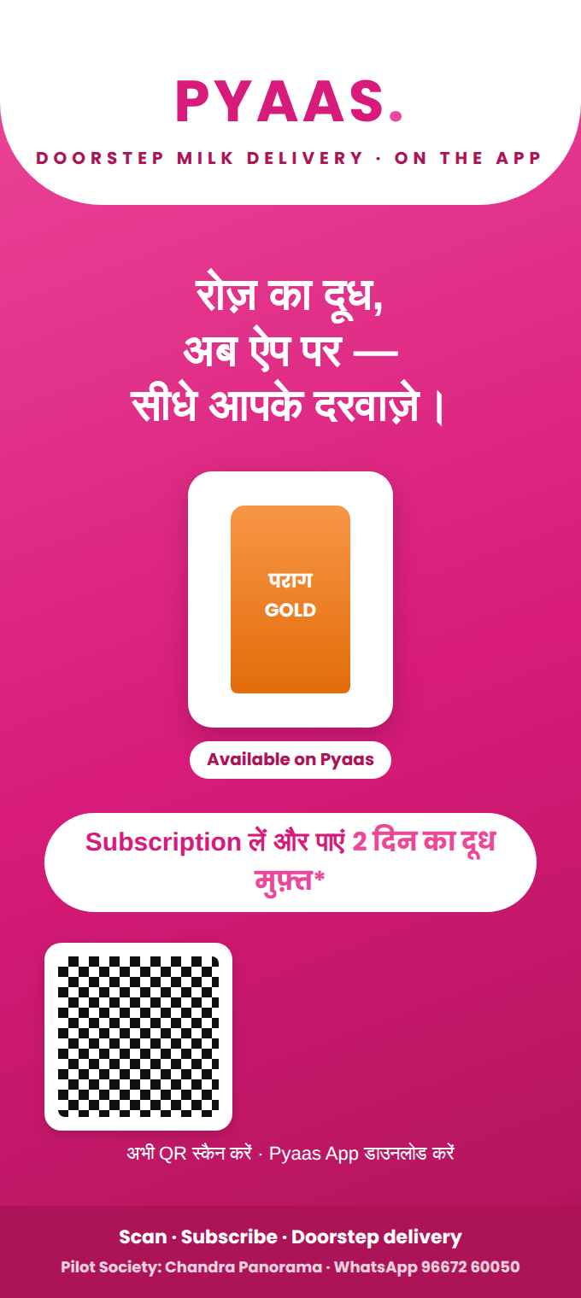  Front — promise, hero pack, offer, scan-to-download | 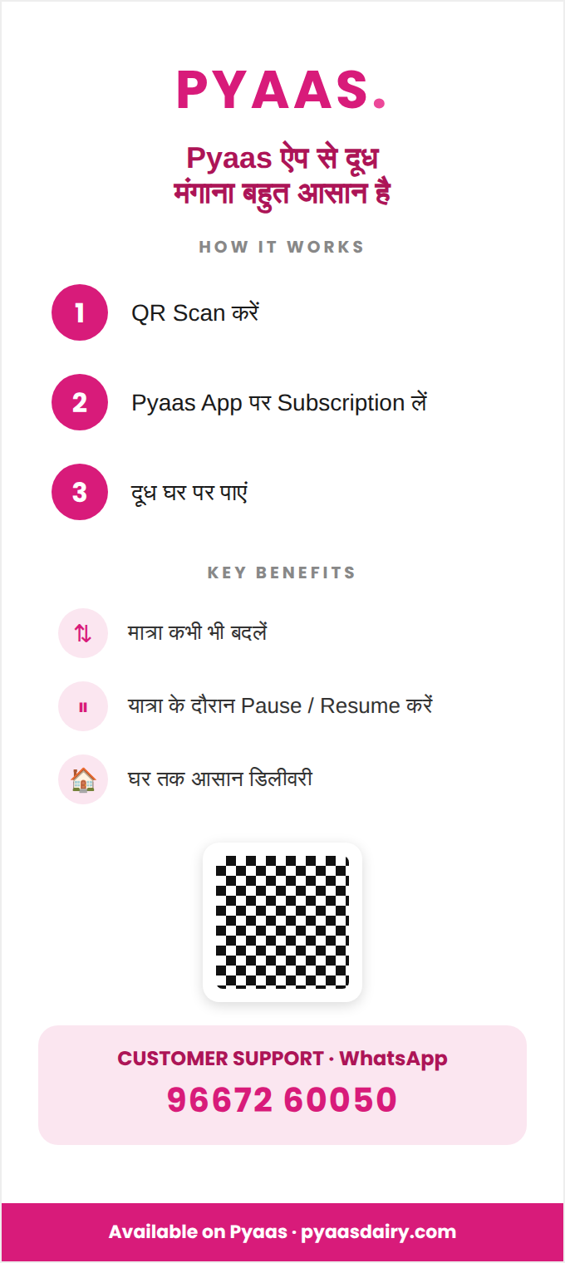  Back — how it works, benefits, support
Front carries the promise “रोज़ का दूध, अब ऐप पर”, the hero Parag Gold pack, the “2 din ka doodh muft*” offer (needs §6B co-funding confirmed), a scan-to-download QR and WhatsApp. Back carries the 3 steps, 3 benefits and the support number.
Lift/lobby poster (A3) · Fridge magnet (Pyaas Wallet)
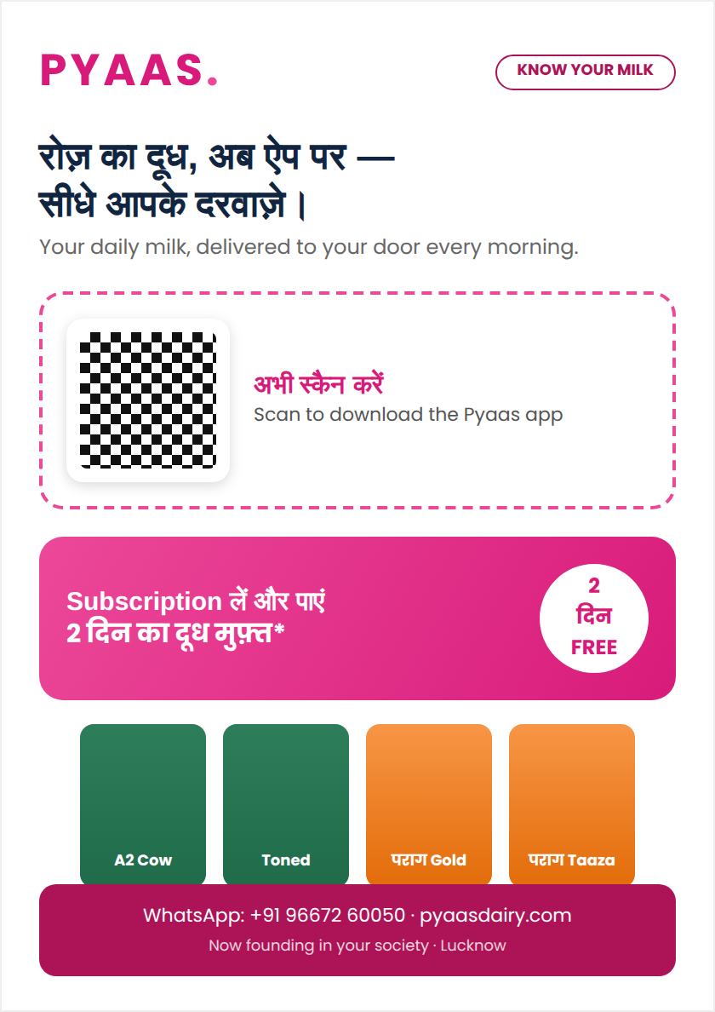  A3 lift/lobby poster — scan-to-download + launch offer | 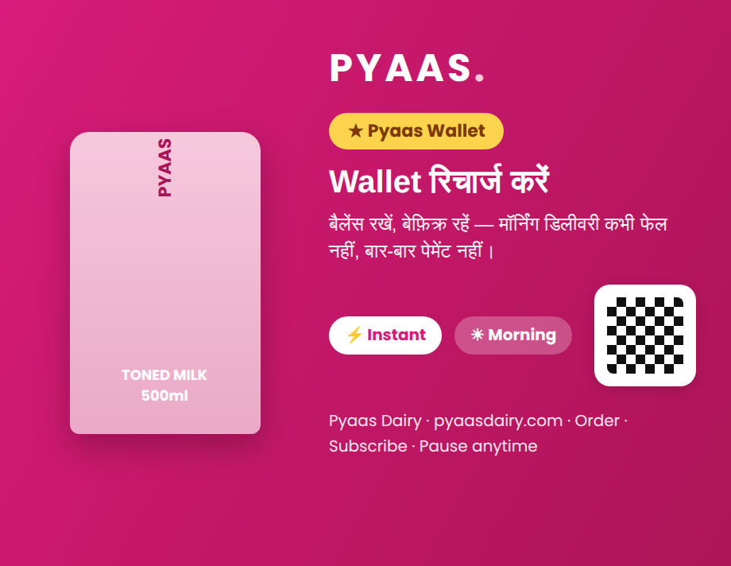  Fridge magnet — Wallet recharge reminder, kitchen-permanent
Founding Family welcome card — double-sided (A5)
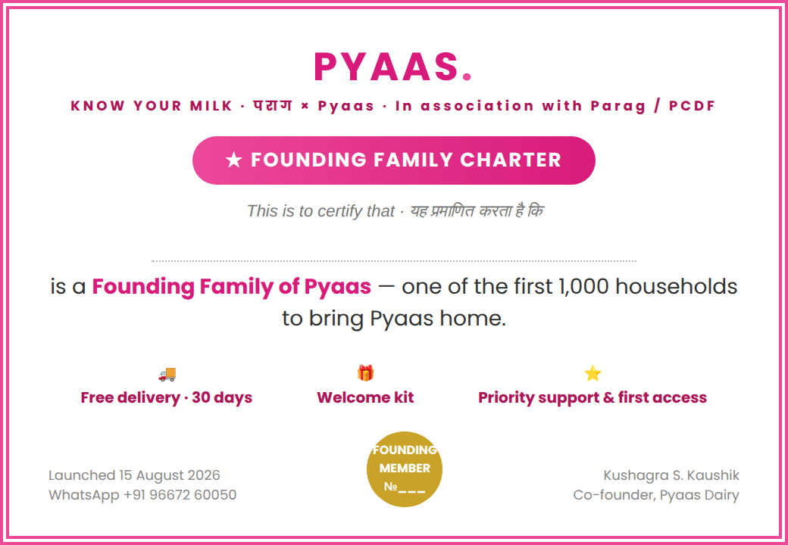  Front — the ceremonial Charter certificate | 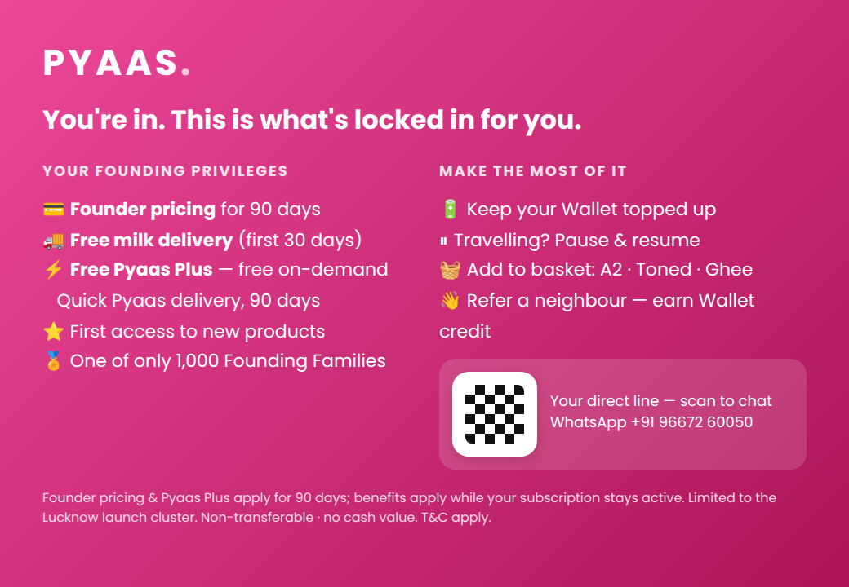  Back — founding privileges incl. free Pyaas Plus (Quick Pyaas bridge)
Note the two-model link on the back: Founding Families get free Pyaas Plus for 90 days — free on-demand Quick Pyaas delivery once §17 is live. Given at onboarding to a household that has already installed and subscribed, so the back drives the next order, not another download.
Senior step card (A5) · WhatsApp launch card
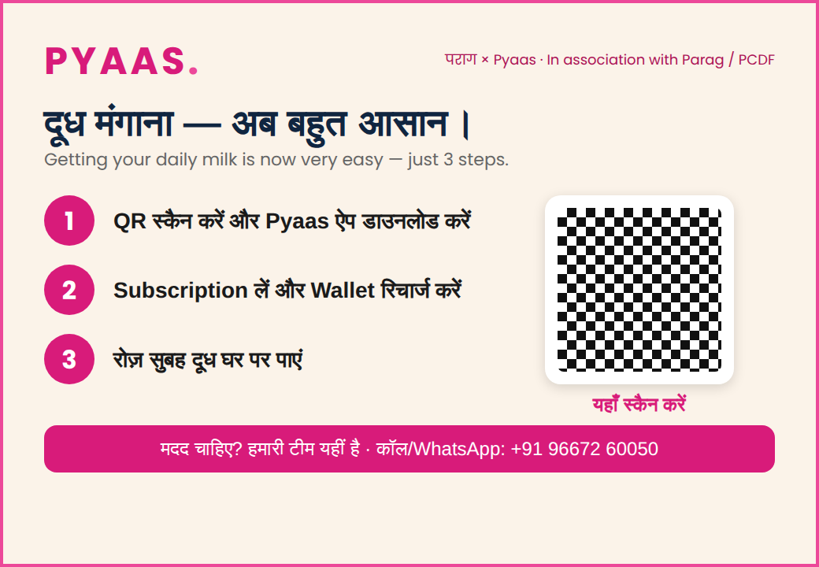  Large-print, Hindi-first, 3 steps + assisted-help footer | 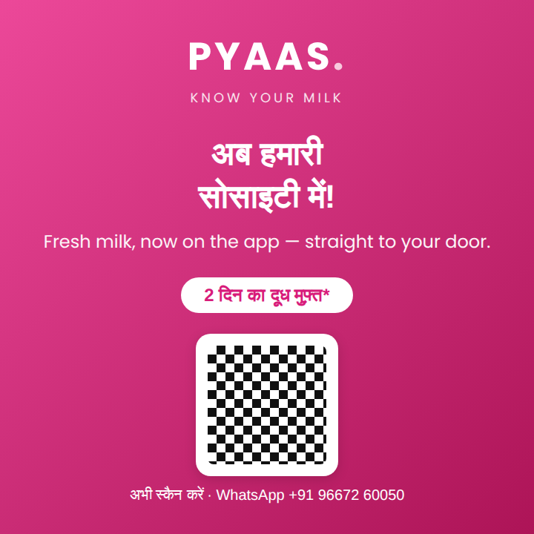  WhatsApp “now in your society” share card (zero print)
NEW — Quick Pyaas fee card (deploy when §17 goes live)
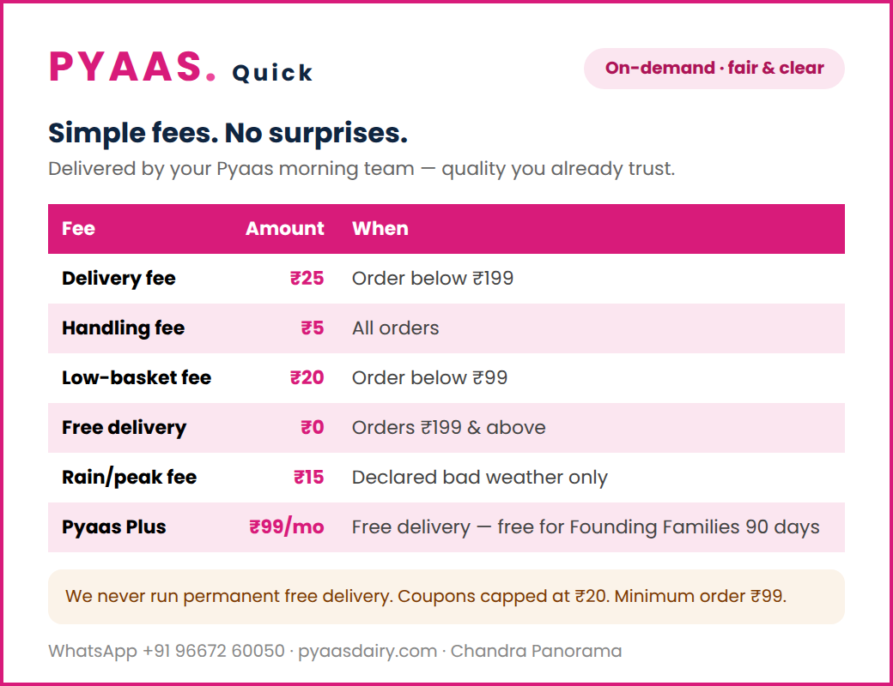
Transparent on-demand fee card — fair, simple, never permanently free; Founding Families get free Pyaas Plus for 90 days.
Creative → placement → message
Door hanger → flat doors → offer + 3-step + Wallet + WhatsApp. Tri-fold → desk/kit → Parag × Pyaas trust + range. Fridge magnet → kitchen → Wallet recharge. Founding card → onboarding → privileges + Quick Pyaas bridge. Senior card → seniors → assisted onboarding. Poster → lift lobbies → headline + QR. Quick Pyaas fee card → desk/app when §17 live → honest fees.

17. Quick Pyaas — the second model (same society, same riders)
Once Morning Delivery is dense and reliable, switch on Quick Pyaas — on-demand, deliver-in-minutes — in the same society, using the same riders and hub during their idle mid-day hours. One rider base, one wallet, two revenue lines.

17.1 Activation gate — do not switch on early
Quick Pyaas activates only when ALL are true
• Morning Delivery route ≥ 120 L/day (economic density); • on-time delivery ≥ 97% for 2 weeks; • complaints resolving < 24h; • riders have proven spare mid-day capacity. Until then, Quick Pyaas stays OFF — a shaky morning route must not be diluted by on-demand trips.

17.2 Why it is cheap here (and nowhere else)
A standalone on-demand trip costs ~₹[40] and is barely covered by an average basket. In Chandra Panorama the rider, hub and cold-chain are already paid for by Morning Delivery, so the marginal cost of a mid-day drop falls to ~₹[22]. That is the only reason Quick Pyaas is viable — never run it as a standalone city-wide service.
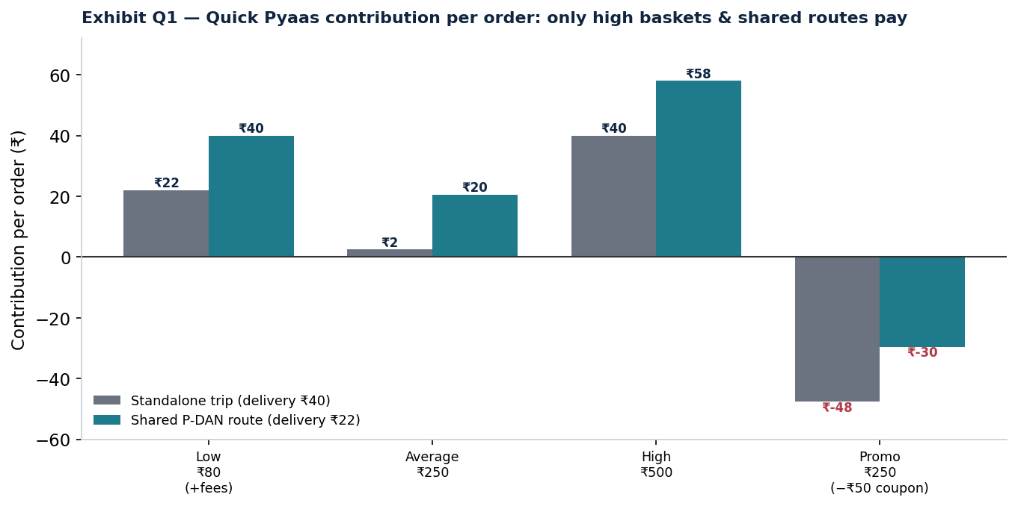
Contribution per order: standalone trips barely pay; shared P-DAN routes (idle mid-day riders) make it work. Promotions destroy it.

17.3 Fee architecture (transparent, market-comparable)
Fee / Charge | Amount | When it applies | When waived
Delivery fee | ₹25 | Order < ₹199 | ≥ ₹199, or Pyaas Plus
Handling fee | ₹5 flat | All orders | Pyaas Plus
Low-basket fee | ₹20 | Order < ₹99 | ≥ ₹99
Minimum order value | ₹99 | — | —
Free-delivery threshold | ₹199 | — | —
Peak / rain fee | ₹15 | Declared heavy-rain / peak only | Default OFF
Pyaas Plus membership | ₹99 / month | Optional | Free for Founding Families, 90 days
Discount / coupon cap | ≤ ₹20/order; ≤ 1/user/week | — | —
Benchmark (public, Nov 2025 / mid-2025; varies by city/time): Blinkit/Instamart charge ₹30 delivery below ₹199 with ₹4–₹10 handling and ₹15–₹20 small-cart fees; Zepto free above ₹99. Pyaas is at or just below the market — honest and simple, never permanently free. Sources: Upstox (3 Nov 2025), Trade Brains (3 Jul 2025).

17.4 Order treatment & positioning
- Accept: baskets ≥ ₹199 in Chandra Panorama during operating hours.
- Charge a fee: baskets < ₹99 (low-basket + delivery) — only viable if the customer pays.
- Bundle: batch nearby mid-day orders into one trip on the idle morning rider.
- Refuse / discourage: out-of-society addresses, deep-promo orders, tiny (< ₹60) single-item late-night trips.
Positioning: reliability, product quality and local relevance — not price. Pyaas cannot out-discount Blinkit/Zepto and must not try. It wins because the milk team is already at the door and trusted.

18. The economics behind the density gate
Both models live or die on route density. A morning rider route costs a near-fixed ~₹[500]/morning plus ~₹0.50/L of other last-mile cost. Delivery cost per litre only falls under the ₹4.70/L margin when the route carries ~120 paying litres/day. This single curve governs the go-live gate, the stop/scale rule and the whole two-model logic.
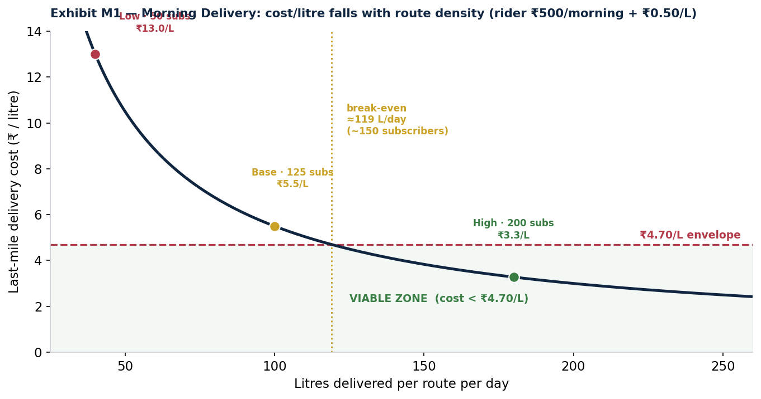
Delivery cost/litre vs route density. Below ~120 L/day the ₹4.70 envelope is breached; above it the model works. Verify the rider cost in the dry run.

18.1 Where the margin actually comes from
Milk is a near-zero habit rail by design; the margin engine is the basket and — from ~Day 180 — Pyaas own-brand A2 ghee. This is why the playbook sells subscription and status, introduces ghee only to trusted active subscribers, and treats milk delivery as the trust-building service, not the profit line.
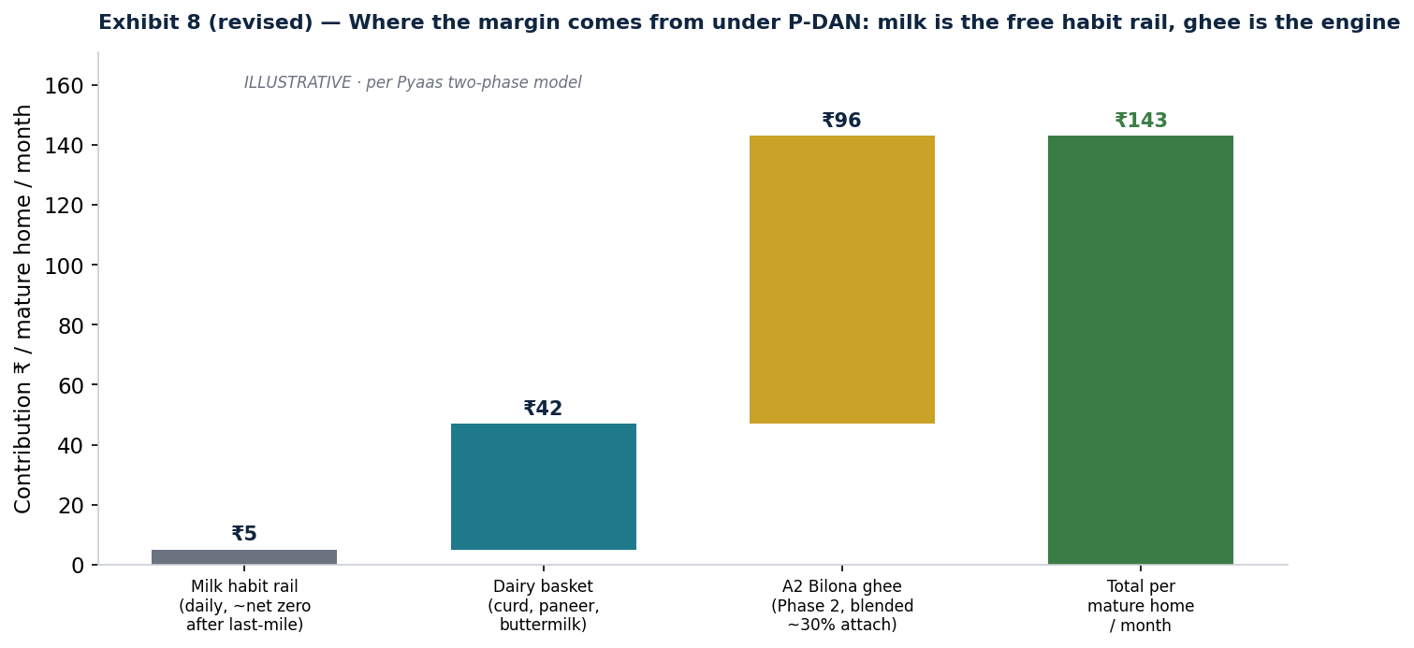
Illustrative contribution per mature home per month: milk ≈ free habit rail; basket + A2 ghee are the engine.
A closing note on trust
In daily milk, trust is the entire product. Deliver reliably, communicate honestly, resolve issues visibly, and make no promise you cannot keep. Do that inside one tight society, honour your Founding Families, reach ≥120 litres a day, and the density — and the referrals, and the second model — will follow.
Prepared for Pyaas Dairy Private Limited · Founding Families — Chandra Panorama · v2.0 Two-Model Edition · Working prototype. Adapt bracketed [ ] figures (occupied flats, rider cost/route, marginal delivery cost/order) to operations-verified values before publishing or committing capital.

