**REST API Graphical User Interface**

* **Getting Started:**

1. I have used Enthought Canopy IDE for python programming and wxPython package for GUI development. The setup folder contains setup for both software in 64-bit or 32-bit for windows OS. For Linux and Mac OS user download setup from:

Canopy:  
<https://store.enthought.com/downloads/#default>

wxPython package:

<http://www.wxpython.org/download.php>

1. Keep all XML files and GUI.py file in same folder. (Note: Please make sure that in XML files the parameter names are not having space in between please replace all blank space separating words by “_”. e.g.: "Leader_Data/stable_version" )
2. Start GUI.py and initially change directory address by using commands:

import os

os.chdir('C:\Users\prox01\Desktop\GUI\GUI')

* **Graphical User Interface:**

1. 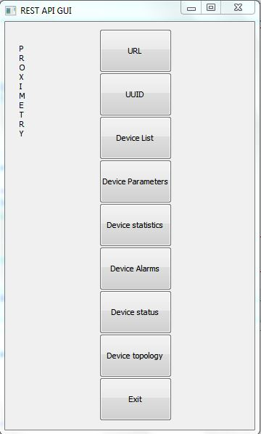

Always click on the URL button to begin with. Enter URL of the server in the window which will pop up.

1. 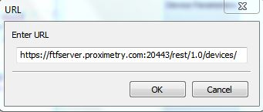

The URL window is having a default server already present in the block. Edit the link and hit OK to change the server.

1. Device list:

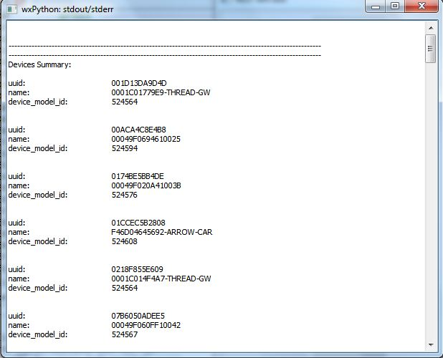

Click on the third button ‘Device list’, an output window will pop up to show all devices on server and will also show total number of devices.

1. UUID:

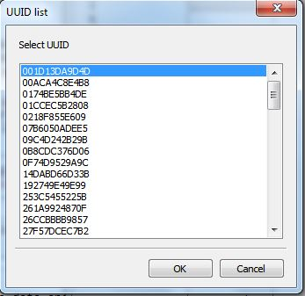

Click on Second button to see all UUIDs present on the server. Select any one out of   
 them and hit OK to find its Device Parameters, Statistics, Alarm, Status and Topology   
 (buttons 4, 5,6,7,8 respectively).

Notes:

1. To get device properties entering URL and selecting UUID is important. UUID list will not appear if URL is not provided initially.
2. In order to rerun the program GUI.py restart the kernel from ‘run’ option from canopy.