Fluxion Technology
Service Hub Website
Information Architecture and Visa User Flow
Site reviewed: amara-reserve.vercel.app
Section 1 business proposal
Prepared for: Aye Myat Thuzar, Business Solution Manager
Date: 25 September 2026
Status: Draft for review

Contents
1. Overview
2. Confirmed decisions
3. Sitemap
4. Services menu
5. Global navigation
6. Home page structure
7. Page templates
8. Visa Service content
9. Visa user flow
10. Visa chooser logic
11. Inquiry status lifecycle
12. Risks and gaps

1. Overview

The site is inquiry first. A visitor picks a service and sends an inquiry with no payment. A coordinator sends a quote. The customer registers, pays, then completes documents.

This IA applies the new six category menu with a maximum of four items in each category. Every add on service is shown on the service detail page, not in the menu.

2. Confirmed decisions (25 Sep 2026)These are fixed in the sitemap and flows below.
- 6 service categories. Visa Service, Medical, Aesthetics, Wellness, Leisure, Transport Services. The stats bar shows 6 categories.
- Menu labels as written in the renovation notes. Medical, Aesthetics and Leisure are kept as menu labels. Each category shows a maximum of 4 items. Add ons appear only on the service detail page.
- Aesthetics menu updated. Partner Clinics, Clinical Appointment, Facial & Body Treatments, Post-Treatment Aftercare. Partner Clinics lists each licensed clinic with its location and published rates, matching Partner Hospitals under Medical. Spa appears only under Wellness.
- Visa Service scope. Tourist Visa, Education Visa and Visa Extension only. DTV and 90 day reporting are removed from the site.
- Payment happens after the customer registers. Guests can browse and send an inquiry. To accept a quote and pay, the customer must create an account or sign in first.
- Payment methods. PromptPay, Visa, Mastercard and KBZPay. Shown on the payment step and in Help Center, Fees and payment.
- Transport Services is a new category. Airport & Hotel Transfers, Intercity Transfers, Private Car with Driver, Car Rental.

3. Sitemap

Seven top level areas. The Services catalog opens as one mega menu, which keeps the desktop nav bar short at 1280px screen width.
ID | Area | Pages
0 | Home | Landing page
1 | Services catalog | Mega menu with 6 categories (see section 4)
2 | Search results | Results by query, empty state with ask a question
3 | Inquiry | 3.1 Add ons  3.2 Terms  3.3 Your details  3.4 Inquiry received  3.5 Payment (registered customers)  3.6 Complete details and documents
4 | Thailand Hub | 4.1 Myanmar restaurants  4.2 Attractions  4.3 Travel guide  4.4 Living in Thailand  4.5 Community board  4.6 News & festivals (proposed)
5 | Help Center | Search help, topics and FAQ, fees and payment, contact a coordinator
6 | Account | Sign in / Create account, Profile, My Inquiries, Wishlist, Notifications
7 | Legal (footer, proposed) | Terms of service, Privacy notice (PDPA), Cookie settings, Agent disclosure

4. Services menu

Six categories, maximum four items each. The category title links to the category page. Each item links to its service detail page.
ID | Category | Menu items
1.1 | Visa Service | Tourist Visa  Education Visa (page title: ED Visa Programs)  Visa Extension
1.2 | Medical | Health Checkup Packages  Hospital Appointment  Special Treatment  Partner Hospitals
1.3 | Aesthetics | Partner Clinics  Clinical Appointment  Facial & Body Treatments  Post-Treatment Aftercare
1.4 | Wellness | Facial Glow & Hydration  Nail & Skin Care  Spa & Body Massage  Personal Color Analysis
1.5 | Leisure | Tour Packages  Admission Tickets  Shows & Entertainment  Dinner Cruise
1.6 | Transport Services | Airport & Hotel Transfers  Intercity Transfers  Private Car with Driver  Car Rental

5. Global navigation

Same header on every page. Items in reading order, left to right.
Element | Behaviour | Status
Logo | Returns to Home | Keep
Services | Mega menu, 6 category columns, max 4 items each | Change
Thailand Hub | Opens Hub landing with tabs 4.1 to 4.6 | Keep
Help Center | Opens Help search | Keep
Language | English, Myanmar, Thai. Remembers the choice per visitor. | Keep
Saved (heart with count) | Opens Wishlist. Asks guests to sign in to save across devices. | Keep
Theme toggle | Light or dark | Keep
Notifications (signed in) | Inquiry status changes, coordinator replies, document reminders | Keep
Account menu (signed in) | Profile, Wishlist, My Inquiries, Help, Log out | Keep
Send an inquiry | Primary button, opens the inquiry with no service preselected | Keep

Mobile navigation

The hamburger opens an accordion: Services (6 categories expand to their 4 items), Thailand Hub, Help Center, then account links and language at the bottom. Keep "Send an inquiry" as a fixed bottom button on service pages only.

6. Home page structure

Top to bottom, with changes agreed or proposed after the 22 Sep meeting.
# | Section | Content | Status
1 | Hero | Video, eyebrow "Bangkok, Chiang Mai, Nationwide", headline "The Art of Pleasant Journeys and Total Serenity Harmony.", current sub headline, search bar, quick chips. Remains the same as the live site. | Keep
2 | Service gallery | One strip per category with service count. Update to 6 strips. | Change
3 | How it works | Tell us, get a quote, register and pay, send documents, we handle it | Keep
4 | Stats bar | 62 services listed, 6 service categories, 3 languages, under 15 mins quick inquiry reply. Replaces "92% answers same day". | Change
5 | Top Picks (Customer Favorites) | Klook and Trip.com style cards for day trips and admission tickets: image, category, name, area, duration, price from, badge. Card opens the service page. | New
6 | Reviews and "What clients say" | Both review blocks on the live site | Remove
7 | Thailand Hub teaser | Restaurants, attractions, travel guide entry points | Keep
8 | Gallery | Replace the passport photo as agreed on 22 Sep | Change
9 | FAQ "Before you send an inquiry" | Short answers, link to Help Center | Keep
10 | Final CTA "Tell us what you need" | Send an inquiry, Read the Help Center | Keep
11 | Footer | Services, Hub, Help, Legal links, social icons, copyright Bangkok | Change

7. Page templates

Six templates cover every page. Content blocks are listed in reading order.
Template | Used by | Content blocks
Category page | 1.1 to 1.6 | Breadcrumb, title and blurb, sub category chips (the 4 menu items), In demand ranking, grouped service cards with price from, "Not sure? Ask a question", sponsored slot
Service detail page | Every menu item | Breadcrumb, name and description, What is included, What we need from you, Good to know FAQ, package selector with quantity, add ons with running total, price panel with key facts, "Start inquiry", "No payment now", related services
Search results | 2 | Result count, query echo, service cards, empty state with ask a question
Inquiry steps | 3.1 to 3.6 | Step indicator, selected service with Change link, add ons, terms with required tick, contact form, confirmation with reference number, payment, complete details form
Hub page | 4.1 to 4.6 | Tabs, filters, cards. Restaurants add "Picked for you" when signed in and "Suggest a place".
Account page | 6 | Profile summary, account details, My Inquiries with status, Wishlist, empty states that link to Services

Inquiry form fields (3.3)

Full name, email, phone, service category, nationality, current status in Thailand, preferred date, number of people, anything else, consent tick. Passport details stay out of this first form, so visitors can ask without sharing sensitive data.

Payment step (3.5)

Shown only to registered, signed-in customers who accepted the quote. Methods: PromptPay, Visa, Mastercard, KBZPay. Card payments go through a PCI DSS-compliant payment gateway, so card numbers never touch Service Hub servers.

Complete details form (3.6)

Full name as in passport, date of birth, nationality, arrival date, passport expiry, length of stay, passport upload, appointment date, add ons, anything else.

8. Visa Service content

Three service pages. The customer sees the processing time. Internal notes are for coordinators and Help Center answers only, not shown on the package card.

1.1.1 Tourist Visa
Package | Description | Processing | Internal note
Single-Entry Tourist Visa (Single TR) | For short term travellers entering Thailand once. Initial stay up to 60 days, can be extended locally. | 5 to 10 working days | Document review 3 to 5 days, e-Visa approval 2 to 5 days
Multiple-Entry Tourist Visa (Multi TR) | For frequent travellers. Valid for 6 months, stay up to 60 days per entry. | 5 to 10 working days | Document review 3 to 5 days, e-Visa approval 2 to 5 days

1.1.2 Education Visa (ED Visa Programs)

Renamed from "ED Visa, Thai Language School". LTR and TR packages are removed from this page. Descriptions and reference images for new items are pending.
Package | Description | Processing | Internal note
ED Visa, Language School (English, Thai, Chinese) | For adults studying non formal courses at private language or culture centres. | 30 to 45 working days | Ministry approval 20 to 30 days, immigration stamp 10 to 15 days
ED Visa, Culinary & Cooking School | For adult students in long term professional culinary, baking or Thai chef programs. | 30 to 45 working days | Ministry approval 20 to 30 days, immigration stamp 10 to 15 days
ED Visa, Hotel and Restaurant Training | For long term stays with certified vocational training in hospitality, culinary arts and service management. | 30 to 45 working days | Ministry approval 20 to 30 days, immigration stamp 10 to 15 days
ED Visa, Premium University | For international university students. Extended stay during the degree plus up to one year after graduation. | 15 to 25 working days | University approval 10 to 15 days, embassy or immigration stamp 5 to 10 days
ED Visa, International School | For students aged 3 to 18 at accredited international schools. Parents can apply for a guardian visa at the same time. | 20 to 30 working days | School clearance 15 to 20 days, immigration 5 to 10 days. Student and guardian processed together.

1.1.3 Visa Extension
Package | Description | Processing | Internal note
Tourist Visa Extension (30 Days) | Lets eligible tourists stay 30 more days without leaving Thailand. | 1 to 3 working days
ED Visa Extension (90 Days / 1 Year) | Extends stay for active students and trainees, based on approved school or university documents. | 1 to 3 working days | Document preparation 1 to 2 days, Immigration Bureau submission same day

9. Visa user flow

From first visit to visa issued. Touch 1, 2 and 3 are the three touch follow up promise attached to the headline "We are always here for you". Blue boxes are follow up touches. The green box is payment.

Part 1: find a visa and send an inquiry

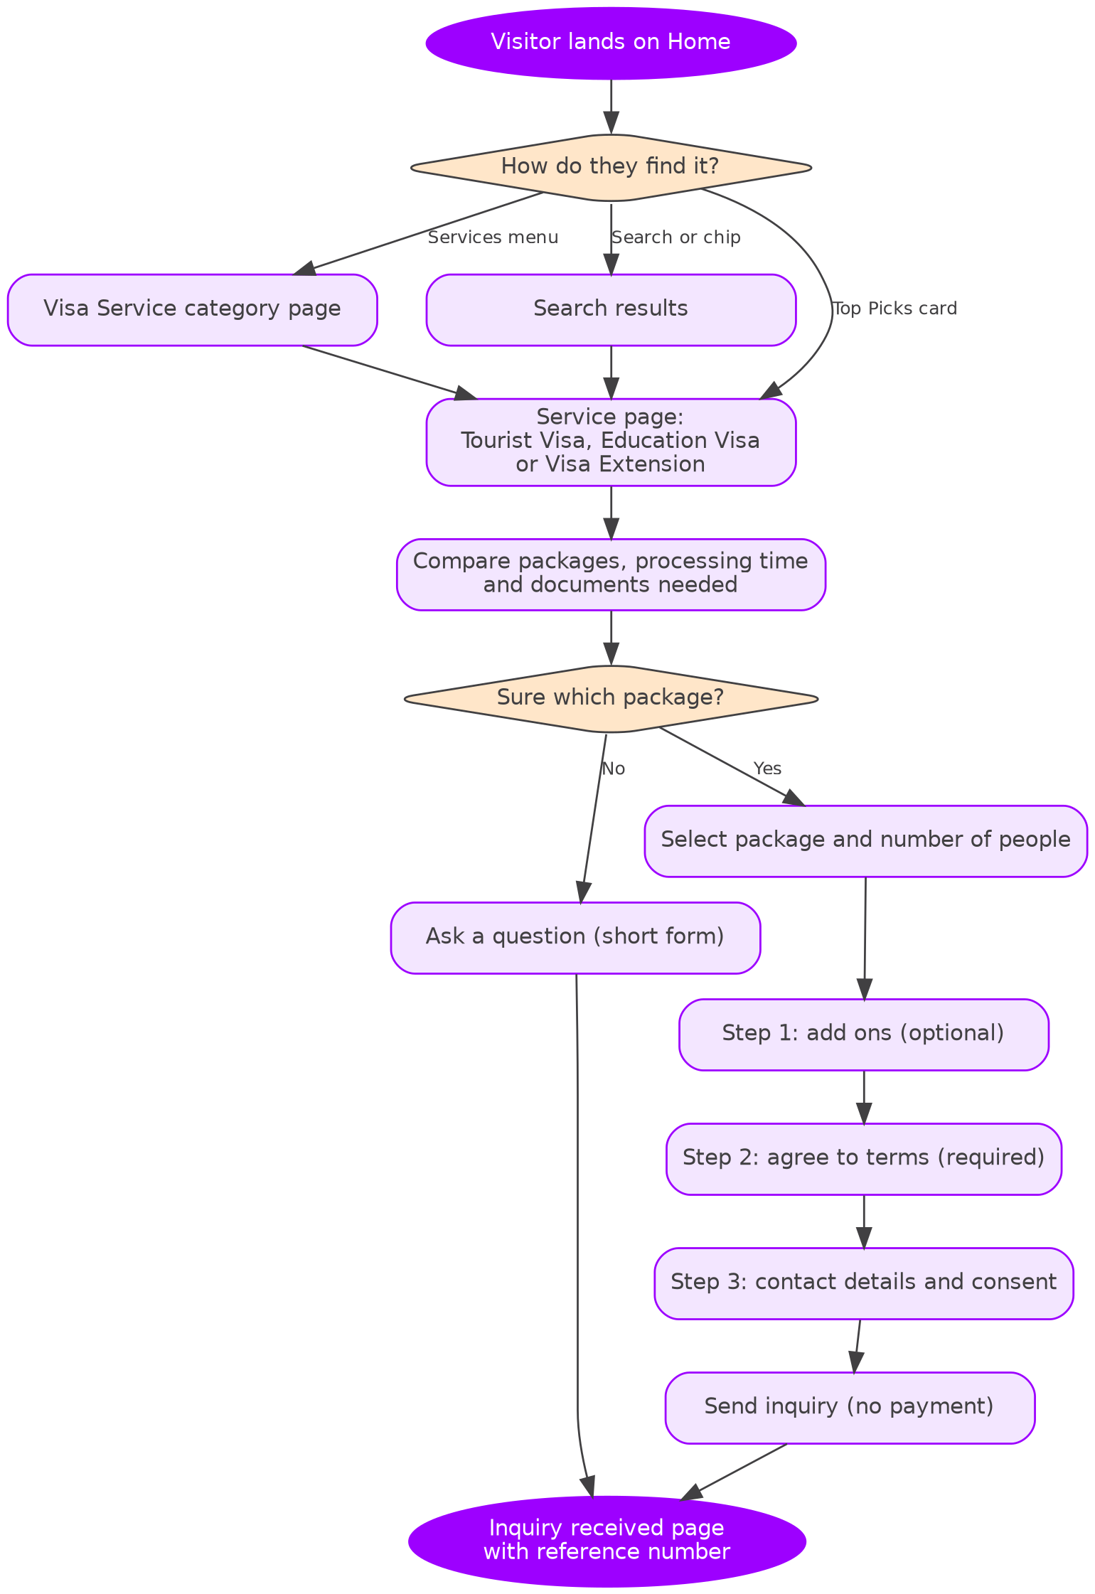

Part 2: quote, registration, payment and processing

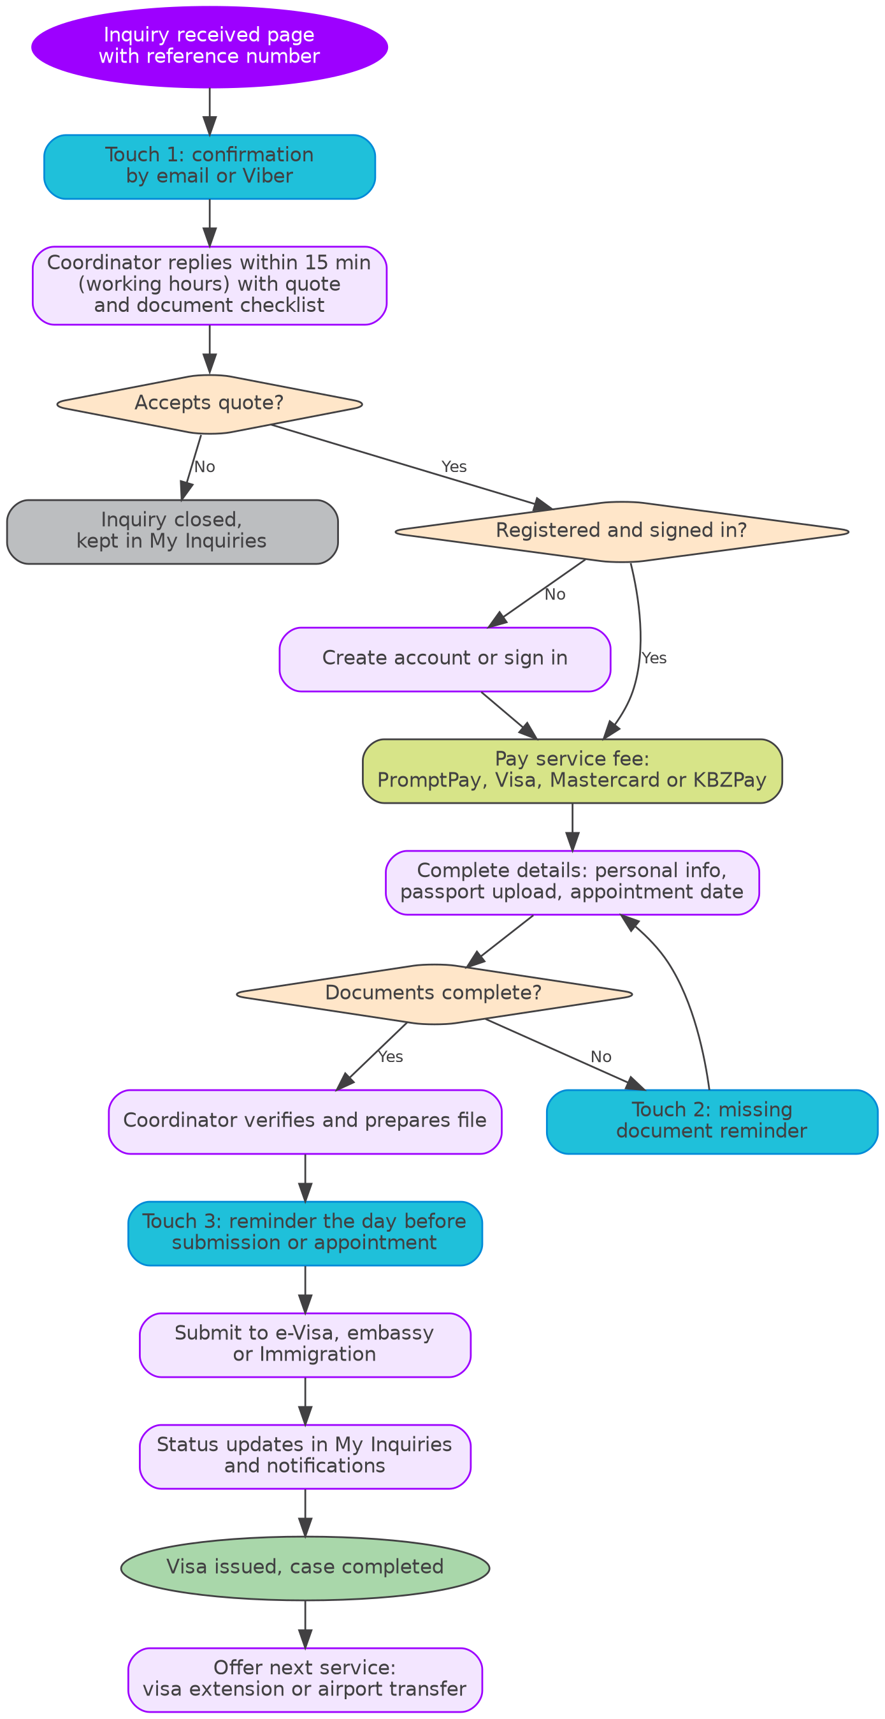

10. Visa chooser logic

Use this for the "Not sure which visa?" helper on the Visa Service category page, and as coordinator guidance.

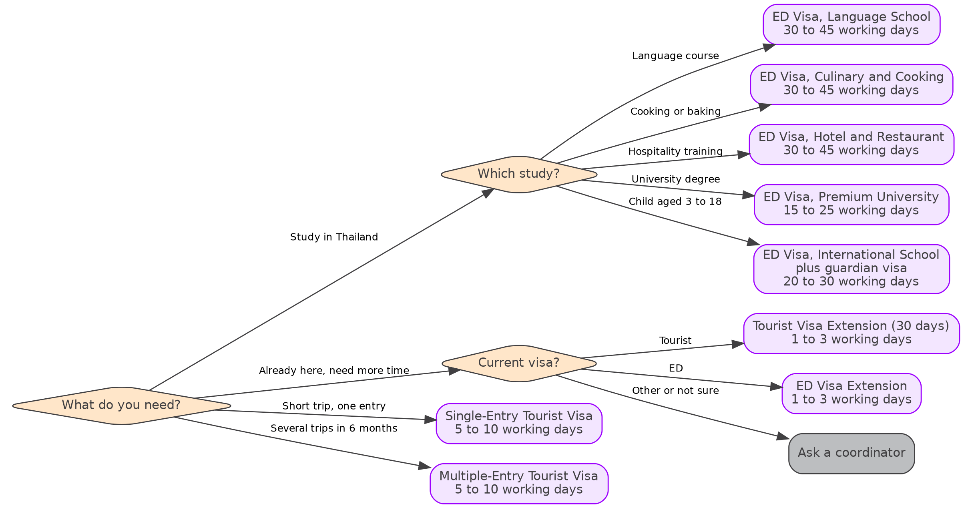

11. Inquiry status lifecycle

Statuses for My Inquiries and notifications. One label per step, used the same way in English, Myanmar and Thai.

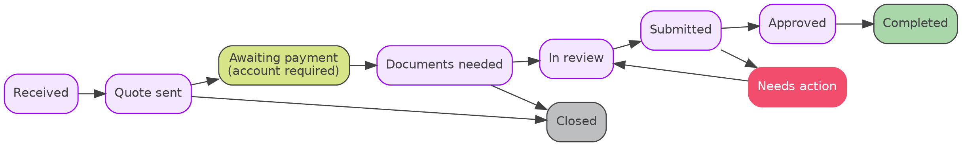
Status | Meaning for the customer
Received | We have your inquiry and reference number
Quote sent | Check your quote and document checklist
Awaiting payment | Create an account or sign in, then pay to continue
Documents needed | Upload your passport and other documents
In review | Your coordinator is checking your documents
Submitted | Your application is with the embassy, e-Visa system or Immigration
Needs action | We need more information from you
Approved | Your visa is approved
Completed | Your case is closed
Closed | Inquiry ended without a booking

12. Risks and gaps

Raise these with the CEO, Legal and the Data Protection lead before build.
- Passport upload and PDPA. Step 3.6 collects passport copies, date of birth and nationality. Needs a PDPA review, a privacy notice, encrypted storage, access limited to coordinators and a retention period before launch. Check with Legal or the Data Protection lead before sharing this data with partners.
- Card payments. Visa and Mastercard need a PCI DSS compliant payment gateway. Confirm the gateway with Finance and the CTO.
- Agent disclosure. Visa, medical and aesthetic pages must say Service Hub arranges the service and is not the embassy, hospital or clinic. Add to the footer and every service detail page.
- Processing time promises. Show times as estimates set by the authority, not a guarantee. Add "Timing depends on the embassy or Immigration" under each price panel.
- Community board. User posts need moderation, report and remove tools, and board rules. Block posts that contain phone numbers or passport details.
- Thailand News missing. The proposal lists Thailand news, festivals and sale seasons, and a public transport guide. Proposed as Hub tab 4.6, with BTS and MRT routes added to 4.3 Travel guide.
- Car Rental. Self drive needs a valid licence check and insurance terms. Consider launching Private Car with Driver first.

