M5 Walmart Sales Forecasting
End-to-End Time-Series Model Development
Prepared by: TN DS ALEX
Project type: Individual Data Science Assignment
Date: September 2026

1. Executive Summary
This report presents an end-to-end sales forecasting project using the Walmart M5 Forecasting Accuracy dataset. The local prototype focused on the CA_1 store and predicted aggregate total daily sales over a 28-day horizon. The workflow included data wrangling, exploratory analysis, feature engineering, rolling-origin validation, model comparison, and a final forecast.
Random Forest produced the strongest local validation result, with average MAE of 266.02, RMSE of 329.87, and RMSSE of 0.3821 across three rolling validation folds. It improved RMSSE by 32.91 percent compared with Seasonal Naive 28, the strongest baseline. The result supports using structured historical and calendar features for short-term planning, while recognizing that this prototype does not yet model all stores or item-level demand.
2. Introduction
Sales forecasting is important because retailers must decide how much inventory to hold, when to replenish products, and how to schedule staffing around expected demand. Under-forecasting can increase stockout risk, while over-forecasting can tie up working capital and create waste, especially for high-volume food departments.
The objective of this assignment was to forecast the next 28 days of sales and demonstrate a complete data science workflow. The project connects raw sales, calendar, event, SNAP, and price data, then evaluates whether models using historical sales patterns can improve on simple baselines.
3. Dataset Description
The M5 dataset contains historical Walmart sales and related calendar and price information. The five files used in the project are described in Table 1. The official dataset page is https://www.kaggle.com/competitions/m5-forecasting-accuracy.
File | Purpose
sales_train_validation.csv | Historical item-store sales through the validation training period.
sales_train_evaluation.csv | Historical item-store sales through the evaluation training period.
calendar.csv | Dates, day identifiers, weeks, events, and SNAP indicators.
sell_prices.csv | Weekly item prices by store and item.
sample_submission.csv | Required Kaggle submission layout with id and F1 through F28 columns.

Table 1. M5 source files used in the project.
The dataset covers stores in California, Texas, and Wisconsin. It contains 10 stores, 3,049 products, and 30,490 item-store series across the FOODS, HOBBIES, and HOUSEHOLD categories. The competition forecasting horizon is 28 days.
4. Project Scope
The main prototype used store CA_1. The transformed CA_1 long dataset contained 5,832,737 item-day records, and the modeling dataset contained 1,913 aggregate daily observations from 2011-01-29 to 2016-04-24. The target variable was aggregate total daily CA_1 sales.
This scope was selected to keep transformation and model development manageable. Transforming all stores at once would require substantially more memory and was not necessary for proving the pipeline. This is a clear limitation: the results describe one store-level aggregate series and should not be treated as a network-wide or item-level production forecast.
5. Data Wrangling
The wrangling stage inspected file availability, shapes, columns, data types, missing values, duplicate rows, sales validity, and dataset relationships. Sales values were checked as numeric and non-negative. Duplicate checks were applied to relevant keys, including item and date combinations after transformation.
The CA_1 sales table was transformed from wide daily columns into a long item-day format. The sales table was connected to calendar data using the d field, and price data was connected using wm_yr_wk, store_id, and item_id. Missing event names were kept unchanged because missing event values indicate that no special event occurred. Missing sell_price values were kept as missing rather than replaced with zero, and a price_available indicator was added. The processed result was stored as Parquet to preserve data types and reduce file size.
6. Exploratory Data Analysis
Exploratory analysis examined trend, weekly seasonality, product group performance, event periods, SNAP days, prices, and intermittent demand. The findings are descriptive associations and should not be interpreted as causal effects.
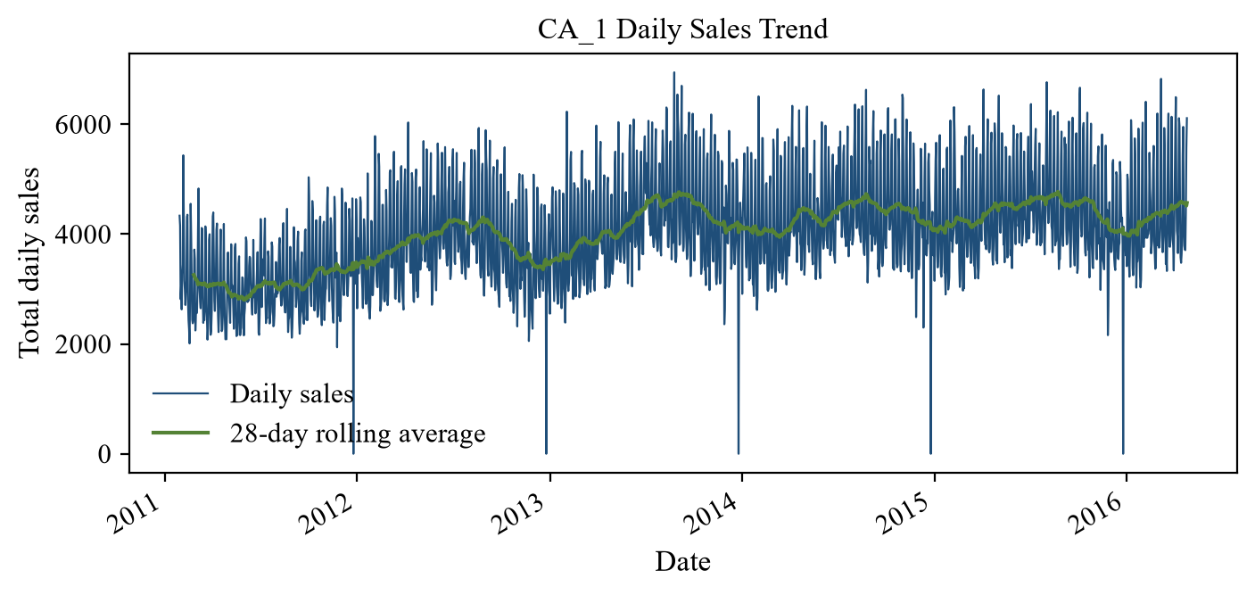
Figure 1. CA_1 daily sales and 28-day rolling average.
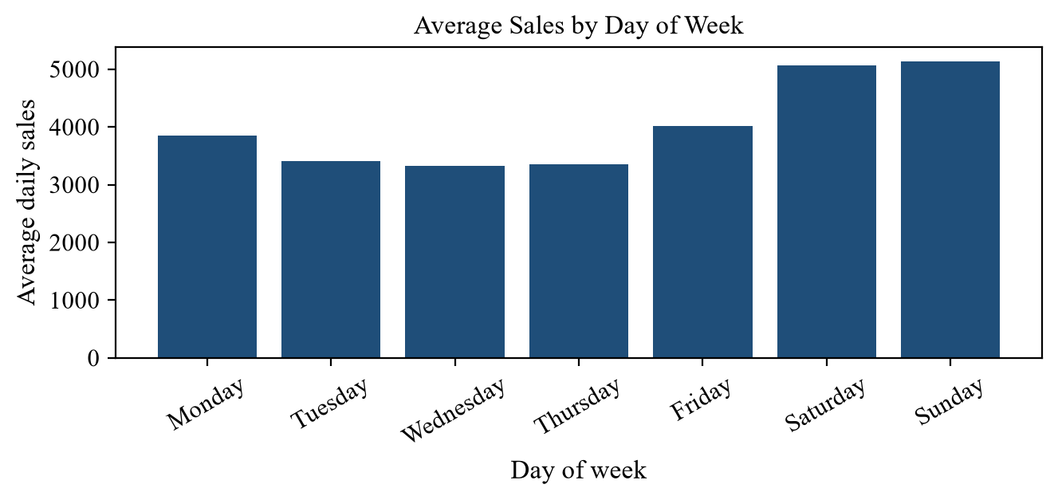
Figure 2. Average aggregate sales by weekday.
Sunday had the highest average daily sales, while Wednesday had the lowest. FOODS was the highest-sales category and HOBBIES was the lowest. FOODS_3 was the highest-sales department and HOBBIES_2 was the lowest. Average daily sales were higher on SNAP-active days than SNAP-inactive days, while event days had lower average aggregate sales than non-event days in this CA_1 view. Zero-sales item-day records were 63.95 percent, and the top-selling item was FOODS_3_090.
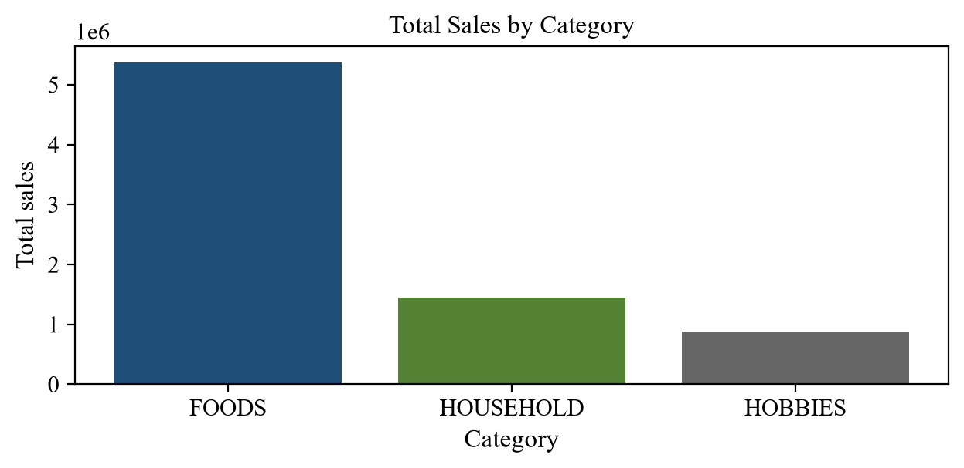
Figure 3. Total sales by product category.
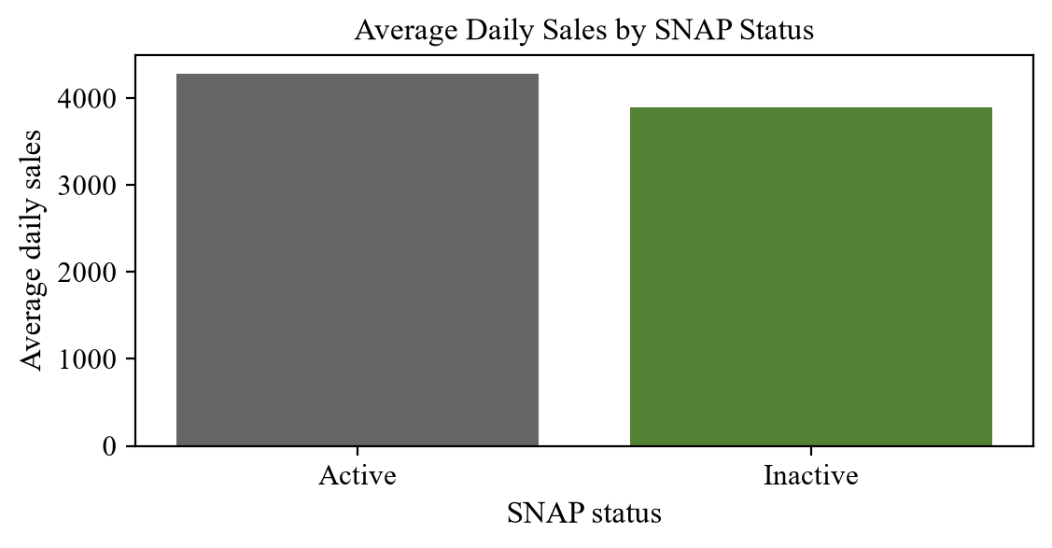
Figure 4. Average daily sales by SNAP status.
7. Feature Engineering
The machine-learning dataset used historical lag features for 1, 7, 14, and 28 days. It also used shifted rolling means and shifted rolling standard deviations for 7-day and 28-day windows. Calendar features included day of week, month, year, a weekend indicator, an event indicator, and the SNAP indicator for California.
Rolling features were shifted by one day before calculation. This prevented future-data leakage because each validation-day feature used only information that would have been available before that day.
8. Models Compared
Model | Method | Main advantage and limitation
Naive | Repeats the most recent observed value. | Simple and transparent, but cannot represent weekly or monthly patterns.
Seasonal Naive 7 | Repeats values from seven days earlier. | Captures weekly seasonality, but is sensitive to unusual prior-week demand.
Seasonal Naive 28 | Repeats values from twenty-eight days earlier. | Provides a strong simple baseline for repeating cycles, but does not adapt to trend or events.
Holt-Winters | Uses exponential smoothing with additive trend and weekly seasonality. | Produces direct multi-step forecasts, but has limited feature flexibility.
Random Forest | Uses lag, rolling, calendar, event, and SNAP features. | Captures nonlinear associations, but recursive forecasts can accumulate errors.

Table 2. Summary of forecasting models compared.
9. Validation and Metrics
Random splitting was not used because time-series validation must respect chronological order. Each validation period occurred after its training period. Three rolling-origin folds were evaluated using a 28-day horizon.
Fold | Training period | Validation period
1 | 2011-01-29 to 2016-01-31 | 2016-02-01 to 2016-02-28
2 | 2011-01-29 to 2016-02-28 | 2016-02-29 to 2016-03-27
3 | 2011-01-29 to 2016-03-27 | 2016-03-28 to 2016-04-24

Table 3. Rolling-origin validation periods.
MAE measures average absolute forecast error. RMSE measures the square root of average squared forecast error and gives more weight to larger errors. RMSSE scales RMSE using only the training data denominator in each fold. Lower values are better for all three metrics. RMSSE is a scaled error metric, not an accuracy percentage.
10. Model Results
Model | MAE | RMSE | RMSSE
Random Forest | 266.02 | 329.87 | 0.3821
Holt-Winters | 284.71 | 377.23 | 0.4370
Seasonal Naive 28 | 379.76 | 491.70 | 0.5696
Seasonal Naive 7 | 457.65 | 589.61 | 0.6828
Naive | 1438.65 | 1588.99 | 1.8415

Table 4. Average validation metrics across three folds.
Random Forest was the best local CA_1 model, with the lowest average RMSSE. Seasonal Naive 28 was the strongest baseline. Random Forest improved RMSSE by 32.91 percent compared with Seasonal Naive 28. These metrics are averages across the three local validation folds.
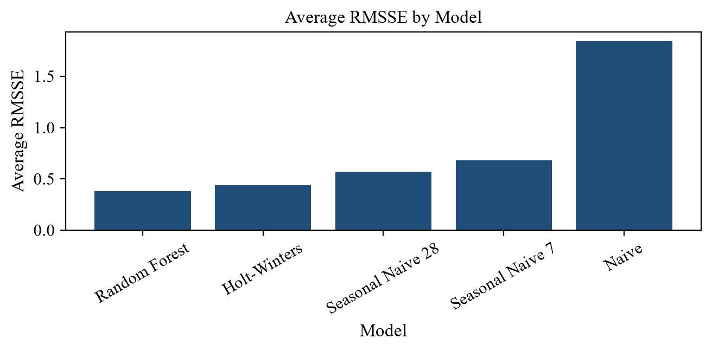
Figure 5. Average RMSSE comparison by model.
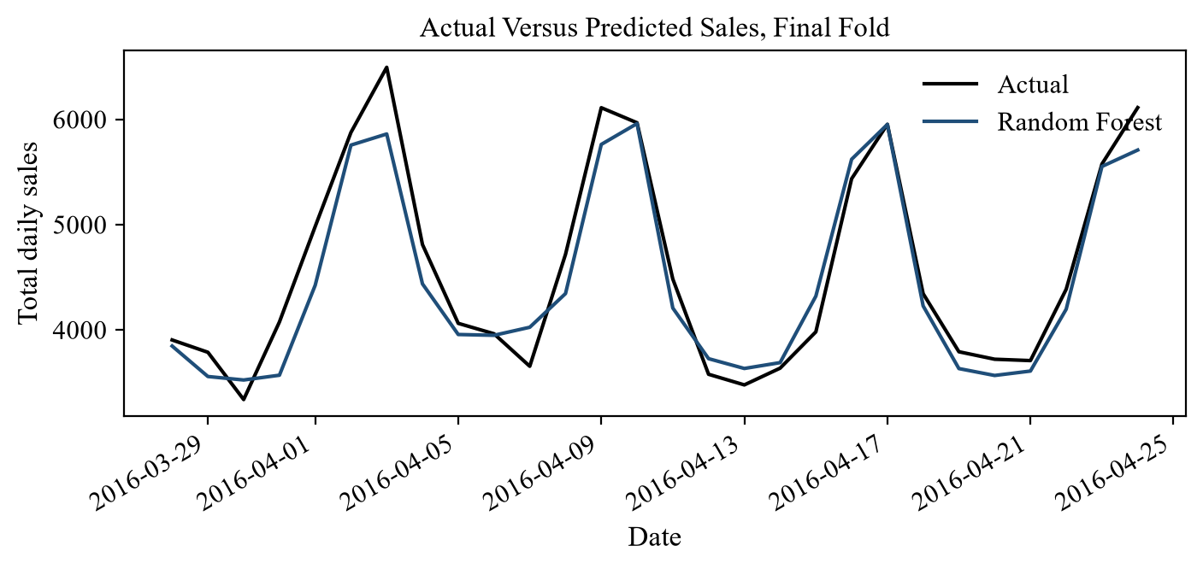
Figure 6. Actual versus predicted aggregate sales for the final validation fold.
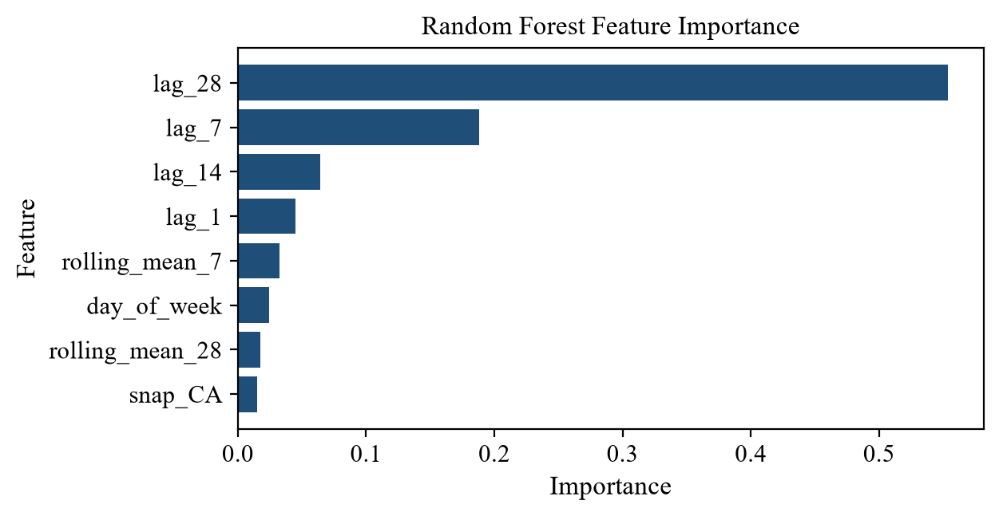
Figure 7. Random Forest feature importance values.
11. Final Forecast
After validation, the strongest local model was retrained using all available CA_1 daily history where technically appropriate. The final forecast period was 2016-04-25 to 2016-05-22. Forecasts were clipped at zero to prevent negative sales predictions.
The forecast can support short-term inventory and staffing planning for the CA_1 prototype scope. It should be treated as a prototype forecast rather than a production deployment, because future event and SNAP inputs and wider store-level testing are needed for operational use.
12. Kaggle Submission
The Kaggle submission was kept separate from the local CA_1 Random Forest model. Kaggle required item-store forecasts for all validation and evaluation identifiers, with columns id and F1 through F28. The submitted Seasonal Naive 28 file had 60,980 rows and 29 columns. The public score was 0.83770, the private score was 0.89562, and the status was complete after deadline.
Random Forest was not submitted because it predicted aggregate CA_1 daily sales, while Kaggle required forecasts for every item-store series. The Kaggle score should not be directly compared with the local Random Forest RMSSE because the modeling scope and evaluation settings differ.
13. Business Recommendations
Pilot the forecasts for short-term inventory planning at the store level. Prepare staffing plans for stronger weekend demand, with special attention to Sunday. Monitor SNAP and event periods separately because those periods showed different aggregate patterns. Prioritize high-volume food departments when translating forecasts into operational actions. Review forecast errors regularly and expand the workflow to item-level and multi-store forecasting before broader use.
14. Limitations and Future Work
The current scope is limited to CA_1 and uses an aggregate store-day target. Aggregation hides item-level intermittent demand, product substitutions, and potential stockouts. Stockouts could not be distinguished from genuine zero demand in this workflow. Random Forest may also accumulate errors during recursive forecasting because each predicted value becomes part of the future feature history.
Future work should expand the pipeline to all stores and product levels. Additional modeling should test LightGBM, XGBoost, hierarchical forecasting, and model ensembles after the leakage-safe validation design is stable.
15. Conclusion
The project completed a full forecasting workflow from raw M5 data inspection through transformation, EDA, feature engineering, model validation, and forecast generation. Random Forest produced the strongest local CA_1 validation result, while Seasonal Naive 28 provided the strongest baseline. The prototype demonstrates useful forecasting patterns but should be expanded before production or network-wide decisions.
16. References
Walmart M5 Forecasting Accuracy dataset. Kaggle competition page: https://www.kaggle.com/competitions/m5-forecasting-accuracy.
Project-generated figures and metrics were produced from the local project notebooks, model comparison CSV files, model evaluation summary, and verified CA_1 transformed dataset outputs.

