

TEMASEK POLYTECHNIC
SCHOOL OF INFORMATICS & IT
DIPLOMA IN APPLIED ARTIFICIAL INTELLIGENCE
ROBOTICS PROCESS AUTOMATION (CAI2C01)
AY2026/2027 April Semester

Project Proposal

Student Name (Matric Number) : Khin Pyaesone Win

Tutorial Group : PC02
Jenny LING (TP)
Tutor : Shuyun CHENG

Submission Date : 28/5/2026

Declaration of Originality

I am the originator of this work, and I have appropriately acknowledged all other original sources used as my references for this work.

I understand that Plagiarism is the act of taking and using the whole or any part of another person’s work, including work generated by AI, and presenting it as my own.

I understand that Plagiarism is an academic offence
and if I am found to have committed or abetted the offence of plagiarism in relation to this submitted work, disciplinary action will be enforced.

Declaration on the use of Generative AI tools for assignments

Describe how you have used Generative AI tools such as ChatGPT or Dall.E- in your assignment.

Share the link to the conversations you had with the AI tool (i.e., the prompts you used and the responses you get from the AI tool).

Please refer to this PDF on “How to share the conversations made with ChatGPT?”


How do you indicate the reference?
The content generated by AI tools are not retrievable except by the user who generated them, so they are considered non-recoverable sources. Although non-recoverable data or quotations in APA Style papers are usually cited as personal communications, with ChatGPT-generated text there is no person communicating. Quoting text from ChatGPT chat is therefore more like sharing the output of an algorithm, with a reference list entry and the corresponding in-text citation.
According to the official APA Style site, ChatGPT references should be cited as:
E.g. OpenAI. (2024). ChatGPT (Feb 13 version) [Large language model].
https://chat.openai.com/chat

Note: The information in parentheses refers to the update or revision date of the model used. Refer to the release notes in the ChatGPT application.

Important Note:

- Do not copy answers produced by the AI tool in totality as it is considered as plagiarism.

- Do not rely on any information produced by the AI tool blindly. You should always verify the answer with other sources. Do not assume that these answers provided by the AI tool are correct.

- To achieve quality outputs from the AI tool, you should provide good prompt that is clear and specific. Be precise and provide context. Avoid asking open-ended questions.

Robot Name

ApplyPilot

Business Domain

Technology recruitment involves hiring candidates for technical and IT-related jobs. Recruitment staff usually need to review many resumes and compare candidate skills before selecting suitable applicants.

Target Department/Users

The main users of ApplyPilot are recruitment staff in technology companies. Their job includes checking application emails, downloading resumes, reviewing candidate skills, and selecting suitable applicants for interviews. Since many applications are received for technical roles, the manual process can become tiring and time-consuming.

Project Scope

ApplyPilot is an automation robot created to help a technology company manage large numbers of job applications for technical positions such as Junior Software Engineer. The robot will automatically collect job application emails from Gmail, download resumes, and organise the files into the correct folders. It can process both PDF and scanned resumes to extract key applicant information such as name, contact details, technical skills, and qualifications.
The robot will use PDF extraction and OCR to process different resume formats, a simple Python scoring system to rank candidates based on required technical skills such as Python, Java, SQL, and relevant qualifications, and a database to detect duplicate applications and store applicant records. It will also generate a ranked Excel report to make the recruitment process faster and more organised.

Justification

Technology companies often receive many job applications for technical roles, making the recruitment process time-consuming when handled manually. Recruitment staff need to perform tasks such as checking emails, downloading resumes, extracting applicant details, identifying duplicate submissions, and organising candidate information. Sometimes, there may also be spam, invalid, or irrelevant applications that still need to be checked manually, which increases workload and slows down the recruitment process.

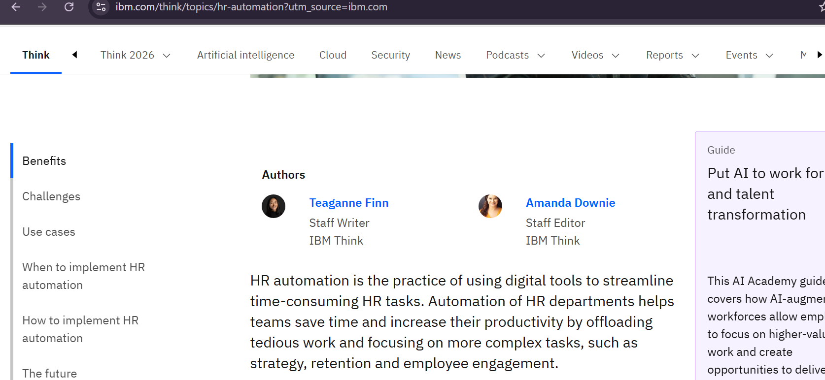

According to IBM, HR automation helps streamline time-consuming HR tasks, save time, and increase productivity by reducing tedious manual work. This supports the need for ApplyPilot to automate repetitive recruitment tasks such as resume screening and applicant processing.

ApplyPilot can make this process faster and more organised by automatically processing applications, extracting candidate information, detecting duplicate or invalid applications, and ranking candidates based on technical skills and qualifications. This helps reduce manual workload and allows recruitment staff to focus more on suitable candidates during the hiring process.

Robot Category

ApplyPilot is an unattended robot because it can run automatically without staff needing to operate it during the process. The robot will start at a scheduled time, check job application emails, process resumes, evaluate candidates, and generate reports by itself. This helps reduce manual work and saves time for the recruitment team.

Current Scenario
List and explain the steps involved in the current scenario (Before automation)

- Check company Gmail inbox manually
Recruitment staff open the company Gmail box and look for new job application emails for technical positions such as Junior Software Engineer.

- Download resumes manually
Staff open each mail one by one and download the attached resumes or CVs. The files are saved into folders for later checking.

- Read each resume manually
Staff open every resume to check applicant details such as name, email address, phone number, education, and technical skills. Some resumes may be PDF files, while others may be scanned images, which makes checking slower.

- Check for invalid or irrelevant applications
Some applications may be spam emails, incomplete submissions, duplicate applications, or applications that do not match the job requirements. Staff need to identify these manually.

- Compare candidate qualifications
Staff check technical skills such as Python, Java, SQL, and relevant qualifications to see which candidates are more suitable for the role.

- Record applicant information manually
Important applicant details are entered manually into an Excel file for record keeping.

- Check for duplicate applications manually
Staff compare applicant records to check whether the same person has applied more than once.

- Prepare the final candidate list

After reviewing all applications, staff organise the candidate information and prepare a final list for easier review.

Automation Scenario (ApplyPilot Execution Process)

List and explain the robot execution steps

- Start scheduled automation and check Gmail inbox
ApplyPilot will run automatically every weekday at 8:00 AM as an unattended robot. It will open the company Gmail inbox and search for new job application emails for technical positions such as Junior Software Engineer using predefined keywords in the email subject.

- Download all resume attachments
ApplyPilot will open the relevant job application emails and download all attached resumes or CVs before processing them. All attachments will be collected first for further checking and processing.

- Save resumes into the Unprocessed folder
All downloaded attachments will be saved into the local “Unprocessed” folder so they can be checked and processed one by one in an organised way.

- Process each downloaded resume
After all attachments have been downloaded and saved in the “Unprocessed” folder, ApplyPilot will begin processing each resume one by one. This ensures that every application is handled in a systematic manner.

- Check file type and extract resume text
ApplyPilot will check whether the selected file is a normal PDF resume or a scanned image-based file. For normal PDF files, PDF text extraction will be used to read the content. For scanned resumes or image files, OCR technology will be used to extract the text. This allows the automation to process different resume formats.

- Extracts applicant information
ApplyPilot will identify important applicant details from the extracted resume text, such as full name, email address, phone number, educational qualifications, years of experience, and technical skills such as Python, Java, and SQL. These details will be used for candidate evaluation.

- Score candidate qualifications using Python

ApplyPilot will use the extracted applicant information to evaluate the candidate using a Python scoring script. Relevant details such as technical skills, qualifications, and years of experience will be assessed based on predefined recruitment requirements. The script will then assign a score and a priority level such as High, Medium, or Low to support faster candidate review.

- Prepare applicant record and connect to database

ApplyPilot will combine the extracted applicant details, score, and priority level into a complete applicant record. The robot will then connect to the MySQL database to prepare for duplicate checking and record storage

- Check for duplicate applications

ApplyPilot will compare the email address of the current applicant being processed with existing applicant records stored in the MySQL database. This is to check whether the same applicant has already submitted a previous application. If a matching email address is found, the application will be identified as a duplicate to avoid repeated processing. If no matching email is found, the applicant record will continue to the next step to be saved in MySQL.

- Save valid applicant record into MySQL
If the current applicant is confirmed to be new and valid, ApplyPilot will save the applicant’s full record into the MySQL database. The record will include applicant details, technical skills, score, priority level, and application status for future reference and reporting.

- Move resume file to the correct folder

After processing each resume, ApplyPilot will move the file to the correct folder based on the processing result. Successfully processed applications will be moved to the “Processed” folder, duplicate applications will be moved to the “Duplicate” folder, and unreadable or invalid applications will be moved to the “Failed” folder.

- Check for remaining resumes
After processing the current application, ApplyPilot will check whether there are additional resumes remaining in the “Unprocessed” folder. If more resumes are available, the automation will repeat the same processing steps for the next application. If no resumes remain, the automation will continue to generate the final recruitment report.

- Generate final Excel recruitment report
After all resumes have been processed, ApplyPilot will generate a final Excel recruitment report containing applicant details, scores, priority levels, and application status. The report will organise candidates based on priority categories such as High, Medium, and Low to help recruitment staff review suitable candidates more efficiently.

Process Flow Chart
Flow chart to illustrate the process identified for automation.

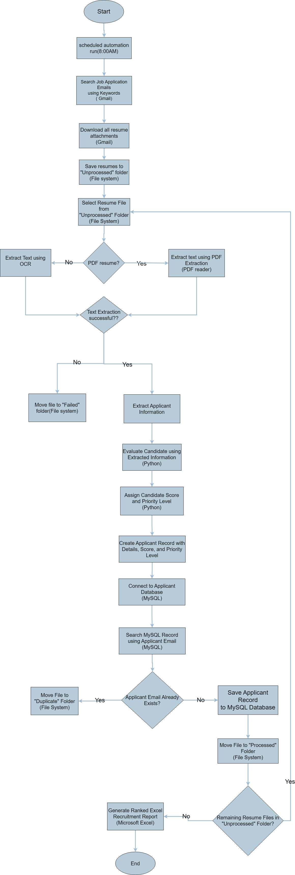

References
https://www.ibm.com/think/topics/hr-automation?utm_source=ibm.com

