RoomStay – Condo & Apartment Rental Management System
Final synchronized system architecture, process/data flows, booking states, and relational database design.

1. System Architecture
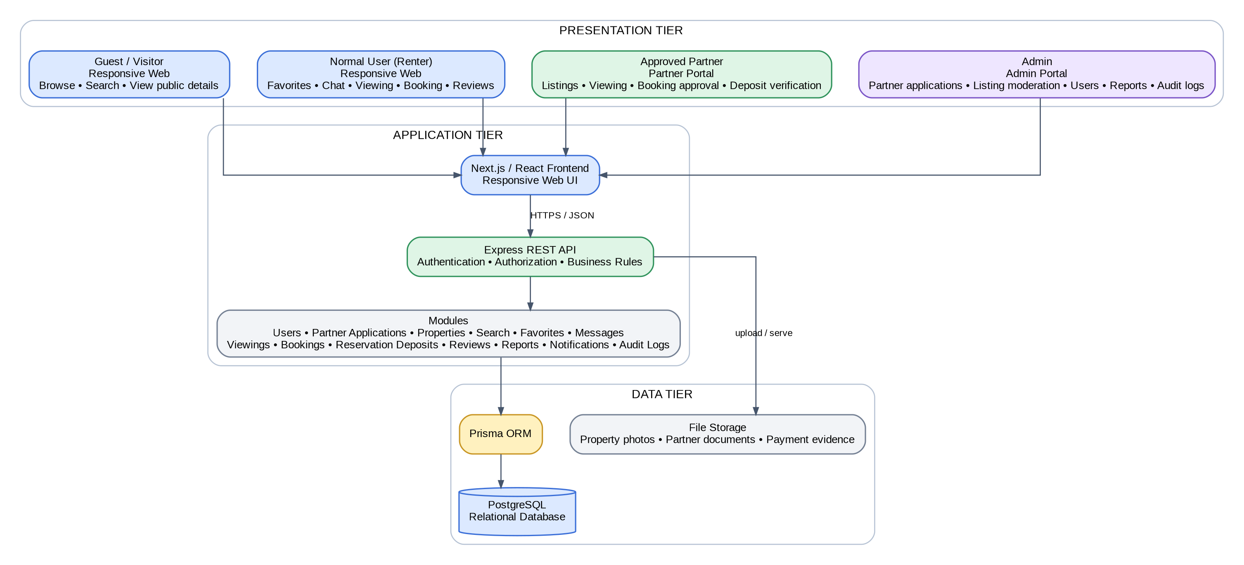
Architecture summary. RoomStay is a responsive web application using a Next.js/React frontend, an Express REST API for authentication and business logic, Prisma ORM, and PostgreSQL. Guest access is limited to public browsing; protected actions require a Normal User account. Approved Partner privileges are granted only after Admin review, and Admin accounts are internal.

2. Final Process Flow – Search to Review
Viewing is optional. A renter may request a viewing first or submit a booking request directly after authentication. The system records and verifies payment evidence but does not process bank transactions.

2.1 Search, Viewing and Booking Approval

2.2 Deposit, Evidence Verification and Completion

3. Booking Status Machine
The booking state model separates approval, deposit collection, evidence verification, confirmation, active rental, completion, and terminal outcomes. CONFIRMED means the reservation is secured after evidence verification; ACTIVE means the rental has begun; COMPLETED means the rental has ended. Room status is synchronized separately: approval reserves the room, expiry/cancellation returns it to Available when appropriate, and rental start changes it to Rented.
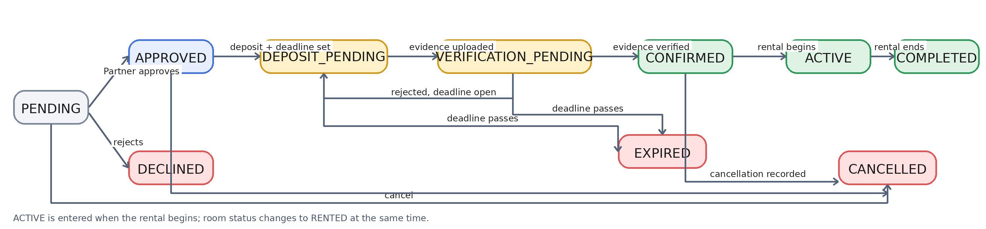

4. Final Database Design – ERD Overview
The final relational model separates listing moderation from room availability and stores reservation-deposit, payment-evidence, and refund records separately from property data. Property photos are one-to-many from Properties; ReservationDeposits and Reviews are one-to-one with Bookings.
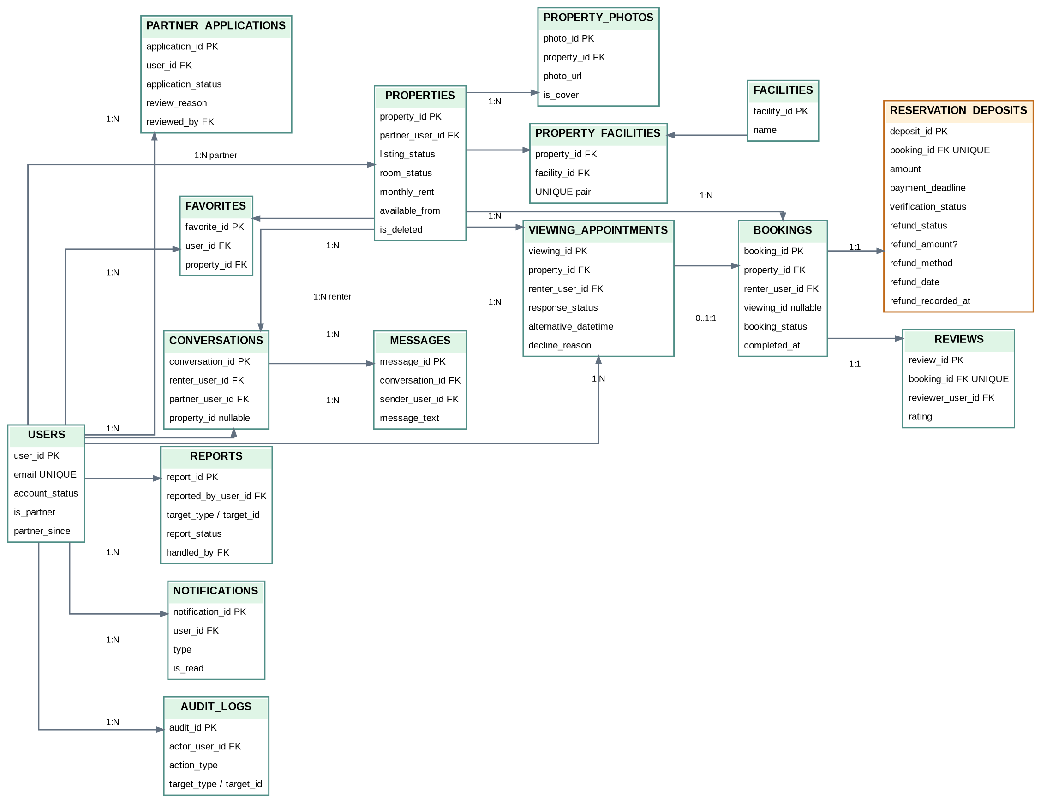

5. Final Status Rules and Key Business Rules
Area | Final Values / Rule | Set By / Trigger
Listing Status | DRAFT, PENDING_REVIEW, PUBLISHED, REJECTED, SUSPENDED | Partner creates/submits; Admin reviews/moderates
Room Status | AVAILABLE, RESERVED, RENTED, UNAVAILABLE | RESERVED immediately on booking approval; RENTED when rental begins; AVAILABLE after expiry/cancellation unless another restriction applies
Viewing Status | REQUESTED, APPROVED, RESCHEDULE_REQUESTED, DECLINED | Renter submits request; Partner approves, suggests another time, or declines
Booking Status | PENDING, APPROVED, DEPOSIT_PENDING, VERIFICATION_PENDING, CONFIRMED, ACTIVE, COMPLETED, DECLINED, CANCELLED, EXPIRED | Partner decision, evidence workflow, rental start/completion, cancellation, and deadline logic
Deposit Verification | AWAITING_EVIDENCE, PENDING_VERIFICATION, VERIFIED, REJECTED | AWAITING_EVIDENCE after Partner sets the deposit amount and deadline; PENDING_VERIFICATION after evidence upload; Partner verifies/rejects it; renter may re-upload while the deadline is open
Refund Status | NOT_APPLICABLE, REFUND_PENDING, REFUNDED, FORFEITED | Recorded by Partner after cancellation; settlement occurs outside the platform
Report Status | OPEN, UNDER_REVIEW, RESOLVED, DISMISSED | User submits report; Admin reviews, resolves, or dismisses it

Key business rules
- There is one public signup account type: Normal User. A Normal User may apply to Become a Partner; Admin approval grants Partner privileges.
- Guests may browse/search and view public property details. Favorites, messaging, viewing requests, booking requests, reviews, and Partner application require login.
- When a Partner approves a booking, the room becomes RESERVED immediately to prevent double-booking. Deposit amount and payment deadline belong to the booking/deposit process, not to the Property record.
- The renter pays externally. The platform stores payment instructions, deadline, uploaded evidence, and verification status only.
- Verified evidence leads to CONFIRMED. Rejected evidence may be re-uploaded while the deadline remains open. If the deadline expires, the booking becomes EXPIRED and the room returns to AVAILABLE.
- When the rental begins, the booking becomes ACTIVE and the room becomes RENTED. When the rental ends, the booking becomes COMPLETED and the room returns to AVAILABLE. Only then may an eligible renter leave one review.
- Refunds are settled outside the platform. The system records refund status, method, optional refund amount, actual refund date, and when the Partner recorded the refund.
- Partner suspension hides public listings and blocks new activity, while already-confirmed bookings and historical records remain.
- Audit logs are read-only from the Admin UI and record important administrative and status-changing actions.

6. Context Diagram (Level 0)
VISITOR is an external actor for unauthenticated browsing only. A Visitor can search, filter, and view public property details; protected actions require login and then continue through the Normal User flow.
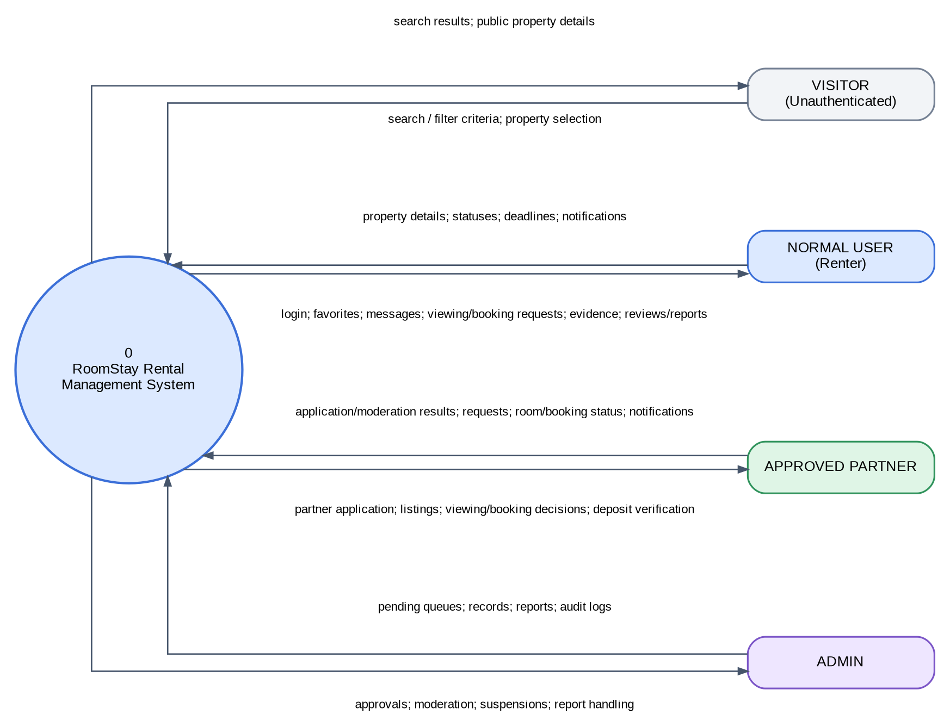
Note: VISITOR is not a database entity. A USERS record is created only when a visitor registers; login authenticates an existing user account.

7. Data Flow Diagram – Diagram 0
Diagram 0 includes VISITOR only in the browse/search process. Saving favorites, messaging, viewing, booking, payment evidence, reviews, reports, and Partner application require an authenticated Normal User account.
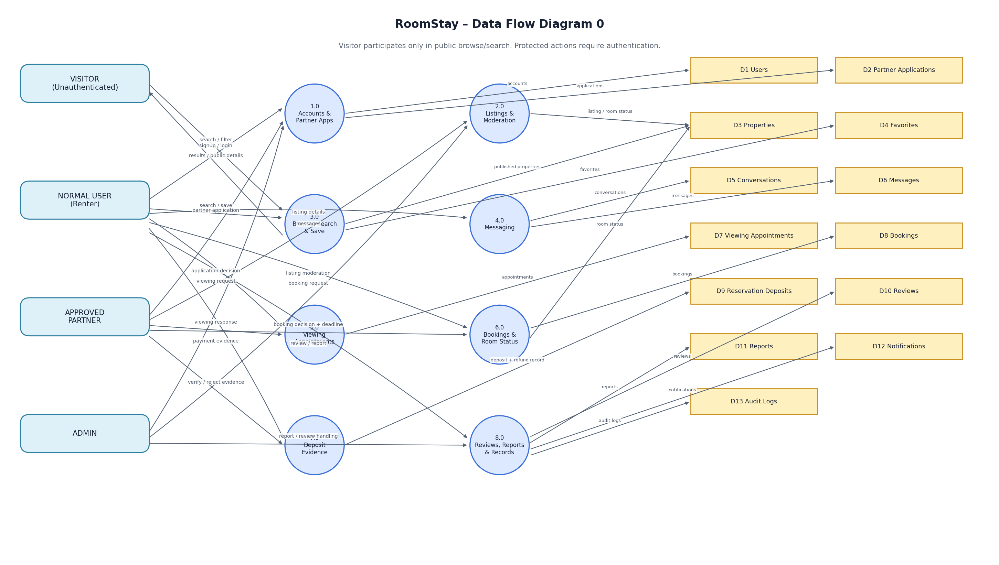
Data stores are logical stores mapped to the PostgreSQL design. Reservation Deposits include verification and refund record fields; actual money transfer remains outside RoomStay.

