The following analysis based on a data set with 30000 iterations.

- Maximum cash received:

If all coupons are received at maximum level, i.e. 5%,
cash received = 10000 * 5% * 12 + 10000 = 16000
return per annum = (16000-10000)/10000 = 30%

- Effect of interest rate:

Normal interest rate, with call:
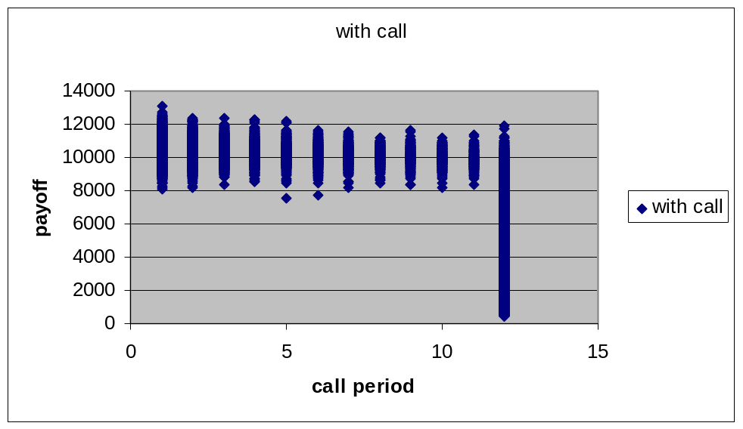
Interest rate = 0, with call
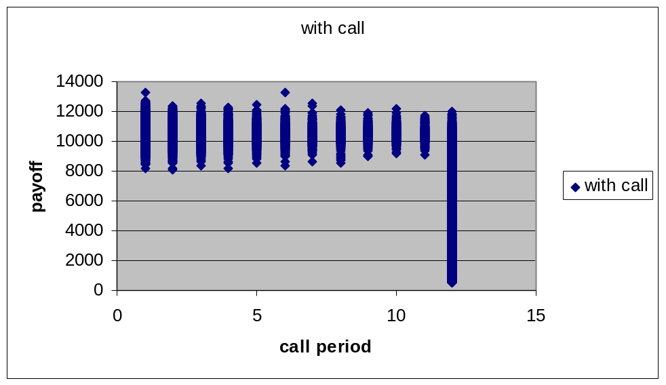
The payoff distribution does not have significant change.

- Effect of call feature

Payoff without call feature
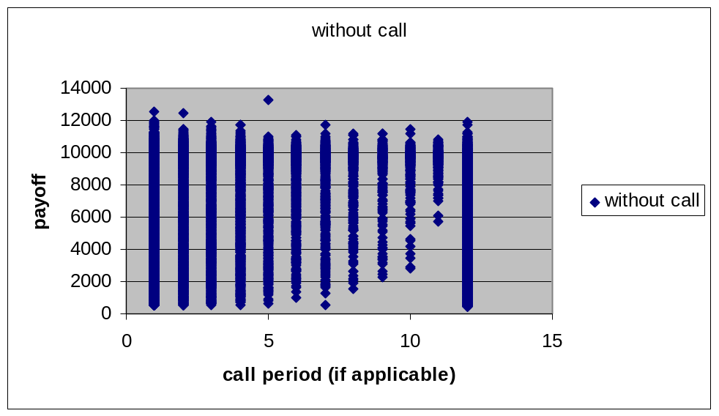

mean (with call) = 7573.168
mean (without call) = 5622.693

The payoff drops dramatically if the call feature is disabled.
- Analysis on payoff :

The distribution of payoff (initial payment not included)
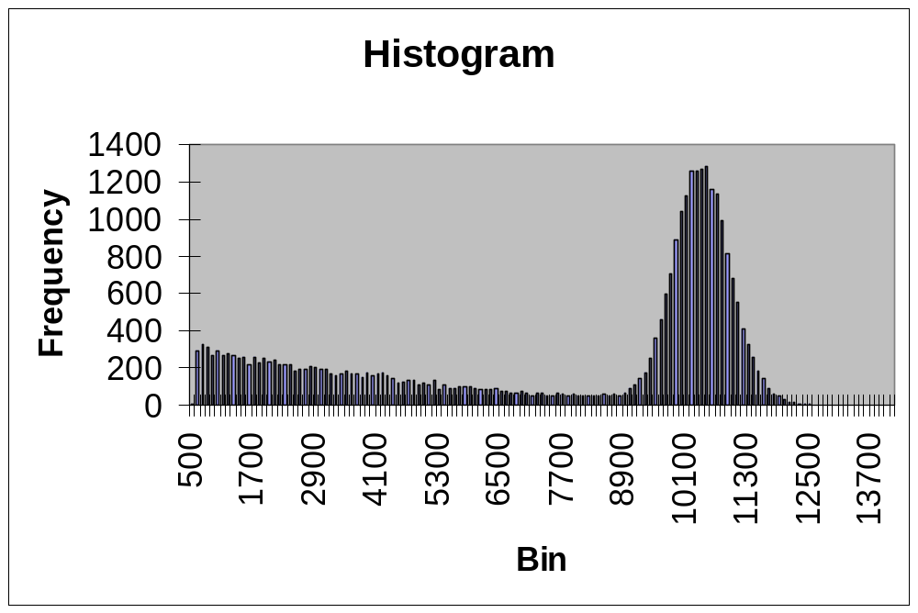

Relationship between payoff and call period (12 for no call)
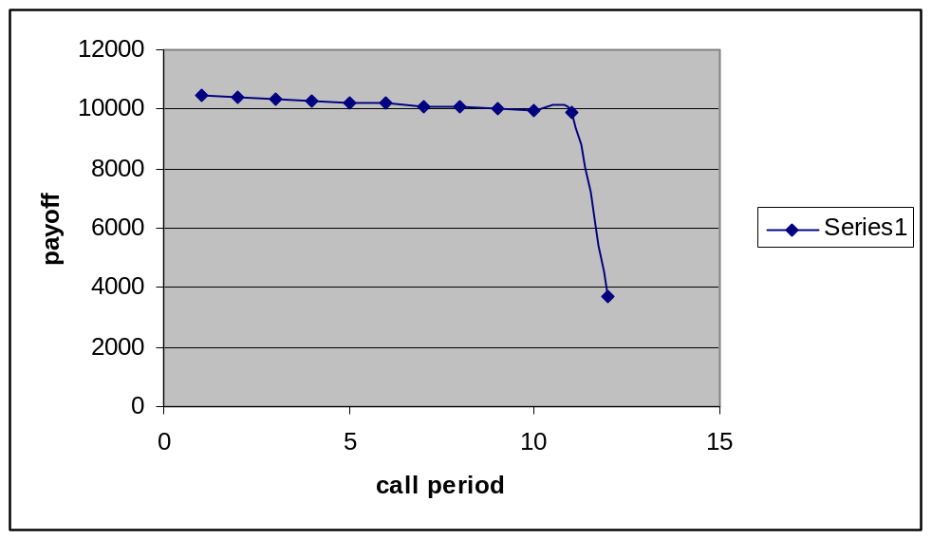
From issuer position,

Max payoff = 9502.752

Corresponding stock paths are:
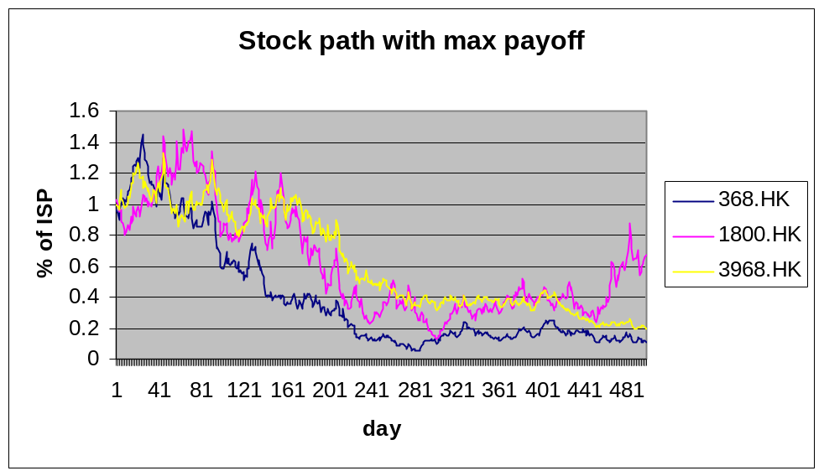
The product is called at the first period.
The stock with worst performance rise greater than 1 (ratio to ISP) so that the holder can obtain profit greater than 10000 at the first call settlement date.

Min payoff = -3105.69

Corresponding stock paths are:
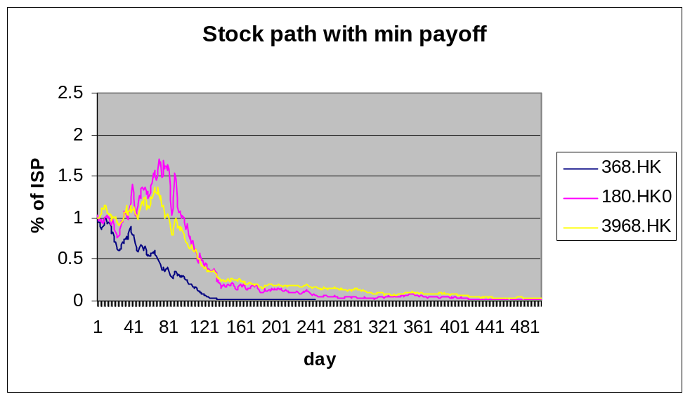
The product has not been called.
The stock with worst performance drop down to ~1x10-4 (ratio to ISP) . The holder receives no coupon till end. The final payment is very low due to the extremely low ratio.

Mean = 2426.832;
Standard deviation = 3695.405;
95% VaR = 1127.197

