MINOR PROJECT – 2

Who Survived the Titanic?
A data analysis project using Python
Submitted by: Praveen Yadav
Registration No.: 12621400
MCA, Lovely Professional University
Submitted to: ______________

1. Introduction
For this project I wanted a dataset that is easy to relate to, so I picked the Titanic passenger data. The ship sank in 1912 and more than 1,500 people died, but not everyone on board had the same chance of making it out alive.
The question I tried to answer is simple: did things like gender, ticket class and age change a passenger's chances of survival? I used Python to clean the data, explore it and draw charts, and then I tried to explain what the charts are actually telling us.

What I set out to do
- Pick a real dataset and understand what is in it.
- Clean it and deal with the missing values.
- Explore it to find patterns.
- Show those patterns with clear charts.
- Explain the results in my own words.

2. About the Dataset
I downloaded train.csv from Kaggle's Titanic competition (Titanic: Machine Learning from Disaster). It is a small dataset with 891 passengers and 12 columns, which makes it a good one for practising EDA. These are the columns:
Column | What it means
Survived | 0 = did not survive, 1 = survived
Pclass | Ticket class: 1 = upper, 2 = middle, 3 = lower
Sex, Age | Gender and age of the passenger
SibSp, Parch | Number of siblings/spouse and parents/children on board
Fare | Price of the ticket
Embarked | Port where the passenger boarded (C, Q or S)
Cabin, Ticket, Name | Cabin number, ticket number and name

3. How I Did It
Everything was done in Python. I used Pandas to work with the data and Matplotlib and Seaborn to make the charts.
I started by simply looking at the data: its size, the column types and the first few rows. Then I checked for missing values. Age was missing for 177 passengers, Embarked for 2, and Cabin for 687 out of 891.
For Age I filled the gaps with the median instead of the mean, because a few very old passengers can pull the mean up. For Embarked I used the most common port (S), since only two values were missing. I dropped Cabin completely because around 77% of it was empty, and filling that much would just be guessing.
After cleaning, I made two extra columns. FamilySize is SibSp + Parch + 1 (the passenger counts too), and AgeGroup puts people into Child, Teen, Adult, Middle-aged and Senior. Then I worked out survival rates for each group and plotted them.

4. Analysis and Charts
First, the big picture. Out of 891 passengers, only 38.4% survived. So fewer than 4 out of every 10 people made it.
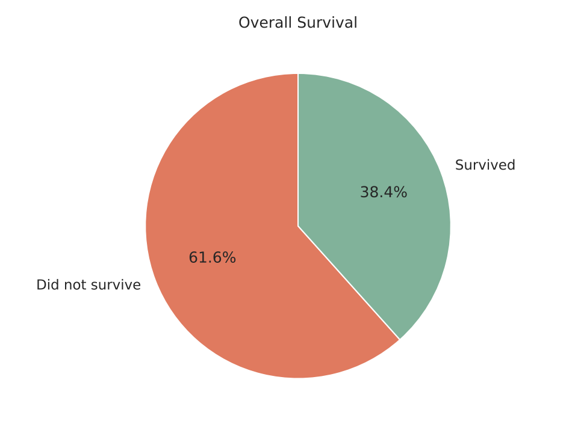
Figure 1: Overall survival

4.1 Gender
This was the biggest gap I found. About 74% of the women survived, but only about 19% of the men. It matches the “women and children first” rule that was followed when the lifeboats were being filled.
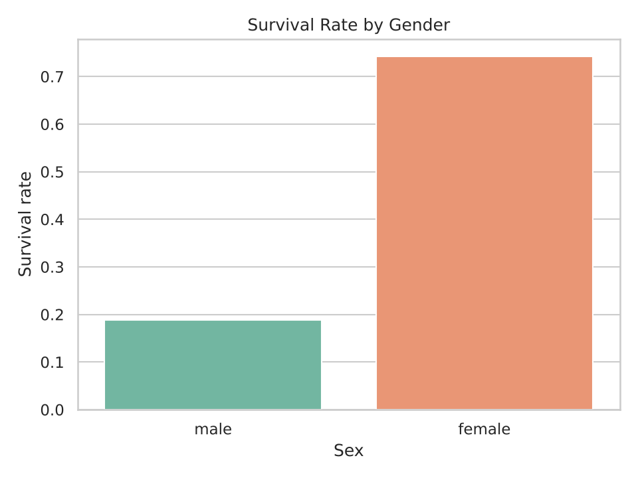
Figure 2: Survival rate by gender

4.2 Passenger class
Class made a big difference too. Survival was 63% in first class, 47% in second and only 24% in third. The fare chart shows how different the classes were: the middle first-class ticket cost about 60, compared with about 8 in third class. Rich passengers were also probably closer to the lifeboats, which may explain part of this.
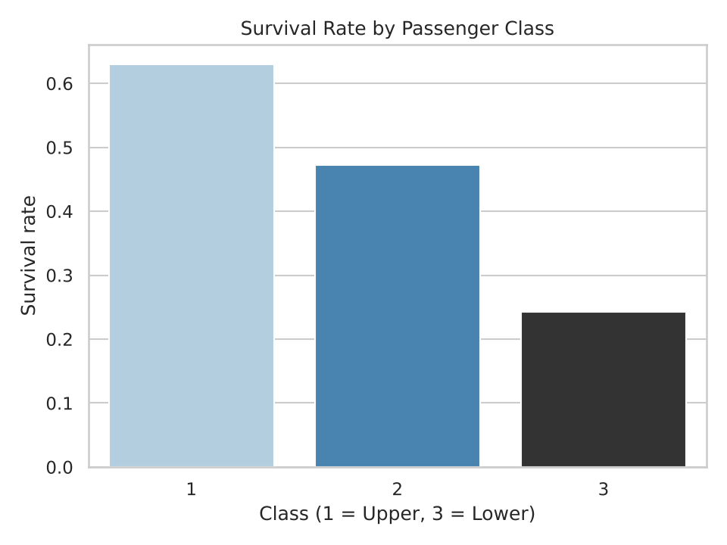
Figure 3: Survival rate by passenger class
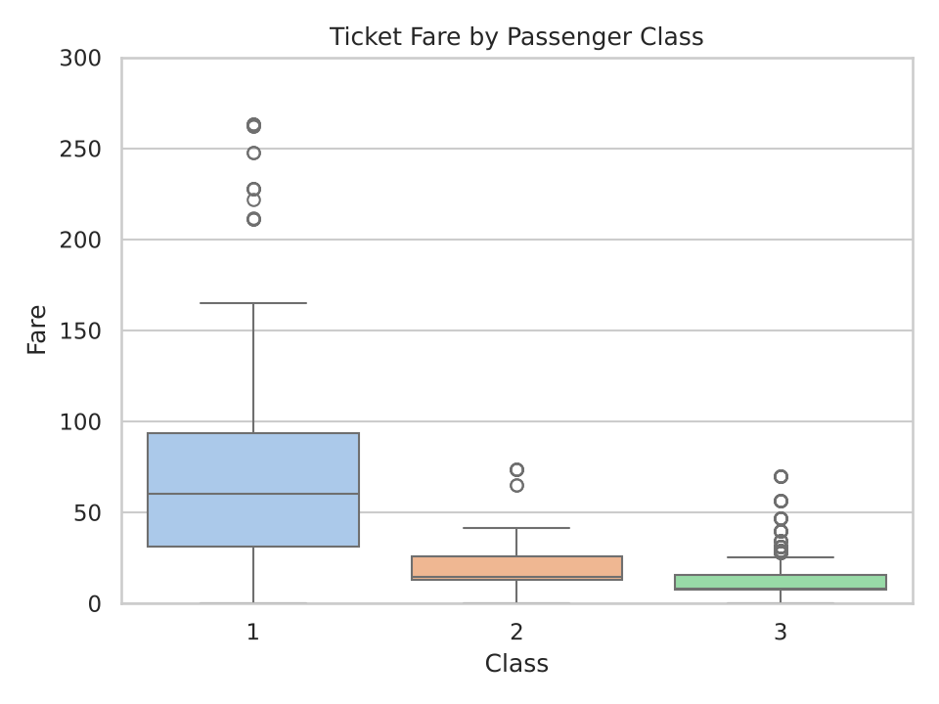
Figure 4: Ticket fare by class

4.3 Age
Most passengers were young adults between 20 and 40. The tall spike near 28 in the histogram is not real. It appears because I filled the missing ages with the median, which is 28. I thought it was worth pointing out so the chart is not misread.
For survival, children under 12 did best at 58%, while seniors did worst at about 23%.
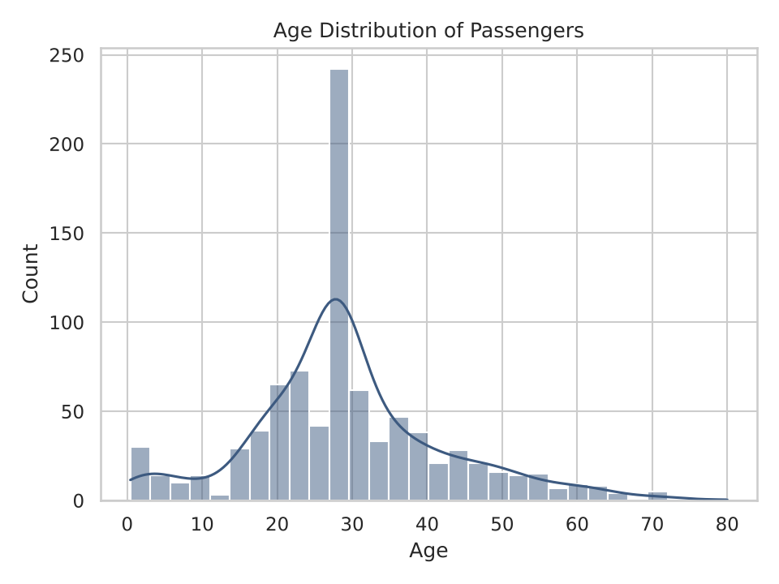
Figure 5: Age distribution
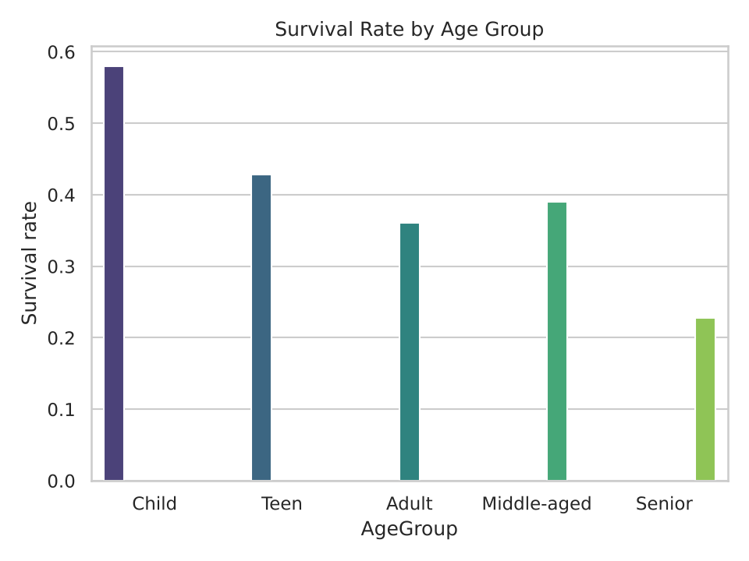
Figure 6: Survival rate by age group

4.4 Family size
People travelling alone had only a 30% survival rate. Small families of 2 to 4 did best, between 55% and 72%. Big families of 5 or more did badly, at 20% or lower. My guess is that large groups found it hard to stay together and reach the boats in time, but the data cannot prove that.
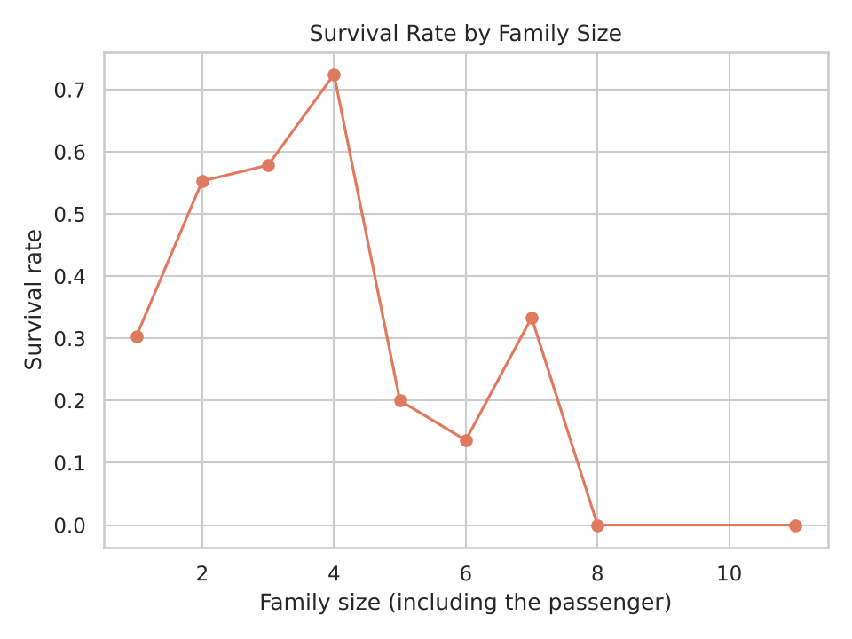
Figure 7: Survival rate by family size

4.5 Correlation
The heatmap shows how the number columns relate to each other. Pclass and Survived have a correlation of -0.34, which means a better class (lower number) goes with a higher chance of survival. Fare is positively related to survival (0.26), which is basically the same story, because richer passengers bought better tickets. Fare and Pclass are strongly linked to each other (-0.55), which makes sense.
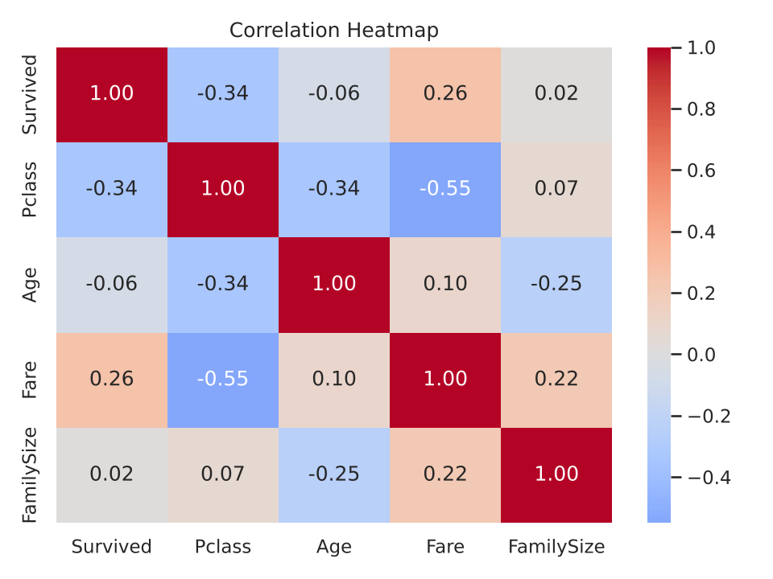
Figure 8: Correlation heatmap

5. Main Findings
- Only 38.4% of the passengers survived.
- Women were almost four times as likely to survive as men (74% vs 19%).
- First class survived at roughly 2.6 times the rate of third class (63% vs 24%).
- Children had the best chances and seniors the worst.
- Travelling alone or with a very large family lowered the chances. Small families did best.
- Gender and class together tell the most. A first-class woman had about a 97% chance of surviving, while a third-class man had only about 14%.

6. Conclusion
The analysis shows that survival on the Titanic was far from random. It depended a lot on who you were: your gender, your ticket class, your age and who you were travelling with. Women, children and first-class passengers had much better odds, while men and third-class passengers had much worse.
This project helped me practise the whole workflow of a data analysis, from loading and cleaning the data to making charts and explaining them. One thing I learned is that the data only shows patterns, not causes. For example, class and fare are so closely linked that I cannot say which one mattered more. Also, filling the missing ages with the median affects how the age chart looks. If I get time later, I would like to build a simple machine learning model to predict survival.

7. Tools and References
- Python 3, Pandas, Matplotlib, Seaborn
- Dataset: Kaggle, Titanic: Machine Learning from Disaster (kaggle.com/c/titanic)
- Source code: project.py, submitted along with this report

