Translation system

To make this you need:
- lupdate
- lrelease
Linguist

I've created a EN_en.ts files through lupdate with this command:

C:\>lupdate my_gui.ui -target-language mylanguage -ts EN_en.ts

It creates a EN_esn.ts files that can ben opend with linguist

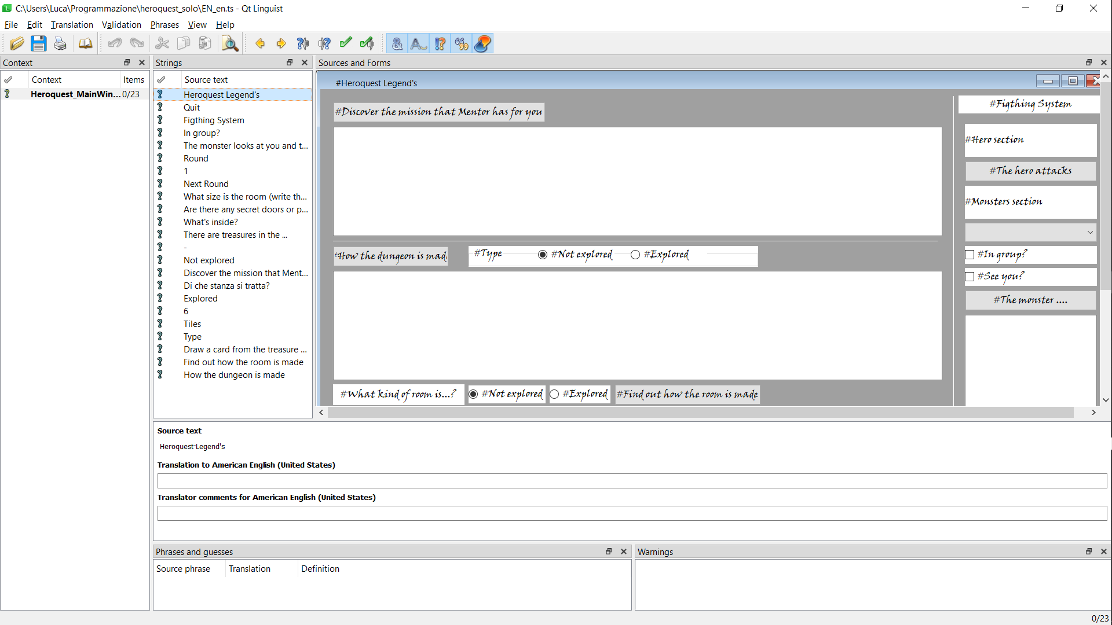
Then I’ve create a C:\>lupdate my_gui.ui -target-language mylanguage -ts IT_it.ts file for italian

Open it with linguist, choose the target language and translate:

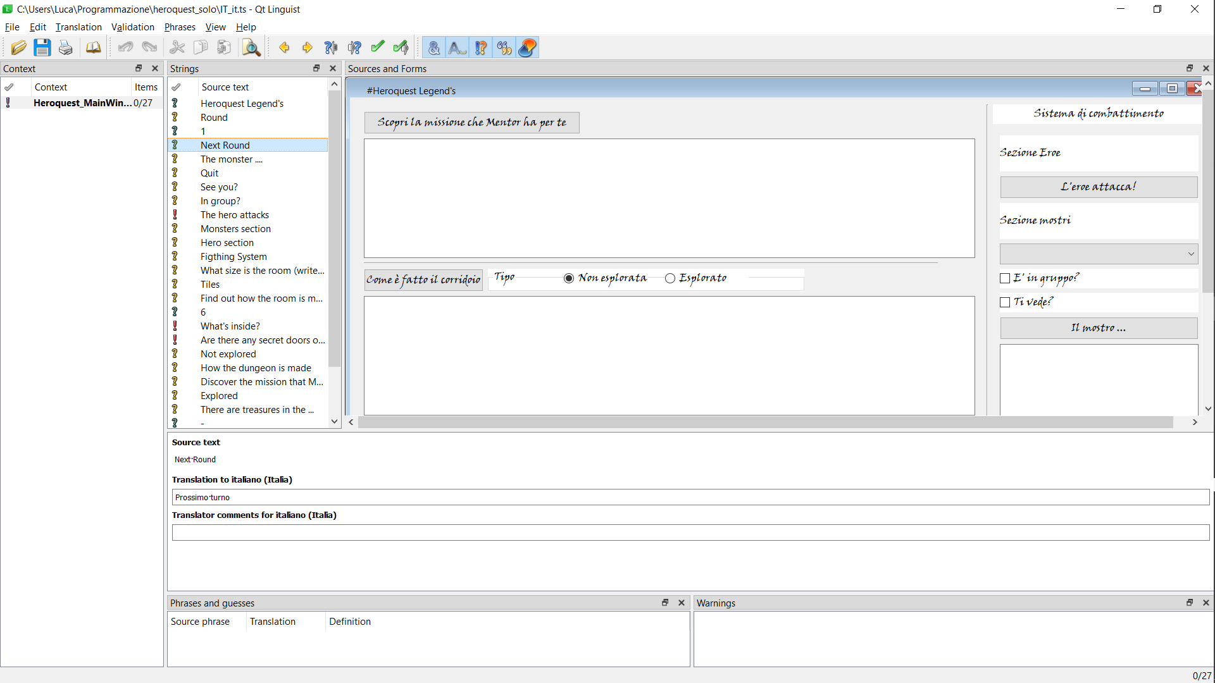

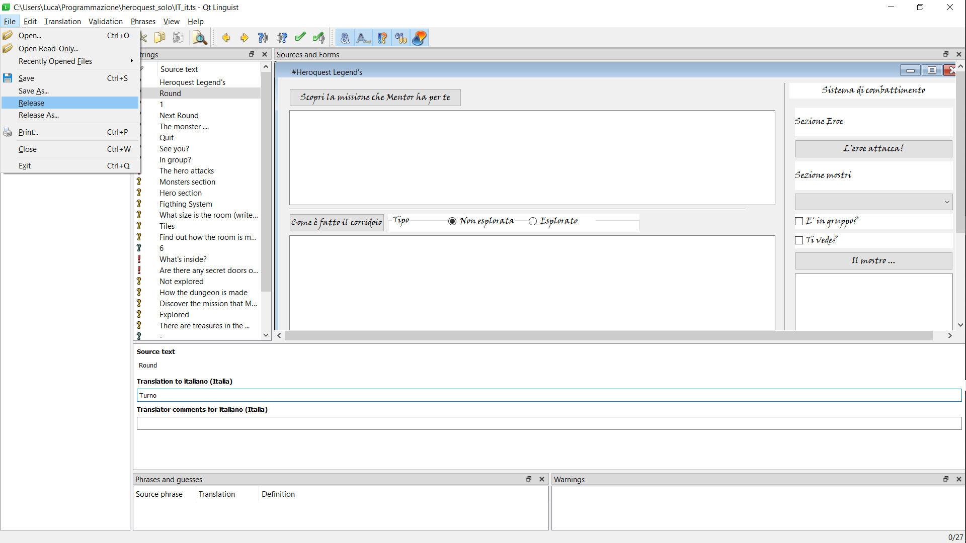

Save and the result into the directory is ….

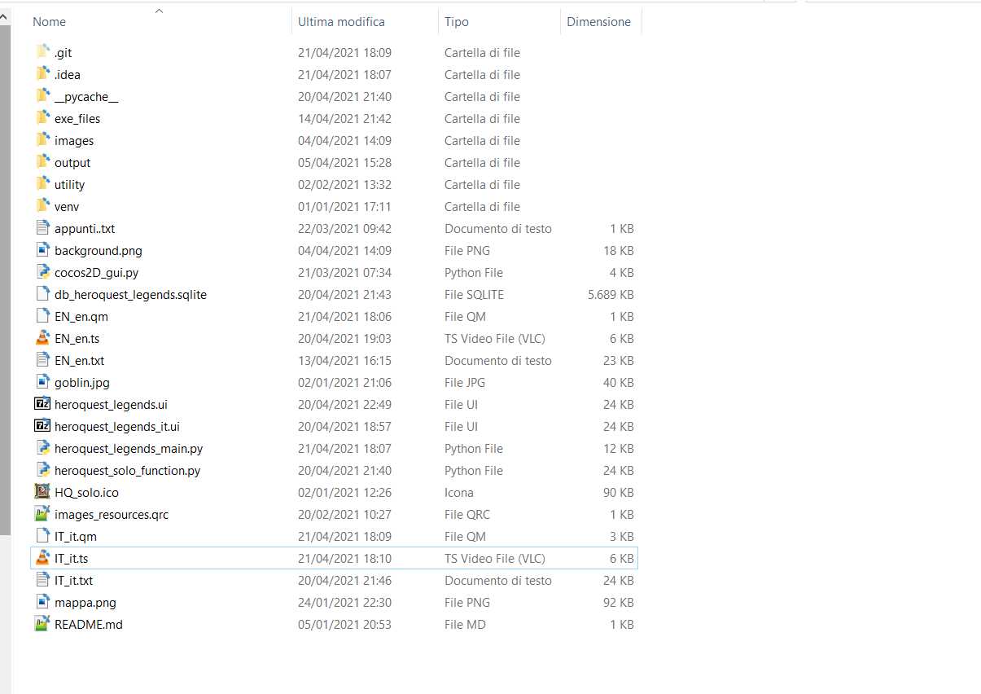

And finally inside the code I’ve added theese lines:
