資料探勘 期中報告
(題目)

國立高雄科技大學
海事資訊科技系

組員：葉育晉
指導老師：張珀銀 老師
(一)摘要
整篇報告的縮影，說明研究的問題、使用的方法和結果。
(二)研究動機與研究問題
研究動機
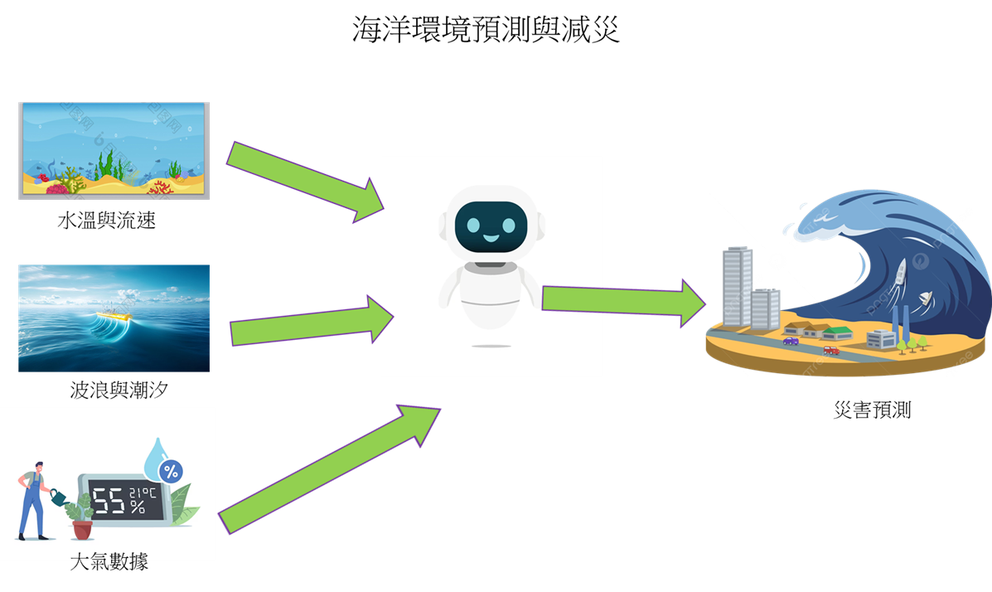
研究問題
說明並列出工作項目，請量化工作項目，至少3項。
研究目的
說明並列出工作項目，請量化工作項目，至少3項。
(三)文獻探討與回顧
針對(1)題目問題及(2)研究方法進行文獻回顧。
(1) 介紹以往此類題目的成果

(2) 例如使用了線性迴歸、決策樹及支持向量機，就針對這3種方法進行探討。

迴歸方法
線性迴歸
決策樹
支持向量機
分類方法
邏吉斯迴歸
決策樹
支持向量機

(四)研究方法與步驟

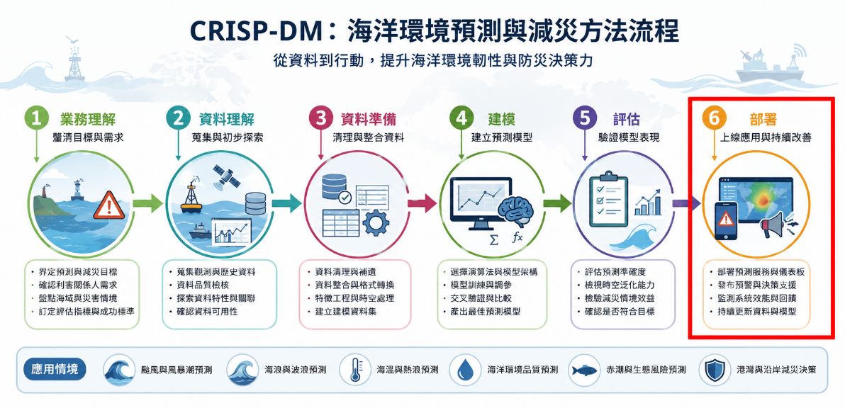

- Business Understanding
- Data Understanding
- Data Preparation
- Modeling
- Evaluation
- Deployment

研究資料說明
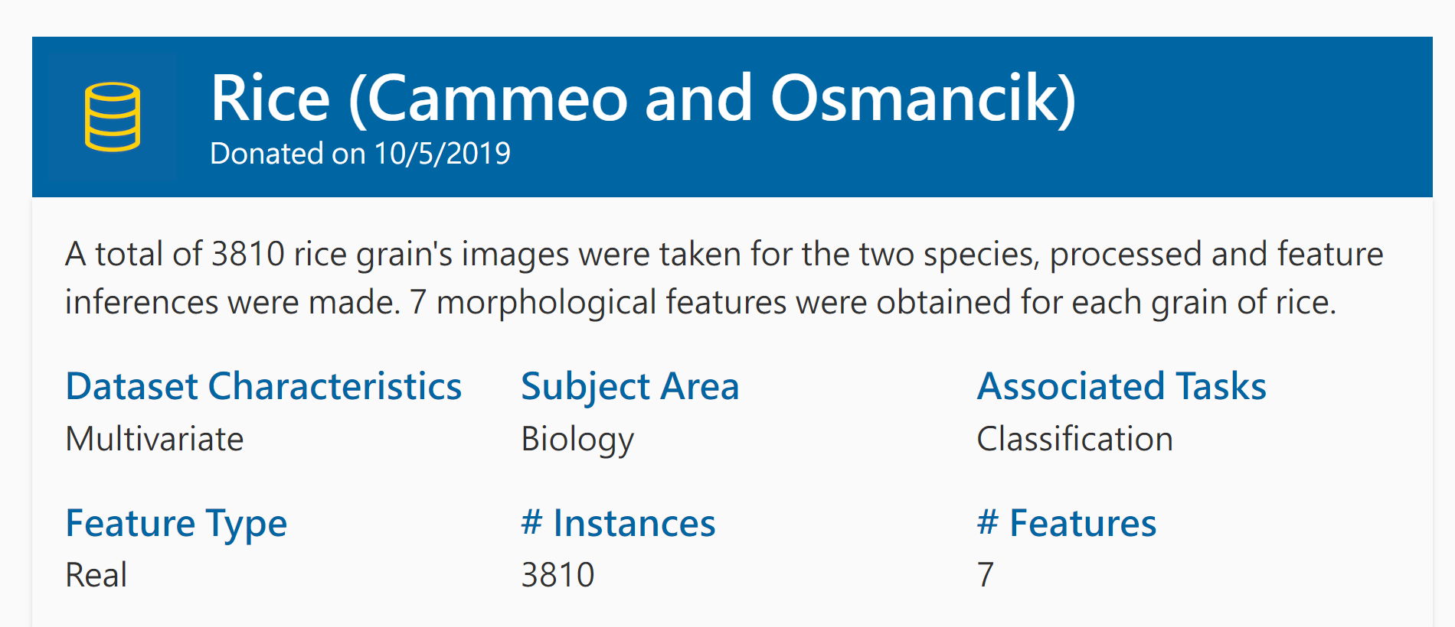

- Data Set Characteristic
- Subject Aera
- Association Tasks
- Feature Type
- Instances
- Features

資料敘述統計

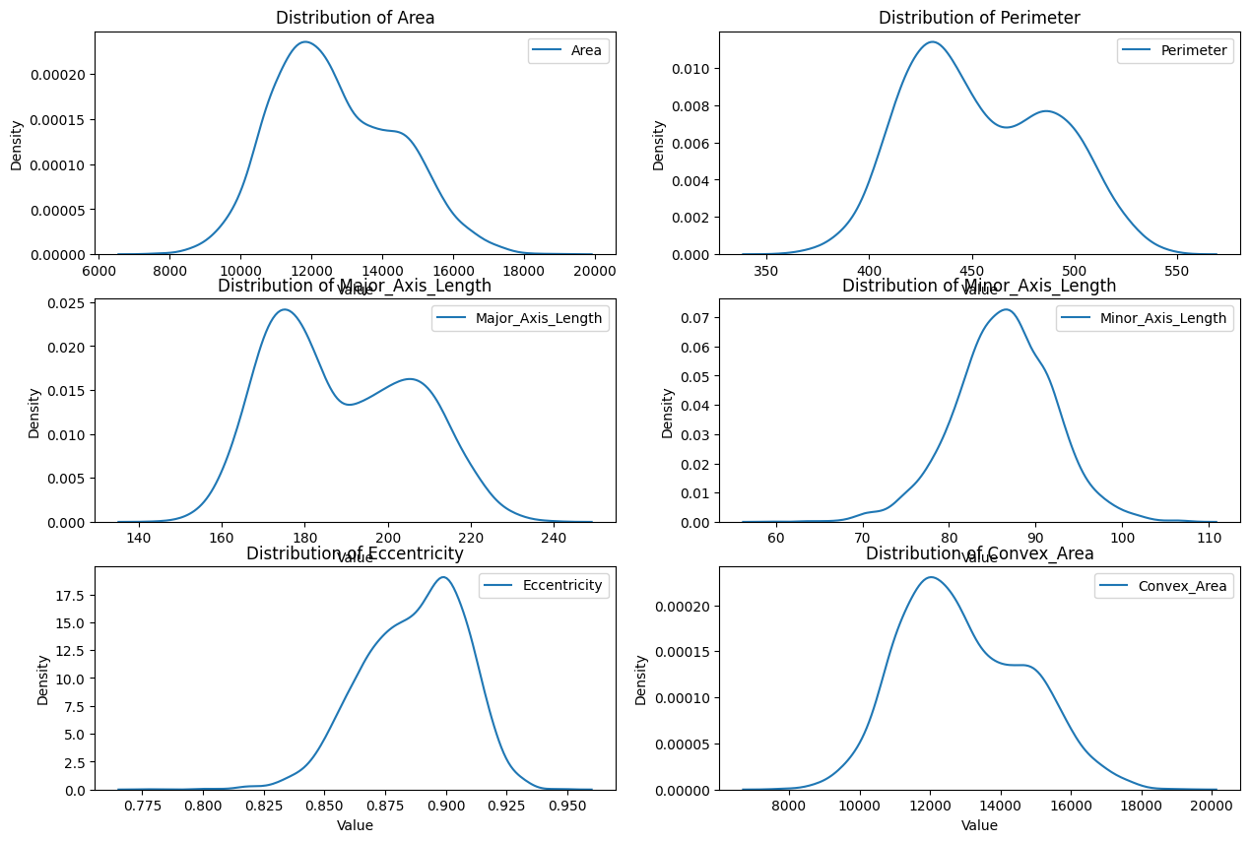

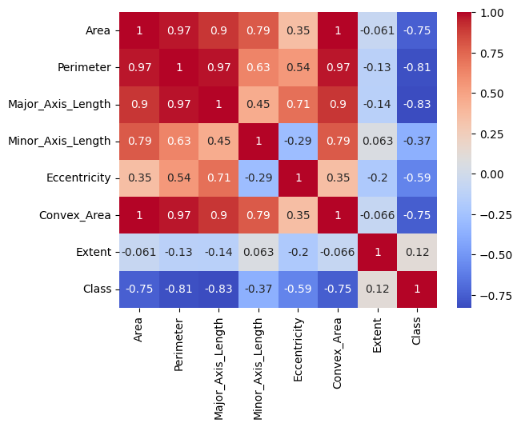

評估指標-分類
可自行增加方法及指標

資料集1
 | Accuracy | Recall | Precious | F1_Score
方法1 | 90 | 60 | 80 | 78
方法2 | 80 | 50 | 70 | 68
方法3 | 70 | 40 | 60 | 52

資料集2
 | Accuracy | Recall | Precious | F1_Score
方法1 | 90 | 60 | 80 | 78
方法2 | 80 | 50 | 70 | 68
方法3 | 70 | 40 | 60 | 52

評估指標-迴歸
可自行增加方法及指標
資料集1
 | RMSE | RMSE | RMSE | RMSE
方法1
方法2
方法3

資料集2
 | RMSE | RMSE | RMSE | RMSE
方法1
方法2
方法3

作者貢獻
表1. 組員分工表
姓名 | 研究資料主題 | 使用工具 | 方法特色 | 其他工具 | 專案GitHub
王小明 | - 鳶尾花-分類 | - VS Code, scikit-learn | 隨機森林  支持向量機 | Excel
王大明 | - 天氣預測-迴歸
李小玉
陳小美

(五)預期結果(結論)
請回應研究問題或研究目的，務必令文章有前後邏輯。

(六)參考文獻 (建議學習使用Endnote)
- H. D. Cheng; J. Wang; Y. G. Hu; C. Glazier; X. J. Shi, and X. W. Chen, Novel approach to pavement cracking detection based on neural network. Transportation Research Record, 2001, 1764, 119-127.
- P. Subirats; J. Dumoulin; V. Legeay, and D. Barba, “Automation of pavement surface crack detection using the continuous wavelet transform,” in 2006 International Conference on Image Processing, 2006; pp. 3037-3040.
- M. Petrou; J. Kittler, and K. Y. Song, Automatic surface crack detection on textured materials. Journal of Materials Processing Technology, 1996, 56, 158-167.
- D. L. Pham; C. Xu, and J. L. Prince, Current methods in medical image segmentation. Annu Rev Biomed Eng, 2000, 2, 315-37.
- B. Khagi; C. G. Lee, and G.-R. Kwon, “Alzheimer’s disease classification from brain mri based on transfer learning from cnn,” in 2018 11th Biomedical Engineering International Conference (BMEiCON), 2018; pp. 1-4.
- D. U. N. Qomariah; H. Tjandrasa, and C. Fatichah, “Classification of diabetic retinopathy and normal retinal images using cnn and svm,” in 2019 12th International Conference on Information & Communication Technology and System (ICTS), 2019; pp. 152-157.
- H. Lee; S. Eum, and H. Kwon, “Cross-domain cnn for hyperspectral image classification,” in IGARSS 2018-2018 IEEE International Geoscience and Remote Sensing Symposium, 2018; pp. 3627-3630.
- X. Lei; H. Pan, and X. Huang, A dilated cnn model for image classification. IEEE Access, 2019, 7, 124087-124095.
- L. Li; H. Huang, and X. Jin, “Ae-cnn classification of pulmonary tuberculosis based on ct images,” in 2018 9th International Conference on Information Technology in Medicine and Education (ITME), 2018; pp. 39-42.
- C. Dong; C. C. Loy; K. He, and X. Tang, “Learning a deep convolutional network for image super-resolution,” in European conference on computer vision, 2014; pp. 184-199.
- J. Yamanaka; S. Kuwashima, and T. Kurita, “Fast and accurate image super resolution by deep cnn with skip connection and network in network,” in International Conference on Neural Information Processing, 2017; pp. 217-225.
- Y. Zhang; Y. Tian; Y. Kong; B. Zhong, and Y. Fu, Residual dense network for image super-resolution. Proceedings of the IEEE conference on computer vision and pattern recognition, 2018, 2472-2481.
- Y. Chen; W. Li; C. Sakaridis; D. Dai, and L. Van Gool, “Domain adaptive faster r-cnn for object detection in the wild,” in Proceedings of the IEEE conference on computer vision and pattern recognition, 2018; pp. 3339-3348.
- J. Hung and A. Carpenter, “Applying faster r-cnn for object detection on malaria images,” in Proceedings of the IEEE conference on computer vision and pattern recognition workshops, 2017; pp. 56-61.
- S. Ren; K. He; R. Girshick, and J. Sun, “Faster r-cnn: Towards real-time object detection with region proposal networks,” in Advances in neural information processing systems, 2015; pp. 91-99.
- W. Chen; B. Liu; S. Peng; J. Sun, and X. Qiao, “S3d-unet: Separable 3d u-net for brain tumor segmentation,” in International MICCAI Brainlesion Workshop, 2018; pp. 358-368.
- L. Luo; D. Chen, and D. Xue, “Retinal blood vessels semantic segmentation method based on modified u-net,” in 2018 Chinese Control And Decision Conference (CCDC), 2018; pp. 1892-1895.
- A. Sevastopolsky, Optic disc and cup segmentation methods for glaucoma detection with modification of u-net convolutional neural network. Pattern Recognition and Image Analysis, 2017, 27, 618-624.
- Y. Guo; Y. Liu; T. Georgiou, and M. S. Lew, A review of semantic segmentation using deep neural networks. International journal of multimedia information retrieval, 2018, 7, 87-93.
- J. Zhang; J. Du; H. Liu; X. Hou; Y. Zhao, and M. Ding, Lu-net: An improved u-net for ventricular segmentation. IEEE Access, 2019, 7, 92539-92546.
- P. Xiuqin; Q. Zhang; H. Zhang, and S. Li, A fundus retinal vessels segmentation scheme based on the improved deep learning u-net model. IEEE Access, 2019, 7, 122634-122643.
- Z. Wei; H. Song; L. Chen; Q. Li, and G. Han, Attention-based denseunet network with adversarial training for skin lesion segmentation. IEEE Access, 2019, 7, 136616-136629.
- M. Goyal; A. Oakley; P. Bansal; D. Dancey, and M. H. Yap, Skin lesion segmentation in dermoscopic images with ensemble deep learning methods. IEEE Access, 2020, 8, 4171-4181.
- V. Badrinarayanan; A. Kendall, and R. Cipolla, Segnet: A deep convolutional encoder-decoder architecture for image segmentation. IEEE Transactions on Pattern Analysis and Machine Intelligence, 2017, 39, 2481-2495.
- Z. Zhou; M. Mahfuzur Rahman Siddiquee; N. Tajbakhsh, and J. Liang, Unet++: A nested u-net architecture for medical image segmentation. 2018, arXiv:1807.10165.
- C. Szegedy; W. Liu; Y. Jia; P. Sermanet; S. Reed; D. Anguelov, et al., Going deeper with convolutions. 2014, arXiv:1409.4842.
- F. Chollet, Xception: Deep learning with depthwise separable convolutions. 2016, arXiv:1610.02357.
- M. Tan and Q. V. Le, Efficientnet: Rethinking model scaling for convolutional neural networks. 2019, arXiv:1905.11946.
- M. Sandler; A. Howard; M. Zhu; A. Zhmoginov, and L.-C. Chen, Mobilenetv2: Inverted residuals and linear bottlenecks. 2018, arXiv:1801.04381.
- N. Codella; V. Rotemberg; P. Tschandl; M. Emre Celebi; S. Dusza; D. Gutman, et al., Skin lesion analysis toward melanoma detection 2018: A challenge hosted by the international skin imaging collaboration (isic). 2019, arXiv:1902.03368.
- T. Mendonça; P. M. Ferreira; J. S. Marques; A. R. S. Marcal, and J. Rozeira, “Ph2 - a dermoscopic image database for research and benchmarking,” in 2013 35th Annual International Conference of the IEEE Engineering in Medicine and Biology Society (EMBC), 2013; pp. 5437-5440.

