Vendor Sales, Purchase & Inventory Performance Analysis

1. Project Overview
This project analyzes vendor-level sales, purchasing, pricing, and inventory performance using transactional data initially available as Excel/CSV files. The objective is to transform raw operational data into actionable business insights that help improve profitability, optimize inventory management, and reduce supplier dependency risks. The final insights are delivered through Python-based analysis and an interactive Power BI dashboard.

2. Business Problem Statement
The business faces challenges in:
- Understanding which vendors and brands contribute most to sales and purchases
- Identifying supplier concentration and dependency risks
- Evaluating the impact of bulk purchasing on unit cost and profitability - Detecting slow-moving inventory and capital locked in unsold stock
- Comparing profitability between high- and low-performing vendors
Key Business Question: > How can vendor-level sales and purchase data be leveraged to improve profitability, inventory efficiency, and supplier strategy?

3. Data Sources
The project started with the following raw CSV files:
- begin_inventory.csv
- end_inventory.csv
- purchase_prices.csv
- purchases.csv - sales.csv
- vendor_invoice.csv
These files contain detailed information on inventory levels, purchase transactions, sales transactions, pricing, and freight costs.

4. Data Ingestion & Storage
A Python ingestion script was developed to automate loading raw CSV files into a SQLite database (inventory.db).

Key Ingestion Steps
- Scanned the data/ directory for CSV files
- Loaded each file into a Pandas DataFrame
- Stored each dataset as a relational table in SQLite using SQLAlchemy
- Replaced existing tables to ensure repeatable ingestion
- Logged ingestion status and execution time for traceability
This created a structured database layer to support downstream SQL transformations and analysis.

5. Data Transformation & Feature Engineering
Using a Jupyter notebook, raw database tables were filtered, transformed, and consolidated into a single analytical table named vendor_sales_summary.

5.1 Engineered Metrics
The following business metrics were created:
- Gross Profit - Profit Margin (%)
- Stock Turnover (Sales Quantity / Purchase Quantity)
- Sales-to-Purchase Ratio
- Unsold Inventory Value
- Order Size Segmentation (Small / Medium / Large using quantiles)
The resulting vendor_sales_summary table served as the single source of truth for analysis and reporting.

6. Exploratory Data Analysis (EDA)

6.1 Summary Statistics
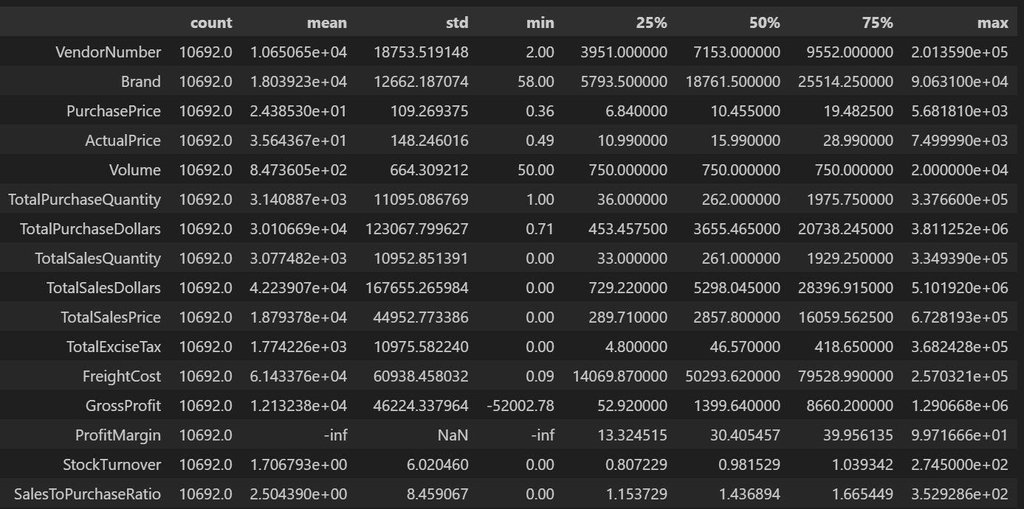

6.2 Distribution & Outlier Analysis
- Sales and purchase values showed right-skewed distributions
- IQR-based clipping was applied for visualization clarity

6.3 Negative & Zero Values
- Gross Profit: Minimum value is -52,002.78, indicating losses. Some products or transactions may be selling at a loss due to high costs or heavy discounts below purchase price.
- Profit Margin: Has a minimum of -∞, which suggests cases where revenue is zero or lower than costs, leading to extreme negative profit margins.
- Total Sales Quantity & Sales Dollars: Some products show zero sales, indicating they were purchased but never sold. These could be slow-moving or obsolete stock, leading to inventory inefficiencies.

6.4 Outliers Indicated by High Standard Deviations
- Purchase & Actual Prices: The maximum values (5,681.81 & 7,499.99) are significantly higher than the mean (24.39 & 35.64), indicating premium product offerings.
- Freight Cost: Extreme variation, from 0.09 to 257,032.07, suggests logistics inefficiencies, bulk shipments or erratic shipping costs across different products.
- Stock Turnover: Ranges from 0 to 274.5, implying some products sell extremely fast while others remain in stock indefinitely. A value greater than 1 indicate that sales for a product exceed the purchase quantity due to older stocks fulfilling orders.

6.5 Data Cleaning
To enhance the reliability of the insights, we removed inconsistent data points where:
- Gross Profit ≤ 0 (to exclude transactions leading to losses)
- Profit Margin ≤ 0 (to ensure analysis focuses on profitable transactions)
- Total Sales Quantity = 0 (to eliminate inventory that was never sold)

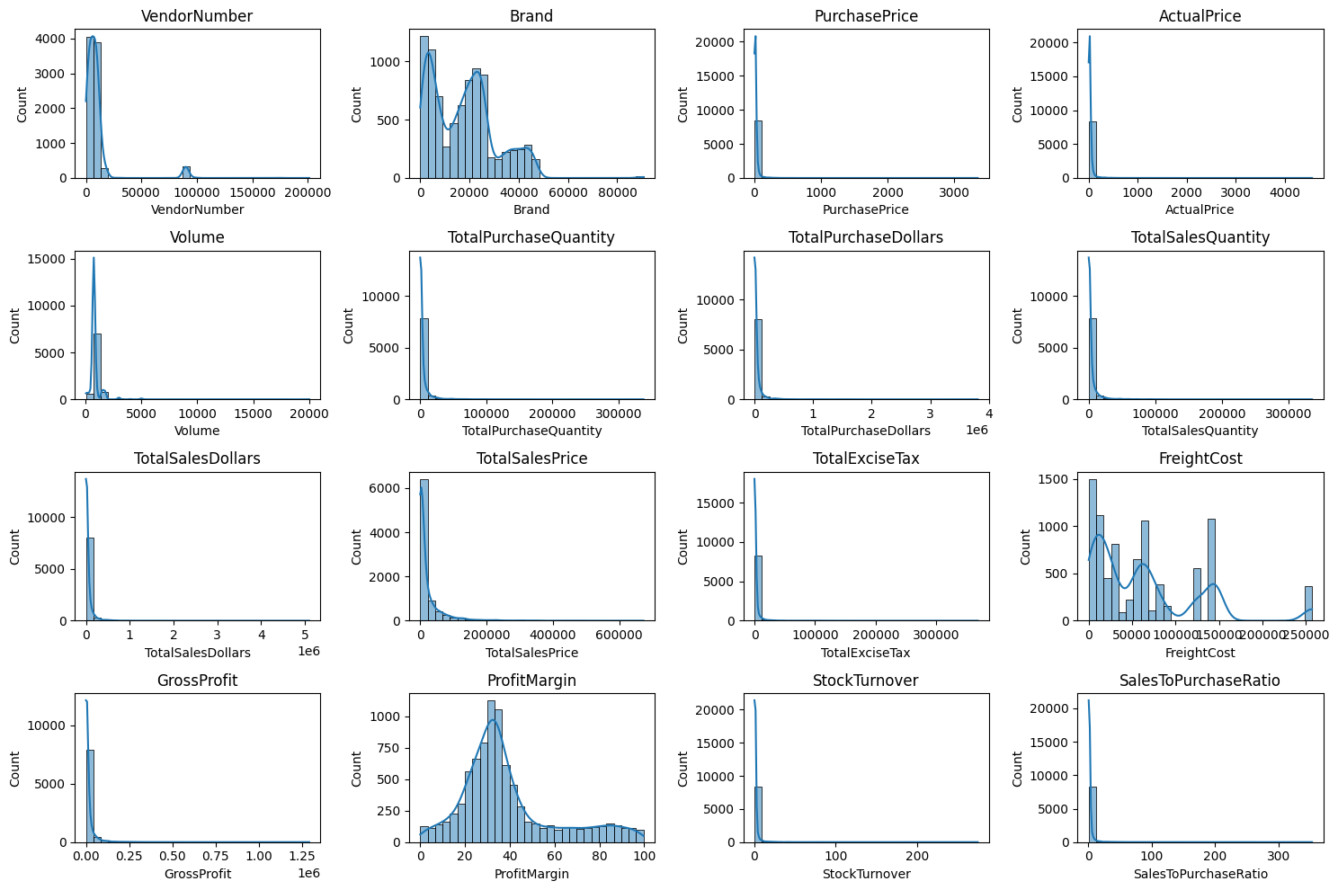

6.6 Correlation Insights
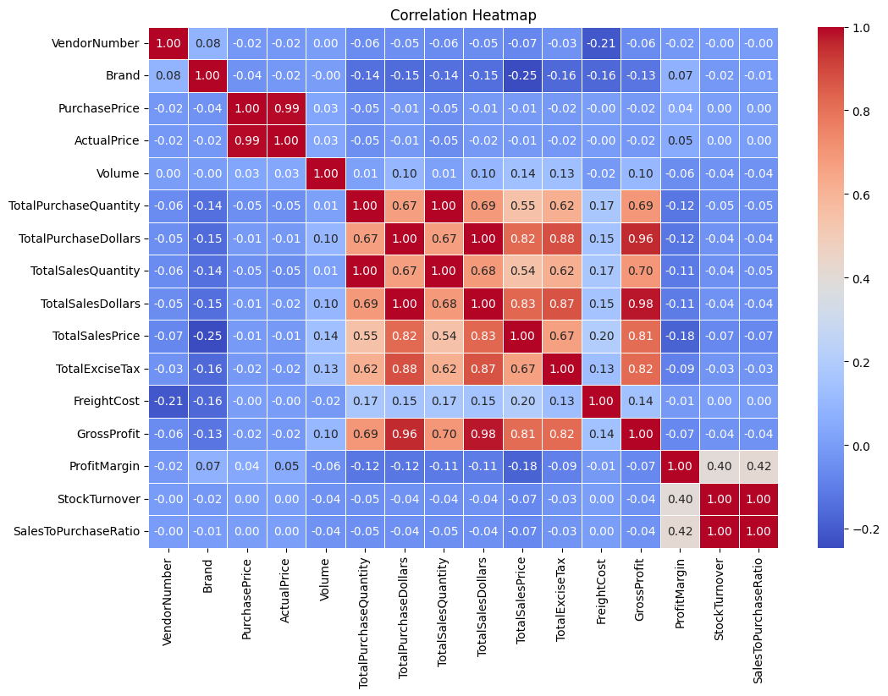
- Purchase Price vs. Total Sales Dollars & Gross Profit: Weak correlation (-0.012 and -0.016), indicating that price variations do not significantly impact sales revenue or profit.
- Total Purchase Quantity vs. Total Sales Quantity: Strong correlation (0.999), confirming efficient inventory turnover.
- Profit Margin vs. Total Sales Price: Negative correlation (-0.179), suggesting increasing sales prices may lead to reduced margins, possibly due to competitive pricing pressures.
- Stock Turnover vs. Gross Profit & Profit Margin: Weak negative correlation (-0.038 & -0.055), indicating that faster stock turnover does not necessarily equate to higher profitability.

7. Vendor & Brand Performance Analysis

7.1 Brands for Promotional or Pricing Adjustments
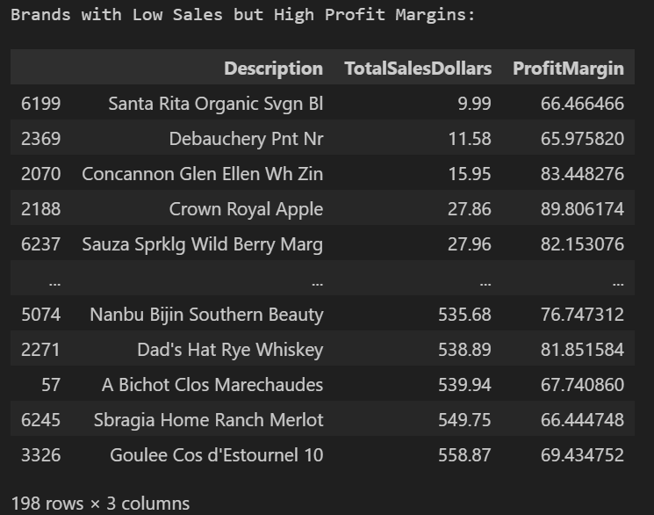

198 brand exhibits lower sales but higher profit margins, which could benefit from targeted marketing, promotions or price optimizations to increase volume without compromising profitability.

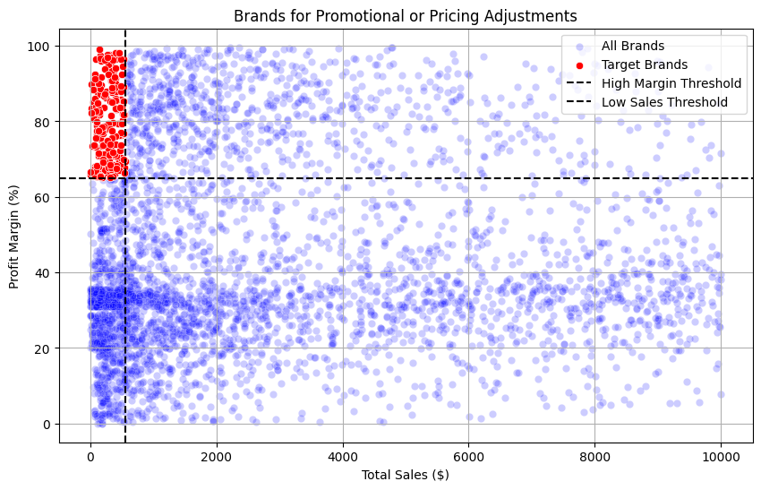

7.2 Top Vendors by Sales & Purchase Contribution
- Top 10 vendors contribute 65.69% of total purchases
- Remaining vendors contribute 34.31%
- This concentration highlights potential supplier dependency risk
Pareto charts and donut charts were used to visualize vendor contribution.
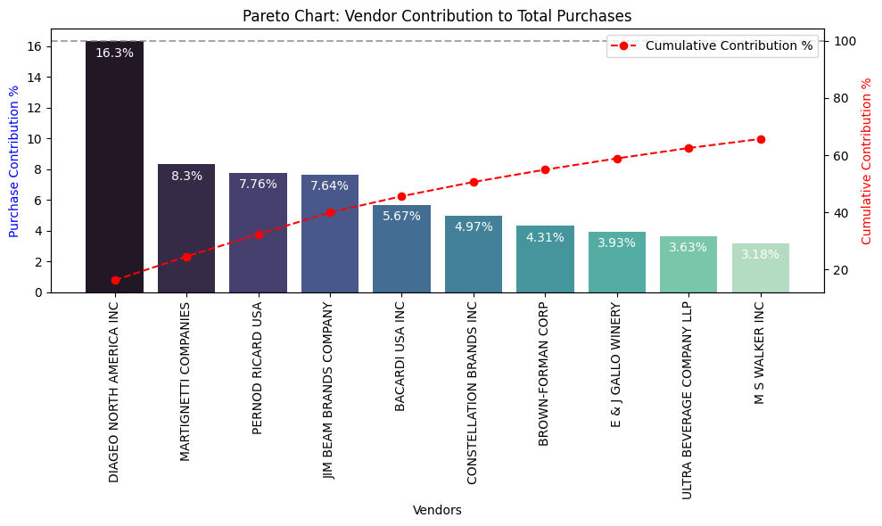
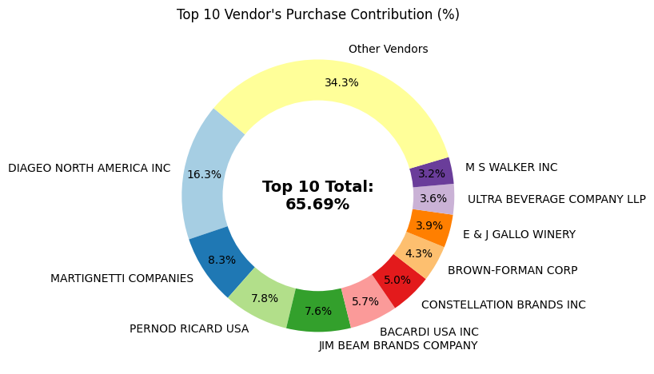

7.3 Top Brands by Sales
- Brand-level analysis identified the highest revenue-generating products
- Helped distinguish between vendor performance and brand popularity

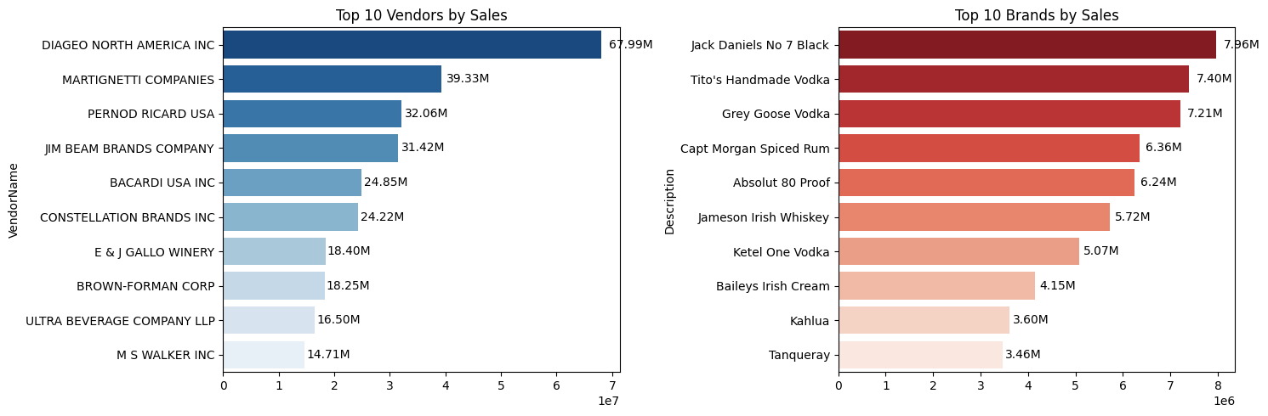

8. Bulk Purchasing & Pricing Analysis

Key Findings
- Vendors purchasing in large quantities receive approximately 72% lower unit costs ($10.78 per unit compared to smaller orders)
- Bulk pricing strategies successfully encourage higher purchase volumes

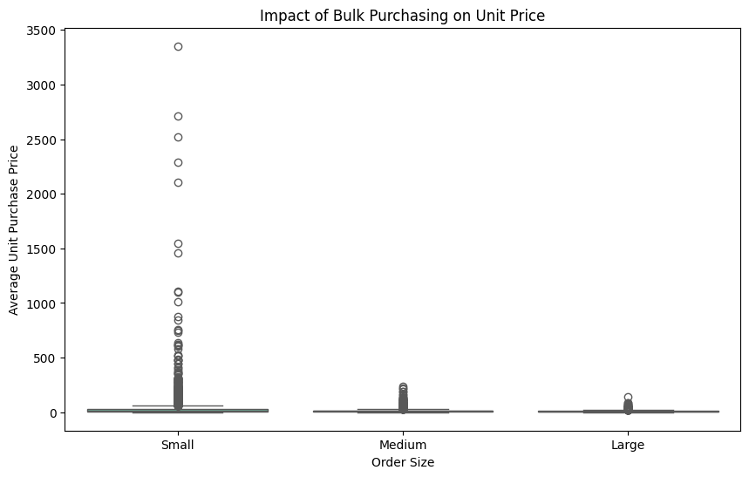

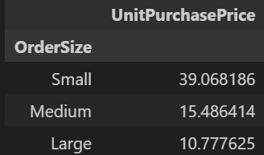

Business Implication: Bulk purchasing improves cost efficiency but requires effective inventory management to avoid excess stock.

9. Inventory & Capital Lock-In Analysis
- Total Unsold Inventory Capital identified: $2.71M
- Vendors with low inventory turnover were flagged
Impact: Slow-moving inventory increases storage costs, reduces cash flow efficiency, and affects overall profitability. Identifying such vendors enables better stock optimization and financial planning.
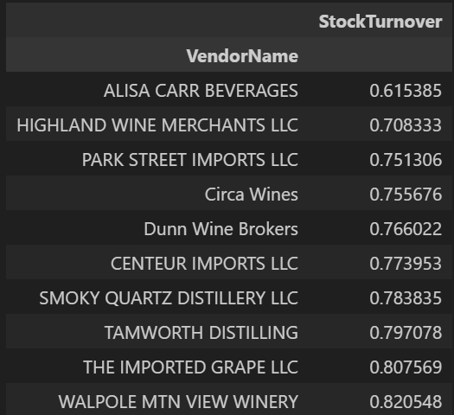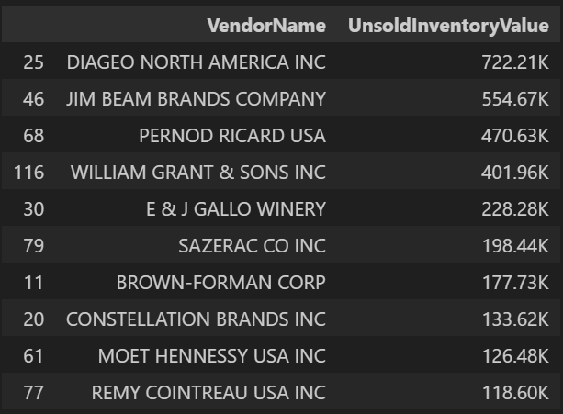

10. Profit Margin Comparison & Statistical Testing

10.1 Vendor Segmentation
- Vendors segmented using 25th and 75th percentiles of Total Sales
- Groups: Top-performing vs. Low-performing vendors

10.2 Results
- Top Vendors Profit Margin (95% CI): 30.74% – 31.61%, Mean: 31.17%
- Low Vendors Profit Margin (95% CI): 40.48% – 42.62%, Mean: 41.55%

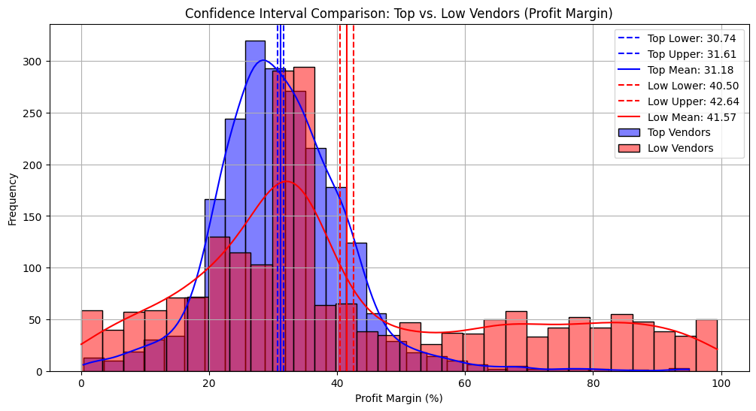

Low-performing vendors maintain higher margins but struggle with sales volumes, indicating potential pricing inefficiencies or market reach issues.

10.3 Actionable Insights
- Top-performing vendors: Optimize profitability by adjusting pricing, reducing operational costs, or offering bundled promotions.
- Low-performing vendors: Improve marketing efforts, optimize pricing strategies, and enhance distribution networks.

10.4 Hypothesis Testing
- H₀ (Null Hypothesis): No significant difference in profit margins between top and low-performing vendors.
- H₁ (Alternative Hypothesis): A significant difference exists in profit margins between the two vendor groups.
Result: The null hypothesis is rejected, confirming that the two groups operate under distinctly different profitability models.
Implication: High-margin vendors may benefit from better pricing strategies, while top-selling vendors could focus on cost efficiency.

11. Power BI Dashboard
The final analytical table (vendor_sales_summary.csv) was exported and used to build an interactive Power BI dashboard.

Dashboard Highlights
- KPI cards: Total Sales, Total Purchase, Gross Profit, Profit Margin, Unsold Capital
- Vendor & brand performance charts
- Purchase contribution donut chart
- Low-performing vendor and brand identification
The dashboard enables stakeholders to interactively explore vendor performance and risk areas.

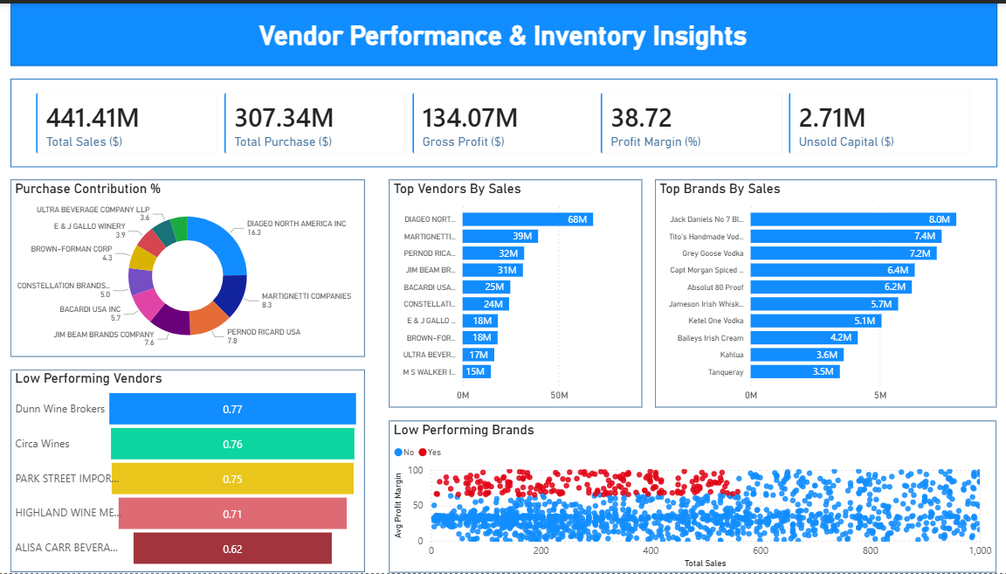

12. Key Business Insights
- High supplier concentration among top vendors
- Bulk purchasing significantly reduces unit cost
- Low-performing vendors maintain higher margins but lack scale
- Significant capital is locked in slow-moving inventory
- High sales volume does not always equate to higher profitability

13. Business Recommendations
- Re-evaluate pricing for low-sales, high-margin brands to boost sales volume without sacrificing profitability.
- Diversify vendor partnerships to reduce dependency on a few suppliers and mitigate supply chain risks.
- Leverage bulk purchasing advantages to maintain competitive pricing while optimizing inventory management.
- Optimize slow-moving inventory by adjusting purchase quantities, launching clearance sales, or revising storage strategies.
- Enhance marketing and distribution strategies for low-performing vendors to drive higher sales volumes without compromising profit margins.
- By implementing these recommendations, the company can achieve sustainable profitability, mitigate risks, and enhance overall operational efficiency.

14. Tools & Technologies
- Python: Pandas, NumPy, Matplotlib, Seaborn, SciPy
- SQL: SQLite, SQLAlchemy
- Visualization: Matplotlib, Seaborn, Power BI
- Data Storage: SQLite

15. Conclusion
This project demonstrates an end-to-end analytics workflow—from raw data ingestion to business-ready dashboards. By combining SQL, Python, statistical analysis, and Power BI, the project delivers actionable insights that support strategic vendor management, pricing optimization, and inventory efficiency.

