Selection类是用鼠标选中对象，可以对其进行一些操作比如获取位置信息或者添加子物体等

**将选中游戏对象的位置保存下来**

[MenuItem("CustomHotKey/GetTransforms &t")]

public static void GetTransforms()

{

Debug.Log("-------------------1-------------------");

Transform[] transforms1 = Selection.transforms;

for (int i = 0, size = transforms1.Length; i < size; i++)

{

Debug.Log("name = " + transforms1[i].gameObject.name + ", position = " + transforms1[i].position);

}

Debug.Log("-------------------2 Unfiltered-------------------");

Transform[] transforms2 = Selection.GetTransforms(SelectionMode.Unfiltered);

for (int i = 0, size = transforms2.Length; i < size; i++)

{

Debug.Log("name = " + transforms2[i].gameObject.name + ", position = " + transforms2[i].position);

}

Debug.Log("-------------------3 TopLevel-------------------");

Transform[] transforms3 = Selection.GetTransforms(SelectionMode.TopLevel);

for (int i = 0, size = transforms3.Length; i < size; i++)

{

Debug.Log("name = " + transforms3[i].gameObject.name + ", position = " + transforms3[i].position);

}

Debug.Log("-------------------4 Deep-------------------");

Transform[] transforms4 = Selection.GetTransforms(SelectionMode.Deep);

for (int i = 0, size = transforms4.Length; i < size; i++)

{

Debug.Log("name = " + transforms4[i].gameObject.name + ", position = " + transforms4[i].position);

}

Debug.Log("-------------------5 ExcludePrefab-------------------");

Transform[] transforms5 = Selection.GetTransforms(SelectionMode.ExcludePrefab);

for (int i = 0, size = transforms5.Length; i < size; i++)

{

Debug.Log("name = " + transforms5[i].gameObject.name + ", position = " + transforms5[i].position);

}

}

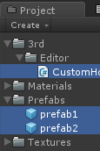

（1）在project中选择

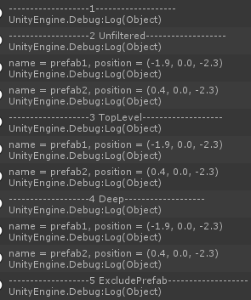

（2）在Hierarchy中选择

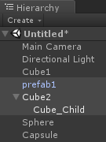

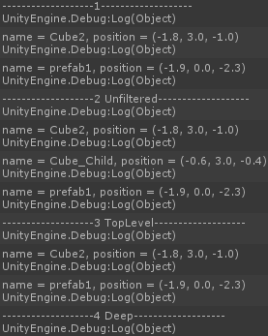

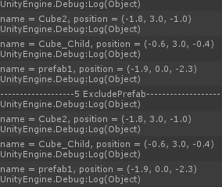

实际上会发现SelectionMode中的ExcludePrefab只对Project中的prefab有效，即使在Hierarchy中的GameObject是从prefab中获取的也无效