

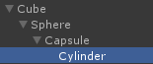

MeshRenderer meshRenderer = objTest.GetComponentInParent<MeshRenderer>();

Debug.Log("name = " + meshRenderer.gameObject.name);



然后再Capsule与Sphere物体上添加People组件

People meshRenderer = objTest.GetComponentInParent<People>();

Debug.Log("name = " + meshRenderer.gameObject.name);



也就是说该函数是找第一个包含该组件的物体（包含自己）