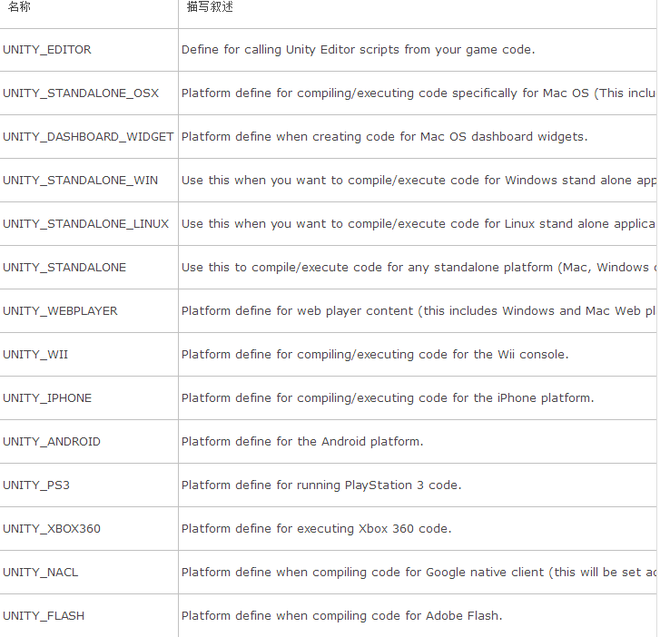

void Start()

{

DecidePlatform0();

DecidePlatform1();

}

void DecidePlatform0()

{

#if UNITY_EDITOR

string platform = "unity编辑模式下";

#elif UNITY_XBOX360

platform = "XBOX360平台";

#elif UNITY_IOS

platform = "IOS平台";

#elif UNITY_ANDROID

platform = "Android平台";

#elif UNITY_STANDALONE_OSX

platform = "OSX平台";

#elif UNITY_STANDALONE_WIN

platform = "Windows平台";

#endif

Debug.Log("platform = " + platform);

}

void DecidePlatform1()

{

string platform = string.Empty;

if (Application.platform == RuntimePlatform.WindowsEditor)

{

platform = "unity在windows中编辑模式下";

}

else if (Application.platform == RuntimePlatform.XBOX360)

{

platform = "XBOX360平台";

}

else if (Application.platform == RuntimePlatform.Android)

{

platform = "Android平台";

}

Debug.Log("platform = " + platform);

}

