<https://blog.csdn.net/puppet_master/article/details/52975666>

**1 基本拉伸效果**

Shader "Unlit/ScreenWaterWave"

{

Properties

{

_MainTex ("Texture", 2D) = "white" {}

}

CGINCLUDE

#include "UnityCG.cginc"

sampler2D _MainTex;

float4 _MainTex_ST;

fixed4 _StartPosition;

float _WaveSpeed;

float _Distort;

struct v2f

{

float4 pos : SV_POSITION;

float2 uv : TEXCOORD0;

};

v2f vert(appdata_img v)

{

v2f o;

UNITY_INITIALIZE_OUTPUT(v2f, o);

o.pos = UnityObjectToClipPos(v.vertex);

o.uv = TRANSFORM_TEX(v.texcoord, _MainTex);

return o;

}

fixed4 frag(v2f i) : SV_Target

{

fixed2 offset = i.uv - _StartPosition.xy;

fixed4 col = tex2D(_MainTex, i.uv + _Distort * normalize(offset));

return col;

}

ENDCG

SubShader

{

Tags { "RenderType"="Opaque" }

ZTest Always

ZWrite Off

Cull Off

Pass

{

CGPROGRAM

#pragma vertex vert

#pragma fragment frag

ENDCG

}

}

}

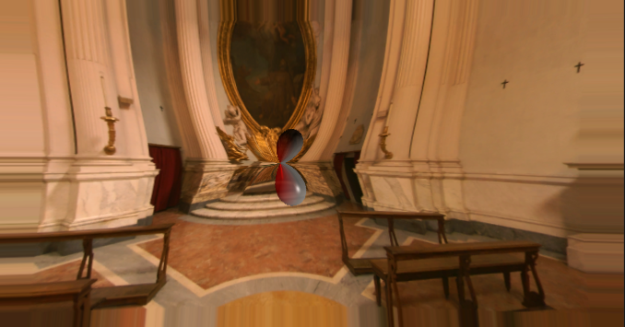

**2 波纹式拉伸**

在上面的例子中，通过像素采样时uv坐标增加一个偏移值来达到拉伸效果，我们就可以让这个偏移值作为这个三角函数的输出，这样，有的地方拉伸少，有的地方拉伸多，就形成了不同的拉伸夏鸥共，也就形成了一个波纹的感觉，那么，输入就很明显了，输入就是距离中心位置的绝对距离。

fixed4 frag(v2f i) : SV_Target

{

fixed2 dv = _StartPosition.xy - i.uv;

// 保证在不同的分辨率上都是圆形

dv = dv * float2(_ScreenParams.x / _ScreenParams.y, 1);

fixed distance = length(dv);

// distance是小于1的，需要乘以一个比较大的数，这样才有多个波峰波谷

float sinFactor = sin(distance * _DistanceScale - _Time.y * 10);

float discardFactor0 = clamp(distance - _CurrentWaveWidth, 0, 1);

float discardFactor1 = clamp(_WaveWidth - distance, 0, 1);

fixed4 col = tex2D(_MainTex, i.uv + _Distort * sinFactor * discardFactor0 * discardFactor1 * normalize(dv));

return col;

}

