<https://blog.csdn.net/u014165119/article/details/46326857>



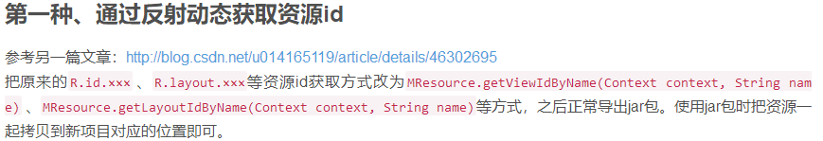

在jar包中调用函数内容：

**int** id = *context*.getResources().getIdentifier("hello_world", "string", *context*.getPackageName());

Log.*i*("unity", "id = " + id);

Log.*i*("unity", "string0 = " + *context*.getResources().getString(id));



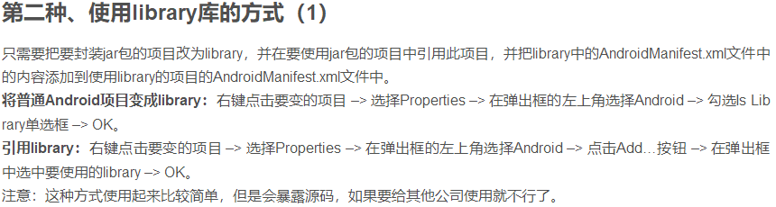

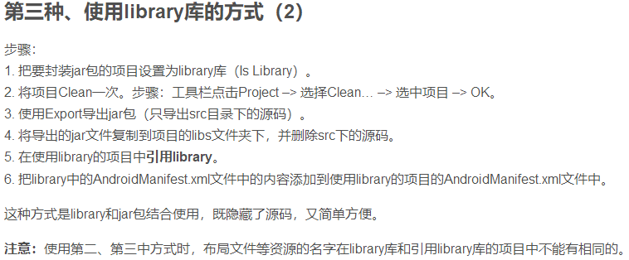



<http://www.androidchina.net/2467.html>