<https://pycon.jp/2016/ja/proposals/vote/77/>

**Machine Translation for Identifiers in Python Programs**

### [Automatic Translation of English Identifiers in Python Programs into Traditional Chinese](https://pycon.jp/2016/en/proposals/vote/77/)

#### Ren-yuan Lyu*, Che-Ning Liu*, Yung-Hsin Kuo*, Calvin Lyu**

#### * renyuan.lyu@gmail.com

#### * Chang-Geng University, Taoyuan, TAIWAN

#### ** Lishan Senior High School, Taipei, TAIWAN

 DESCRIPTION:

This is a demonstration for a two-year research project sponsored by Taiwan government, which is aimed to translating Python programs into traditional Chinese in order to help those who feel interested in learning computer programming but are not very good at English. The idea could also be helpful for those countries where English is not an official language in elementary or secondary schools.

OBJECTIVES

Translation of identifiers into programmers' native languages will help them understand programs much more. This will help education for younger students in non-English countries.

Abstract

* Should Google Translate have the ability **to translate a Python program**?
* In this project, an effort was tried toward that possibility!

1. … Introduction

Guido van Rossum mentioned in "Computer Programming for Everybody" that everyone should have a chance to write programs. However, in a non-English speaking countries, the lack of English proficiency may be the first obstacle to hinder people from coding. In order to lower down the threshold of English proficiency for potential programming learners, providing a non-English translation for tutorial programming examples was recognized as a significant task. The Scratch programming language has been an example of success. One of the good points of Scratch is that learners can freely choose their most fluently native languages to learn it.

Thanks to Pep-3131 , starting in Python 3.0, the source coding of Python has been changed into UTF-8. This means that all the identifiers of the Python programs can be named in many international languages. Based on such an infrastructure, we choosed the Turtle module in Python as an example, made an alias list of all classes/functions in the module, and created an automatic translation program to translate a set of 70 more tutorial programs for use in teaching fundamental python programming to those who without English proficiency. All programs along with the translating/browsing program have been put in GitHub for reference.

In this proposal, we will provide the detail in the "**automatic**" translation of Python programs into another natural languages, taking the Traditional Chinese as an example. The authors hope to call for participation in translation into the other Asian Languages, such as Japanese, Korean and Simplified Chinese.

Last year, at the PyCon JP 2015 conference, we presented a report entitled “[**Translation of Python Programs into non-English Languages for Learners without English Proficiency**](https://pycon.jp/2015/ja/schedule/presentation/43/)” (<https://youtu.be/effsaVIfSws>), and got a good response.

In that report, we mentioned the advantages of using the programs’ native language to think and write programs. Adopting the Python Turtle module as an example, we have created a module, namely, “turtle_tc.py” used as a traditional Chinese interface. It made possible to write Python programs in Chinese. A set of 18 demonstration programs and a GUI program to browse the set of demo programs are also available to help Python teachers for younger students.

This year, in the continuation of this theme, under the support of the Taiwan Government (the Ministry of Science and Technology), we have carried out a research project, whose goal is to translate the programs in English into Traditional Chinese via the use of machine translation technology. In this way we can produce a large number of Chinese programs, so that teachers teaching computer programming in Taiwan, especially for those in elementary or secondary schools, can have abundant Chinese programs as examples in teaching younger students, who are usually not yet good at English.

This report is about the preliminary results of this research. In addition to the kernel program which is able to do automatic bidirectional translation for identifiers in Python programs. We also create a GUI-program for users to browse, edit, and translate any Python programs in Turtle Graphics. A set of 72 programs collected from the Internet were includes as a bank to test the kernel program. Some interesting statistics about this set of programs were also provided, which can be used to be the background truth for further improvement of the performance of the translation engine in the future.

1. … Task Definition

* The task looks as that in <fig.01>, where the left column is the input, the middle column is the output, and the right column show their common running results.
* The input is the source code of an original Python program completely in English.
* The desired output is the automatically translated program in almost all Chinese identifiers, such that it looks like a Chinese Python program.

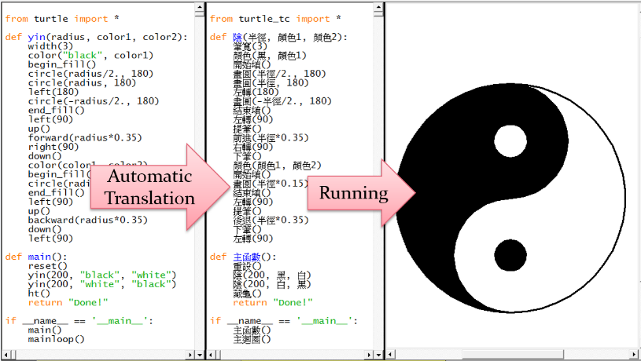

<fig.01> Task Definition

1. … Block Diagram of the System

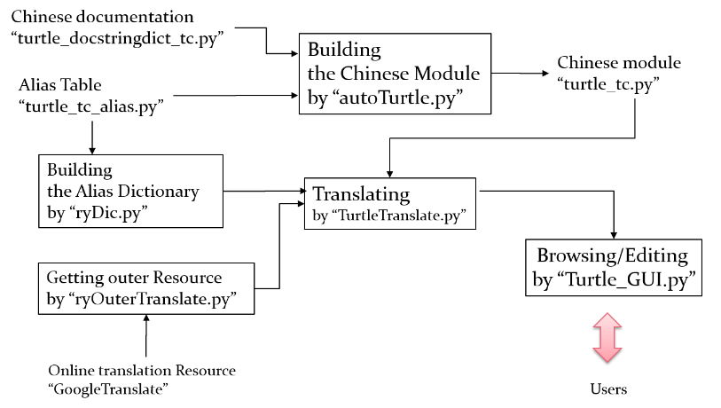

[fig.02] Block Diagram of the System

<https://dl.dropboxusercontent.com/u/33089565/_pyconjp2016/02.png>

The whole system can be divided into the following “blocks”，and we will provide some description in more detail in the following

Chinese documentation: “turtle_docstringdict_tc.py”

Alias Table : “turtle_tc_alias.py”

Building the Chinese Module by “autoTurtle.py”

Chinese module: “turtle_tc.py”

Building the Alias Dictionary by “ryDic.py”

Online translation Resource “GoogleTranslate”

Getting outer Resource by “ryOuterTranslate.py”

Translating by “TurtleTranslate.py”

Browsing/Editing by “Turtle_GUI.py”

1. … Chinese documentation: “turtle_docstringdict_tc.py”

For programmers to get the online help, the module should contain the “docstrings” in itself. The original turtle module provided the “turtle_docstringdict.py” as an example to code the docstrings into the program. We use GoogleTranslate to translate it into a Chinese version roughly and then manually correct them into more readable text. It was then named as “turtle_docstringdict_tc.py”. Using “_tc” in the filename as a language code to represent “traditional Chinese”. It turns out to be a near 2000-line-long program. Although this is not much technically attractive, it is important for the whole project to succeed.

Partially of it look as the following

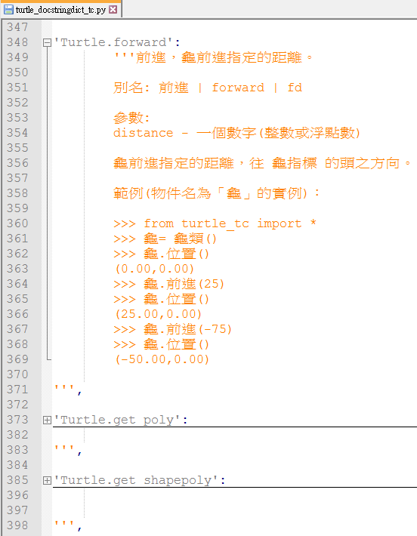

[fig.101]

Thanks to this effort, the programmers can use online help just by typing in “≫> help(前進)” to get the important information for the function like the following:

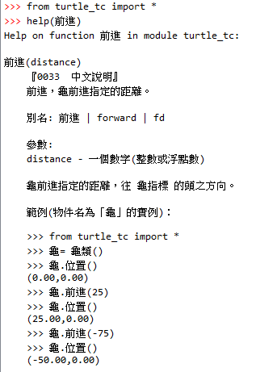

[fig.102]

1. … Alias Table : “turtle_tc_alias.py”

An alias is a second name for an identifier. When this alias is called, it equals to call the original identifier. Using alias is the major strategy we adopted in this project. It simplifies the whole process for translating English identifiers into Chinese identifiers to a significant degree.

To get the most convenience of such an “alias strategy”, we hard-coded the whole table of English-to-Chinese correspondence for all the major identifiers used in the Turtle module, including those of classes, methods, globally accessible variables and functions. This table was put in the module “turtle_tc_alias.py”, where the simple Python List structures were used to store the correspondence between 2 languages. A partial list of this module looks like the following figure.

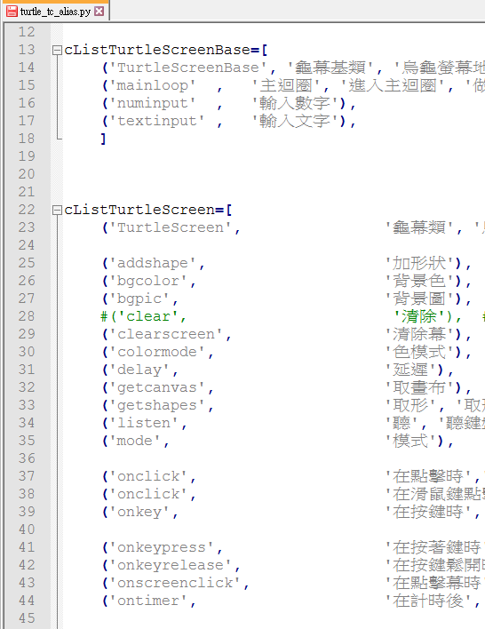

[fig.103]

1. … Chinese module: “turtle_tc.py”

This is the major python module we built up based on the original turtle module “turtle.py” and the other 2 associated modules discussed in the above, i.e., the Alias Table and the Chinese documentation file. This major module was named as “**turtle_tc.py”,** providing the alias in **traditional Chinese** (thus the subscript “**_tc**” ) for almost all identifiers (names) in “turtle.py”. The previous version was described in detail in the Pycon JP 2015, and could be downloaded from Gihub, at <http://github.com/renyuanL/pythonTurtleInChinese>.

A partial list of the alias identifiers in **turtle_tc.py** looks like this:

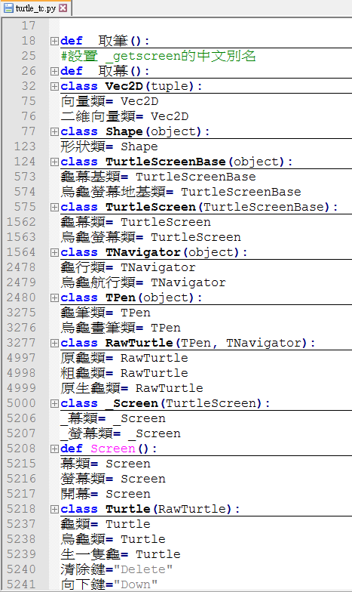

[fig.104]

You will find that the bi-lingual translation pairs provided in the Alias Table was now carefully aligned in this python module in a perfect Python syntax.

The major improvement in the current version is that this module could be **generated automatically** using another building program “autoTurtle.py”, which read in the Alias Table and the Chinese documentation file, and did some routine procedures automatically. Such a building program will be described in the next paragraph.

1. … Building the Chinese Module by “autoTurtle.py”

The first version of “turtle_tc.py” was hard coded manually. This made it difficult to transfer the code into another language. Therefore, we created a building program named “autoTurtle.py” for building the major Chinese module by reading in the Alias Table of the bi-lingual pairs. The advantage to do this is to make it easier to change into the other languages.

The main steps for “autoTurtle.py” could be summarized in the following steps:

* + 1. Reading in the Alias Table and generate the codes for aliasing all classes with methods in the Turtle module. A partial list of the automatically generated code in “turtle_tc.py” looks like the following figure.

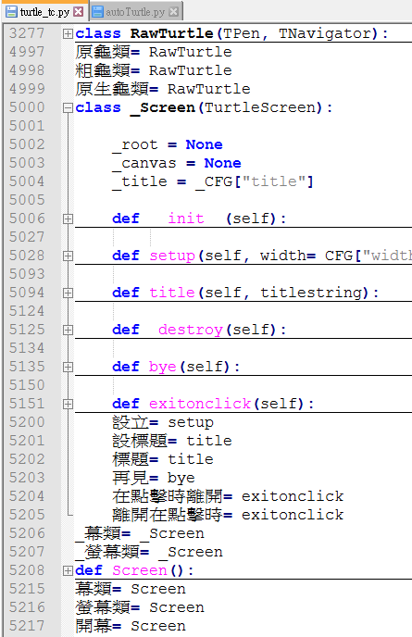

[fig.105]

* + 2. Reading in the docstrings and insert them into the appropriate places in the code.

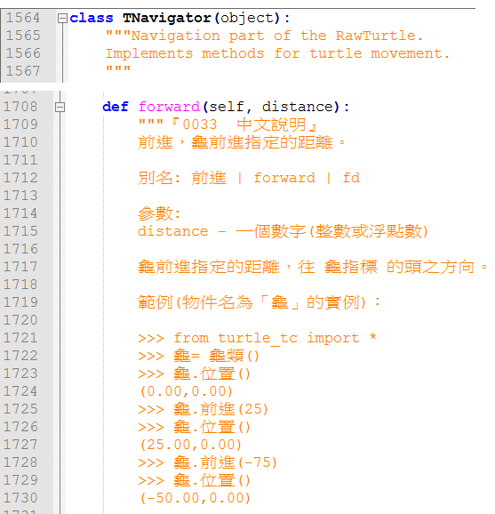

[fig.106]

<https://dl.dropboxusercontent.com/u/33089565/_pyconjp2016/10.png>

* + 3. Generating the other alias, which were not incorporated in the Alias Table.

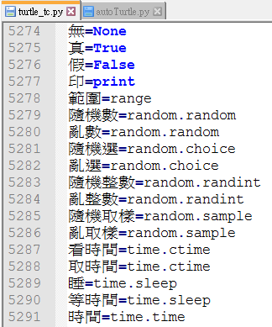

[fig.107]

* + 4. Generating a subset of globally accessible functions, which would be used in procedure-oriented programming paradigm.

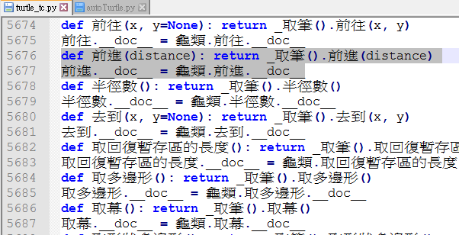

[fig.108]

* + 5. Writing out the final result as “turtle_tc.py” to be used as the major Chinese module.

Currently, this is a near **6000-line-long** python module file used as the major import for Chinese Python Turtle Graphics.

1. …Building an Alias Dictionary for **out-of-Turtle** identifiers by “ryDic.py”

Only using the alias in the turtle module cannot cover all identifiers to a satisfactory percentage. To increase the coverage of the code translation. We needed to add many **out-of-Turtle** identifiers, which were not included in the Turtle module. Those identifiers were collected by looking up all turtle programs we had collected in the web, totally about 70 programs. By doing some statistics, we chosen those identifiers with frequency more than a threshold, translated them using GoogleTranslate with human correction. All of these were put in another Alias Dictionary, named “ryDic.py”

The partial list looks like the following figure.

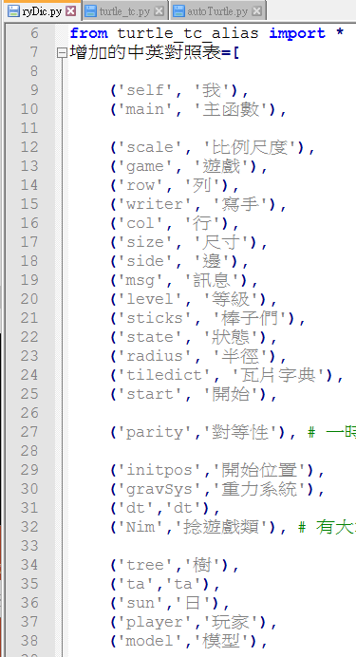

[fig.109]

1. …Online translation Resource “GoogleTranslate”

In order to further improve the translation coverage in arbitrary Turtle program, the GoogleTranslate was considered in translating the part of code in natural English, including the text in string variables or in the comment lines. Although it is not perfect at present for arbitrary English sentences, there are indeed valuable for reference for experienced users, who can help polish the machine translation for younger learners. And in this project, we will use a module to deal with communication to the GoogleTranslate. It will be described in the next paragraph.

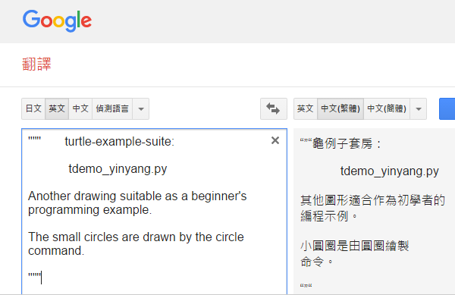

[fig.110]

1. … Getting outer Resource by “ryOuterTranslate.py”

* This is a small module adapted from “terryyin/google-translate-python” in GitHub.
* It was originally based on GoogleTranslate, but currently on MyMemory-Translation ( <http://mymemory.translated.net/>), because of GoogleTranslate no longer providing free API.
* It uses Python’s Standard Library─”urllib.request“ and "urllib.parse“.
* It sends HTTP GET Request to MyMemory with parameters like that in the following:

“http://mymemory.translated.net/api/get?q=An%20example& langpair=en|zh-TW”

* It returns string of JSON format, which looks as the following.

{“responseData”:{“translatedText”:“舉個例子","match":0.85},"responseDetails":"","responseStatus":200,"responderId":"235","matches":[{"id":0,"segment":"An example adapted from the example-suite",...............}

* All we need to do is to parse the string and get what we need as the translated text.

1. … Translating by “TurtleTranslate.py”

By integrating the submodules described in the above paragraphs, the main process of translating could be set up. The block diagram in [fig.201] shows the process in detail. The whole process could be divided into 5 steps:

1. Parsing the input program
2. Translating the identifiers
3. Translating the comments
4. Post processing
5. Outputing

<https://dl.dropboxusercontent.com/u/33089565/_pyconjp2016/201.png>

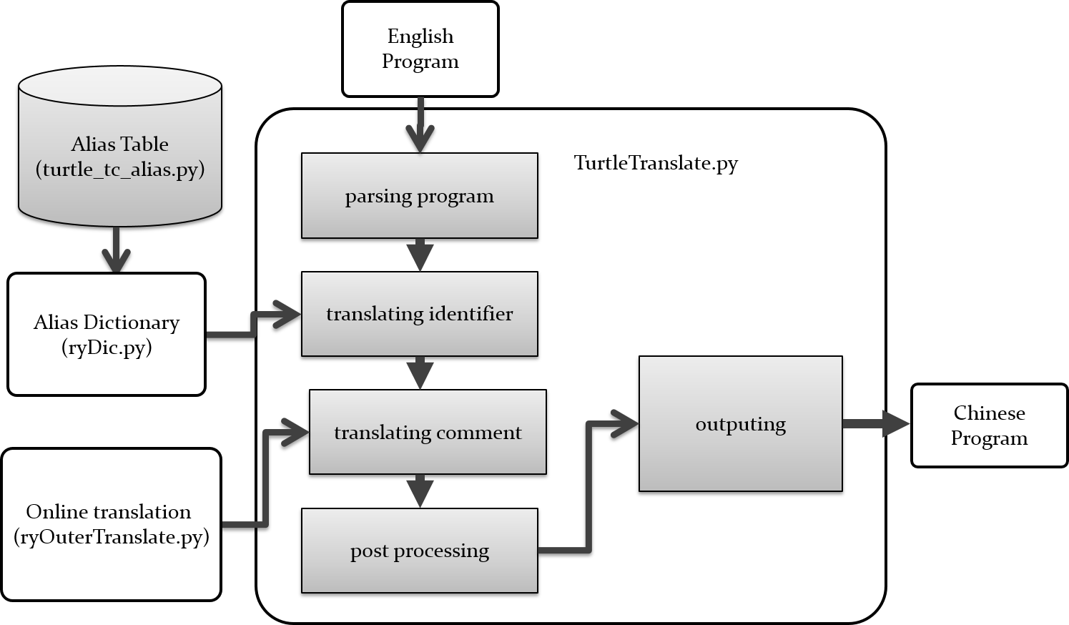

[fig.201]

Let’s describe more in detail about each sub-processing block.

1. Parsing the input program

This process uses the “**generate_tokens()”**, a method from the **“tokenize”** module, one of the critically important modules used in this project. This process will generate type, string and position as tokens. Then they will be stored in a Python List. Taking a short segment of python code as an example to be parsed. After tokenization, we could get the results as shown in the following. Among all types of tokens, 3 of them were chosen to be further processed, i.e, NAME, STRING, and COMMENT.

<https://dl.dropboxusercontent.com/u/33089565/_pyconjp2016/202.png>

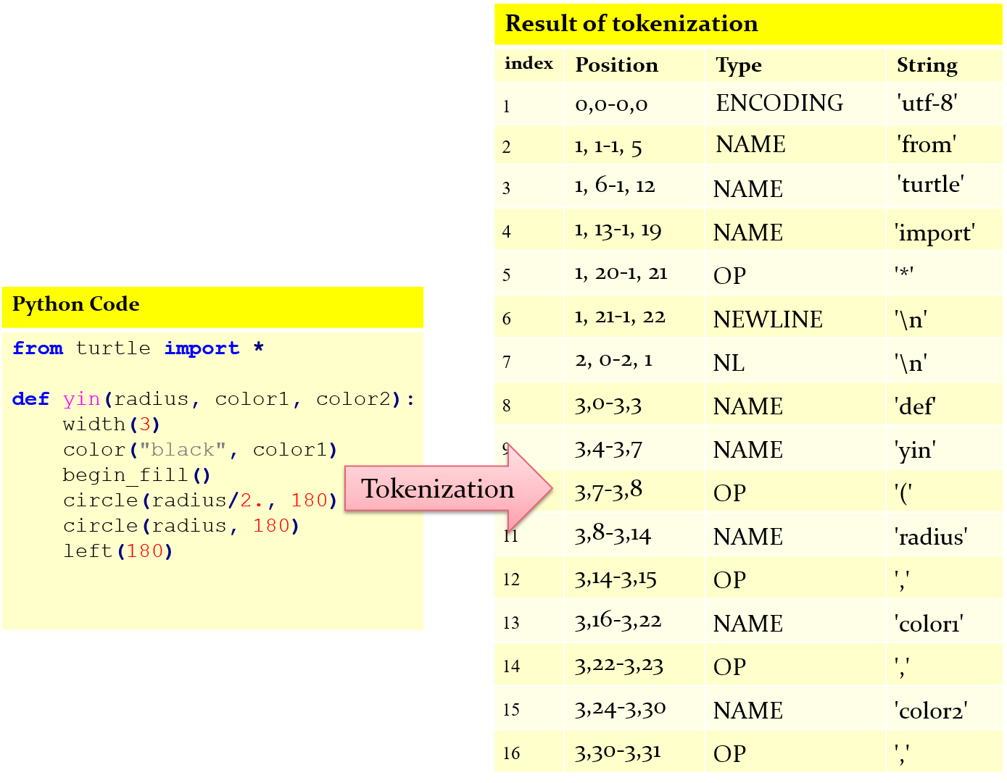

[fig.202]

1. Translating the names of identifiers

As long as the names of identifiers were spot, we did a table lookup for translating English words into Chinese characters. However, there was one exception. We do not translate those names used in the ***named arguments*** inside a function which was imported from those modules not created by ourselves. Because those ones were usually in English inside those modules, where we decided not to alter anything in the source code. The figures listed below help clarify this strategy.

[fig.203] The usual cases we did the translations for names of identifiers

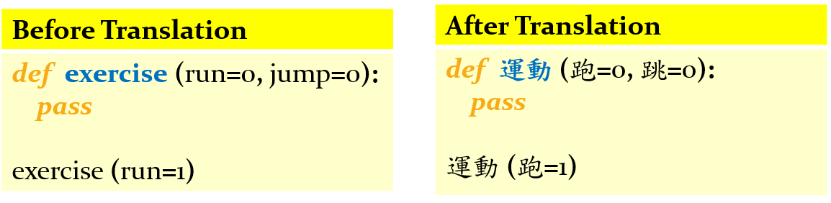

[fig.204] An exceptional name (“jump”), which was not translated.

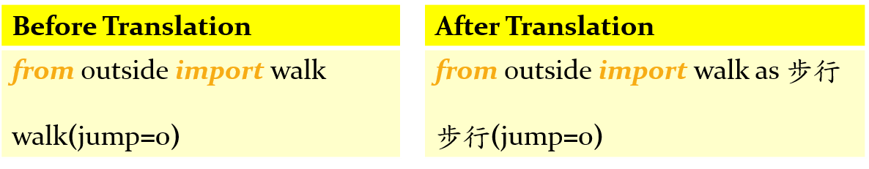

The detail flow chart for doing the translating task could be then summarized as follows:

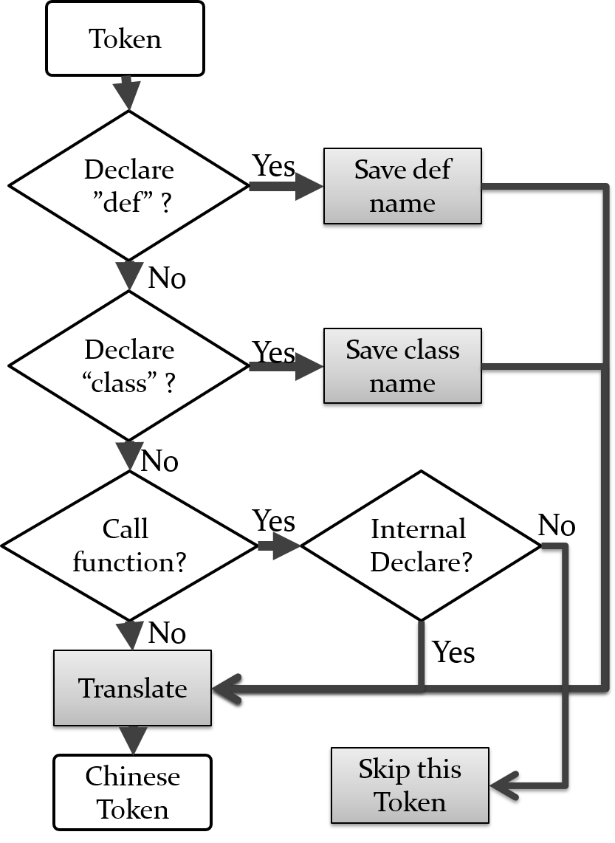

[fig.205] the flow chart for doing the translating task for names

<https://dl.dropboxusercontent.com/u/33089565/_pyconjp2016/205.png>

1. Translating the comments

This part of sub-processing deals with the comments or text strings in the code. They are usually in natural language (English) syntax, not in the Python syntax. We call the outside machine translation engine to perform such a task.

The flowchart in the following figure show the detail to do it.

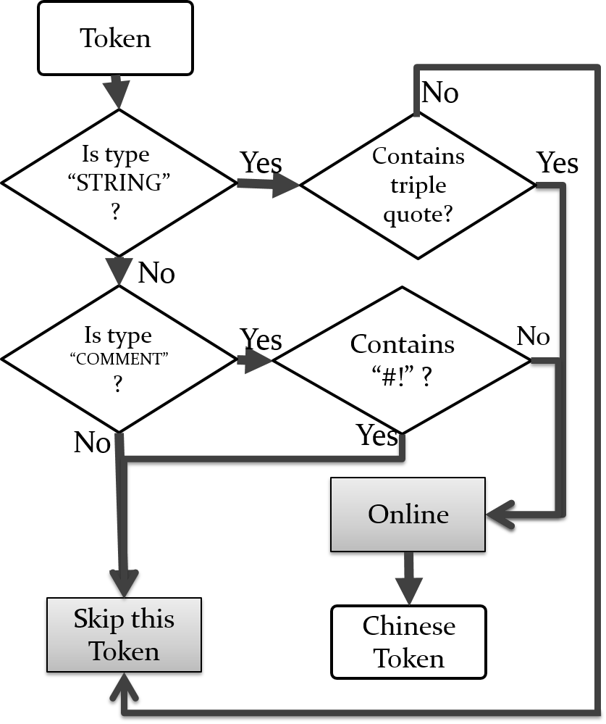

[fig.206] the flow chart for doing the translating task for comments and text strings

<https://dl.dropboxusercontent.com/u/33089565/_pyconjp2016/206.png>

1. Post processing

There exists an untokenize() function in the tokenize module. It was used to combine all translated tokens into a syntactically correct Python codes. Furthermore, several post processing steps should be done, including modifying the head of the program, changing the import module from “turtle” to “turtle_tc”, … etc.

1. Outputing

Finally, the task of translation from a English program into an Chinese program was done！

Here is a good example.

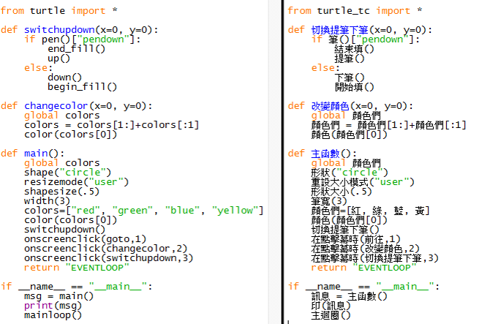

1. … Browsing/Editing by “Turtle_GUI.py”

To put everything mentioned above together, we have also built a Tk-based GUI program which provides simple functions for users to load, translate, edit, and run a Python program in Turtle Graphics. A batch mode translation function was provided to translate a full set of programs. In this way, we have successfully tested this project for more than 70 programs. It also means that we have at least 70 Chinese programs for teachers to use as examples to teach Python programming in Turtle Graphics to younger kids in Taiwan.

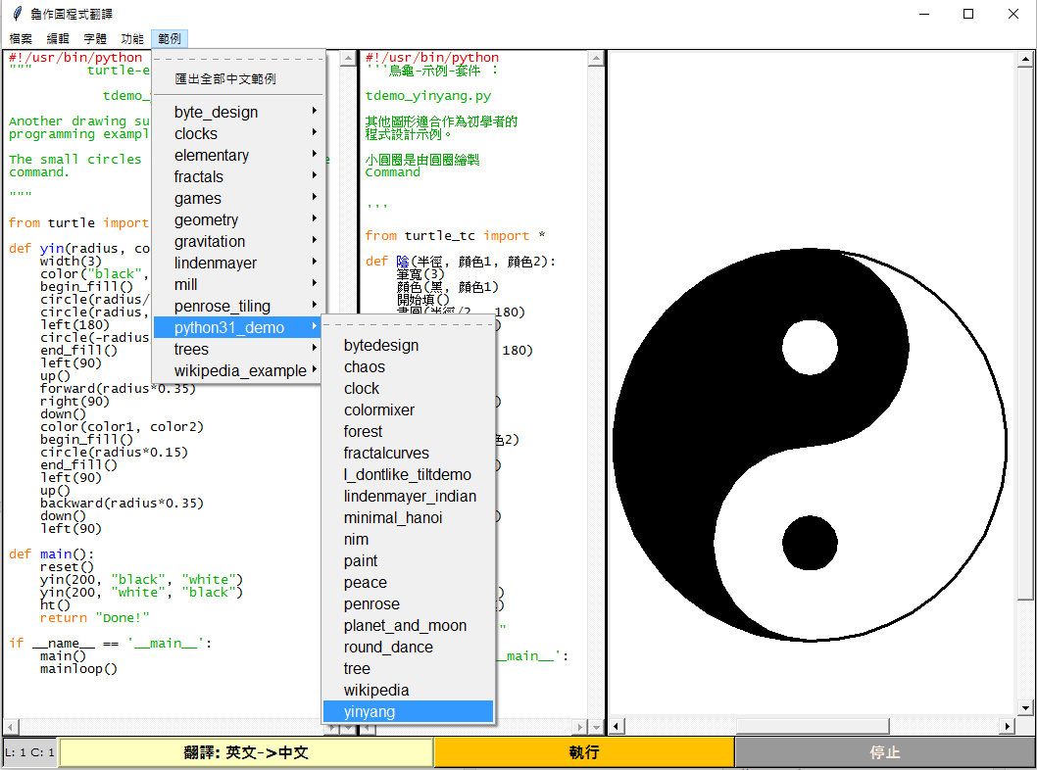

[fig.300] a Tk-based GUI program to browse, edit and translate Python program

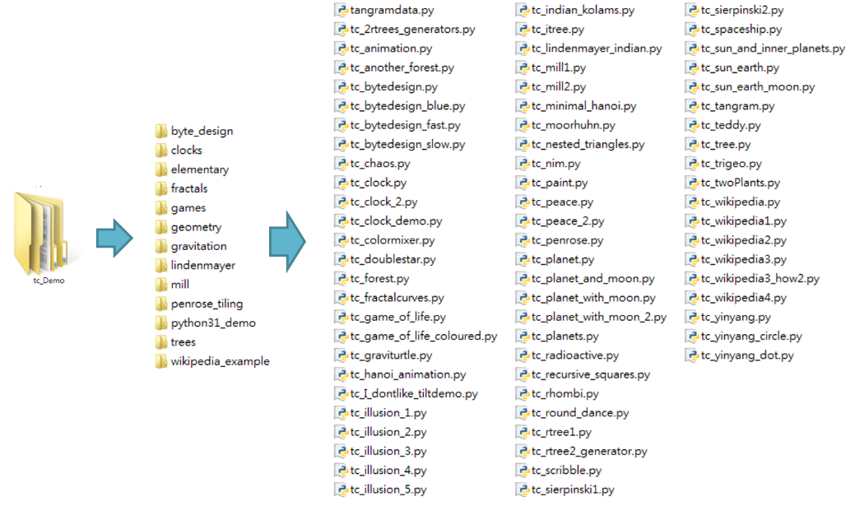

[fig.301] a set of 70 Chinese programs translated automatically

1. … Performance analysis for the translation task

In an ordinary program, there are not only identifiers, but also keywords, numbers, symbols, …etc.

In this project, we deal only with the identifiers but leave those reserved keywords untouched. Currently, we choose not to translate keywords for 2 reasons: (1) the total number of them is small (only 33 in Python 3.5), and they are usually short, easy English words; (2) we can assume the percentage of coverage in an ordinary program is also small. To validate the assumption in (2), we have done a statistic estimation from all 70 programs successfully translated. According to this statistics, we found that in an ordinary program, the coverage percentage of keywords is about 14%, and the identifiers occupy about 86% of the total. Furthermore, 62% of identifiers could be translated in this initial study of the project. It means that we still have near 40% of identifiers not translated. This is not a small percentage, thus we still need do more research about improving the translated percentage.

**>>>** **import** keyword

**>>>** keyword**.**kwlist

**[**'False'**,** 'None'**,** 'True'**,** 'and'**,** 'as'**,** 'assert'**,** 'break'**,** 'class'**,** 'continue'**,** 'def'**,** 'del'**,** 'elif'**,** 'else'**,** 'except'**,** 'finally'**,** 'for'**,** 'from'**,** 'global'**,** 'if'**,** 'import'**,** 'in'**,** 'is'**,** 'lambda'**,** 'nonlocal'**,** 'not'**,** 'or'**,** 'pass'**,** 'raise'**,** 'return'**,** 'try'**,** 'while'**,** 'with'**,** 'yield'**]**

**>>>** len**(**_**)**

33

|  |  |  |
| --- | --- | --- |
|  | **Keyword** | **Identifier** |
| Occurrence  percentage | 1937/14075  = 14% | 12138/14075  = 86% |

[fig.401] the distribution of Keywords and Identifiers in a typical program

|  |  |  |
| --- | --- | --- |
|  | **Could be**  **translated** | **Could not be**  **translated** |
| percentage | 7584/12138  = 62% | 4554/12138  = 38% |

[fig.402] the percentage of identifiers successfully translated

1. … Conclusion
2. … Reference
3. 中蟒（chinese python）編程語言，http://www.chinesepython.org/
4. 周蟒zhpy，https://code.google.com/archive/p/zhpy/
5. A Python program written with 90% Traditional Chinese characters，22 May 2014
6. Ren-Yuan Lyu,Translation of Python Programs into non-English Languages for Learners without English Proficiency，https://pycon.jp/2015/en/schedule/presentation/43/
7. Python，http://www.python.org/
8. Tokenizer，https://docs.python.org/3/library/tokenize.html
9. Regular expression，https://docs.python.org/3/library/re.html
10. Turtle graphics，https://docs.python.org/3/library/turtle.html?highlight=turtle#module-turtle
11. Wikipedia，https://zh.wikipedia.org
12. Gregor Lingl，Python turtle graphics demo suite for Python 3.1，https://code.google.com/archive/p/python-turtle-demo/downloads
13. MyMemory.translated.net ，<https://mymemory.translated.net>
14. [A Python program written with 90% Traditional Chinese characters](https://dl.dropboxusercontent.com/u/33089565/ry2014_thinkcspy/html/_ryTurtle04.html)

<https://www.reddit.com/r/Python/comments/268fts/a_python_program_written_with_90_traditional/>

1. [Chinese Python: “Translating a programming language”](http://reganmian.net/blog/2008/11/21/chinese-python-translating-a-programming-language/)

<https://www.reddit.com/r/Python/comments/7g2mz/chinese_python_translating_a_programming_language/?sort=controversial>

1. Chinese Python, multilingual programming

<http://reganmian.net/blog/2008/12/04/chinese-python-multilingual-programming-2/>

1. …
2. ….
3. …
4. …