Table of Contents

*1.* *Git hub link of stroke detection project:* 1

*2.* *Console output of building a package* 1

*3.* *FastApi Application* 6

*4.* *CI workflow* 7

*5.* *CD workflow* 7

*6.* *Dockerization* 8

## **Git hub link of stroke detection project:**

<https://github.com/pycsr/stroke_detection>

## **Console output of building a package**

(venv) (base) quicktech@psoni stroke_detection % python -m build

* Creating venv isolated environment...

* Installing packages in isolated environment... (setuptools>=42, wheel)

* Getting build dependencies for sdist...

/Users/quicktech/Documents/IISc_AIMLOps_Projects/Part-B_MiniProject/stroke_detection

running egg_info

creating stroke_detection_model.egg-info

writing stroke_detection_model.egg-info/PKG-INFO

writing dependency_links to stroke_detection_model.egg-info/dependency_links.txt

writing requirements to stroke_detection_model.egg-info/requires.txt

writing top-level names to stroke_detection_model.egg-info/top_level.txt

writing manifest file 'stroke_detection_model.egg-info/SOURCES.txt'

reading manifest file 'stroke_detection_model.egg-info/SOURCES.txt'

reading manifest template 'MANIFEST.in'

warning: no files found matching '*.txt'

warning: no files found matching '*.pkl'

warning: no previously-included files found matching '*.log'

warning: no previously-included files found matching '*.cfg'

warning: no previously-included files matching '__pycache__' found under directory '*'

adding license file 'LICENSE'

writing manifest file 'stroke_detection_model.egg-info/SOURCES.txt'

* Building sdist...

/Users/quicktech/Documents/IISc_AIMLOps_Projects/Part-B_MiniProject/stroke_detection

running sdist

running egg_info

writing stroke_detection_model.egg-info/PKG-INFO

writing dependency_links to stroke_detection_model.egg-info/dependency_links.txt

writing requirements to stroke_detection_model.egg-info/requires.txt

writing top-level names to stroke_detection_model.egg-info/top_level.txt

reading manifest file 'stroke_detection_model.egg-info/SOURCES.txt'

reading manifest template 'MANIFEST.in'

warning: no files found matching '*.txt'

warning: no files found matching '*.pkl'

warning: no previously-included files found matching '*.log'

warning: no previously-included files found matching '*.cfg'

warning: no previously-included files matching '__pycache__' found under directory '*'

adding license file 'LICENSE'

writing manifest file 'stroke_detection_model.egg-info/SOURCES.txt'

running check

creating stroke_detection_model-0.0.1

creating stroke_detection_model-0.0.1/requirements

creating stroke_detection_model-0.0.1/stroke_detection_model

creating stroke_detection_model-0.0.1/stroke_detection_model/config

creating stroke_detection_model-0.0.1/stroke_detection_model/datasets

creating stroke_detection_model-0.0.1/stroke_detection_model/processing

creating stroke_detection_model-0.0.1/stroke_detection_model/trained_models

creating stroke_detection_model-0.0.1/stroke_detection_model.egg-info

creating stroke_detection_model-0.0.1/tests

copying files to stroke_detection_model-0.0.1...

copying LICENSE -> stroke_detection_model-0.0.1

copying MANIFEST.in -> stroke_detection_model-0.0.1

copying README.md -> stroke_detection_model-0.0.1

copying pyproject.toml -> stroke_detection_model-0.0.1

copying setup.py -> stroke_detection_model-0.0.1

copying ./requirements/requirements.txt -> stroke_detection_model-0.0.1/./requirements

copying ./requirements/test_requirements.txt -> stroke_detection_model-0.0.1/./requirements

copying ./stroke_detection_model/.DS_Store -> stroke_detection_model-0.0.1/./stroke_detection_model

copying ./stroke_detection_model/VERSION -> stroke_detection_model-0.0.1/./stroke_detection_model

copying ./stroke_detection_model/__init__.py -> stroke_detection_model-0.0.1/./stroke_detection_model

copying ./stroke_detection_model/config.yml -> stroke_detection_model-0.0.1/./stroke_detection_model

copying ./stroke_detection_model/pipeline.py -> stroke_detection_model-0.0.1/./stroke_detection_model

copying ./stroke_detection_model/predict.py -> stroke_detection_model-0.0.1/./stroke_detection_model

copying ./stroke_detection_model/train_pipeline.py -> stroke_detection_model-0.0.1/./stroke_detection_model

copying ./stroke_detection_model/config/__init__.py -> stroke_detection_model-0.0.1/./stroke_detection_model/config

copying ./stroke_detection_model/config/core.py -> stroke_detection_model-0.0.1/./stroke_detection_model/config

copying ./stroke_detection_model/datasets/.DS_Store -> stroke_detection_model-0.0.1/./stroke_detection_model/datasets

copying ./stroke_detection_model/datasets/__init__.py -> stroke_detection_model-0.0.1/./stroke_detection_model/datasets

copying ./stroke_detection_model/datasets/healthcare-dataset-stroke-data.csv -> stroke_detection_model-0.0.1/./stroke_detection_model/datasets

copying ./stroke_detection_model/processing/__init__.py -> stroke_detection_model-0.0.1/./stroke_detection_model/processing

copying ./stroke_detection_model/processing/data_manager.py -> stroke_detection_model-0.0.1/./stroke_detection_model/processing

copying ./stroke_detection_model/processing/features.py -> stroke_detection_model-0.0.1/./stroke_detection_model/processing

copying ./stroke_detection_model/processing/validation.py -> stroke_detection_model-0.0.1/./stroke_detection_model/processing

copying ./stroke_detection_model/trained_models/__init__.py -> stroke_detection_model-0.0.1/./stroke_detection_model/trained_models

copying ./stroke_detection_model/trained_models/stroke_detection_model_output_v0.0.1.pkl -> stroke_detection_model-0.0.1/./stroke_detection_model/trained_models

copying stroke_detection_model/VERSION -> stroke_detection_model-0.0.1/stroke_detection_model

copying stroke_detection_model/__init__.py -> stroke_detection_model-0.0.1/stroke_detection_model

copying stroke_detection_model/config.yml -> stroke_detection_model-0.0.1/stroke_detection_model

copying stroke_detection_model/pipeline.py -> stroke_detection_model-0.0.1/stroke_detection_model

copying stroke_detection_model/predict.py -> stroke_detection_model-0.0.1/stroke_detection_model

copying stroke_detection_model/train_pipeline.py -> stroke_detection_model-0.0.1/stroke_detection_model

copying stroke_detection_model.egg-info/PKG-INFO -> stroke_detection_model-0.0.1/stroke_detection_model.egg-info

copying stroke_detection_model.egg-info/SOURCES.txt -> stroke_detection_model-0.0.1/stroke_detection_model.egg-info

copying stroke_detection_model.egg-info/dependency_links.txt -> stroke_detection_model-0.0.1/stroke_detection_model.egg-info

copying stroke_detection_model.egg-info/requires.txt -> stroke_detection_model-0.0.1/stroke_detection_model.egg-info

copying stroke_detection_model.egg-info/top_level.txt -> stroke_detection_model-0.0.1/stroke_detection_model.egg-info

copying stroke_detection_model/config/__init__.py -> stroke_detection_model-0.0.1/stroke_detection_model/config

copying stroke_detection_model/config/core.py -> stroke_detection_model-0.0.1/stroke_detection_model/config

copying stroke_detection_model/datasets/__init__.py -> stroke_detection_model-0.0.1/stroke_detection_model/datasets

copying stroke_detection_model/datasets/healthcare-dataset-stroke-data.csv -> stroke_detection_model-0.0.1/stroke_detection_model/datasets

copying stroke_detection_model/processing/__init__.py -> stroke_detection_model-0.0.1/stroke_detection_model/processing

copying stroke_detection_model/processing/data_manager.py -> stroke_detection_model-0.0.1/stroke_detection_model/processing

copying stroke_detection_model/processing/features.py -> stroke_detection_model-0.0.1/stroke_detection_model/processing

copying stroke_detection_model/processing/validation.py -> stroke_detection_model-0.0.1/stroke_detection_model/processing

copying stroke_detection_model/trained_models/__init__.py -> stroke_detection_model-0.0.1/stroke_detection_model/trained_models

copying stroke_detection_model/trained_models/stroke_detection_model_output_v0.0.1.pkl -> stroke_detection_model-0.0.1/stroke_detection_model/trained_models

copying tests/test_features.py -> stroke_detection_model-0.0.1/tests

copying tests/test_predictions.py -> stroke_detection_model-0.0.1/tests

copying stroke_detection_model.egg-info/SOURCES.txt -> stroke_detection_model-0.0.1/stroke_detection_model.egg-info

Writing stroke_detection_model-0.0.1/setup.cfg

Creating tar archive

removing 'stroke_detection_model-0.0.1' (and everything under it)

* Building wheel from sdist

* Creating venv isolated environment...

* Installing packages in isolated environment... (setuptools>=42, wheel)

* Getting build dependencies for wheel...

/private/var/folders/vs/6l92ypwj3sbc973853q9w9w00000gn/T/build-via-sdist-ca8j0naj/stroke_detection_model-0.0.1

running egg_info

writing stroke_detection_model.egg-info/PKG-INFO

writing dependency_links to stroke_detection_model.egg-info/dependency_links.txt

writing requirements to stroke_detection_model.egg-info/requires.txt

writing top-level names to stroke_detection_model.egg-info/top_level.txt

reading manifest file 'stroke_detection_model.egg-info/SOURCES.txt'

reading manifest template 'MANIFEST.in'

warning: no files found matching '*.txt'

warning: no files found matching '*.pkl'

warning: no previously-included files found matching '*.log'

warning: no previously-included files matching '__pycache__' found under directory '*'

warning: no previously-included files matching '*.py[co]' found under directory '*'

adding license file 'LICENSE'

writing manifest file 'stroke_detection_model.egg-info/SOURCES.txt'

* Installing packages in isolated environment... (wheel)

* Building wheel...

/private/var/folders/vs/6l92ypwj3sbc973853q9w9w00000gn/T/build-via-sdist-ca8j0naj/stroke_detection_model-0.0.1

running bdist_wheel

running build

running build_py

creating build

creating build/lib

creating build/lib/stroke_detection_model

copying stroke_detection_model/train_pipeline.py -> build/lib/stroke_detection_model

copying stroke_detection_model/predict.py -> build/lib/stroke_detection_model

copying stroke_detection_model/__init__.py -> build/lib/stroke_detection_model

copying stroke_detection_model/pipeline.py -> build/lib/stroke_detection_model

creating build/lib/stroke_detection_model/config

copying stroke_detection_model/config/__init__.py -> build/lib/stroke_detection_model/config

copying stroke_detection_model/config/core.py -> build/lib/stroke_detection_model/config

creating build/lib/stroke_detection_model/processing

copying stroke_detection_model/processing/__init__.py -> build/lib/stroke_detection_model/processing

copying stroke_detection_model/processing/features.py -> build/lib/stroke_detection_model/processing

copying stroke_detection_model/processing/data_manager.py -> build/lib/stroke_detection_model/processing

copying stroke_detection_model/processing/validation.py -> build/lib/stroke_detection_model/processing

creating build/lib/stroke_detection_model/datasets

copying stroke_detection_model/datasets/__init__.py -> build/lib/stroke_detection_model/datasets

creating build/lib/stroke_detection_model/trained_models

copying stroke_detection_model/trained_models/__init__.py -> build/lib/stroke_detection_model/trained_models

running egg_info

writing stroke_detection_model.egg-info/PKG-INFO

writing dependency_links to stroke_detection_model.egg-info/dependency_links.txt

writing requirements to stroke_detection_model.egg-info/requires.txt

writing top-level names to stroke_detection_model.egg-info/top_level.txt

reading manifest file 'stroke_detection_model.egg-info/SOURCES.txt'

reading manifest template 'MANIFEST.in'

warning: no files found matching '*.txt'

warning: no files found matching '*.pkl'

warning: no previously-included files found matching '*.log'

warning: no previously-included files matching '__pycache__' found under directory '*'

warning: no previously-included files matching '*.py[co]' found under directory '*'

adding license file 'LICENSE'

writing manifest file 'stroke_detection_model.egg-info/SOURCES.txt'

copying stroke_detection_model/VERSION -> build/lib/stroke_detection_model

copying stroke_detection_model/config.yml -> build/lib/stroke_detection_model

copying stroke_detection_model/datasets/healthcare-dataset-stroke-data.csv -> build/lib/stroke_detection_model/datasets

copying stroke_detection_model/trained_models/stroke_detection_model_output_v0.0.1.pkl -> build/lib/stroke_detection_model/trained_models

installing to build/bdist.macosx-10.9-x86_64/wheel

running install

running install_lib

creating build/bdist.macosx-10.9-x86_64

creating build/bdist.macosx-10.9-x86_64/wheel

creating build/bdist.macosx-10.9-x86_64/wheel/stroke_detection_model

copying build/lib/stroke_detection_model/train_pipeline.py -> build/bdist.macosx-10.9-x86_64/wheel/stroke_detection_model

creating build/bdist.macosx-10.9-x86_64/wheel/stroke_detection_model/config

copying build/lib/stroke_detection_model/config/__init__.py -> build/bdist.macosx-10.9-x86_64/wheel/stroke_detection_model/config

copying build/lib/stroke_detection_model/config/core.py -> build/bdist.macosx-10.9-x86_64/wheel/stroke_detection_model/config

creating build/bdist.macosx-10.9-x86_64/wheel/stroke_detection_model/processing

copying build/lib/stroke_detection_model/processing/__init__.py -> build/bdist.macosx-10.9-x86_64/wheel/stroke_detection_model/processing

copying build/lib/stroke_detection_model/processing/features.py -> build/bdist.macosx-10.9-x86_64/wheel/stroke_detection_model/processing

copying build/lib/stroke_detection_model/processing/data_manager.py -> build/bdist.macosx-10.9-x86_64/wheel/stroke_detection_model/processing

copying build/lib/stroke_detection_model/processing/validation.py -> build/bdist.macosx-10.9-x86_64/wheel/stroke_detection_model/processing

creating build/bdist.macosx-10.9-x86_64/wheel/stroke_detection_model/datasets

copying build/lib/stroke_detection_model/datasets/__init__.py -> build/bdist.macosx-10.9-x86_64/wheel/stroke_detection_model/datasets

copying build/lib/stroke_detection_model/datasets/healthcare-dataset-stroke-data.csv -> build/bdist.macosx-10.9-x86_64/wheel/stroke_detection_model/datasets

copying build/lib/stroke_detection_model/predict.py -> build/bdist.macosx-10.9-x86_64/wheel/stroke_detection_model

copying build/lib/stroke_detection_model/__init__.py -> build/bdist.macosx-10.9-x86_64/wheel/stroke_detection_model

creating build/bdist.macosx-10.9-x86_64/wheel/stroke_detection_model/trained_models

copying build/lib/stroke_detection_model/trained_models/stroke_detection_model_output_v0.0.1.pkl -> build/bdist.macosx-10.9-x86_64/wheel/stroke_detection_model/trained_models

copying build/lib/stroke_detection_model/trained_models/__init__.py -> build/bdist.macosx-10.9-x86_64/wheel/stroke_detection_model/trained_models

copying build/lib/stroke_detection_model/VERSION -> build/bdist.macosx-10.9-x86_64/wheel/stroke_detection_model

copying build/lib/stroke_detection_model/pipeline.py -> build/bdist.macosx-10.9-x86_64/wheel/stroke_detection_model

copying build/lib/stroke_detection_model/config.yml -> build/bdist.macosx-10.9-x86_64/wheel/stroke_detection_model

running install_egg_info

Copying stroke_detection_model.egg-info to build/bdist.macosx-10.9-x86_64/wheel/stroke_detection_model-0.0.1-py3.11.egg-info

running install_scripts

creating build/bdist.macosx-10.9-x86_64/wheel/stroke_detection_model-0.0.1.dist-info/WHEEL

creating '/Users/quicktech/Documents/IISc_AIMLOps_Projects/Part-B_MiniProject/stroke_detection/dist/.tmp-e7ycyhc8/stroke_detection_model-0.0.1-py3-none-any.whl' and adding 'build/bdist.macosx-10.9-x86_64/wheel' to it

adding 'stroke_detection_model/VERSION'

adding 'stroke_detection_model/__init__.py'

adding 'stroke_detection_model/config.yml'

adding 'stroke_detection_model/pipeline.py'

adding 'stroke_detection_model/predict.py'

adding 'stroke_detection_model/train_pipeline.py'

adding 'stroke_detection_model/config/__init__.py'

adding 'stroke_detection_model/config/core.py'

adding 'stroke_detection_model/datasets/__init__.py'

adding 'stroke_detection_model/datasets/healthcare-dataset-stroke-data.csv'

adding 'stroke_detection_model/processing/__init__.py'

adding 'stroke_detection_model/processing/data_manager.py'

adding 'stroke_detection_model/processing/features.py'

adding 'stroke_detection_model/processing/validation.py'

adding 'stroke_detection_model/trained_models/__init__.py'

adding 'stroke_detection_model/trained_models/stroke_detection_model_output_v0.0.1.pkl'

adding 'stroke_detection_model-0.0.1.dist-info/LICENSE'

adding 'stroke_detection_model-0.0.1.dist-info/METADATA'

adding 'stroke_detection_model-0.0.1.dist-info/WHEEL'

adding 'stroke_detection_model-0.0.1.dist-info/top_level.txt'

adding 'stroke_detection_model-0.0.1.dist-info/RECORD'

removing build/bdist.macosx-10.9-x86_64/wheel

**Successfully built stroke_detection_model-0.0.1.tar.gz and stroke_detection_model-0.0.1-py3-no**

## **FastApi Application**

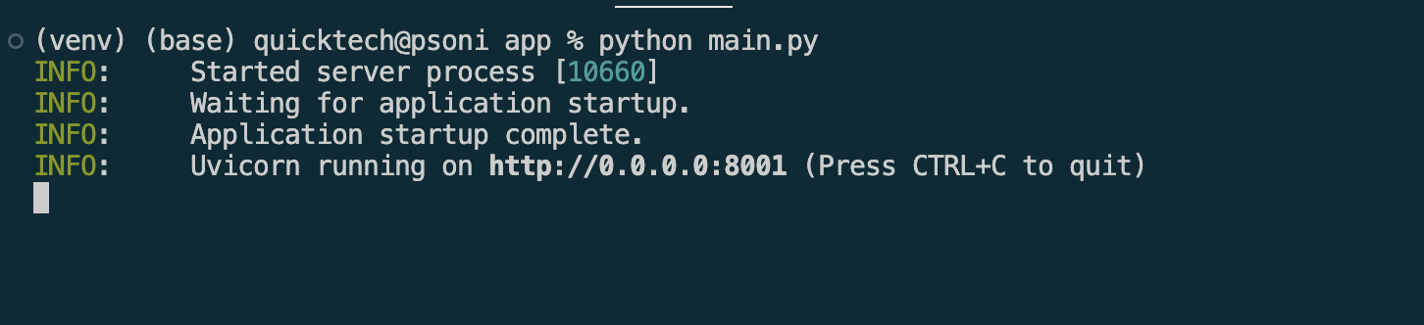

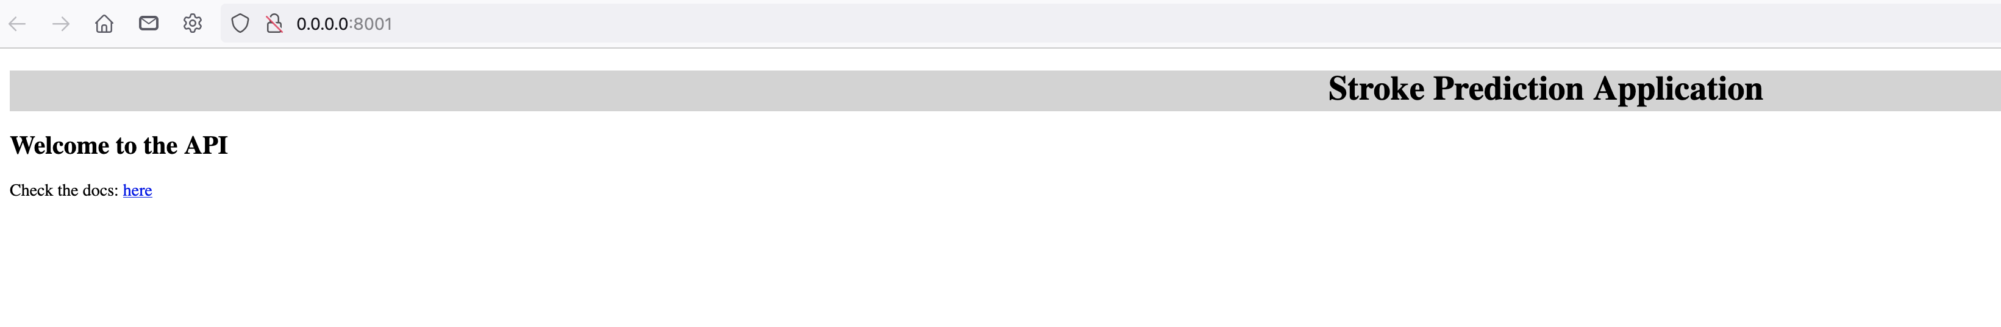

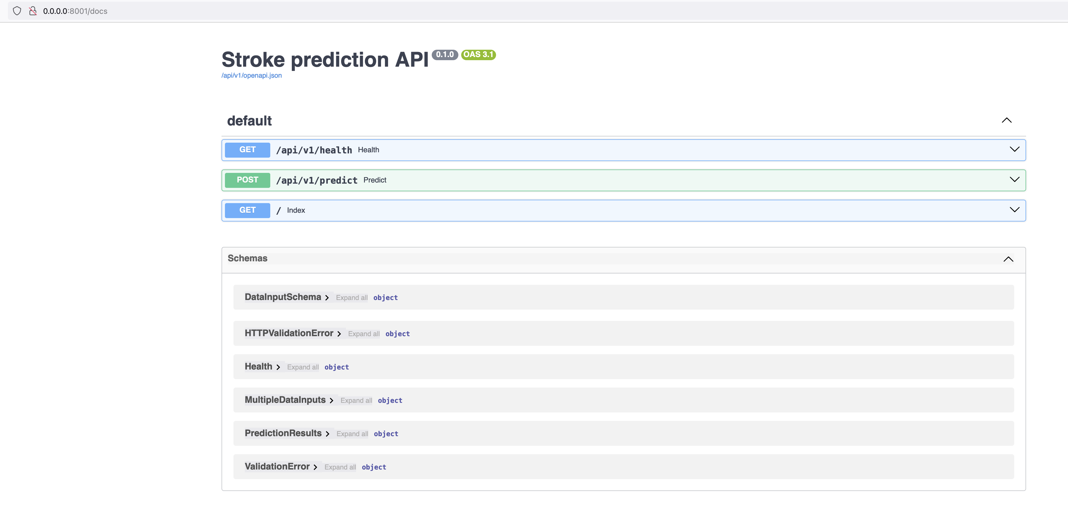

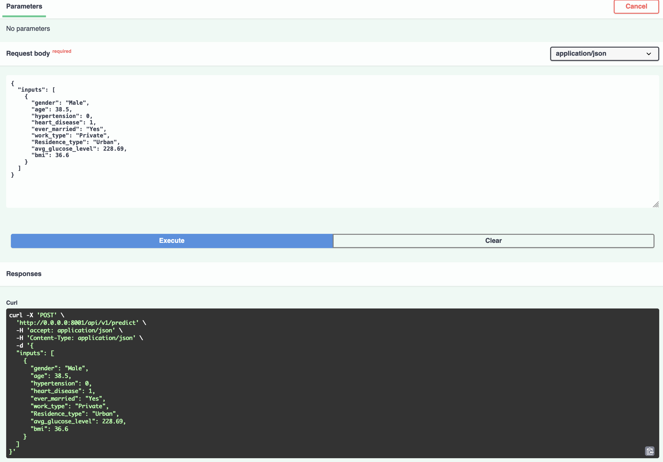

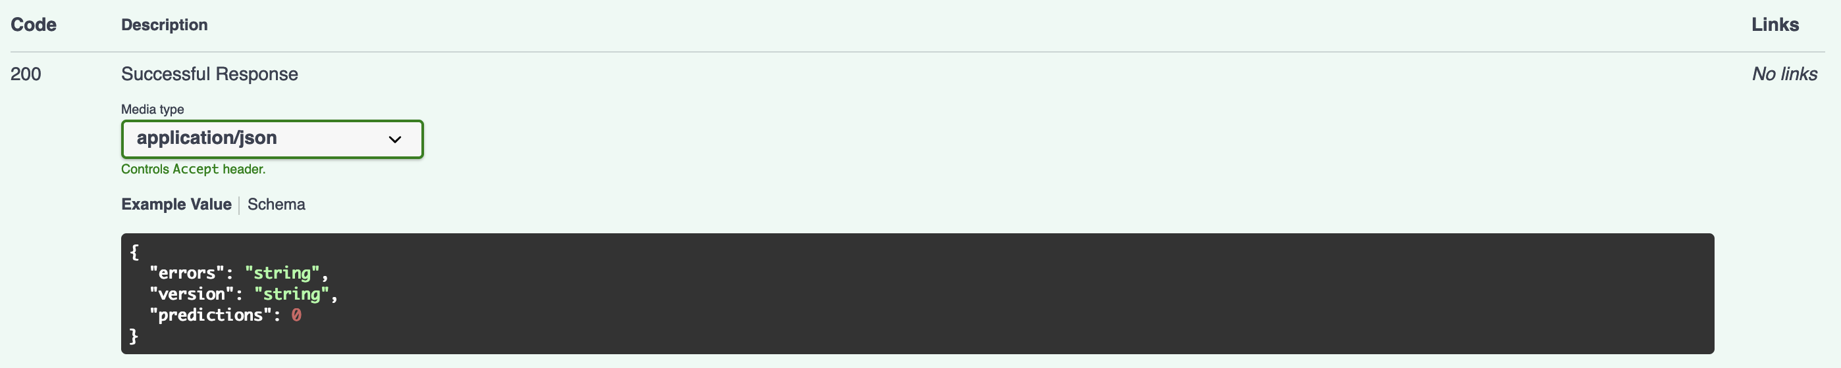

## **CI workflow**

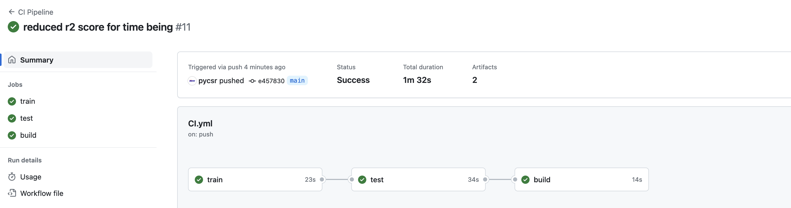

## **CD workflow**

TBD

## **Dockerization**

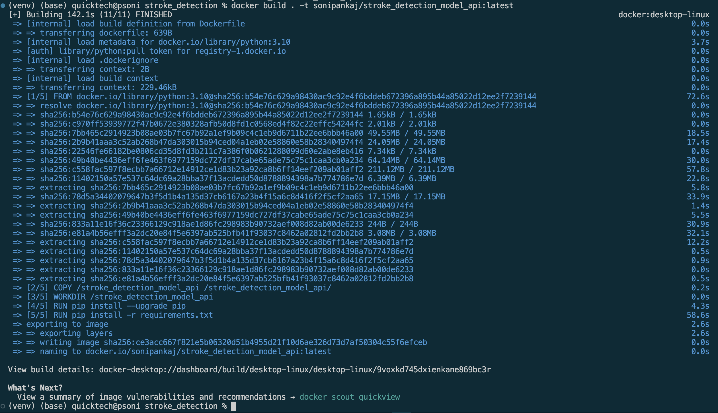

1. **Docker images**

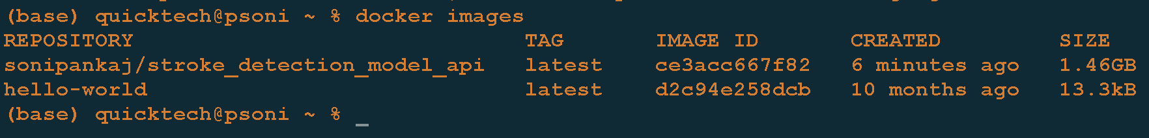

1. **In VS code**

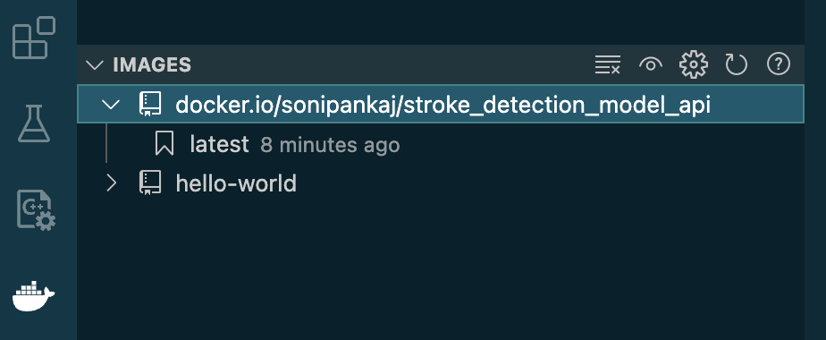

1. Running Docker app from CLI

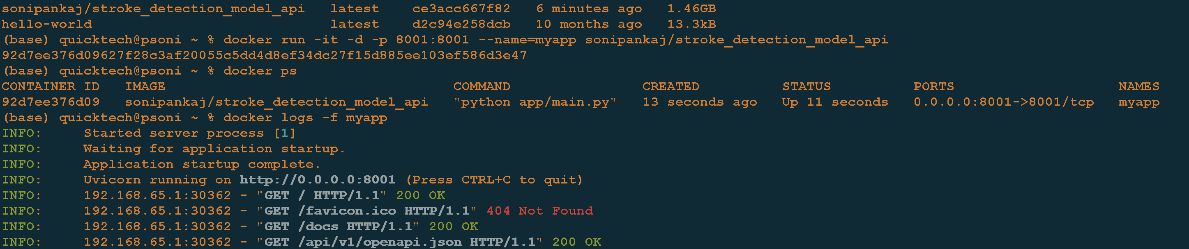

1. Stop app and push to image to docker

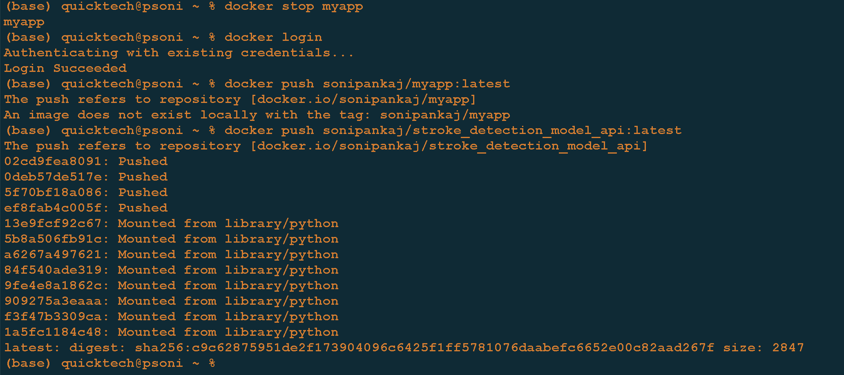

1. Added Docker pass_token and secret

