Lab 2: Multi-Programming

1. Purpose

User programs in JNachos are written in C language and compiled into the MIPS assembly language. The executable files can then be run on our emulated MIPS JNachos processor. Adding the following flag -x /..path../testfile should run one of the user programs.

Your goal is to change this such that: "-x /path/testfile1,/path/testfile2" will run both of these programs.

1. Implement details
2. The argument is like -x /path/testfile1,/path/testfile2 and we need to split it into 2 pathes. In the Main.java, we could use this code to make the arguments to be separate:

String[] arguments=args[argv + 1].split(",");

Then we could create the different process to run the 2 user programs.

1. To start different process, I create a new class named NewProcess to run the startProcess function. When we need to start a new process, we could create a new object of the NewProcess and pass the argument as the path of the user program:

System.***out***.println("The path of the first user program");

System.***out***.println(arguments[0]);

**new** NewProcess(arguments[0]);

1. In the NewProcess, we use fork function to run the user program in the new thread. We create a new class StartProcess to do the Machine.run() in different processees. To implement these methods, we create 2 new java files in the jnachos.kern package: NewProcess.java and StartProcess.java.
2. Testing results

Now, I could run the program by Run->Run Configurations…->make the Argument as:

-x /eclipse-workspace/JNachos/test/sort,/eclipse-workspace/JNachos/test/matmult

Then, run the project and here are the outputs in the Console:

The users could change the arguments which are the path of the user programs and run other user programs in the test directory.

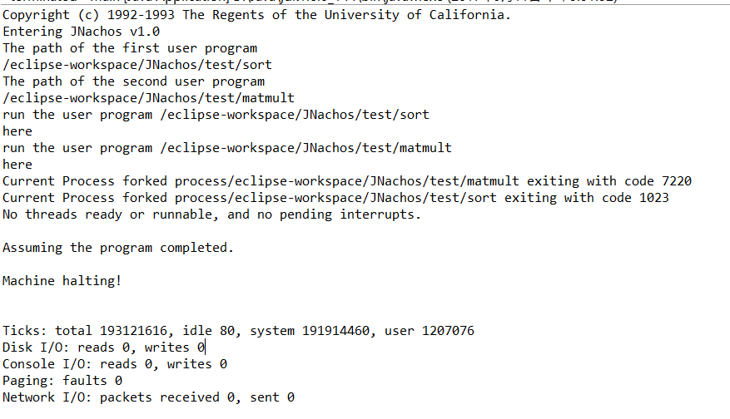

If I make the arguments as:

-x /eclipse-workspace/JNachos/test/sort,/eclipse-workspace/JNachos/test/halt

Then the result in the console would be:

