ROADMAP
Project Approach

Title
An Explainable AI-Driven Big Data Analytics Framework for Climate Prediction and Environmental Risk Assessment
Domain
Climate Change Analytics | Environmental Data Science | Big Data Analytics | Explainable AI

Benchmark Datasets
Dataset 1 – NASA EarthData
https://earthdata.nasa.gov/
Purpose
- Land Surface Temperature
- Vegetation Index (NDVI)
- Soil Moisture
- Wildfire Data

Dataset 2 – India Open Government Data (OGD)
https://data.gov.in/
Contains
- Rainfall
- Temperature
- Forest Cover
- Water Resources
- Groundwater
- Renewable Energy

Dataset 3 – India Meteorological Department (IMD)
https://mausam.imd.gov.in/
Contains
- Daily Temperature
- Rainfall
- Humidity
- Wind Speed
- Cyclone Data
- Heat Wave Records

Data Analytics (EDA)
Recommended EDA Flow
Raw Benchmark Datasets
│
▼
Dataset Integration
│
▼
Dataset Overview
│
▼
Data Quality Assessment
│
▼
Missing Value Analysis
│
▼
Duplicate Detection
│
▼
Outlier Detection
│
▼
Data Distribution
│
▼
Univariate Analysis
│
▼
Bivariate Analysis
│
▼
Multivariate Analysis
│
▼
Time-Series Trend Analysis
│
▼
Correlation Analysis
│
▼
Seasonality Analysis
│
▼
Spatial (Geographical) Analysis
│
▼
Climate Trend Analysis
│
▼
Feature Engineering
│
▼
Feature Selection
│
▼
Machine Learning Models

Data Preprocessing
- Missing Value Imputation
- Duplicate Removal
- Label Encoding
- One-Hot Encoding
- Standardization
- Normalization
- Feature Scaling
- Date-Time Feature Extraction
- Noise Removal
- Dataset Integration
- Train-Test Split

Feature Engineering
Create features like:
- Monthly Average Temperature
- Annual Rainfall
- Rainfall Anomaly
- Heatwave Days
- Drought Index
- Forest Loss Percentage
- AQI Category
- Pollution Index
- Carbon Emission Level
- Soil Moisture Index
- Vegetation Index (NDVI)
- Population Density
- Urbanization Index

Feature Selection
Use
- Chi-Square Test
- Mutual Information
- Recursive Feature Elimination (RFE)
- Random Forest Feature Importance

Machine Learning Models
Compare
- Logistic Regression
- Decision Tree
- Random Forest
- XGBoost
- LightGBM
- CatBoost
- Gradient Boosting
- Support Vector Machine (SVM)
(Optional)
- LSTM
- Prophet

Explainable AI
Use
- SHAP
- LIME

Visualization
Develop a Power BI or Streamlit dashboard including:
- Global Temperature Trends
- Rainfall Trend Analysis
- AQI Dashboard
- CO₂ Emission Analysis
- Forest Cover Changes
- Heat Maps
- Correlation Heatmap
- Feature Importance
- SHAP Summary Plot
- SHAP Waterfall Plot
- LIME Explanation
- Interactive State-wise Climate Dashboard
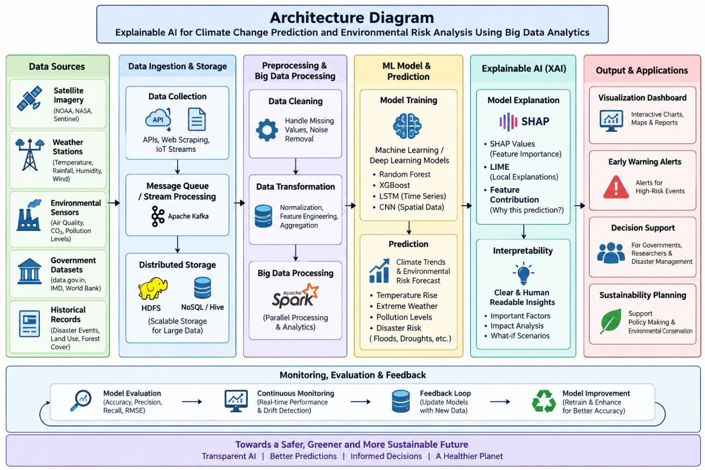

Comparative Analysis
Compare all models using
Metric
Accuracy
Precision
Recall
F1 Score
ROC-AUC
MAE
RMSE
R² Score
Training Time
Prediction Time

Recommended Research Pipeline
Benchmark Datasets
│
▼
Dataset Integration
│
▼
Data Cleaning
│
▼
Exploratory Data Analysis
│
▼
Feature Engineering
│
▼
Feature Selection
│
▼
Train-Test Split
│
▼
Machine Learning Models
(Logistic Regression
Decision Tree
Random Forest
XGBoost
LightGBM
CatBoost)
│
▼
Performance Evaluation
│
▼
Explainable AI
(SHAP + LIME)
│
▼
Interactive Dashboard
(Streamlit / Power BI)
│
▼
Comparative Analysis
│
▼
Climate Risk Prediction
│
▼
Research Conclusions

Expected Outcomes
- Predict climate risk levels (Low, Medium, High)
- Forecast temperature and rainfall trends
- Predict air quality categories
- Identify the most influential environmental factors
- Support decision-making for environmental planning using explainable AI

Team Details:
2420030591-L.Mrudani
2420090003-S.Kruthi
2420090107-P.Hasitha

