For the community, by the community, of the community

Pydelhi, organised its biweekly meetup on Saturday, 01 September 2018 which certainly proved the right way to commemorate the beginning of the month. The meetup was organized at e2e networks, which certainly stood by its name, helping us to “network” and learn from the members of the community by providing us the comfortable venue.

The meetup started at 11:00 a.m. amidst the presence of enthusiastic learners who introduced themselves and provided an insight into each of their tech stack. One of the many newly arrived python enthusiast was Gaurav Jain, who gave a talk on “How to make a crud rest APIs in 20 minutes”, that explained what rest APIs are?, types of requests needed to make a crud application, How to work on django rest API using the raw implementation of Jsonresponse, The need of serializers for SQL database, How to use django rest framework's modelserializer and modelviewset.

With a coffee break to settle our minds, we were greeted with another enlightening talk by Mr Amit Singh Sethi, titled “django on day 500”, that comprehended an authentic situation wherein a group of developers struggle as their business scale ,,because what it demands primarily is ”growth,growth,growth!!!” As quoted by Amit. However the problems are solved with “django”, which firmly and eloquently manages your database, provides a distributed environment, and increases the transparency of your django app.

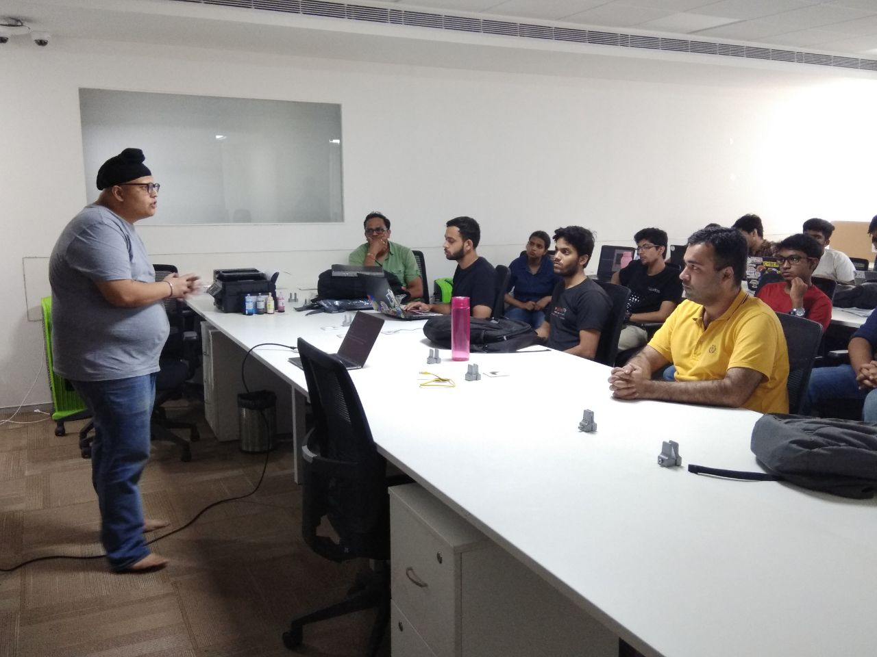

*Mr Amit Sethi explaining the beauty of Django on day 500 to upscale any business model*

The insightful talk made us all hungry for more knowledge and food alike, thus we headed to the cafeteria space to grab the tasty lunch waiting for us.

After the heartfelt lunch, the much awaited lightning talk session started, marking its initiation by Vipul Gupta, who clarified doubts regarding “how to contribute to open source”, followed by “scrapping dynamic JS pages” by Aaqa Ishtyaq, which paved way to an awe-inspiring talk by Mr Akshay on “success stories of python and use of python in the industry” which delivered the very essence of python as a tool helping us achieve what seems impossible to attain. Amidst the inspiration, Rohan demonstrated how a life wrecking experience such as a car accident, can be an inspiration for him to build a life saver system in vehicle. Thus lightning talks certainly stood by their name, they were short yet “impactful”, and within a span of a time we realized it was time to wrap up.

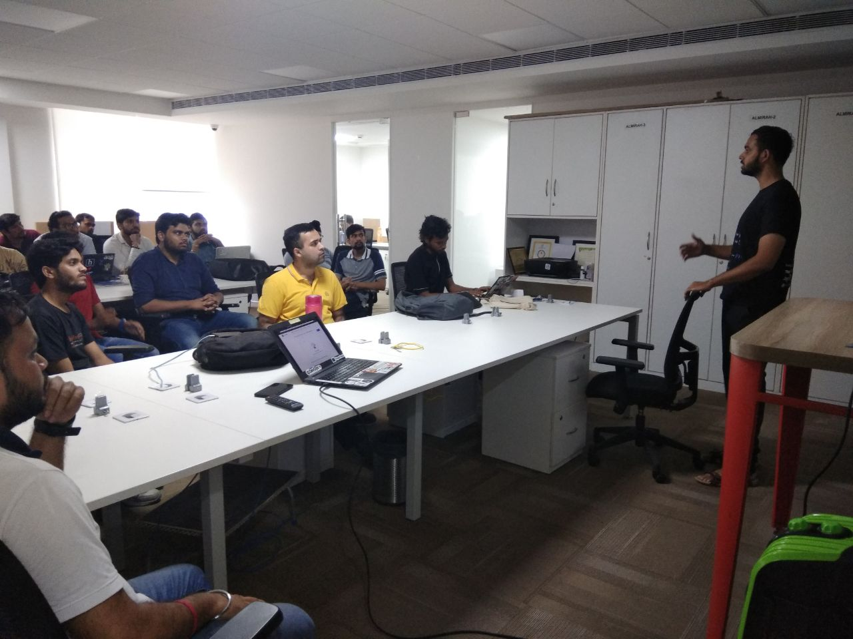

*Vipul explaining “How to contribute to open source” to fellow attendees*

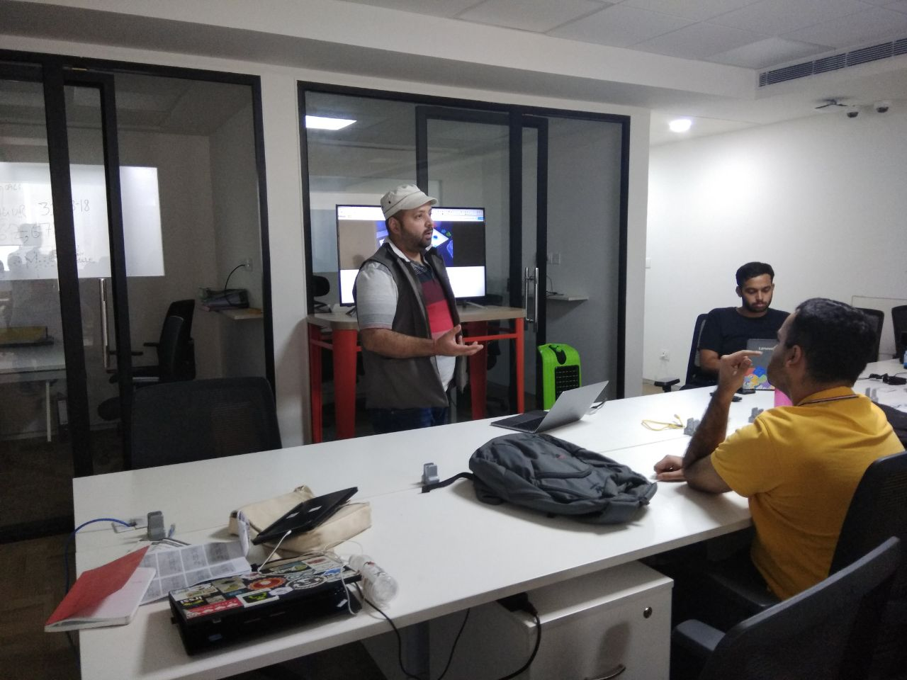

*Success stories written with the help of python, inspired the attendees.*

The keynote here is fact that even though it rained heavily, our day didn’t went gloomy, because we communicated with the best people and learned from them. So it was as bright as the sun, or maybe brighter.

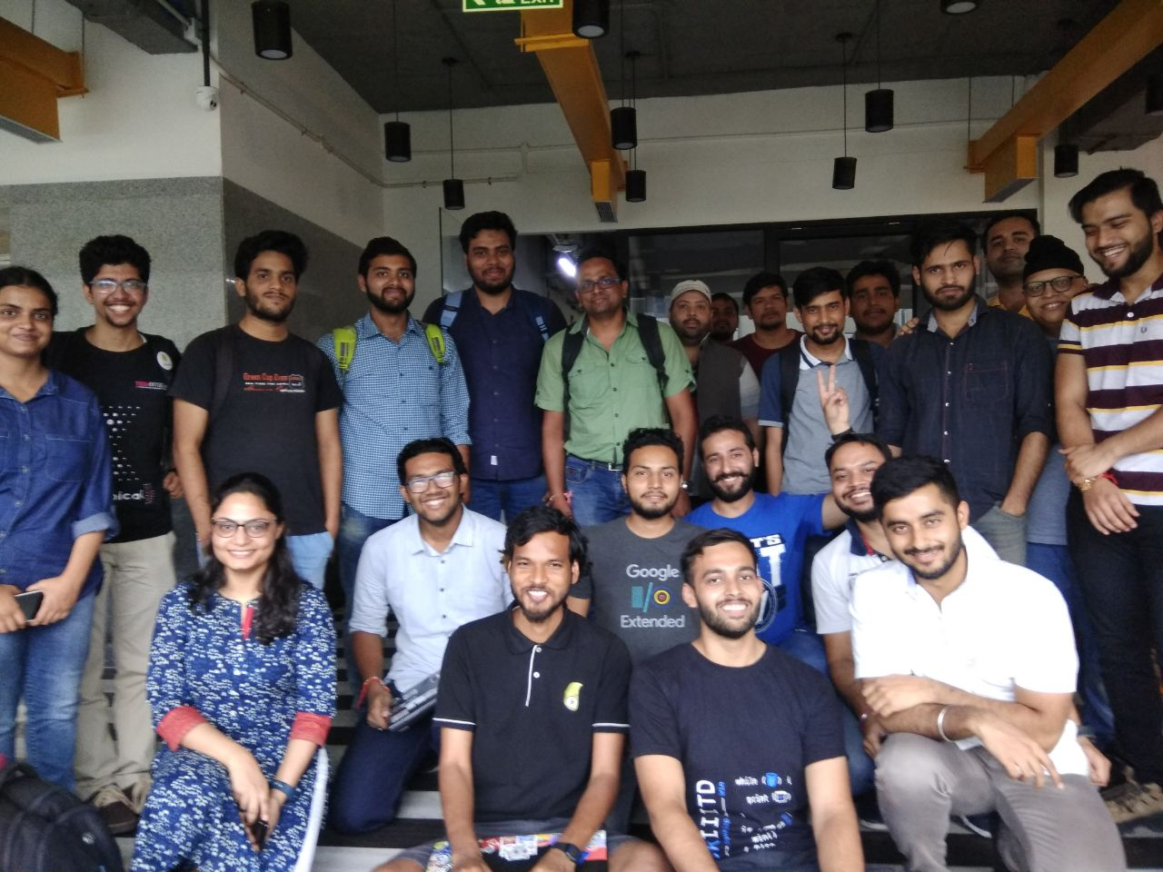

*A day ending with the note of “learning, contributing and winning”*