activAnalyzer: An R Shiny app to analyse ActiGraph accelerometer data and to implement the use of the PROactive Physical Activity in COPD instruments

05 July 2022

# Summary

Physical activity is a behaviour related to many health outcomes (WHO 2020). Accelerometry has become a method to be prefered to questionnaires when available to measure physical activity, at least because: (i) it allows avoiding psychosocial bias related to questionnaire use (e.g., recall bias) (Ainsworth et al. 2015); (ii) it allows capturing all activities, while questionnaires capture physical activity of moderate-to-vigorous intensity only (Ekelund et al. 2020); (iii) accelerometry is a more valid method than questionnaires to estimate total energy expenditure (Hallal et al. 2013; Colbert et al. 2011; Gardner and Poehlman 1998); (iv) and accelerometry is now a way to access a diversity of metrics that cannot be obtained using questionnaires (Keadle et al. 2017; Backes et al. 2022).

ActiGraph devices (ActiGraph LLC, Pensacola, FL) have been the most used accelerometers in scientific literature (Bassett et al. 2015; Migueles et al. 2017). These devices, along with their software companion ActiLife (ActiGraph LLC, Pensacola, FL), allow to get movement data expressed in either *activity counts* or *G-force* units. Activity counts represent the amount of acceleration produced over a given epoch of time at the wearing position of the device. While analytic methods based on G-force data are developping, the use of activity counts to assess physical activity and sedentary behaviours remains common (Migueles et al. 2017).

If the protocol for measuring physical activity itself may be relatively simple to implement for a given individual, the way to get the final results of the assessment is not straightforward. Indeed, several steps of data analysis must be completed, with one or several choices to be made at each step. These steps and choices could be described as follows (Heil, Brage, and Rothney 2012):

* Controlling quality of data: the choices to be made concern the threshold value (e.g., in counts/min) above wich data should be flagged as abnormal, and also concern the algorithm to be implemented to quantify nonwear time;
* Controlling quantity of data that can be used for characterizing physical behaviour: the choices to be made concern the minimum wear time to be obtained in a day to consider a day as valid, and the choices also concern the minimum number of valid days to be obtained to consider the whole measurement as valid;
* Converting activity counts into physiological meaningful units: the choices to be made concern the most appropriate algorithm to characterize the nature and/or the intensity of the activity performed at each epoch, such as an algorithm for classifying intensity of activity as sedentary, light, moderate, or vigorous for each epoch;
* Summarising data using metrics of interest: the choices to be made concern the most appropriate method to get the most appropriate metric depending on the objective of the measurement (e.g., physical activity volume, time spent in different intensities of physical activity).

Beyond these general steps, additional steps may be required to get the final results in some research or clinical frameworks that use accelerometer data. A good example is the use of the PROactive Physical Activity in chronic obstructive pulmonary disease (COPD) instruments (Dobbels et al. 2014; Gimeno-Santos et al. 2015; Garcia-Aymerich et al. 2021). Such a framework requires to combine scores related to answers to questionnaire items and scores related to accelerometer metrics (i.e., daily mean vector magnitude and daily total steps count) obtained from a week of measurement. Of note, ActiGraph devices are among the accelerometers that can be used to implement this framework in COPD patients.

In view of the interest of using accelerometry to measure physical activity, in particular using activity counts from ActiGraph accelerometers, there is a need to train students, future healthcare providers, and clinicians, to implement this method, and there is also a need to have the possibility to use a simple data analysis procedure to favor the implementation of this method routinely in clinical settings or when required in research settings.

# A need of a simple app to analyse ActiGraph accelerometer counts and to get the PROactive instruments results

Due to the large size of data files to analyse when using accelerometry and due to the relative complexity of the implementation of some algorithms (e.g., to detect nonwear time), a simple spreadsheet does not appear to be a feasible tool to complete all the accelerometer data analysis workflow from the same place. The ‘Full’ version of ActiLife software allows completing all the general steps of the data analysis workflow described above with activity counts but the cost of this ActiLife version may prevent teaching a wide audience to implement such a workflow and working with large teams on the data (‘Lite’ versions of ActiLife software, that are at a lower cost than ‘Full’ versions, allow device initialisation and data downloading only). Moreover, there is no solution in ActiLife software to fully implement the PROactive framework for COPD patients described above.

Other ways than ActiLife software to analyse activity counts include using programming languages. R (R Core Team 2022) and Python (Python Software Foundation 2022) have been programming languages commonly used by scientists to build tools aiming at fostering physical activity data analysis. In R, the ‘accelerometry’ and ‘nhanesaccel’ packages by Van Domelen and Pittard (2014), the ‘actigraph.sleepr’ package by Petkova (2021), and the ‘pawacc’ package by Geraci (2017), provide several functions to perform analyses of interest with activity counts. In Python, the ‘pyActigraphy’ library by Hammad and Reyt (2020) also allows, among various other features, to handle ActiGraph activity counts. While useful for research settings, these ressources may be of a little interest for other settings where people have no programming skills, because they do not propose a GUI to help people who do not code, and who have no time to learn this skill, to use the software. Van Domelen has proposed a Shiny app to analyse NHANES data (<https://jhubiostatistics.shinyapps.io/process_nhanes_app/>), but the flexibility of this app is too restricted to be usefull to assess people or patients for other purposes. Beyond the lack of a free and simple interface to analyse ActiGraph activity counts data, there is, to our knowledge, no app to allow an easy implementation of the PROactive framework that would be based on an analysis of ActiGraph activity counts. This is why we have developed the ‘activAnalyzer’ app. For now, a first main interest of this app is to allow teaching large groups of students or professionnals, who have no programming skills, to analyse activity counts for assessing physical behaviour. A second main interest is to allow an easy implementation of the PROactive framework with COPD patients when working with an ActiGraph accelerometer, this by clinicians, healthcare providers and/or researchers, either in clinical routine or in research setting.

# Use of activAnalyzer app

activAnalyzer is an app built as a package using R programming language. Several R packages have been used to develop this app, in particular the ‘Shiny’ package (Chang et al. 2021), which leverages web technology to make the app alive, and the ‘Golem’ package (Fay et al. 2022), which has provided the initial architecture of the app. The app can be used according to three different frameworks as explained elsewhere (<https://pydemull.github.io/activAnalyzer/>), including a standalone desktop application for Windows machines only, or using R (<https://CRAN.R-project.org/>) and RStudio (<https://www.rstudio.com/>) software.

When the user opens the app, he/she has to deal with four ordered sections. The first section allows the user to complete information related to the measurement setup (patient’s characteristics, device position, etc.). In the second section, the user must upload an .agd data file (‘.agd’ being the extension of the initial file generated by ActiLife software when the user wants to work with activity counts data). Then, the user has to configure the app to detect nonwear time. The results from this first analysis can be visualised by the user, as shown in .

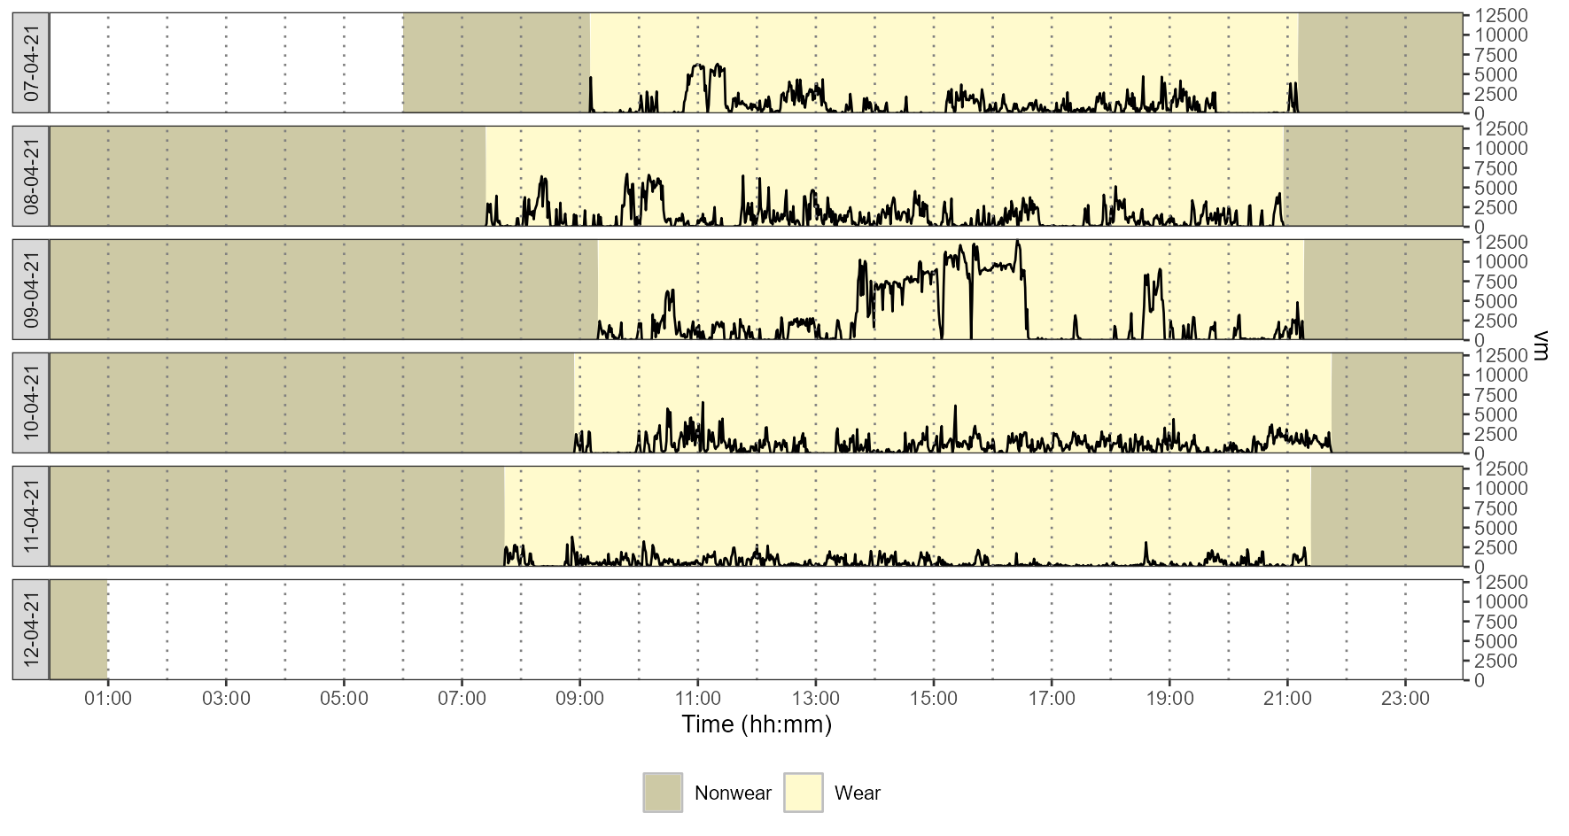

Example of analysis for nonwear time detection.

In a third section, the user has to select an equation to estimate METs (an indicator of energy expendiure) and values to define cut-points in counts/min. Cut-points are the values below or above which one can be classified as being in sedentary behaviour or in light, moderate, or vigourous physical activity. Once the user has completed the configuration for intensity analysis, he/she can run analysis. Then, the user can see a figure showing time spent in the different categories of activity intensity (), a table showing the results of the measurement for each day (), and tables with daily means and daily medians, respectively, showing metrics summarised from valid days (e.g., for means).

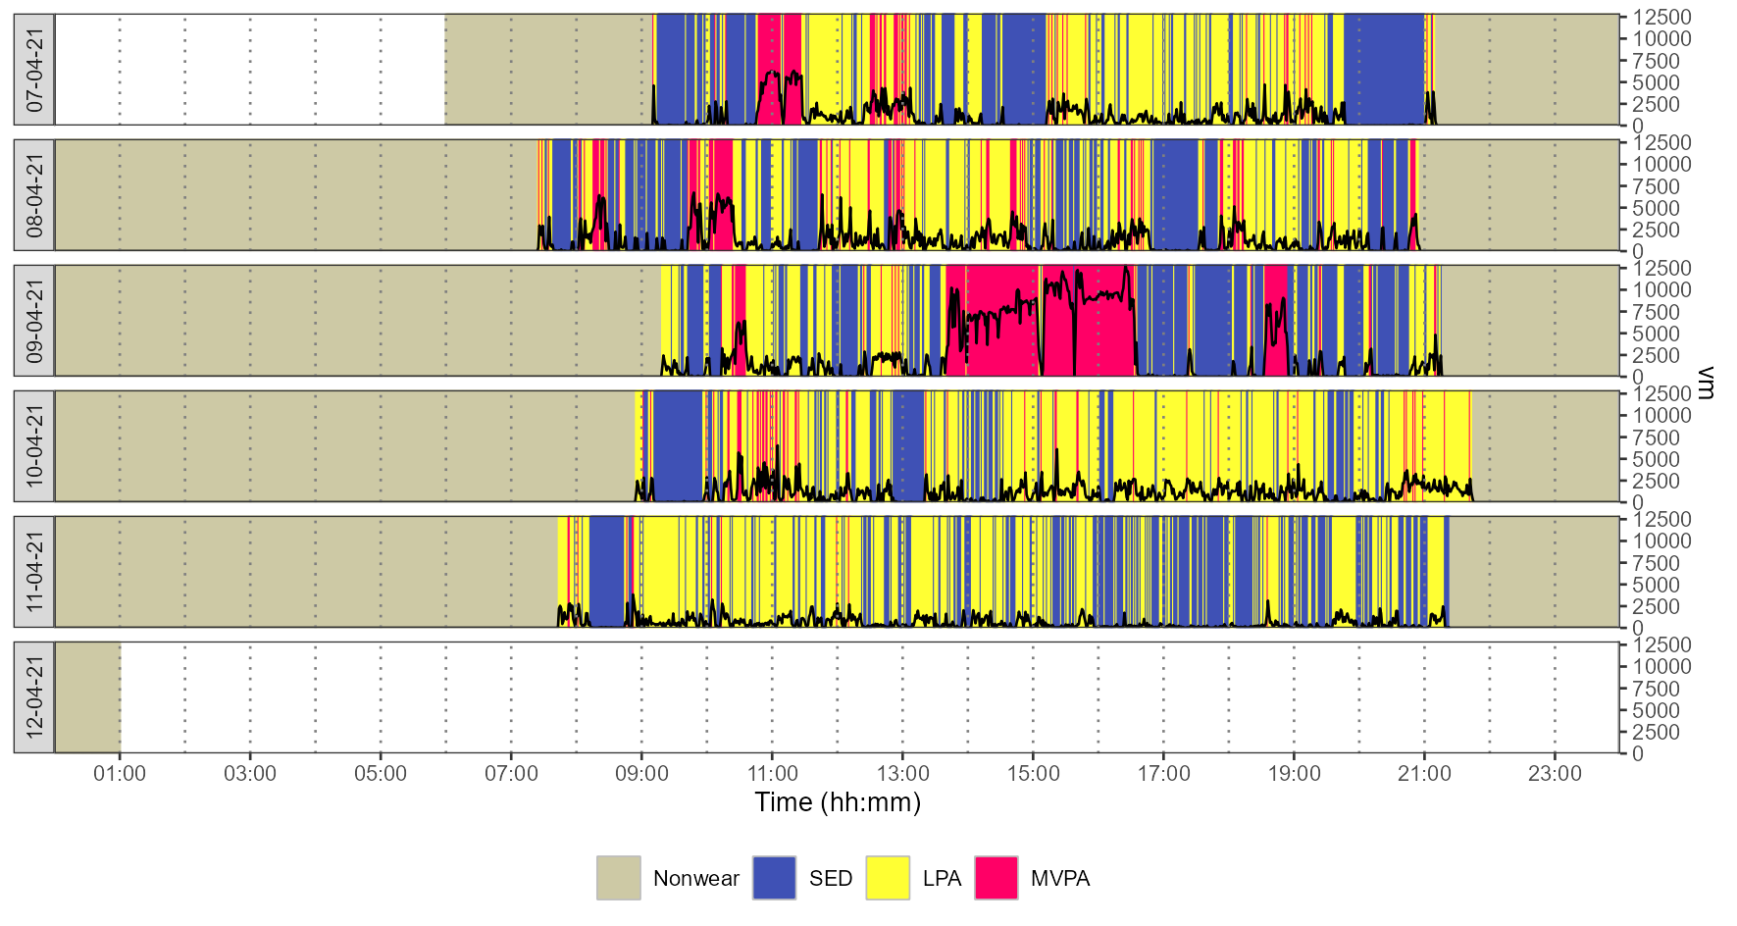

Example of analysis for intensity of physical behaviour.

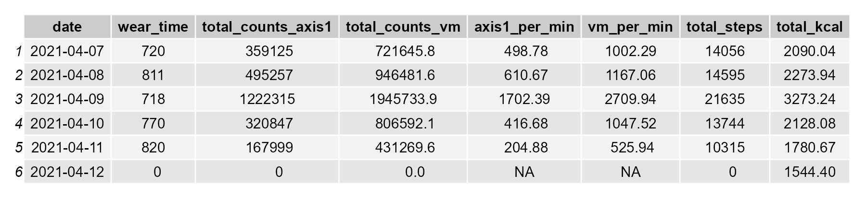

Example of table of results with the metrics for each day (first columns).



Example of table of results with the means of the metrics from valid days (first columns).

Once analysis is finished, the user can generate a report of the measurement, download .csv files containing data produced by the app (i.e., the whole dataset, the table containing a summary of metrics for each day of the measurement, and the tables with daily means or medians of the metrics summarised from the valid days), or go to the questionnaires related to the PROactive framework. This last part simply consists of completing the chosen questionnaire, and downloading a report once analysis is completed.

# Perspectives

For now, activAnalyzer has been used during clinical practice at the Saint Philibert hospital in Lille (France) with COPD patients and during research courses at the Institute of Physical Education and Sport Sciences in Les Ponts-de-Cé (France). Students, clinical practitionners, in particular those wanting to implement the PROactive framework with COPD patients, could benefit from this app if their structures would be working with ActiGraph accelerometers and at least ‘Lite’ versions of ActiLife software to initialize devices and to download data. The current version of the app allows getting classic metrics such as time spent at different intensities of physical activity, or a range of step-based metrics, but it does not allow to perform analyses at the bout level. Such features could be interesting to be implemented in future versions of the app.

# Acknowledgements

The authors thank Florian Congnard (IFEPSA-UCO) and Bénédicte Noury-Desveaux (IFEPSA-UCO) for their valuable feedbacks.

# References

Ainsworth, Barbara, Lawrence Cahalin, Matthew Buman, and Robert Ross. 2015. “The Current State of Physical Activity Assessment Tools.” *Prog Cardiovasc Dis* 57 (4): 387–95. <https://doi.org/10.1016/j.pcad.2014.10.005>.

Backes, Anne, Tripti Gupta, Susanne Schmitz, Guy Fagherazzi, Vincent Hees, and Laurent Malisoux. 2022. “Advanced Analytical Methods to Assess Physical Activity Behavior Using Accelerometer Time Series: A Scoping Review.” *Scand J Med Sci Sports* 32 (1): 18–44. <https://doi.org/10.1111/sms.14085>.

Bassett, David R., Richard P. Troiano, James J. Mcclain, and Dana L. Wolff. 2015. “Accelerometer-Based Physical Activity: Total Volume Per Day and Standardized Measures.” *Medicine & Science in Sports & Exercise* 47 (4): 833–38. <https://doi.org/10.1249/MSS.0000000000000468>.

Chang, Winston, Joe Cheng, JJ Allaire, Carson Sievert, Barret Schloerke, Yihui Xie, Jeff Allen, Jonathan McPherson, and Alan Dipert. 2021. *Shiny: Web Application Framework for R. R Package* (version 1.17.1). <https://CRAN.R-project.org/package=shiny>.

Colbert, Lisa H., Charles E. Matthews, Thomas C. Havighurst, Kyungmann Kim, and Dale A. Schoeller. 2011. “Comparative Validity of Physical Activity Measures in Older Adults.” *Med Sci Sports Exerc* 43 (5): 867–76. <https://doi.org/10.1249/MSS.0b013e3181fc7162>.

Dobbels, Fabienne, Corina de Jong, Ellen Drost, Janneke Elberse, Chryssoula Feridou, Laura Jacobs, Roberto Rabinovich, et al. 2014. “The PROactive Innovative Conceptual Framework on Physical Activity.” *Eur Respir J* 44 (5): 1223–33. <https://doi.org/10.1183/09031936.00004814>.

Ekelund, Ulf, Knut Eirik Dalene, Jakob Tarp, and I-Min Lee. 2020. “Physical Activity and Mortality: What Is the Dose Response and How Big Is the Effect?” *Br J Sports Med* 54 (19): 1125–26. <https://doi.org/10.1136/bjsports-2019-101765>.

Fay, Colin, Vincent Guyader, Sébastien Rochette, and Cervan Girard. 2022. *Golem: A Framework for Robust Shiny Applications* (version 0.3.2).

Garcia-Aymerich, Judith, Milo A Puhan, Solange Corriol-Rohou, Corina de Jong, Heleen Demeyer, Fabienne Dobbels, Damijan Erzen, et al. 2021. “Validity and Responsiveness of the Daily- and Clinical Visit-PROactive Physical Activity in COPD (D-PPAC and C-PPAC) Instruments.” *Thorax* 76 (3): 228–38. <https://doi.org/10.1136/thoraxjnl-2020-214554>.

Gardner, A. W., and E. T. Poehlman. 1998. “Assessment of Free-Living Daily Physical Activity in Older Claudicants: Validation Against the Doubly Labeled Water Technique.” *The Journals of Gerontology Series A: Biological Sciences and Medical Sciences* 53A (4): M275–80. <https://doi.org/10.1093/gerona/53A.4.M275>.

Geraci, Marco. 2017. *Pawacc: Physical Activity with Accelerometers* (version 1.2.2). <https://CRAN.R-project.org/package=pawacc>.

Gimeno-Santos, Elena, Yogini Raste, Heleen Demeyer, Zafeiris Louvaris, Corina de Jong, Roberto A. Rabinovich, Nicholas S. Hopkinson, et al. 2015. “The PROactive Instruments to Measure Physical Activity in Patients with Chronic Obstructive Pulmonary Disease.” *Eur Respir J* 46 (4): 988–1000. <https://doi.org/10.1183/09031936.00183014>.

Hallal, Pedro C., Felipe F. Reichert, Valerie L. Clark, Kelly L. Cordeira, Ana M. B. Menezes, Simon Eaton, Ulf Ekelund, and Jonathan C. Wells. 2013. “Energy Expenditure Compared to Physical Activity Measured by Accelerometry and Self-Report in Adolescents: A Validation Study.” Edited by Susanne Breuer Votruba. *PLoS One* 8 (11): e77036. <https://doi.org/10.1371/journal.pone.0077036>.

Hammad, Grégory, and Mathilde Reyt. 2020. *pyActigraphy* (version 1.0). <https://github.com/ghammad/pyActigraphy>.

Heil, Daniel P., Soren Brage, and Megan P. Rothney. 2012. “Modeling Physical Activity Outcomes from Wearable Monitors.” *Med Sci Sports Exerc* 44 (January): S50–60. <https://doi.org/10.1249/MSS.0b013e3182399dcc>.

Keadle, Sarah Kozey, Joshua N. Sampson, Haocheng Li, Kate Lyden, Charles E. Matthews, and Raymond J. Carroll. 2017. “An Evaluation of Accelerometer-Derived Metrics to Assess Daily Behavioral Patterns.” *Med Sci Sports Exerc* 49 (1): 54–63. <https://doi.org/10.1249/MSS.0000000000001073>.

Migueles, Jairo H., Cristina Cadenas-Sanchez, Ulf Ekelund, Christine Delisle Nyström, Jose Mora-Gonzalez, Marie Löf, Idoia Labayen, Jonatan R. Ruiz, and Francisco B. Ortega. 2017. “Accelerometer Data Collection and Processing Criteria to Assess Physical Activity and Other Outcomes: A Systematic Review and Practical Considerations.” *Sports Med* 47 (9): 1821–45. <https://doi.org/10.1007/s40279-017-0716-0>.

Petkova, Desislava. 2021. *Actigraph.sleepr: Detect Periods of Sleep and Non-Wear from ’ActiGraph’ Data* (version 0.2.0). <https://github.com/dipetkov/actigraph.sleepr>.

Python Software Foundation. 2022. *Python*. <https://www.python.org/>.

R Core Team. 2022. *R: A Language and Environment for Statistical Computing. R Foundation for Statistical Computing, Vienna, Austria.* <https://www.R-project.org/>.

Van Domelen, Dane, and W. Stephen Pittard. 2014. “Flexible R Functions for Processing Accelerometer Data, with Emphasis on NHANES 2003-2006.” *The R Journal* 6 (2): 52. <https://doi.org/10.32614/RJ-2014-024>.

WHO. 2020. *WHO Guidelines on Physical Activity and Sedentary Behaviour*. Geneva: World Health Organization.