Mineral Prospectivity Mapping
from Open Data
Lithium & Rare-Earth (REE) Pegmatites
Complete User & Technical Documentation
Critical Minerals Innovation Hackathon 2026 — Problem Statement 1
Ministry of Mines · JNARDDC · National Critical Mineral Mission
Software package: CMiH2026_pegmatite_MPM
Version 1.0
Extractmet Private Limited · IIT Madras Research Park

Contents
If the list below appears empty, right-click it in Microsoft Word and choose “Update Field” to populate the page numbers.

1. Introduction
This document explains, from the ground up, a complete software package that produces a prospectivity map (a coloured “heatmap” of how favourable each location is for a mineral deposit) for lithium (Li) and rare-earth-element (REE) pegmatites, using freely available public geoscience data, and then measures how good that map is against the deposits that are already known.
It was built to answer Problem Statement 1 of the Critical Minerals Innovation Hackathon 2026, whose brief is, in short: produce a prospectivity heatmap for lithium or REE pegmatites from open data, validated against known mineral occurrences.

Who this document is for
You do not need to be a programmer, a geologist, or a data scientist to use the package. This manual assumes only that you can install a program on your computer and copy files into folders. Wherever a concept is needed (what a pegmatite is, what a coordinate system is, what “cross-validation” means), it is explained in plain language before it is used.

What you will be able to do after reading this
- Run a self-contained demonstration on your computer in a few minutes, with no downloads, and see a real prospectivity map and its validation charts.
- Understand what every output means and how to read the map for exploration decisions.
- Know exactly which public datasets to download, from which websites, in what format, and which folder to put each file in.
- Produce a prospectivity map for your own study area in India (or anywhere) from that real data, using a ready-made template you only lightly edit.

The two ways to run it
Mode A — Demonstration (no data needed). The package can build its own realistic, physics-based “synthetic” pegmatite region and run the whole method on it. This exists so you can prove the method works end-to-end without downloading anything. In this mode the program even knows the hidden “true” answer, so it can show you that the model recovers it (a spatial correlation of about 0.88).
Mode B — Real open data. You download public datasets (geology, elevation, geophysics, geochemistry, known occurrences), drop them into a folder, and the identical method runs on them. Sections 9 and 10 are a complete, click-by-click guide to doing this.
Important: The program does not connect to the internet on its own. It never downloads data automatically. In Mode B you fetch the public files yourself (this manual shows you how) and the program reads them from your disk. This keeps everything transparent, offline-capable, and under your control.

2. Background concepts, in plain language
This section builds the handful of ideas the rest of the manual relies on. If you already know a topic, skip it.

2.1 Critical minerals and pegmatites
“Critical minerals” are raw materials that a country’s economy and security depend on but whose supply is at risk — lithium for batteries, and the rare-earth elements for magnets in motors, wind turbines and electronics, are prime examples. India’s National Critical Mineral Mission is a push to find domestic sources of these.
A pegmatite is a very coarse-grained igneous rock — think of granite with unusually large crystals — that forms from the last, water-and-rare-element-rich liquid left over when a body of granite magma crystallises. That leftover liquid concentrates exactly the elements we care about. Two “families” matter here:
- LCT pegmatites (Lithium–Caesium–Tantalum): the world’s main hard-rock source of lithium (in the mineral spodumene), plus caesium and tantalum.
- NYF pegmatites (Niobium–Yttrium–Fluorine): enriched in rare-earth elements, niobium and related metals.
Because pegmatites form from the last squeeze of a granite, they occur in predictable geological settings, and they leave measurable “fingerprints” in the rocks and soils around them. That predictability is what makes mapping their favourability possible.

2.2 What a “prospectivity map” is
A prospectivity map divides your study area into a fine grid of small square cells and gives each cell a score from 0 to 1 that answers: “based on the evidence, how favourable is this spot for the deposit type we are hunting?” Displayed as a heatmap (dark = unfavourable, bright = favourable), it turns a large, expensive-to-explore region into a ranked shortlist, so field teams can focus on the brightest few percent of the ground first.

2.3 What “open data” means here
Open data is public information that anyone may download and use, typically published by government agencies. For this project it means national geological maps, airborne geophysical surveys, soil/stream geochemistry, elevation models and databases of known mineral occurrences — most of it available for India through the Geological Survey of India and ISRO, and globally through several portals. Section 9 lists each source with its website and download steps.

2.4 The “mineral system” idea — turning geology into map layers
Rather than feeding a computer random data and hoping, the package encodes how pegmatites actually form and what they leave behind. Every input map layer corresponds to one ingredient of the pegmatite “mineral system”:
Mineral-system ingredient | What it means | How it shows up in data
Source | A fertile, highly-evolved granite that expelled the pegmatite liquid | Proximity to fractionated granite bodies on the geological map
Halo / zonation | Pegmatites sit a certain distance out from the parent granite (a sweet-spot band, not right on top) | Distance-to-granite, used as a band rather than “closer is always better”
Pathway | Cracks and shear zones that let the liquid travel | Distance to faults/shears; density of lineaments and their intersections
Host / trap | Favourable rocks (e.g. mica schist) that hosted and trapped the pegmatite | The rock-type (lithology) map
Signature — radiometric | Pegmatites are rich in potassium (feldspar/mica) and thorium/uranium (in monazite etc.) | Airborne gamma-ray survey: K, eTh, eU all HIGH
Signature — magnetic | Pegmatites lack magnetite, so they read as magnetic “lows” | Aeromagnetic survey: a magnetic LOW
Signature — geochemical | The rock sheds pathfinder elements into soils/streams | Stream-sediment chemistry: Li-Cs-Rb-Ta-Sn (Li) or LREE-Y-Nb-F (REE)
Expression — terrain | Hard, resistant pegmatite/quartz bodies can stand out in the landscape | Roughness/slope from a digital elevation model

This is the heart of why the map is trustworthy rather than a black box: the model is given evidence that has a genuine geological reason to matter, and (Section 8) we can check afterwards that it actually relied on those geological controls.

2.5 What the machine-learning model does
At the known occurrence locations, the program reads the values of every evidence layer — these are examples of “what favourable ground looks like.” It also samples many locations away from any known deposit as examples of “ordinary ground.” A machine-learning classifier learns the pattern that separates the two, then applies that learned pattern to every cell in the map to produce the 0–1 score. The package uses three complementary classifiers (a Random Forest, a Logistic Regression, and a Gradient-Boosted model) and also an average of the three (an “ensemble”), and keeps whichever performs best.

2.6 Spatial cross-validation — “no marking your own homework”
Geological data is spatially “smooth”: two neighbouring cells look almost identical. If you tested the model on cells randomly mixed in with the ones it learned from, it would score almost perfectly — not because it is good, but because it has effectively already seen each test location’s neighbours. That flatters the map and misleads you.
To prevent this, the package uses spatial cross-validation: it cuts the area into a grid of large blocks, hides one whole block at a time, trains on the rest, and predicts the hidden block. Every cell is therefore scored by a model that never saw its neighbourhood. The map assembled this way is the honest one — it estimates how well the method will find undiscovered deposits — and its score is the one this manual reports as the headline. A separate “delivered” map, trained on all known occurrences, is what you would actually take to the field; it looks a little sharper, which is expected.

2.7 How we measure whether the map is any good
The map is validated against the known occurrences using the standard exploration metrics. In plain terms:
- ROC-AUC: a single 0.5–1.0 number for how well the score separates real occurrences from ordinary ground. 0.5 is a coin-flip; higher is better.
- Success-rate curve: “if we explore the brightest X% of the area, what percentage of the known deposits do we catch?” A good map catches most deposits in a small area.
- Prediction-Area plot and Normalized Density (Nd): a measure of how tightly the deposits cluster into the high-score ground. Nd = 1 means the map is no better than random; Nd of 2–3 means deposits are 2–3× more concentrated in the favourable zones than chance.

3. The approach (methodology overview)
Putting Section 2 together, the package follows a pipeline that mirrors accepted best practice in mineral-prospectivity research:
- 1. Assemble evidence. Bring every data layer onto one common grid and coordinate system.
- 2. Engineer features. Convert raw layers into geologically meaningful indicators (e.g. a magnetic-low indicator, radiometric ratios, terrain roughness, distances to granite and structure).
- 3. Label examples. Mark occurrence cells as “favourable” and sample ordinary ground as “background.”
- 4. Train with spatial cross-validation. Fit the classifiers block-by-block so validation is honest.
- 5. Produce maps. An honest (out-of-fold) map, a delivered (all-data) map, and an uncertainty map showing where the model is unsure.
- 6. Cross-check with expert knowledge. Independently combine the same layers using a knowledge-driven “fuzzy” overlay, as a benchmark.
- 7. Validate against known occurrences. Compute ROC, success-rate and Prediction-Area metrics.
- 8. Export deliverables. Figures, a georeferenced GeoTIFF you can open in any GIS, a CSV, and a metrics file.
Two design choices make the result defensible: the evidence is chosen from real pegmatite geology (not arbitrary), and the validation is leakage-free (spatial blocks). The package also reports the honest, harder number as the headline rather than the flattering one.

4. The algorithm sequence (what the program does internally)
This section is for readers who want to know precisely what happens under the hood. Each stage names the file that performs it. You do not need to read the code to use the package.

Stage 1 — Build or load the evidence layers
In Mode A, synthetic_province.py generates a realistic pegmatite region: rock units, a fertile granite body, fault and lineament networks, airborne radiometric and magnetic fields, gravity, a pathfinder-geochemistry layer, and a digital elevation model — plus a set of known occurrences planted where the hidden geological favourability is genuinely high (with a small amount of realistic “off-trend” noise). In Mode B, adapters.py loads your downloaded files and reprojects them all onto one common grid.

Stage 2 — Engineer the features
features.py converts the raw layers into the indicators the model actually uses. Notable ones: radiometric K and the Th/K and U/K ratios and a combined radiometric-fertility anomaly; a magnetic-low indicator (the survey minus its regional trend, negated) and a magnetic edge indicator; a gravity residual; the geochemical pathfinder index; terrain roughness and slope; the distances to granite and to structure and the lineament and intersection densities; and the rock-type map expanded into one indicator per rock class. Any layer you did not supply is simply skipped — the model uses whatever is available.

Stage 3 — Construct training labels
models.py marks occurrence cells (with a one-cell buffer to allow for location imprecision) as positives, and randomly samples cells well away from any occurrence as negatives, at a controlled ratio. Because real deposits are rare, the classifiers are told to weight the classes so the rare positives are not ignored.

Stage 4 — Spatial blocking
The area is divided into a grid of large blocks (5 per side by default). These blocks define the “hide one, train on the rest” folds used for honest validation, so that no test cell shares its immediate neighbourhood with any training cell.

Stage 5 — Train and cross-validate
For each classifier, the program runs the block-wise cross-validation, records the honest ROC-AUC, and stitches the held-out-block predictions into a full “out-of-fold” map. It also averages the classifiers into an ensemble and keeps the best performer.

Stage 6 — Build the delivered map and the uncertainty map
The best classifier is retrained on all known occurrences to produce the sharpest “delivered” map for field use. Separately, the spread of predictions across the spatial folds is used to build an uncertainty map: bright-but-uncertain areas are flagged as needing more data before drilling.

Stage 7 — Knowledge-driven benchmark
Independently of the machine learning, models.py also combines the same layers using a classic “fuzzy-gamma” overlay that encodes expert rules (near granite is good, magnetic low is good, radiometric high is good, and so on). This provides a sanity-check benchmark; in testing the data-driven map out-performs it on discrimination, which is the expected and desirable result.

Stage 8 — Validate against known occurrences
validation.py computes the ROC curve and AUC, the success-rate (capture-vs-area) curve, and the Prediction-Area plot with the Normalized Density, for the honest map, the delivered map and the fuzzy benchmark.

Stage 9 — Produce outputs
viz.py renders the figures, and the runner writes a georeferenced GeoTIFF (openable in QGIS/ArcGIS), a CSV of coordinates and scores, a metrics file, and a ranked list of which evidence layers mattered most.

5. What’s in the package (folder structure)
After you unzip the package you will have a top folder (the “deck”). Its contents:
CMiH2026_pegmatite_MPM/
│
├── cmih_mpm/ ← the engine (the Python “package”)
│ ├── __init__.py
│ ├── synthetic_province.py build the demo region (Mode A)
│ ├── adapters.py load REAL downloaded data (Mode B)
│ ├── features.py turn raw layers into evidence indicators
│ ├── models.py training, spatial cross-validation, fuzzy overlay
│ ├── validation.py ROC / success-rate / Prediction-Area metrics
│ └── viz.py make all the figures
│
├── run_demo.py ← RUN THIS for the no-download demo (Mode A)
├── app.py ← the interactive web app (Streamlit)
├── real_data_example.py ← template to run on YOUR data (Mode B)
├── requirements.txt the list of software the package needs
├── README.md short overview
├── DOCUMENTATION.docx this manual
│
├── tests/
│ └── test_pipeline.py automated self-checks (optional to run)
│
├── data/ ← YOU CREATE THIS in Mode B; put downloads here
│ (see Section 9.4 for the exact layout)
│
└── outputs/ ← results appear here (maps, GeoTIFF, metrics)
Note: The data/ folder does not exist until you create it for Mode B. The outputs/ folder is created automatically the first time you run anything.

6. Installation
The package is written in Python. The steps below are written for Windows using Anaconda, which is the simplest way to get Python plus the geospatial libraries working together. macOS and Linux users can follow the same commands in a terminal.

6.1 Prerequisites
Install Anaconda (or the smaller Miniconda) from anaconda.com. This gives you Python and the “conda” environment manager. You do not need anything else installed first.

6.2 Step-by-step (Windows / Anaconda)
1. Unzip CMiH2026_pegmatite_MPM.zip to a convenient location, for example your Downloads folder.
2. Open “Anaconda Prompt” from the Start menu.
3. Move into the package folder (adjust the path to where you unzipped it):
cd C:\Users\<you>\Downloads\Mineral_Prospectivity_Mapping\CMiH2026_pegmatite_MPM
4. Create and activate a dedicated environment (keeps this project’s software separate from everything else):
conda create -n mpm python=3.11 -y
conda activate mpm
5. Install the geospatial library rasterio via conda (this is the reliable way on Windows), then the rest via pip:
conda install -c conda-forge rasterio -y
pip install -r requirements.txt
Tip: If you skip the conda step and install rasterio only with pip, it sometimes fails on Windows with errors about GDAL. Installing rasterio from conda-forge first, as above, avoids that.

6.3 Check it worked
Run the demo (next section). If a prospectivity map appears in the outputs folder, your installation is good. You can also run the automated self-checks:
pytest -q
A line such as “7 passed” confirms the engine is healthy.

7. Quick start: the demonstration (no downloads)
This is the fastest way to see the package work. It needs no data files.

7.1 The one-shot demo
With the environment active and inside the package folder, run:
python run_demo.py
In under a minute it builds the demo region, trains and cross-validates the models, validates the result, and writes everything to the outputs/ folder. You will see a short summary in the window, ending with the honest validation numbers.
To target REE (NYF) pegmatites instead of lithium, open run_demo.py and change the last line to main("REE"), or run this one-liner:
python -c "import run_demo; run_demo.main('REE')"

7.2 The interactive web app
For a point-and-click experience with sliders and tabs, run:
streamlit run app.py
Your web browser opens a dashboard. Use the sidebar to choose the commodity and adjust settings; the tabs show the prospectivity map, the evidence layers, the validation charts, the layer-importance chart, the uncertainty map, and a “truth recovery” view. Buttons let you download the GeoTIFF and the metrics. Close it later by pressing Ctrl+C in the Anaconda Prompt.

7.3 What appears, and where
Everything lands in outputs/:
File | What it is
01_evidence_layers.png | All the raw input layers, side by side
02_prospectivity_map.png | The delivered prospectivity heatmap
03_compare_maps.png | Honest vs delivered vs knowledge-driven maps
04_truth_vs_pred.png | (Demo only) the hidden truth vs the model’s map
05_validation.png | ROC, success-rate and Prediction-Area charts
06_importance.png | Which evidence layers the model relied on
07_uncertainty.png | Where the model is confident vs unsure
prospectivity.tif | Georeferenced heatmap — open in QGIS/ArcGIS
prospectivity.csv | x, y, score for every cell
metrics.json | All the validation numbers
feature_importance.csv | Ranked layer-importance table

8. Understanding the outputs
Here is how to read each result. The figures below are from an actual demo run.

8.1 The evidence layers
This panel shows the raw inputs. In the demo you can already see the pegmatite fingerprints: the radiometric potassium/thorium/uranium layers light up in rings around the granite bodies, the geochemistry shows matching haloes, the magnetic layer shows lows over the favourable ground, and the structural layers pick out the fault network.
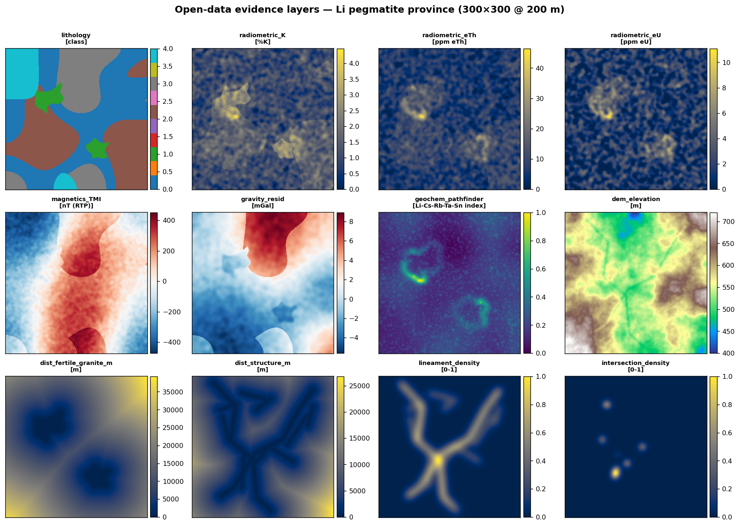
Figure 1 — The raw open-data evidence layers for a lithium-pegmatite region.

8.2 The prospectivity map
This is the headline product. Bright (yellow/white) cells are the most favourable; dark cells are least. Green circles are the known occurrences; cyan lines are interpreted structures. A good map has most green circles sitting in bright ground.
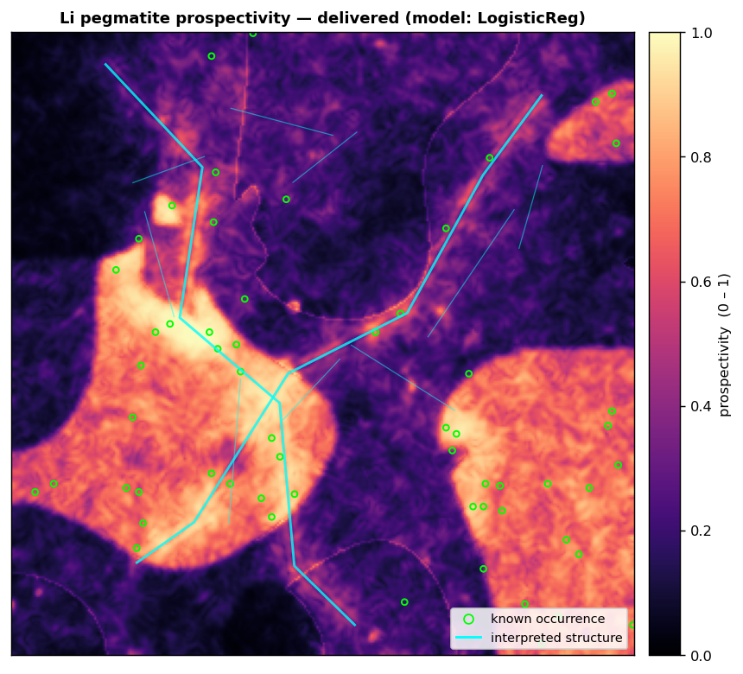
Figure 2 — The delivered prospectivity heatmap. Known occurrences (green) fall largely in the favourable zones.

8.3 The validation charts
These three charts prove the map is meaningful, not decorative.
- Left (ROC): the higher the blue curve bows toward the top-left, the better. The data-driven curve sits well above the diagonal “random” line and above the fuzzy benchmark.
- Middle (success-rate): read it as “explore this % of area (x-axis) → catch this % of known deposits (y-axis).” Being above the diagonal means the map concentrates deposits into less ground.
- Right (Prediction-Area): the Normalized Density (Nd) printed here summarises that concentration; above 1 is better than random, and 2–3 is a strong, useful map.
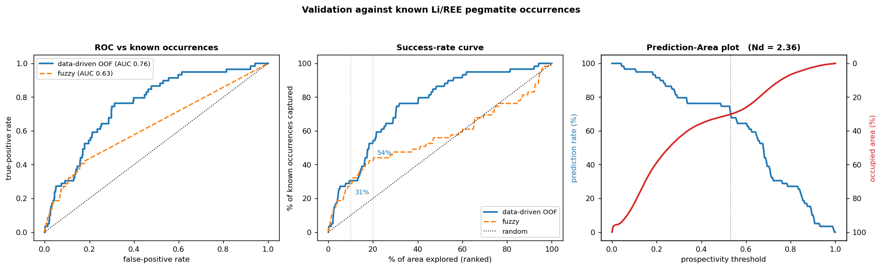
Figure 3 — Validation against known occurrences: ROC (left), success-rate (middle), Prediction-Area (right).

8.4 Layer importance and uncertainty
The importance chart (06_importance.png) ranks how much each evidence layer influenced the result; you should see genuine pegmatite controls — host rock type, radiometrics, and distances to structure and granite — near the top, which confirms the model learned geology rather than noise. The uncertainty map (07_uncertainty.png) shows where predictions are shakiest; treat bright-but-uncertain areas as “collect more data before committing.”

8.5 The metrics file
metrics.json records the numbers behind the charts. The key fields:
Field | Meaning
spatial_cv_auc | Honest ROC-AUC for each model (and the ensemble)
honest_oof | Headline metrics from the leakage-free out-of-fold map
delivered | Metrics for the all-data map you take to the field
knowledge_driven_fuzzy | Metrics for the expert-rules benchmark
auc_roc | 0.5 random → 1.0 perfect
Nd | Normalized Density: 1 random, higher is better
capture_at_10pct | Fraction of occurrences caught in the top 10% of area
area_for_80pct_capture | Fraction of area needed to catch 80% of occurrences

9. Using real open data (Mode B)

9.1 Do you need to download data? Yes — here’s the honest picture
To make a map of a real area you must supply real data for that area; the demo region is synthetic. The good news is that the package is deliberately forgiving:
- Every input layer is optional except a list of known occurrences (needed to train and to validate). The model uses whatever layers you provide and skips the rest.
- You can therefore start small — just an elevation model and an occurrences list — get a first real map, and add more layers later to improve it.
Because some Indian datasets (especially airborne radiometrics and high-resolution aeromagnetics) are not always easy to obtain as open files, this manual uses a tiered plan so you always have a workable path:
Tier | What you supply | Effort | Result
0 — Demo | Nothing | None | Proves the method (Section 7)
1 — Minimal real map | Elevation (DEM) + occurrences; optionally fault lines & granite outlines you trace in a GIS | Low | A genuine map on real terrain & structure, validated against real occurrences
2 — Add geophysics/geochemistry | Add magnetics, gravity, radiometrics and/or stream-geochemistry rasters | Medium (some GIS prep) | A markedly stronger, more defensible map
3 — Full system | All of the above plus a reclassified geology raster | Higher | The complete mineral-system map

9.2 The data checklist
Each row is one canonical layer the package understands. “Required?” shows what you truly need versus what merely helps.
Layer (file) | What it is | Best open source | Required?
occurrences.csv | Known Li/REE pegmatite locations (lon, lat) | NGDR mineral data + published literature | Yes
dem.tif | Elevation model | Bhuvan CartoDEM or OpenTopography (Copernicus/SRTM) | Recommended
geology.tif | Rock-type map, as integer classes 0–4 | GSI geology via NGDR (reclassify — 9.6) | Optional
faults.geojson | Fault / shear lines | GSI structural/lineament layers, or trace in QGIS | Optional
granites.geojson | Fertile-granite outlines (polygons) | From the geology map | Optional
magnetics_TMI.tif | Airborne magnetic intensity | GSI aerogeophysics (NGPM) via NGDR | Optional
gravity.tif | Bouguer/residual gravity | GSI gravity (NGPM) via NGDR | Optional
radiometric_K/eTh/eU.tif | Airborne gamma-ray K, eTh, eU | GSI airborne radiometrics via NGDR | Optional
geochem/<El>.tif | Pathfinder-element grids (Li, Rb, Cs, Sn…) | GSI National Geochemical Mapping via NGDR | Optional

9.3 Coordinate systems, made simple
Two ideas are enough. Locations can be given as longitude/latitude in degrees (the familiar GPS system, called WGS84), or as eastings/northings in metres on a flat map (a “UTM” zone). The package works internally in metres, so it needs to know which UTM zone your area is in. Pick the zone from your area’s longitude:
Longitude band (India) | UTM zone | Code to use | Example areas
west of 72° E | 42 N | EPSG:32642 | western Gujarat/Rajasthan
72°–78° E | 43 N | EPSG:32643 | Rajasthan (Degana); Karnataka (Mandya)
78°–84° E | 44 N | EPSG:32644 | Chhattisgarh; Telangana
84°–90° E | 45 N | EPSG:32645 | Jharkhand; Bihar mica belt
90°–96° E | 46 N | EPSG:32646 | north-east India
Note: You will type this code into one line of the template in Section 9.7. If unsure, take your area’s centre longitude and match the band above.

9.4 Where to put the files
Create a folder named data inside the package (next to run_demo.py), and place files with exactly these names:
CMiH2026_pegmatite_MPM/
└── data/
├── occurrences.csv (columns: lon,lat) ← needed
├── dem.tif elevation
├── geology.tif rock classes 0..4 (optional)
├── faults.geojson fault/shear lines (optional)
├── granites.geojson granite polygons (optional)
├── magnetics_TMI.tif magnetic intensity (optional)
├── gravity.tif gravity (optional)
├── radiometric_K.tif %K (optional)
├── radiometric_eTh.tif ppm eTh (optional)
├── radiometric_eU.tif ppm eU (optional)
└── geochem/ folder of element grids (optional)
├── Li.tif Rb.tif Cs.tif Sn.tif ... (for lithium)
└── La.tif Ce.tif Y.tif Nb.tif ... (for REE)
Important: The file names matter — the template looks for these exact names. If a file is missing, that layer is simply skipped. Rasters (.tif) may be in any projection and resolution; the program reprojects and resamples them onto your chosen grid automatically.

9.5 Where to download each dataset

(a) NGDR — the primary Indian portal
The Geological Survey of India’s National Geoscience Data Repository is the main open source for Indian geology, geochemistry, geophysics and mineral data. The NGDR portal is reached at geodataindia.gov.in (an upgraded “NGDR 2.0” version is now live with improved visualisation and download tools).
- Portal: https://geodataindia.gov.in
It hosts many map layers spanning baseline and exploration geoscience data, which can be viewed and downloaded. Create a free account, navigate to the layer you need (geology, geochemistry, geophysics, or mineral blocks/occurrences), define your area, and download. Because portals evolve, if a control has moved, search the portal’s help or a recent “how to download from NGDR” tutorial video.
Tip: The older GSI “Bhukosh” portal (bhukosh.gsi.gov.in) offered similar map-sheet downloads, but its GIS download service has at times been unavailable; NGDR at geodataindia.gov.in is the current recommended route. Keep Bhukosh as a fallback.

(b) Bhuvan — Indian elevation model (CartoDEM)
ISRO’s Bhuvan portal offers the CartoDEM elevation model (about 30 m) for India, free after a quick registration. The Cartosat-1 DEM at roughly 30 m posting is available on Bhuvan for free download.
- Portal: https://bhuvan.nrsc.gov.in → “Open Data Archive”
Steps: open the Open Data Archive, log in (top-right), choose category Satellite/Sensor, sub-category Cartosat-1, product CartoDEM; select your area by bounding box; download the tile(s). If your area spans several tiles, merge them into one file in a GIS (Section 9.6). Save the result as data/dem.tif.

(c) OpenTopography — easiest global elevation (works anywhere)
If Bhuvan is inconvenient, OpenTopography serves global elevation models (Copernicus 30 m, SRTM, NASADEM) by bounding box, and even offers a simple web link (“API”) that returns a GeoTIFF directly. You request a free API key, then a single URL of the form below returns your DEM:
- Portal: https://opentopography.org (Data → Global DEMs)
https://portal.opentopography.org/API/globaldem?demtype=COP30
&south=<minLat>&north=<maxLat>&west=<minLon>&east=<maxLon>
&outputFormat=GTiff&API_Key=<your key>
Paste that (as one line, with your area’s coordinates and key) into a browser to download the GeoTIFF, and save it as data/dem.tif. Section 9.8 shows how the template can fetch this for you automatically.

(d) Sentinel-2 — optional alteration mapping
Advanced users can add satellite band-ratio layers that highlight the mica/greisen and clay alteration around pegmatites, from ESA’s Sentinel-2 imagery (free). Sources include the Copernicus Data Space (dataspace.copernicus.eu) and Microsoft’s Planetary Computer. This is optional and beyond the basic workflow; if you produce such a ratio raster you can drop it in as an extra layer.

(e) Global fallbacks (outside India, or to fill gaps)
- Known mineral occurrences worldwide: USGS Mineral Resources Data System — https://mrdata.usgs.gov/mrds.
- Satellite imagery / Landsat: USGS EarthExplorer — https://earthexplorer.usgs.gov (free account).
- Geology (global index): OneGeology — https://onegeology.org.

9.6 Preparing the files (simple GIS recipes)
Some downloads need a little preparation in a free GIS such as QGIS (qgis.org). You only need the layers you actually choose to use.

Build the occurrences file
Create a plain text file data/occurrences.csv with a header line and one row per known deposit, longitude then latitude in degrees:
lon,lat
76.912,12.706
76.887,12.731
74.061,26.951
…one row per known Li/REE pegmatite occurrence…
You can type these from published locations, or in NGDR/QGIS select the mineral-occurrence points in your area and export their coordinates to CSV. The values above are placeholders — replace them with your area’s real occurrences.

Merge and reproject a DEM (if needed)
If your DEM came as several tiles, in QGIS use Raster → Miscellaneous → Merge to combine them. You do not need to reproject by hand — the package reprojects for you — but merging into one dem.tif is convenient.

Turn a geology map into a class raster
The package expects geology.tif as whole-number classes with this meaning: 0 = gneiss, 1 = (fertile) granite, 2 = schist/host, 3 = mafic/other, 4 = cover/soil. In QGIS: open the geology polygons, add an integer field, assign each mapped unit to the nearest class above, then Raster → Conversion → Rasterize using that field to make geology.tif. This layer is optional; skip it if it is too involved for now.

Trace or export faults and granite outlines
If you have structural/lineament lines, export them from QGIS as faults.geojson (right-click the layer → Export → Save Features As → GeoJSON). If you do not have a dataset, you can draw the main faults as a new line layer over a hillshade/imagery and export the same way. Likewise, select the fertile-granite polygons from the geology map and export them as granites.geojson. Both are optional but each adds a genuine pathway/source signal.

Turn geochemistry points into element grids
Stream-sediment geochemistry usually comes as points with element concentrations. For each pathfinder element you want to use, in QGIS run an interpolation (Processing → Interpolation → IDW) on that element’s column to make a raster, and save it as data/geochem/Li.tif, Rb.tif, and so on. The package averages whichever elements it finds into one pathfinder index.

9.7 Running the pipeline on your data
Open real_data_example.py in any text editor. You only edit the small block near the top (Step 1). Three things:
1. Choose the commodity:
COMMODITY = "Li" # or "REE"
2. Set your study area as (min-longitude, min-latitude, max-longitude, max-latitude) in degrees. You can read these off Google Maps corners:
STUDY_AREA_LONLAT = (76.75, 12.55, 77.05, 12.80)
3. Set the UTM code for that area from the table in Section 9.3:
UTM_EPSG = "EPSG:32643"
Save the file, make sure your downloaded files are in data/ (Section 9.4), then run:
python real_data_example.py
The program loads whatever layers it finds, trains and validates, and writes real_prospectivity_map.png, real_validation.png, real_prospectivity.tif and real_metrics.json into outputs/. If nothing is in data/ yet, it prints a friendly reminder of what to download.

9.8 Optional: let the template fetch the DEM for you
If you obtain a free OpenTopography API key, you can have the elevation model downloaded automatically instead of by hand. Add this small function near the top of real_data_example.py and call it once before main():
import urllib.request
def fetch_dem(bbox_lonlat, api_key, out='data/dem.tif'):
w,s,e,n = bbox_lonlat[0], bbox_lonlat[1], bbox_lonlat[2], bbox_lonlat[3]
url = ('https://portal.opentopography.org/API/globaldem?'
f'demtype=COP30&south={s}&north={n}&west={w}&east={e}'
f'&outputFormat=GTiff&API_Key={api_key}')
import os; os.makedirs('data', exist_ok=True)
urllib.request.urlretrieve(url, out)
print('DEM saved to', out)
Note: This needs an internet connection and your own key; it is the only part of the package that reaches the network, and only if you add and call it. Everything else remains fully offline.

10. A complete worked example
This walks through a Tier-1 map for a real lithium area — the Marlagalla–Allapatna area of Mandya district, Karnataka, where lithium-bearing pegmatite has been reported — using just elevation and occurrences, plus optionally traced structures.

Step 1 — Decide the area and zone
Centre longitude is about 77° E, so the UTM code is EPSG:32643 (Section 9.3). A bounding box of roughly (76.75, 12.55, 77.05, 12.80) covers the area.

Step 2 — Download the data
- Elevation: from OpenTopography (Section 9.5c) or Bhuvan CartoDEM (9.5b) for that box → save as data/dem.tif.
- Occurrences: from NGDR mineral data and published reports for the area → data/occurrences.csv with lon,lat rows.
- (Optional) Structures & granite: trace the main lineaments and the granite outlines in QGIS → data/faults.geojson, data/granites.geojson.

Step 3 — Put the files in place
CMiH2026_pegmatite_MPM/data/
├── dem.tif
├── occurrences.csv
├── faults.geojson (optional)
└── granites.geojson (optional)

Step 4 — Edit the three lines and run
COMMODITY = "Li"
STUDY_AREA_LONLAT = (76.75, 12.55, 77.05, 12.80)
UTM_EPSG = "EPSG:32643"

python real_data_example.py

Step 5 — Read the results
Open outputs/real_prospectivity.tif in QGIS to see the heatmap over a basemap, check outputs/real_validation.png for the ROC/Nd, and consult outputs/real_metrics.json for the numbers. Then add geophysics/geochemistry layers (Tier 2) and re-run to strengthen the map.

11. Interpreting and using the map
- Rank, don’t threshold. Treat the score as a ranking. Start fieldwork in the brightest few percent of the area rather than picking an arbitrary cut-off.
- Cross-check with uncertainty. A bright cell with high uncertainty means “promising but under-constrained” — a candidate for more data rather than an immediate drill target.
- Believe the honest map. Use the out-of-fold metrics as your realistic expectation of performance on new ground; the delivered map is sharper but naturally optimistic.
- Sanity-check against knowledge. If the data-driven map and the fuzzy benchmark agree on a target, confidence is higher.
- Watch the importance chart. If an implausible layer dominates, revisit that input’s quality before trusting the map.
Important: A prospectivity map narrows where to look; it does not prove a deposit exists. Every target still requires field checking, sampling and, ultimately, drilling.

12. Troubleshooting
Symptom | Cause and fix
“ModuleNotFoundError: rasterio” (or GDAL errors on install) | Install rasterio from conda-forge before pip: conda install -c conda-forge rasterio -y (Section 6.2).
“cannot identify image file” in the web app | An older build issue, fixed in v1.0. Ensure you are running the app.py shipped with this package.
The app opens but figures don’t show | Refresh the browser tab; if it persists, stop (Ctrl+C) and rerun streamlit run app.py.
real_data_example prints “No input files found” | Your data/ folder is empty or misnamed. Check the exact file names in Section 9.4.
“cannot train/validate: occurrences.csv missing” | Add data/occurrences.csv with lon,lat rows — it is the one required input.
“Very few occurrences in-area” | Your bounding box caught too few known points. Enlarge STUDY_AREA_LONLAT.
The map looks blank or all one colour | Usually too few layers or occurrences. Add a DEM and more occurrences; add geophysics/geochem for contrast.
A downloaded raster seems ignored | It must be a .tif with the exact name in Section 9.4; other formats/names are skipped.
Nothing downloads automatically | By design — the package is offline. Download data yourself (Section 9.5); only the optional DEM-fetch in 9.8 uses the network.

13. Frequently asked questions
Is the program connected to the internet or live geospatial databases? No. It reads files from your disk. In Mode B you download the public data yourself; the program then works entirely offline. The single exception is the optional DEM-fetch helper in Section 9.8, which you must add and call deliberately.
Can downloads be automated? Partly. Elevation (OpenTopography) and satellite imagery (Planetary Computer) have programmatic access and could be automated. Most Indian geology/geophysics/geochemistry on NGDR is downloaded through the portal by hand. This keeps the workflow transparent and licence-compliant.
How do I switch to REE instead of lithium? In the demo, run main("REE"); in the template, set COMMODITY = "REE". The pathfinder-element list changes automatically (LREE-Y-Nb-F instead of Li-Cs-Rb-Ta-Sn).
Do I really need all those datasets? No. Only a known-occurrences list is strictly required. A DEM is strongly recommended. Everything else is optional and additive.
Why is the demo region synthetic? So the method can be demonstrated and, uniquely, checked against a known “true” answer without any downloads. On real data you supply real inputs and the same code runs.
Can I use this outside India? Yes. Use the global sources (OpenTopography, USGS MRDS, OneGeology) and set the appropriate UTM code for your area.
What are the limitations? Results depend on the quality and completeness of the data you supply and of the known-occurrence list. The map guides exploration; it does not replace fieldwork.

14. Glossary
Pegmatite — A very coarse-grained igneous rock formed from the last, element-rich liquid of a crystallising granite; host to Li and REE minerals.
LCT / NYF — The lithium-rich (Lithium–Caesium–Tantalum) and REE-rich (Niobium–Yttrium–Fluorine) pegmatite families.
Prospectivity map — A grid of 0–1 favourability scores for a deposit type across an area.
Evidence layer / feature — A map used as input to the model (e.g. distance to structure, magnetic low).
Mineral system — The set of geological ingredients (source, pathway, host, signature) that together form a deposit.
Radiometrics — Airborne gamma-ray measurements of potassium (K), thorium (eTh) and uranium (eU).
Aeromagnetics / TMI — Airborne total-magnetic-intensity survey; pegmatites read as lows.
Geochemistry / pathfinder — Element concentrations in soils/streams that point to nearby mineralisation.
DEM — Digital Elevation Model — a grid of ground heights.
Lineament — A linear landscape feature often marking a fault or fracture.
Cross-validation — Testing a model on data it did not learn from, to estimate real performance.
Spatial (block) CV — Cross-validation that hides whole spatial blocks, preventing neighbour leakage.
Out-of-fold (OOF) map — The map assembled from held-out-block predictions — the honest one.
ROC-AUC — A 0.5–1.0 score for how well the map separates occurrences from ordinary ground.
Success-rate curve — % of known deposits captured versus % of area explored.
Normalized Density (Nd) — How concentrated deposits are in high-score ground; 1 = random.
Fuzzy overlay — A knowledge-driven combination of layers using expert rules, used as a benchmark.
GeoTIFF — An image file carrying map coordinates, openable in any GIS.
UTM / EPSG code — A metre-based map projection zone and its numeric code (e.g. EPSG:32643).
WGS84 (lon/lat) — The longitude/latitude system used by GPS, in degrees.

Appendix A — Canonical layer reference
Raw layer name (as the program expects) | Units | Feeds these engineered indicators
lithology | class 0–4 | One indicator per rock class
radiometric_K | %K | rad_K; ratios Th/K, U/K; radiometric anomaly
radiometric_eTh | ppm eTh | Th/K ratio; radiometric anomaly
radiometric_eU | ppm eU | U/K ratio; radiometric anomaly
magnetics_TMI | nT | Magnetic-low indicator; magnetic edge
gravity_resid | mGal | Gravity residual
geochem_pathfinder | index | Geochemical pathfinder
dem_elevation | m | Terrain roughness; slope
dist_fertile_granite_m | m | Source/halo proximity
dist_structure_m | m | Pathway proximity
lineament_density | 0–1 | Pathway density
intersection_density | 0–1 | Structural-intersection density

Appendix B — Command cheat-sheet
# one-time setup
conda create -n mpm python=3.11 -y
conda activate mpm
conda install -c conda-forge rasterio -y
pip install -r requirements.txt

# demonstration (no downloads)
python run_demo.py # lithium
python -c "import run_demo; run_demo.main('REE')" # REE
streamlit run app.py # interactive web app

# run on your own downloaded data (edit Step 1 in the file first)
python real_data_example.py

# optional self-checks
pytest -q

Appendix C — File-placement cheat-sheet
Put downloads in CMiH2026_pegmatite_MPM/data/ with these exact names (only what you have):
occurrences.csv REQUIRED (header line: lon,lat)
dem.tif recommended
geology.tif optional (integer classes 0..4)
faults.geojson optional (line features)
granites.geojson optional (polygon features)
magnetics_TMI.tif optional
gravity.tif optional
radiometric_K.tif optional
radiometric_eTh.tif optional
radiometric_eU.tif optional
geochem/Li.tif ... optional (per-element grids; REE: La,Ce,Y,Nb,...)
— End of documentation —

