Unity Assignment1

some side scroller

Makoto Wilson

2016

Table of Contents

1. Game Description 2

2. Game Objective 2

3. Control 2

4. Images 2

# Game Description

Pikachu loves teddy bear. One day, while he was on a hunt for teddy bears, meteors started to fall from the sky. Only problem is that he found lots of teddy bears, so Pikachu is forced to collect teddy bear while avoiding raining meteors.

# Game Objective

* Players must avoid falling meteor and collect as many teddy bears as possible.
* Collecting a teddy bear earns 1 point in the game.
* Players have 3 lives. Each hit by the meteor, or falling off the platform deducts 1 life.
* Game finishes when player has 0 life.
* Meteor moves diagonally across the screen. Player keys shifts meteor slightly to left or right.

# Control

A or Left Arrow: Move left

D or Right Arrow: Move Right

W or Space bar: Jump

# Images

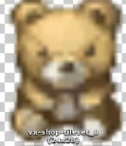Teddy Bear

Adds 1 points to player

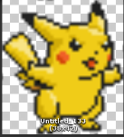Pikachu

Loves Teddy Bears

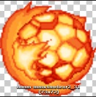Falling Meteor

Pikachu’s enemy, reduces Pikachu’s life by 1

Ground

Pikachu can only walk on these

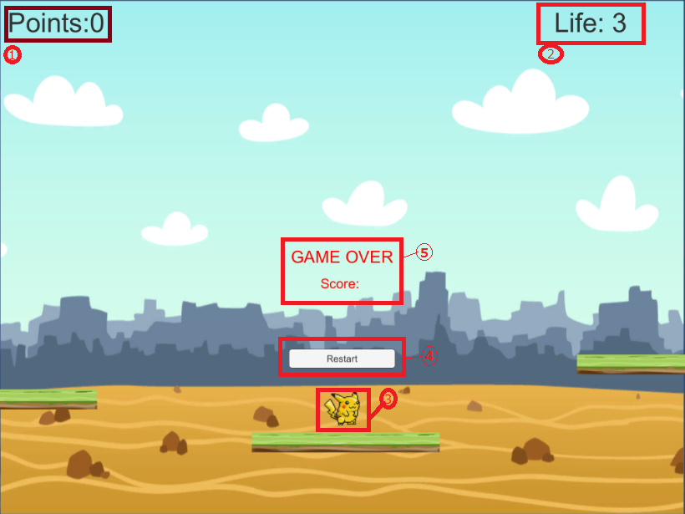

1: Points Label

2: Life Label

3: Player

4: Restart Button

5: Game Over and Score display