Assignment Task 3: Api testing in Jmeter

For this task the website “https://www.videogamedb.uk/swagger-ui/index.html#/” was provided. The swagger showed the following api and some of the possible response message and status codes

- api/authenticate → used to provide auth token that we are going to pass in other api
Expected Status Codes:
200 → OK
400 → Invalid Username or Password

- v1 api

  - GET /api/videogame → provides all the list of videogames
Expected Status Codes:
200 → OK

  - POST /api/videogame → creates a new videogame
200 → OK
400 → Invalid Request

  - GET /api/videogame/{id} → get single videogame based on ID provided
200 → OK
404 → Video game not found

  - PUT /api/videogame/{id} → update the videgame whose ID is provided
200 → OK
400 → Invalid Request
404 → Video game not found
  - DELETE /api/videogame/{id} → Delet the video game whose ID is provided
200 → OK
404 → Video game not found
- v2 api

  - GET /api/v2/videogame → provides all the list of videogames
Expected Status Codes:
200 → OK

  - POST /api/v2/videogame → creates a new videogame
200 → OK
400 → Invalid Request

  - GET /api/v2/videogame/{id} → get single videogame based on ID provided
200 → OK
404 → Video game not found

  - PUT /api/v2/videogame/{id} → update the videgame whose ID is provided
200 → OK
400 → Invalid Request
404 → Video game not found
  - DELETE /api/v2/videogame/{id} → Delet the video game whose ID is provided
200 → OK
404 → Video game not found

In addition to application/json v2 also accepts application/xml

Test Plan
For testing V1 and V2 I created two thread groups(1 threads and 1 second Ramp up time with no loop). Then each thread group had global HTTP Request Defaults and HTTP Header Manager

Also User Defined Variables was used for:
baseUrl → baseUrl for v1 and v2 → www.videogamedb.uk
gameId → to be used in put post and get by Id methods → 1
schemaPath → for JSON schema validation → path where schema folder is located
Overall Structure
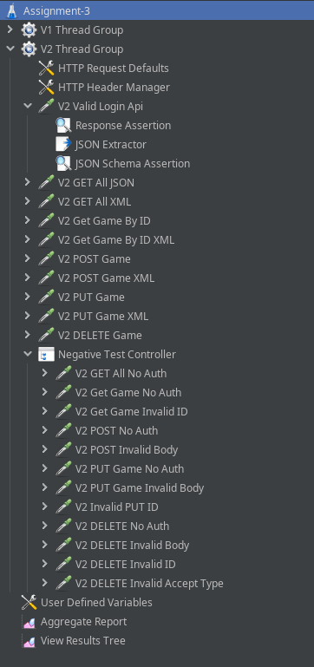
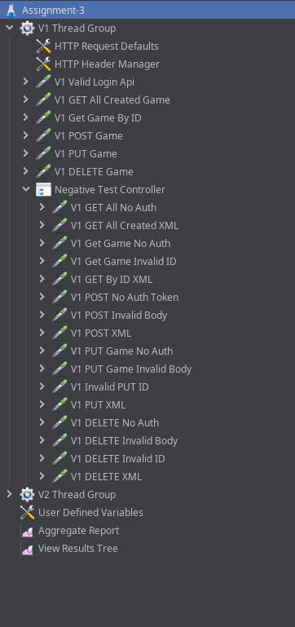

Cases:

V1 Thread Group
HTTP Request Defaults has following properties
protocol: https
server name: ${baseUrl}// User Defined Variable
port: 443

HTTP Header Manager has:
Content-Type and Accept both set to application/json as per the documentation

API Requests
Valid login api to fetch token then use JSON Extractor to assign it to ${token} variable

All following requests use the HTTP header Authorization with value Beare ${token}

Then all the valid requests utilize the JSON schema assertion
(Plugin: https://github.com/kde-intro/jmeter-json-schema-assertion-plugin)

It also uses Response Assertion with status code and the DELETE request uses Response Assertion with text response.

The Negative Test Controller contains all API request that are bound to fail by logic comprising of no auth header, invalid body or invalid ID.
Also it validates if application/xml is a valid response or not
Similar approach is used for Thread Group V2

Result and Analysis
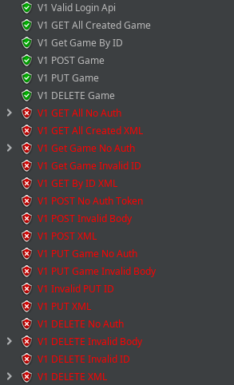
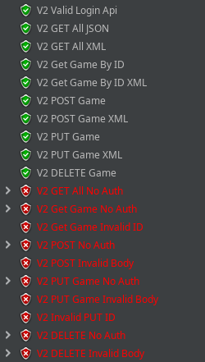
Failures:
- V1 Get All No Auth: The api document explicitly does not include anywhere that GET api can return success without providing auth header so in order to test that GET all games request was sent without authorization header and expected Error:403 forbidden but received 200
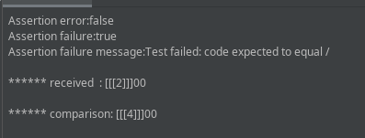

- Same case for GET with ID
- V1 Delete Invalid Body
The DELETE request does not require body parameter from the api documentaion. However even on sending a body it send success so there is a possibility that the api request is ignoring the body or this might not be the case so it is flagged.
- The api v1 doesnot provide info on it accepting application/xml so DELETE was expected to return 406 as in other requests. However it sent success 200.
- V2 GET all No Auth and V2 Get by ID
Same reason as for no auth in v1
- V2 POST No Auth: Critical
POST request is returning success even without providing auth token in header.
- V2 PUT No Auth: Critical
PUT request is returning success even without providing auth token in header.
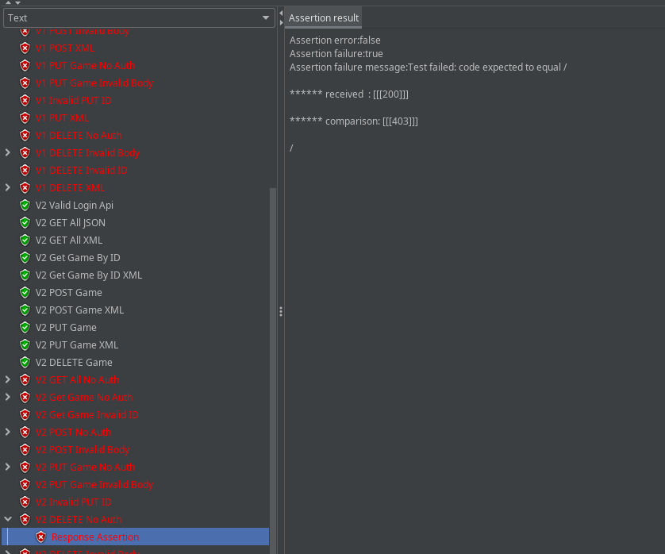
- V2 DELETE No Auth: Critical
DELETE request is returning success even without providing auth token in header.

- V2 Delete Invalid Body

