**[[BOTTOM]](http://pmatwiki.sandia.gov/pmatwiki/how-to-use-Co-Pylot?action=print#bottom)[[TOP]](http://pmatwiki.sandia.gov/pmatwiki/how-to-use-Co-Pylot?action=print#top)How to use Co-Pylot**

**[[BOTTOM]](http://pmatwiki.sandia.gov/pmatwiki/how-to-use-Co-Pylot?action=print#bottom)[[TOP]](http://pmatwiki.sandia.gov/pmatwiki/how-to-use-Co-Pylot?action=print#top)Introduction**

Co-Pylot is part of the code triumvirate of [Pylot](http://pmatwiki.sandia.gov/pmatwiki/how-to-use-pylot) / Co-Pylot / [eCo-Pylot](http://pmatwiki.sandia.gov/pmatwiki/how-to-use-eCo-Pylot). These codes can be used in stand-alone mode or together to easily move data files to database tables on a remote server (Co-Pylot, eCo-Pylot) as well as display the tables in an intuitive interface and analyze table data using various kinds of plots and statistical analysis (Pylot).

Co-Pylot is a graphical interface written in Python that allows the user to select one or batches of data files and send them to a database table on a local or remote server. Co-Pylot can be run locally (contact the author for installation details) or remotely from *glory.sandia.gov*. All datafiles that will be sent to a database must reside on the host running Co-Pylot. So, for example, data files on another machine must be transferred to *glory.sandia.gov* so that Co-Pylot can find and send the files.

Compared to eCo-Pylot, Co-Pylot has the ability to capture more information to send to a database table. However, it is not as convenient, as eCo-Pylot uses common email to capture and send datafiles to a database table.

Suggestions for improvements to Co-Pylot are welcome.

**[[BOTTOM]](http://pmatwiki.sandia.gov/pmatwiki/how-to-use-Co-Pylot?action=print#bottom)[[TOP]](http://pmatwiki.sandia.gov/pmatwiki/how-to-use-Co-Pylot?action=print#top)Co-Pylot Startup**

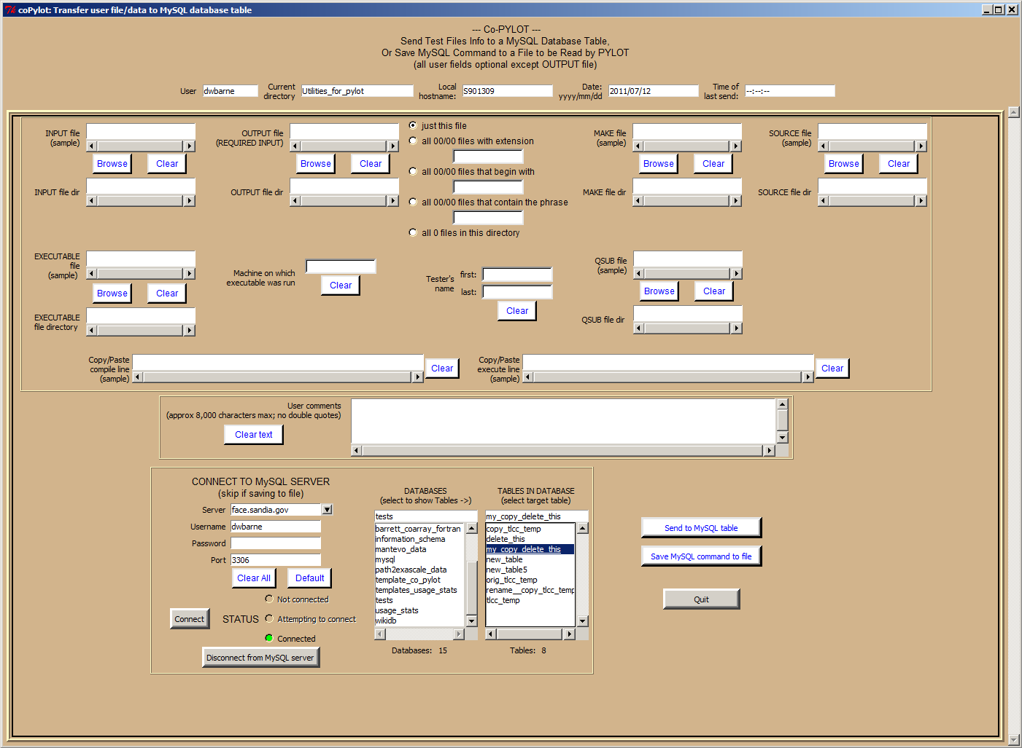

An X server is needed to display images back to the console. On *nix boxes, the X server comes as part of the OS.

On Window boxes, however, the user must install an X server. Xming, for example, is known to run well on Windows and is easy to install and launch. Go to [XmingDownload](http://sourceforge.net/projects/xming/) to download this server's installation package. Install and launch before continuing with following instructions.

Use the following to login to *glory.sandia.gov* to run Co-Pylot from there. From a *nix machine:

<prompt>$ export DISPLAY=localhost:0.0

<prompt>$ ssh -X <username>@face.sandia.gov

From a Windows machine, the DISPLAY variable is set by entering the following command in the command/terminal window:

<prompt>> set DISPLAY=localhost:0.0

<prompt>> ssh -X <username>@face.sandia.gov

Again, these commands assume an X server is running on the local machine.

Next, enter the following on the command line.

python /home/dwbarne/Pylot/co-pylot.py

and hit enter.

This should bring up Co-Pylot's one and only screen.

**[[BOTTOM]](http://pmatwiki.sandia.gov/pmatwiki/how-to-use-Co-Pylot?action=print#bottom)[[TOP]](http://pmatwiki.sandia.gov/pmatwiki/how-to-use-Co-Pylot?action=print#top)Capturing data to send to a database table**

The top fields in Co-Pylot's interface are auto-filled with the

* user
* current directory
* local hostname
* date
* time of last send

Actually, the 'Time of last send' field will auto-fill when the data are sent to the specified table.

Fields are also provided for

* input filename and directory
* output filename and directory (this is a required field; Co-Pylot will not send data until output files are specified)
* make filename and directory
* source filename and directory
* executable filename and directory
* machine on which the executable was run
* tester's first and last name (to accommodate the fact that the tester may be different from the person actually submitting the data)
* qsub filename and directory
* compile line (filled by cut and paste)
* execute line (filled by cut and paste)
* user comments

Again, all fields are optional except the output filename and directory. The output files are the files that are parsed for relevant information such as performance data. The contents of the output file will also be saved to the database. Only filenames and directory names are saved for the other files.

The user must also specify one of the following for the output files:

* just this file, or
* all files with a specified extension, or
* all files that begin with a specified string, or
* all files that contain a specified phrase, or
* all files in the specified directory

This allows the user to send one or many files in the directory to the targeted database.

The next step is to login to the database server and send the data.

**[[BOTTOM]](http://pmatwiki.sandia.gov/pmatwiki/how-to-use-Co-Pylot?action=print#bottom)[[TOP]](http://pmatwiki.sandia.gov/pmatwiki/how-to-use-Co-Pylot?action=print#top)Logging In To A Database Server**

Co-Pylot allows the user to login to the database server to which files will be sent. The database login interface is identical to that in Pylot.

Choose following (example):

Server: <server_location>

Username: <your_user_name_to_server>

Password: <your_password_to_server>

Port: <port> (default is 3306 for MySQL servers)

Click 'Connect'.

A list of databases will be shown. Click on the database and table desired. The table should be structured to receive Co-Pylot data. This should have been done previously when the target table was constructed. Such tables can be constructed from the table **template_co_pylot_eco_pylot** located in the database **template_co_pylot**. The Pylot code can be used to check table structure if there is any doubt, as well as to construct the target table from the templates provided.

To disconnect from the server at any time, click on 'Disconnect from server' button.

**[[BOTTOM]](http://pmatwiki.sandia.gov/pmatwiki/how-to-use-Co-Pylot?action=print#bottom)[[TOP]](http://pmatwiki.sandia.gov/pmatwiki/how-to-use-Co-Pylot?action=print#top)Sending data to a database table**

The data is sent to the selected table by clicking 'Send to MySQL table'. A pop-up will indicate whether the table insertion was a success.

In case it cannot connect to a particular database, Co-Pylot has the ability to save the table insertion command to a file. Pylot can be used later to insert the data by reading the file. Confer [Pylot's](http://pmatwiki.sandia.gov/pmatwiki/how-to-use-pylot) home page for details. This is particularly handy if a remote user or collaborator does not have access to the database table in which the data is to be inserted, or if the server is for some reason not readily accessible to the user.