Contents

1. [Author Contact Information](http://pmatwiki.sandia.gov/pmatwiki/how-to-use-pylot?action=print#head-288227ce0999c15b7f7cbee2ed01a77958dd4904)
2. [Download Pylot and Installation Software](http://pmatwiki.sandia.gov/pmatwiki/how-to-use-pylot?action=print#head-7778b8ab2528e08eb8dd06909eb6650ba2649b60)
3. [How to use Pylot](http://pmatwiki.sandia.gov/pmatwiki/how-to-use-pylot?action=print#head-63d35aea2f6af83e12ce8c0cf16ddc85525ce0ff)
   1. [Introduction](http://pmatwiki.sandia.gov/pmatwiki/how-to-use-pylot?action=print#head-66162f146d5ddf7af89c4baf3b3c08cdd6aba038)
   2. [Pylot Startup](http://pmatwiki.sandia.gov/pmatwiki/how-to-use-pylot?action=print#head-4e18db72e1f9d378a0fb86c1c6dc97d670179a3d)
   3. [Pylot's 'I/O Windows' Screen](http://pmatwiki.sandia.gov/pmatwiki/how-to-use-pylot?action=print#head-32e8ec7a22c9a5791c4ede6f3066fc2ea711a6a4)
   4. [Logging In To A Database Server](http://pmatwiki.sandia.gov/pmatwiki/how-to-use-pylot?action=print#head-462f10f0a79bbc8a6be5f2cff0ef8d6abfdd64e0)
4. [Managing Databases, Tables, and Fields](http://pmatwiki.sandia.gov/pmatwiki/how-to-use-pylot?action=print#head-7be00c3dc3e2a07d0a626caabe49f98e27f0ace8)
   1. [Management of Databases: Create, Delete, Rename database](http://pmatwiki.sandia.gov/pmatwiki/how-to-use-pylot?action=print#head-26b04cf0774fdf014beeaa5b0f4921acfd8a27e9)
      1. [Create a database](http://pmatwiki.sandia.gov/pmatwiki/how-to-use-pylot?action=print#head-9f846fab945e9d43409572070194c7fbfe9fa66c)
      2. [Delete a database](http://pmatwiki.sandia.gov/pmatwiki/how-to-use-pylot?action=print#head-9f273b76b6c864bfb950874f4acd42d97baa9d79)
      3. [Rename a database](http://pmatwiki.sandia.gov/pmatwiki/how-to-use-pylot?action=print#head-967b267812b461f41de77d8b5e73e929cea8b729)
   2. [Management of Tables: Create, Delete, Rename, Copy](http://pmatwiki.sandia.gov/pmatwiki/how-to-use-pylot?action=print#head-f7cc6de7d8e479615f029e5dec50bcc90243d8fb)
      1. [Create a Table](http://pmatwiki.sandia.gov/pmatwiki/how-to-use-pylot?action=print#head-87afebec03a29af4bc4f1acf16aadc3c14cb039a)
         1. [Method 1: From Scratch](http://pmatwiki.sandia.gov/pmatwiki/how-to-use-pylot?action=print#head-7072842e00bee7bd23056504042a0e4db7565312)
         2. [Method 2: From an Existing Database and Table](http://pmatwiki.sandia.gov/pmatwiki/how-to-use-pylot?action=print#head-9f7901b52b580636b9c526efab445632816238f3)
   3. [Management of Fields: Add, Delete, Edit field name](http://pmatwiki.sandia.gov/pmatwiki/how-to-use-pylot?action=print#head-239bb7d37e0925ebb22813d259f7ed4aa2579822)
      1. [Add a Field](http://pmatwiki.sandia.gov/pmatwiki/how-to-use-pylot?action=print#head-42e5541952ae5bdb698b2967f7feeafbd94b2146)
      2. [Delete a Field](http://pmatwiki.sandia.gov/pmatwiki/how-to-use-pylot?action=print#head-40cdac47da28c0652f107640f9e8a56c34152c9c)
      3. [Edit a field name](http://pmatwiki.sandia.gov/pmatwiki/how-to-use-pylot?action=print#head-ec3e6a96e7f0382342dfb5271853c6255b42ebf5)
   4. [Backup & Restore Databases and Tables](http://pmatwiki.sandia.gov/pmatwiki/how-to-use-pylot?action=print#head-261683ce5382b3ea50e17ff0ba2753c9999bd8c2)
      1. [Backup](http://pmatwiki.sandia.gov/pmatwiki/how-to-use-pylot?action=print#head-63da9259a0555f3e19dbb52dafbca028d8e08ffa)
      2. [Restore](http://pmatwiki.sandia.gov/pmatwiki/how-to-use-pylot?action=print#head-283ef46293d3ed0ad9336b3dc14424860a0acdc0)
      3. [Other notes](http://pmatwiki.sandia.gov/pmatwiki/how-to-use-pylot?action=print#head-d1235fcce285445e1f480f50c6b1f2624cd846fd)
5. [Functions for Manipulating Fields and Data Within a Selected Table](http://pmatwiki.sandia.gov/pmatwiki/how-to-use-pylot?action=print#head-d2a37dd2c3a3ee26a46b5b8597d6d78bcddb6d48)
   1. [Main Table Functions](http://pmatwiki.sandia.gov/pmatwiki/how-to-use-pylot?action=print#head-a640e874dfc1f80339b127ed0489146b5f9a9405)
      1. [Refresh complete table](http://pmatwiki.sandia.gov/pmatwiki/how-to-use-pylot?action=print#head-6c2de88fb36eab3a34d96f3d3f991ea3e14c16bd)
      2. [Show Numerical Fields Only](http://pmatwiki.sandia.gov/pmatwiki/how-to-use-pylot?action=print#head-708ddd4b28992d08bd9ffb0c77f2d93e61290407)
      3. [Show Text Fields Only](http://pmatwiki.sandia.gov/pmatwiki/how-to-use-pylot?action=print#head-0b528bc3ae22c8cc5068f3864c35029889ecadb2)
      4. [Show Selected Rows Only](http://pmatwiki.sandia.gov/pmatwiki/how-to-use-pylot?action=print#head-b9459ffb2cc0abce3d940dc8ce942585e4ac2742)
      5. [Stats for X-Select Field](http://pmatwiki.sandia.gov/pmatwiki/how-to-use-pylot?action=print#head-e4f6779735766e8e50d7d74df150f41406837e99)
      6. [Table Filtering Options](http://pmatwiki.sandia.gov/pmatwiki/how-to-use-pylot?action=print#head-5356d802ff4ac180fca8282ec97eaa4362089419)
      7. [X-Y Plots using X-Y-Select Fields](http://pmatwiki.sandia.gov/pmatwiki/how-to-use-pylot?action=print#head-41613ebc54bb9ba0b3964bc16e1be0def2f257c9)
      8. [Kiviat Plots using Y-Select Fields and Select Rows](http://pmatwiki.sandia.gov/pmatwiki/how-to-use-pylot?action=print#head-34619fbf9602c709a1124d571e9ebacaa5cc6c7a)
      9. [Import Co-Pylot Data File](http://pmatwiki.sandia.gov/pmatwiki/how-to-use-pylot?action=print#head-1b052f98d3e59775824f73e3496aeef7ce7832e0)
      10. [Import CSV Data](http://pmatwiki.sandia.gov/pmatwiki/how-to-use-pylot?action=print#head-4e89c3b9ad822b66927c0348ae9a160327c96501)
      11. [Edit Selected Rows](http://pmatwiki.sandia.gov/pmatwiki/how-to-use-pylot?action=print#head-a6626c574a027ba8dd861dfba10b563aaeea20cb)
      12. [Input New Rows Manually](http://pmatwiki.sandia.gov/pmatwiki/how-to-use-pylot?action=print#head-310714274af3f5edb31517747d4dd420d28164f2)
      13. [Export Y-Select Fields to CSV File](http://pmatwiki.sandia.gov/pmatwiki/how-to-use-pylot?action=print#head-6e587629ee99d5564b0f59f0e898a68fbc849446)
      14. [Extract Data & Fill Table Using X-Select Field](http://pmatwiki.sandia.gov/pmatwiki/how-to-use-pylot?action=print#head-da7a3db0f12fda09c142e03876795e4c6b6ee4a7)
          1. [YAML-formatted field in table](http://pmatwiki.sandia.gov/pmatwiki/how-to-use-pylot?action=print#head-e58d596f97e2817e6563ae6f906c17d2658a3fd1)
          2. [Text field](http://pmatwiki.sandia.gov/pmatwiki/how-to-use-pylot?action=print#head-45af5c056c9f4f09de4a4416c7878afe5aecd91b)
   2. [Buffer functions](http://pmatwiki.sandia.gov/pmatwiki/how-to-use-pylot?action=print#head-75e0a3a3a43490643f8ba2ecc1b2c09ff8c68fcd)
      1. [BUFFER: Store X-Y Fields](http://pmatwiki.sandia.gov/pmatwiki/how-to-use-pylot?action=print#head-f30984ec1909afea1bebb2827168cca2442a4546)
      2. [BUFFER: Display](http://pmatwiki.sandia.gov/pmatwiki/how-to-use-pylot?action=print#head-d9a881da54f2daafd54953a0060b9258cbaf5df2)
         1. [Refresh display](http://pmatwiki.sandia.gov/pmatwiki/how-to-use-pylot?action=print#head-278542de550c35200ee436b83240de9ead794831)
         2. [Hide user fields](http://pmatwiki.sandia.gov/pmatwiki/how-to-use-pylot?action=print#head-dd85e383cf862edb344d7f8c5dd6bc9a8c9e4649)
         3. [Pickle select rows to file](http://pmatwiki.sandia.gov/pmatwiki/how-to-use-pylot?action=print#head-d24dfd81804e02fb9f5d4f2b9249b328f37045e4)
         4. [unPickle file to buffer](http://pmatwiki.sandia.gov/pmatwiki/how-to-use-pylot?action=print#head-7c6f9a5a898977fde21809c9a47cbc2dd97b2310)
         5. [Save select rows to CSV file](http://pmatwiki.sandia.gov/pmatwiki/how-to-use-pylot?action=print#head-fa11ce388da6f8ba49157d476e8a5971a3a07d89)
         6. [Read/append CSV file to buffer](http://pmatwiki.sandia.gov/pmatwiki/how-to-use-pylot?action=print#head-5d23cb9e8d9d2575177aeb38c6de7e7a5e8e83aa)
         7. [Purge duplicates from buffer](http://pmatwiki.sandia.gov/pmatwiki/how-to-use-pylot?action=print#head-70e8569b12dd372cd633dc4f75b8e69b5a61ace8)
         8. [Auto-Sort on selected column](http://pmatwiki.sandia.gov/pmatwiki/how-to-use-pylot?action=print#head-ddf1822f94f901a30cade6f8e2f4a0958cf72e69)
         9. [Move selected row](http://pmatwiki.sandia.gov/pmatwiki/how-to-use-pylot?action=print#head-b299ec4fcaa16860930469b1ee85122350d3f627)
         10. [Delete select rows](http://pmatwiki.sandia.gov/pmatwiki/how-to-use-pylot?action=print#head-30a7a6243ab4682ab47f8a0af022d439ebc72c2a)
         11. [Clear buffer](http://pmatwiki.sandia.gov/pmatwiki/how-to-use-pylot?action=print#head-e8d80597fd27db241436ced536b1274a4f6ab36f)
      3. [Additional Buffer Functions](http://pmatwiki.sandia.gov/pmatwiki/how-to-use-pylot?action=print#head-3d5560be4b20bdabc939d58bb55542dcb83d92ba)
         * 1. [Clear/Select all](http://pmatwiki.sandia.gov/pmatwiki/how-to-use-pylot?action=print#head-f51214315c3ab1cdb6b34e591f5e3c029b461cb9)
           2. [FORM new row](http://pmatwiki.sandia.gov/pmatwiki/how-to-use-pylot?action=print#head-bfdfea708704412fb09fbe4ab8165b018a2dbbb6)
           3. [UPDATE x-y plots (from Storage Buffer)](http://pmatwiki.sandia.gov/pmatwiki/how-to-use-pylot?action=print#head-5daeccad0c566366c1cf2f064a9fa0013ffbc794)
   3. [Update plot functions](http://pmatwiki.sandia.gov/pmatwiki/how-to-use-pylot?action=print#head-8ff341a4d949889e4447ead22aea1d1fda25ffbb)
      1. [UPDATE X-Y Plots](http://pmatwiki.sandia.gov/pmatwiki/how-to-use-pylot?action=print#head-8d2fcbf31bf3ef7e3291478b30e3d15765356d77)
      2. [UPDATE KIVIAT Plots](http://pmatwiki.sandia.gov/pmatwiki/how-to-use-pylot?action=print#head-180649645d70bc6e2492177dffc9f13d4d4e8c8e)
   4. [Select/De-Select Field Functions](http://pmatwiki.sandia.gov/pmatwiki/how-to-use-pylot?action=print#head-1b5f6ae29dc16deefc8f49023cb391cfa92545e1)
      1. [Select numerical Y Fields (except X)](http://pmatwiki.sandia.gov/pmatwiki/how-to-use-pylot?action=print#head-de200a67d2fbd883c598d6d7c842ffbd09d95ccf)
      2. [De-select all Y](http://pmatwiki.sandia.gov/pmatwiki/how-to-use-pylot?action=print#head-3f15c4d3da1ab9204925a088dab26c287ad87fa2)
      3. [De-select X](http://pmatwiki.sandia.gov/pmatwiki/how-to-use-pylot?action=print#head-a4bc30b8e1c1b113f9670f663c0f72a7e4be403e)
   5. [Partial display functions](http://pmatwiki.sandia.gov/pmatwiki/how-to-use-pylot?action=print#head-6b3bc30888a0172161ad284733546dbef386ce94)
      1. [Max lines to display](http://pmatwiki.sandia.gov/pmatwiki/how-to-use-pylot?action=print#head-85dfaf8f79811400e0e7573db83385b80c3634b0)
      2. [Beginning](http://pmatwiki.sandia.gov/pmatwiki/how-to-use-pylot?action=print#head-40e9b2c14fcfebaca2fdab81cb72b98994c1a8be)
      3. [Middle](http://pmatwiki.sandia.gov/pmatwiki/how-to-use-pylot?action=print#head-6699fcf97190404f7f7b95e78317947d0af5b63b)
      4. [End](http://pmatwiki.sandia.gov/pmatwiki/how-to-use-pylot?action=print#head-b87ec4691acd8adfa9127a8803769e3b8a6f34fa)
      5. [Range...](http://pmatwiki.sandia.gov/pmatwiki/how-to-use-pylot?action=print#head-875a829f8276d17ba98a904a1e7697a87ef07877)
   6. [Re-sequence auto_index](http://pmatwiki.sandia.gov/pmatwiki/how-to-use-pylot?action=print#head-27fa7c22ccbcb158107570ff09a20fa5b40ca817)
   7. [Clear/Select all](http://pmatwiki.sandia.gov/pmatwiki/how-to-use-pylot?action=print#head-f51214315c3ab1cdb6b34e591f5e3c029b461cb9-2)
   8. [Cancel](http://pmatwiki.sandia.gov/pmatwiki/how-to-use-pylot?action=print#head-ed45e3a84121865608f93658eb68d70df8aaab54)
6. [Plotting](http://pmatwiki.sandia.gov/pmatwiki/how-to-use-pylot?action=print#head-0da52b486259a7fcd00105dc36818af5c47ce952)
   1. [Bar and Pie Charts](http://pmatwiki.sandia.gov/pmatwiki/how-to-use-pylot?action=print#head-d8e8849b23047b9b6f9726edd31b8f50ee2dbab2)
   2. [Cartesian Plots](http://pmatwiki.sandia.gov/pmatwiki/how-to-use-pylot?action=print#head-6a522adee3d70c38199e178147bc94667596d248)
   3. [Semi-Log Plots](http://pmatwiki.sandia.gov/pmatwiki/how-to-use-pylot?action=print#head-1cea163a86387f7b601f8feaf1dee531dd0fba71)
   4. [Log-Log Plots](http://pmatwiki.sandia.gov/pmatwiki/how-to-use-pylot?action=print#head-820659ea5e83dcd987f3d5e199a481cdc63cbd6f)
   5. [Kiviat (Radar) Plots for Multi-Variate data](http://pmatwiki.sandia.gov/pmatwiki/how-to-use-pylot?action=print#head-4b3660965c40b3d123cf723fc86cf5da513355df)
7. [References](http://pmatwiki.sandia.gov/pmatwiki/how-to-use-pylot?action=print#head-c404218048b65f4d3acb1b26d5b5853f3e12275d)

**[[BOTTOM]](http://pmatwiki.sandia.gov/pmatwiki/how-to-use-pylot?action=print#bottom)[[TOP]](http://pmatwiki.sandia.gov/pmatwiki/how-to-use-pylot?action=print#top)Author Contact Information**

The author of Pylot is Daniel Barnette, Org. 1422. Daniel can be reached as follows:

* Sandia email: [dwbarne@sandia.gov](mailto:dwbarne@sandia.gov)
* Gmail: [dwbarne@gmail.com](mailto:dwbarne@gmail.com)
* Office phone: 505.844.0214 (do not leave voicemail)
* Cell phone (preferred!!!): 505.453.1032

**[[BOTTOM]](http://pmatwiki.sandia.gov/pmatwiki/how-to-use-pylot?action=print#bottom)[[TOP]](http://pmatwiki.sandia.gov/pmatwiki/how-to-use-pylot?action=print#top)Download Pylot and Installation Software**

Pylot and associated installation software downloads [here](http://pmatwiki.sandia.gov/pmatwiki/how-to-use-pylot?action=AttachFile&do=view&target=Pylot.zip).

**[[BOTTOM]](http://pmatwiki.sandia.gov/pmatwiki/how-to-use-pylot?action=print#bottom)[[TOP]](http://pmatwiki.sandia.gov/pmatwiki/how-to-use-pylot?action=print#top)How to use Pylot**

**[[BOTTOM]](http://pmatwiki.sandia.gov/pmatwiki/how-to-use-pylot?action=print#bottom)[[TOP]](http://pmatwiki.sandia.gov/pmatwiki/how-to-use-pylot?action=print#top)Introduction**

Pylot is part of the code triumvirate of Pylot / [Co-Pylot](http://pmatwiki.sandia.gov/pmatwiki/how-to-use-Co-Pylot) / [eCo-Pylot](http://pmatwiki.sandia.gov/pmatwiki/how-to-use-eCo-Pylot). These codes can be used in stand-alone mode or together to easily move data files to database tables on a remote server (Co-Pylot, eCo-Pylot) as well as display the tables in an intuitive interface and analyze table data using various kinds of plots and statistical analysis (Pylot).

Pylot is database management software written in 100% Python. With Pylot, you can access local or remote MySQL servers to display, manage, and/or analyze databases, tables in the databases, and fields in the tables.

Although a stand-alone code in its own right, Pylot may be used with Co-Pylot and eCo-Pylot, software used to easily transfer datafiles to database tables. Co-Pylot is a one-window stand-alone interface that allows the user to select and transfer one or batches of datafiles to a previously-created database, along with other user info and user-specified comments. eCo-Pylot is a Python script that intercepts emails sent to a specific address, extracts one or more attached datafiles, parses the email for user and database information, and inserts the information into a database table (each datafile inserts into separate table rows). The target database is specified in the username. The target database table is specified in the subject line. Either code makes it very straightforward for users to send datafiles to a specific database and table. How the table's datafiles are handled from there is discussed in detail below (*cf* 'Extract Data & Fill Table Using X-Select Field' widget). More information on these codes may be found at [how-to-use-Co-Pylot](http://pmatwiki.sandia.gov/pmatwiki/how-to-use-Co-Pylot) and [how-to-use-eCo-Pylot](http://pmatwiki.sandia.gov/pmatwiki/how-to-use-eCo-Pylot).

Pylot is targeted for users who have at least some working knowledge or concept of SQL databases. However, Pylot can be used to learn about SQL database concepts as well since knowledge of the SQL language is helpful but not absolutely necessary to run the code. The database functions and table data can be accessed, processed, and/or manipulated simply by point and click methods. Helpful messages will pop up if the user tries to execute an improper operation.

Once the server is accessed and a database and table have been selected, Pylot allows operations such as database/table/field creation; backup/restore of databases to the local machine from local or remote servers; data filtering; plotting with x-y, semi-log, log-log, and kiviat charts for multivariate datasets; statistical analyses with bar and pie graphs for both numerical and text data; reference curve generation as a multiple of an existing curve, a vertical line, and/or a horizontal reference line. Pylot also uses an internal storage buffer that allows data to be stored from different databases for a wide range of data comparisons. The buffer also permits mathematically combining up to 4 different data sets to generate unlimited number of new data fields that are not contained in the original database tables, resulting in a large degree of flexibility for the user. Any numerical data from the storage buffer and/or database tables can be plotted in either separate graphs or all in one graph. All of these functionalities are discussed in detail below.

It has been the author's goal to design each window to be as intuitive to the user as possible. Suggestions for improvement are always welcome.

**[[BOTTOM]](http://pmatwiki.sandia.gov/pmatwiki/how-to-use-pylot?action=print#bottom)[[TOP]](http://pmatwiki.sandia.gov/pmatwiki/how-to-use-pylot?action=print#top)Pylot Startup**

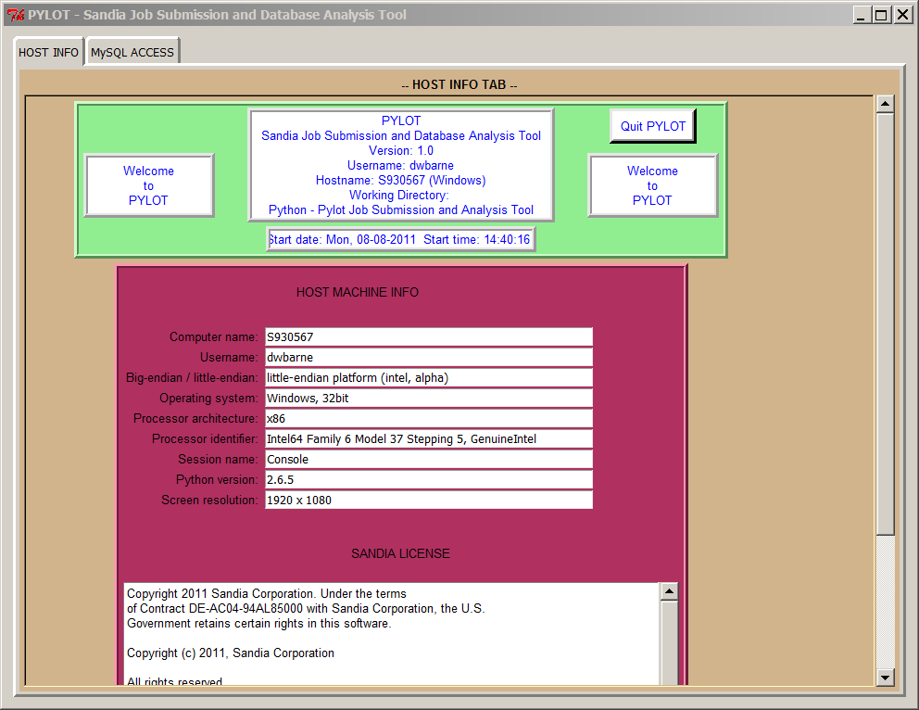

Pylot is currently installed on Glory (glory.sandia.gov) and Face (face.sandia.gov). With the correct libraries, Pylot may also be installed to a local machine allowing faster execution. Contact the author for details.

An X server is needed to display images back to the console. On *nix boxes, the X server comes as part of the OS.

On Window boxes, however, the user must install an X server. Xming, for example, is known to run well on Windows and is easy to install and launch. Go to [XmingDownload](http://sourceforge.net/projects/xming/) to download this server's installation package. Install and launch before continuing with following instructions.

Use the following to login to the database server Face. As of July 2011, current version of Python on Face is 2.6.6.

From a *nix machine:

<prompt>$ export DISPLAY=localhost:0.0

<prompt>$ ssh -X <username>@face.sandia.gov

From a Windows machine, the DISPLAY variable is set by entering the following command in the command/terminal window:

<prompt>> set DISPLAY=localhost:0.0

<prompt>> ssh -X <username>@face.sandia.gov

Again, these commands assume an X server is running on the local machine.

Next, enter the following on the command line.

python /home/dwbarne/Pylot/pylot.py

and hit enter.

This should bring up Pylot's welcome screen as well as Pylot's "I/O Windows" screen.

**[[BOTTOM]](http://pmatwiki.sandia.gov/pmatwiki/how-to-use-pylot?action=print#bottom)[[TOP]](http://pmatwiki.sandia.gov/pmatwiki/how-to-use-pylot?action=print#top)Pylot's 'I/O Windows' Screen**

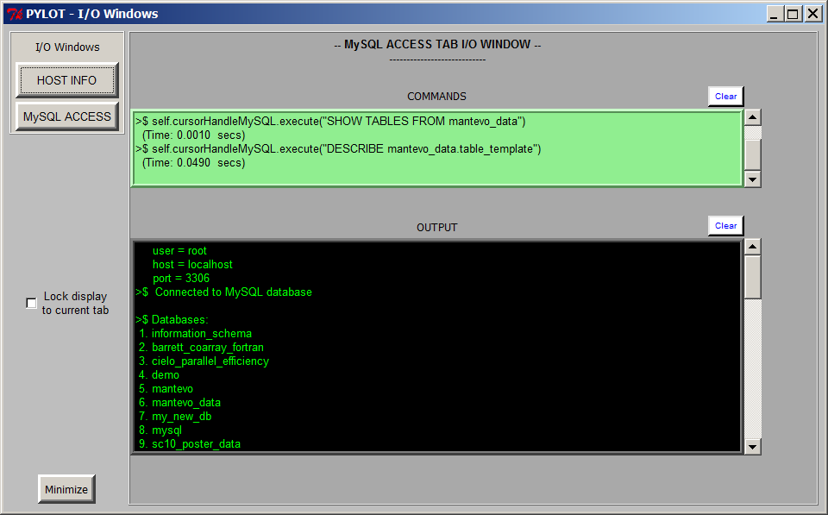

Upon startup, Pylot opens two windows: the main window with tabs for **HOST INFO** and **MySQL ACCESS**, and the window **PYLOT - I/O Windows**. The tabbed windows will be discussed below. First, let's focus on the 'I/O Windows' window.

The **I/O Windows** window lists most commands generated in Pylot in the upper scrolled box. The results of the commands are shown in the lower scrolled box. Database-server command timings are shown in the upper box. This allows the user to gage server performance.

The I/O Window senses when different tabs are chosen in Pylot's main window and displays output from the chose tab. If desired, the user can lock the display on a particular tab by simply clicking the checkbox next to **Lock display to current tab**. The I/O Window will continue to show output from that particular tab even if other tabs are selected for display in the main window.

If it is distracting, the I/O Window can be minimized by clicking the **Minimize** button.

Either display box may be cleared by clicking the **Clear** button at the upper right hand corner of the box.

**[[BOTTOM]](http://pmatwiki.sandia.gov/pmatwiki/how-to-use-pylot?action=print#bottom)[[TOP]](http://pmatwiki.sandia.gov/pmatwiki/how-to-use-pylot?action=print#top)Logging In To A Database Server**

Click on the MySQL ACCESS tab, which generates the following window.

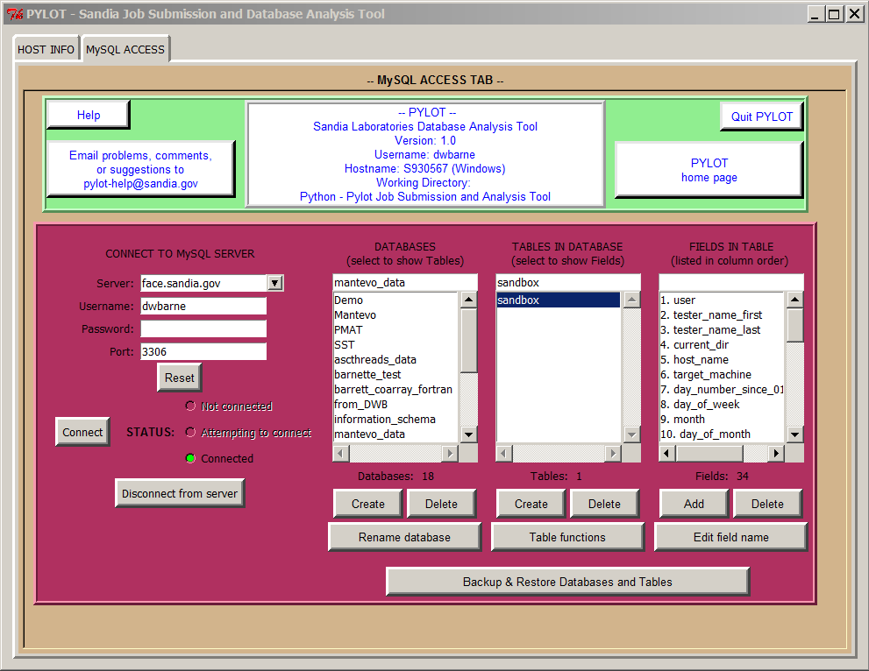

Choose following (example):

Server: <server_location>

Username: <your_user_name_to_server>

Password: <your_password_to_server>

Port: <port> (default is 3306 for MySQL servers)

Click 'Connect'.

A list of databases will be shown. Click on the database called 'mantevo_data'.

Table 'sandbox' should be shown. Click on 'sandbox' and the fields in 'sandbox' will be shown.

Click on 'Table functions', then 'Show table' to go to the 'Values for Table' window, or 'Show table structure' to show how the currently selected table is structured (field names, datatypes, etc.). Note that the table may be empty.

Once the 'Values for Table' window is displayed, you can practice by clicking on one of the widgets to the left of the table. Click on 'Input New Rows Manually' and you can manually input data to the table.

You will have to click on 'Refresh complete table' to see what you've input into the database.

When finished, just click on Cancel and the window will close. Click on Cancel again in the Table Functions window to close it as well. This will bring you back to the main tabbed window for Pylot.

To disconnect from the server at any time, click on 'Disconnect from server' button.

**[[BOTTOM]](http://pmatwiki.sandia.gov/pmatwiki/how-to-use-pylot?action=print#bottom)[[TOP]](http://pmatwiki.sandia.gov/pmatwiki/how-to-use-pylot?action=print#top)Managing Databases, Tables, and Fields**

In the following discussion, it is helpful to think of a database as having a folder/file/content-type structure. In other words, you create the name of the database (folder). There is nothing in the database (folder) until you create a table (file) and then add data (content) to that table (file). A database (folder) can have one or more tables (files). In the case of a database, each table has one or more fields (or columns of data) associated with it.

We will now discuss

1. database creation/deletion/renaming
2. how to create/delete/rename/copy a table within our database
3. how to add/delete fields and edit field names within our table

Let's discuss database creation/deletion/renaming first.

**[[BOTTOM]](http://pmatwiki.sandia.gov/pmatwiki/how-to-use-pylot?action=print#bottom)[[TOP]](http://pmatwiki.sandia.gov/pmatwiki/how-to-use-pylot?action=print#top)Management of Databases: Create, Delete, Rename database**

Buttons located in the 'MySQL ACCESS' tab under the 'DATABASES' box allow the user to create, delete, or rename a database. Clicking on any one of these buttons causes any windows associated with the other buttons to close and then opens the window associated with the selected button. For example, clicking on the 'Create' button causes the 'Delete' or 'Rename database' window to close if they are open, and the 'Create' window is then displayed.

**[[BOTTOM]](http://pmatwiki.sandia.gov/pmatwiki/how-to-use-pylot?action=print#bottom)[[TOP]](http://pmatwiki.sandia.gov/pmatwiki/how-to-use-pylot?action=print#top)Create a database**

Clicking on 'Create' button under the 'DATABASES' box displays the following pop-up window on top of the main window:

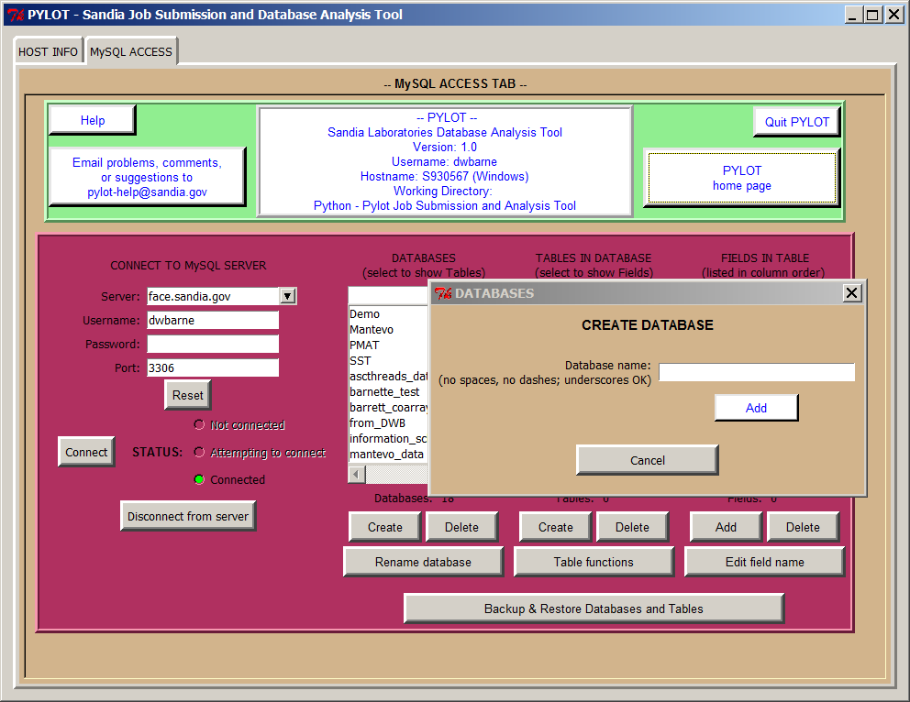

Type in any name you wish, with the following caveats:

1. do not use spaces or dashes
2. underscores are ok to use
3. filenames can be no longer than XX characters
4. use lowercase only

After entering a properly-formatted name, click 'Add' and the database name will appear in the 'DATABASES' window. Database names in this window are listed in alphabetical order.

**[[BOTTOM]](http://pmatwiki.sandia.gov/pmatwiki/how-to-use-pylot?action=print#bottom)[[TOP]](http://pmatwiki.sandia.gov/pmatwiki/how-to-use-pylot?action=print#top)Delete a database**

Clicking on 'Delete' button displays the following pop-up window on top of the main window:

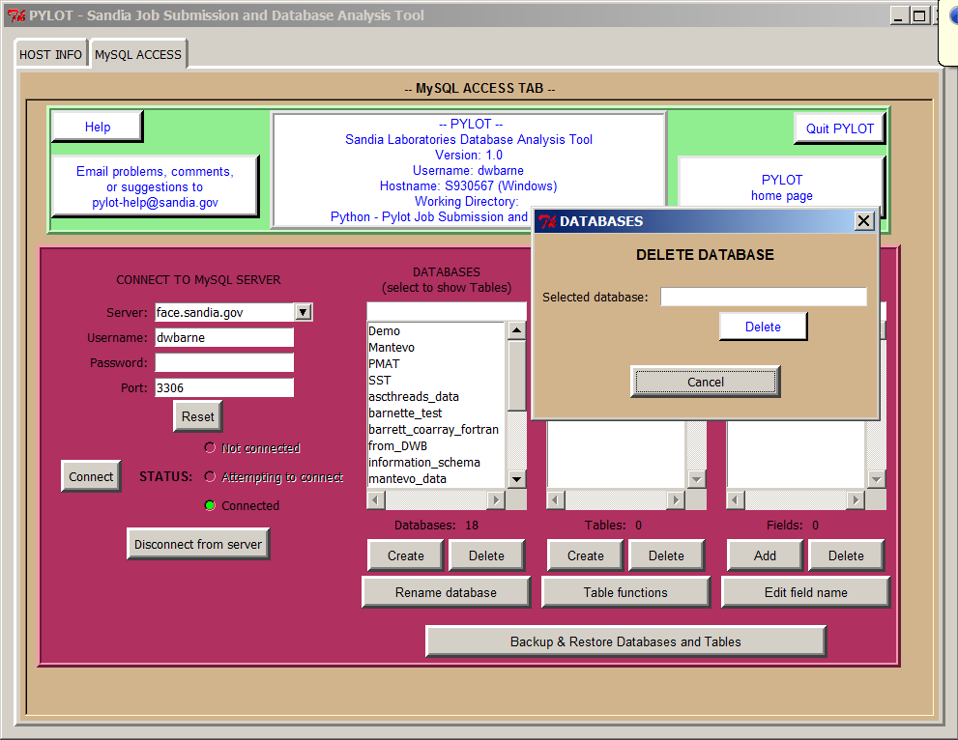

**[[BOTTOM]](http://pmatwiki.sandia.gov/pmatwiki/how-to-use-pylot?action=print#bottom)[[TOP]](http://pmatwiki.sandia.gov/pmatwiki/how-to-use-pylot?action=print#top)Rename a database**

Clicking on 'Rename database' button displays the following pop-up window on top of the main window:

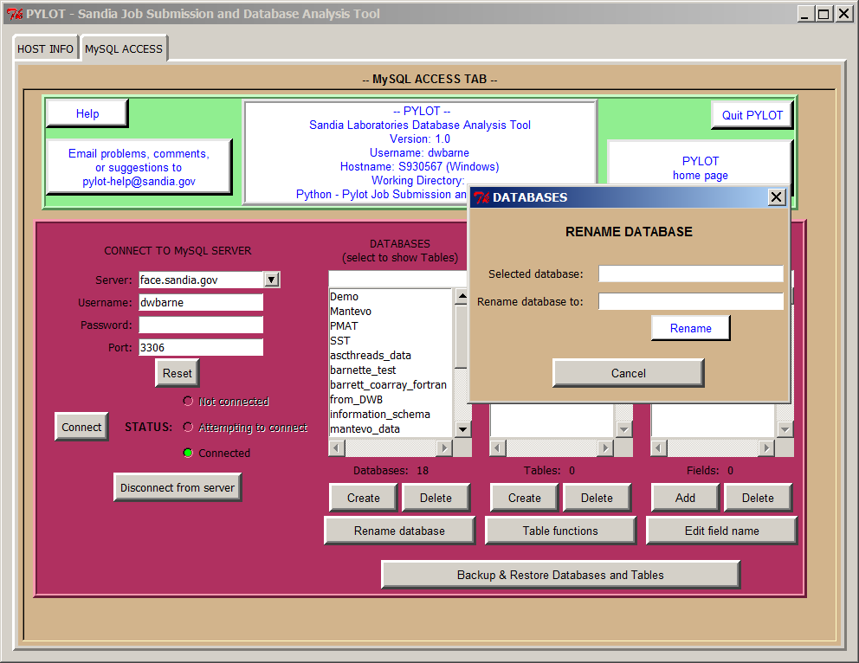

**[[BOTTOM]](http://pmatwiki.sandia.gov/pmatwiki/how-to-use-pylot?action=print#bottom)[[TOP]](http://pmatwiki.sandia.gov/pmatwiki/how-to-use-pylot?action=print#top)Management of Tables: Create, Delete, Rename, Copy**

Buttons located in the 'MySQL ACCESS' tab under the 'TABLES IN DATABASE' box allow the user to create or delete a database table. The 'Table functions' button allows the user to display the table (which in turn exposes other table functions), show the table structure, rename the currently-selected table, or copy the selected table to another database. Clicking on any one of these buttons under the 'TABLES IN DATABASE' box causes any windows associated with the other buttons to close and then opens the window associated with the selected widget. For example, clicking on the 'Create' button causes the 'Delete' or 'Table functions' window to close if they are open, and the 'Create' window is then displayed.

**[[BOTTOM]](http://pmatwiki.sandia.gov/pmatwiki/how-to-use-pylot?action=print#bottom)[[TOP]](http://pmatwiki.sandia.gov/pmatwiki/how-to-use-pylot?action=print#top)Create a Table**

Clicking on 'Create' under the 'TABLES IN DATABASE' box displays the following pop-up window on top of the main window:

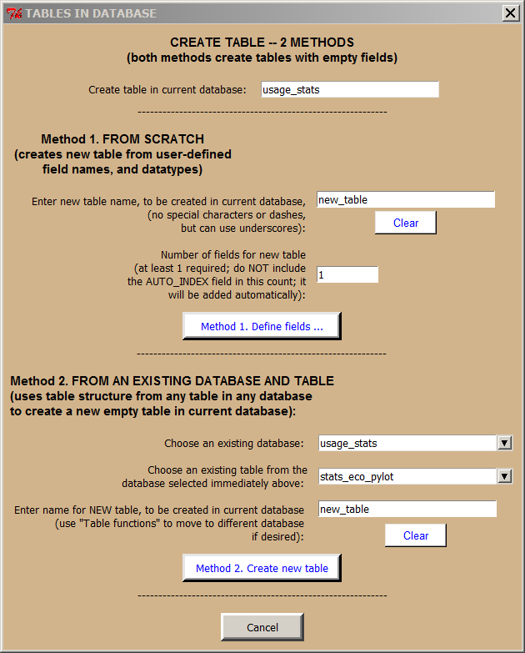

As the window title indicates, there are two methods for creating a table with empty fields, discussed below. Both methods assume the table is to be created in the currently selected database. The table can always be moved to another database using the 'Table functions' button if necessary.

**[[BOTTOM]](http://pmatwiki.sandia.gov/pmatwiki/how-to-use-pylot?action=print#bottom)[[TOP]](http://pmatwiki.sandia.gov/pmatwiki/how-to-use-pylot?action=print#top)Method 1: From Scratch**

Enter a name for the new table. A good name for a first-time table in a newly created database is 'sandbox' as used below. Enter the number of fields for the new table -- '10' was entered for the sample table creation below. Then click on 'Method 1. Define fields...' button. This will bring up the 'Create Table From Scratch' window, appearing as

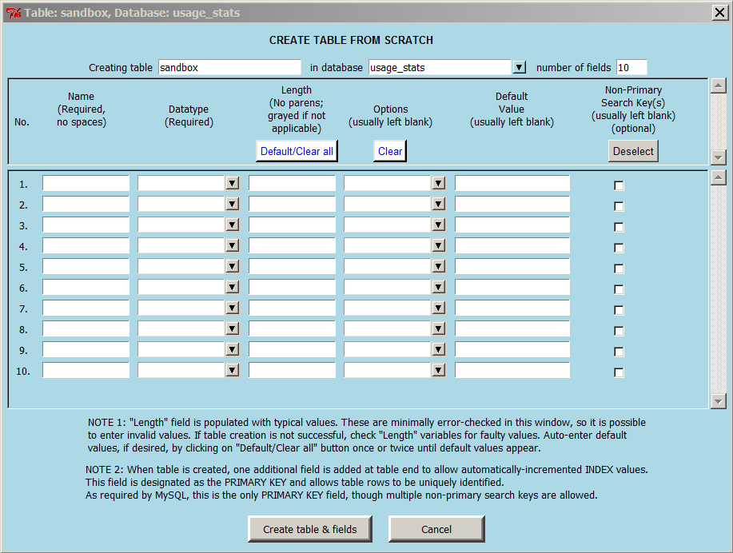

Under Name, enter the names for the fields you want to define. No spaces are allowed.

Using the dropdown menu, select the datatype of the field.

Lengths will fill in by default. Just use the default values. No other fields need to be dealt with right now.

Finally, click on 'Create table & fields' button, and after a couple of messages and clicking OK, the table will be created. Don't worry if the table you just created is not quite right for your tasks. Fields can easily be added or deleted, and field headers can easily be changed, from Pylot's main window by selecting the desired database and table and then using the buttons under the 'FIELDS IN TABLE' box.

SQL requires at least one field to be unique among all the fields in a table. To accommodate this, Pylot creates an additional field called 'auto_index' that is automatically indexed. Pylot does not allow the user to edit or delete this field. The user can, however, filter the data to be displayed using this field. If rows are deleted, the user can also re-sequence the auto_index field to be numbered sequentially.

From here, go back to the main tabbed window, click on the new table, click on 'Table functions -> Show tables', and you should see your newly-created empty table with the defined headers. Click on 'Table functions -> Show table structure' to examine field names, field datatypes, and other field values associated with how the server stores your table.

We will discuss how to enter data into the table in another section. Pylot provides several ways to enter and edit data in any user-created user-owned table.

**[[BOTTOM]](http://pmatwiki.sandia.gov/pmatwiki/how-to-use-pylot?action=print#bottom)[[TOP]](http://pmatwiki.sandia.gov/pmatwiki/how-to-use-pylot?action=print#top)Method 2: From an Existing Database and Table**

Using this method, tables may be created directly from the tan 'CREATE TABLE -- 2 METHODS' window show above. This method uses the same table structure (field names, field datatypes, etc.) as the user-selected table to create an empty table under the current database. Simply choose any existing database, select any table from that database, and enter a name for the new table. Clicking on the 'Method 2. Create new table' button, the table will be created within the currently selected database shown at the top of the window.

**[[BOTTOM]](http://pmatwiki.sandia.gov/pmatwiki/how-to-use-pylot?action=print#bottom)[[TOP]](http://pmatwiki.sandia.gov/pmatwiki/how-to-use-pylot?action=print#top)Management of Fields: Add, Delete, Edit field name**

Buttons located in the 'MySQL ACCESS' tab under the 'FIELDS IN TABLE' box allow the user to add or delete individual fields within a table. The 'Edit field name' button allows the user to change the name of any field as long as it does not conflict with other field names. Clicking on any one of these buttons causes any windows associated with the other buttons to close and then opens the window associated with the selected button. For example, clicking on the 'Add' button causes the 'Delete' or 'Edit field name' window to close if they are open, and the 'Add' window is then displayed.

Keep in mind that once a field or table has been deleted, it cannot be recovered unless the table has been backed up using the 'Backup & Restore Databases and Tables' functions. These functions are discussed elsewhere in this document.

**[[BOTTOM]](http://pmatwiki.sandia.gov/pmatwiki/how-to-use-pylot?action=print#bottom)[[TOP]](http://pmatwiki.sandia.gov/pmatwiki/how-to-use-pylot?action=print#top)Add a Field**

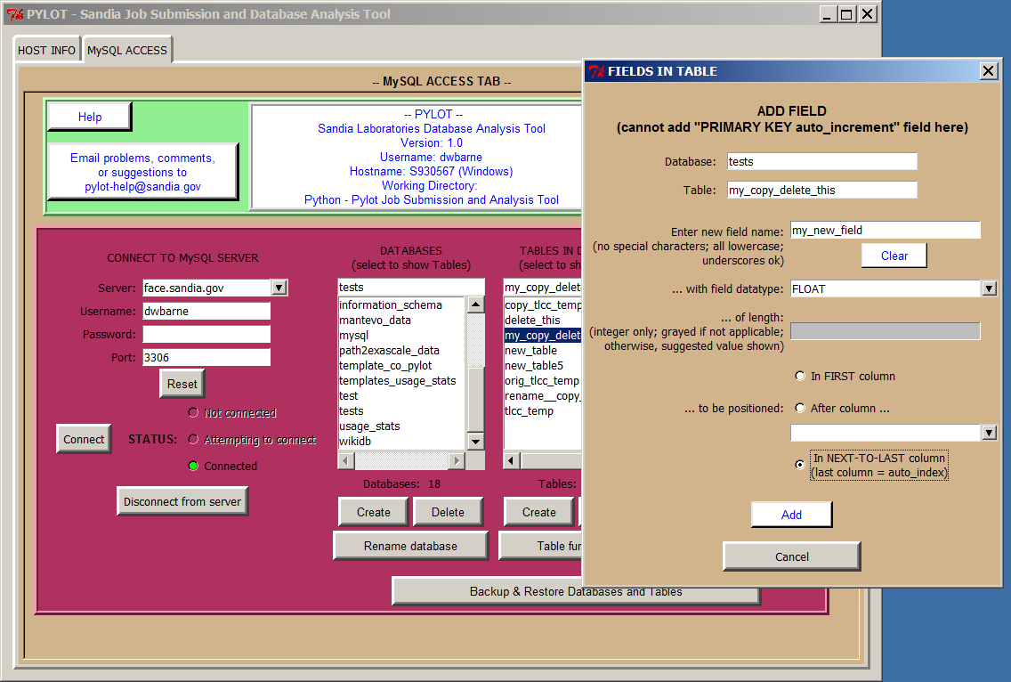

Fields can be added by clicking on 'Add' under the 'FIELDS IN TABLE' box. The pop-up shows the currently selected database and table. To add a field, enter the desired field name in the 'Enter new field name' field, and select a datatype from the dropdown menu provided in the next field. If appropriate, Pylot will provide a default integer length for new field name; if not, the field will be grayed out and will not permit an entry.

Finally, the user can select field placement in the table:

* In FIRST column
* After column ... (select 'after' column using the dropdown menu provided)
* In NEXT-TO-LAST column (last column is always the 'auto_index' field)

Click 'Add' to add the field.

Click 'Cancel' to cancel the current operation and close the pop-up.

**[[BOTTOM]](http://pmatwiki.sandia.gov/pmatwiki/how-to-use-pylot?action=print#bottom)[[TOP]](http://pmatwiki.sandia.gov/pmatwiki/how-to-use-pylot?action=print#top)Delete a Field**

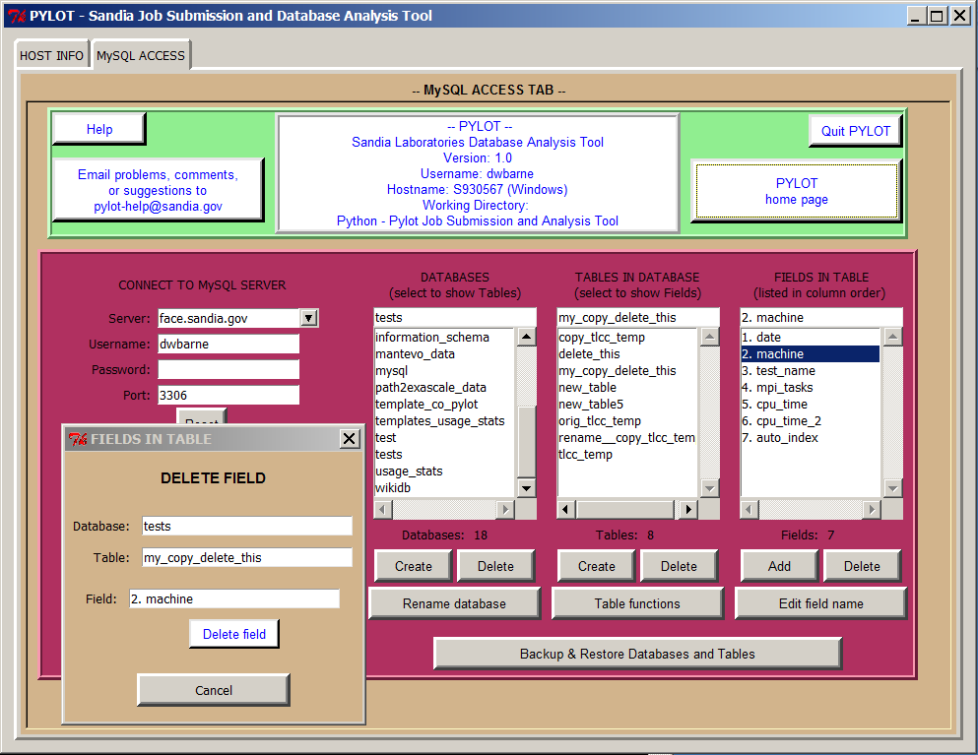

Fields can be deleted by first selecting a field in the 'FIELDS IN TABLE' box, then clicking on 'Delete' below the box. The pop-up shows the currently selected database, table, and field to be deleted. If the pop-up shows the wrong field, simply select another field from the box under 'FIELDS IN TABLE', and the newly-selected field will display in the 'DELETE FIELD' pop-up. Clicking on the 'Delete field' button will then delete the selected field.

Click on 'Cancel' to cancel the current operation and close the pop-up.

**[[BOTTOM]](http://pmatwiki.sandia.gov/pmatwiki/how-to-use-pylot?action=print#bottom)[[TOP]](http://pmatwiki.sandia.gov/pmatwiki/how-to-use-pylot?action=print#top)Edit a field name**

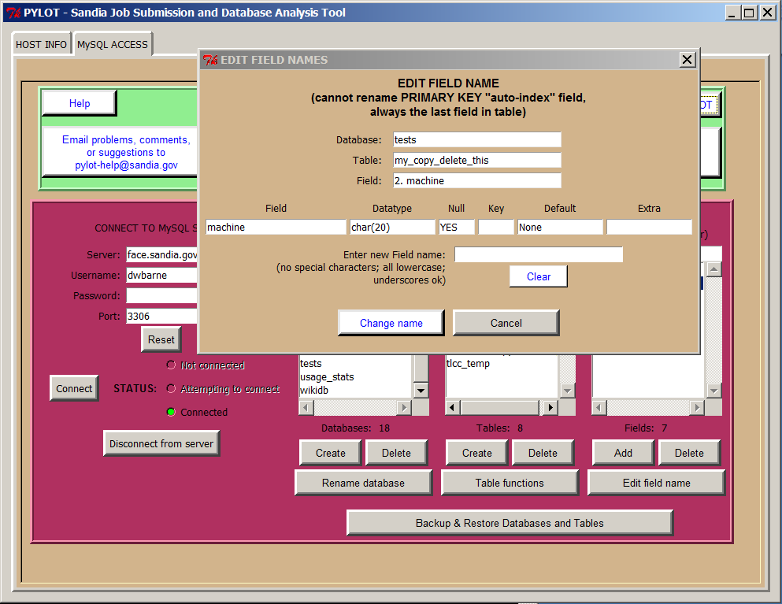

Field names can be edited by clicking on 'Edit field name' under the 'FIELDS IN TABLE' box. The pop-up shows the currently selected database, table, and field to be changed. Also show is the field structure (name, datatype, etc.) so that the user has all the field information before deciding to make the name change. Simply enter the new field name in the box provided (no special characters, use all lowercase, underscores are ok), click on 'Change name', and the field name will be changed. The user can continue making name changes for other fields simply by clicking on any of the fields in the box under 'FIELDS IN TABLE'. The newly selected field will appear in the pop-up with an empty box for 'Enter new Field name'. Repeat the process stated above.

Click 'Cancel' to close the pop-up.

**[[BOTTOM]](http://pmatwiki.sandia.gov/pmatwiki/how-to-use-pylot?action=print#bottom)[[TOP]](http://pmatwiki.sandia.gov/pmatwiki/how-to-use-pylot?action=print#top)Backup & Restore Databases and Tables**

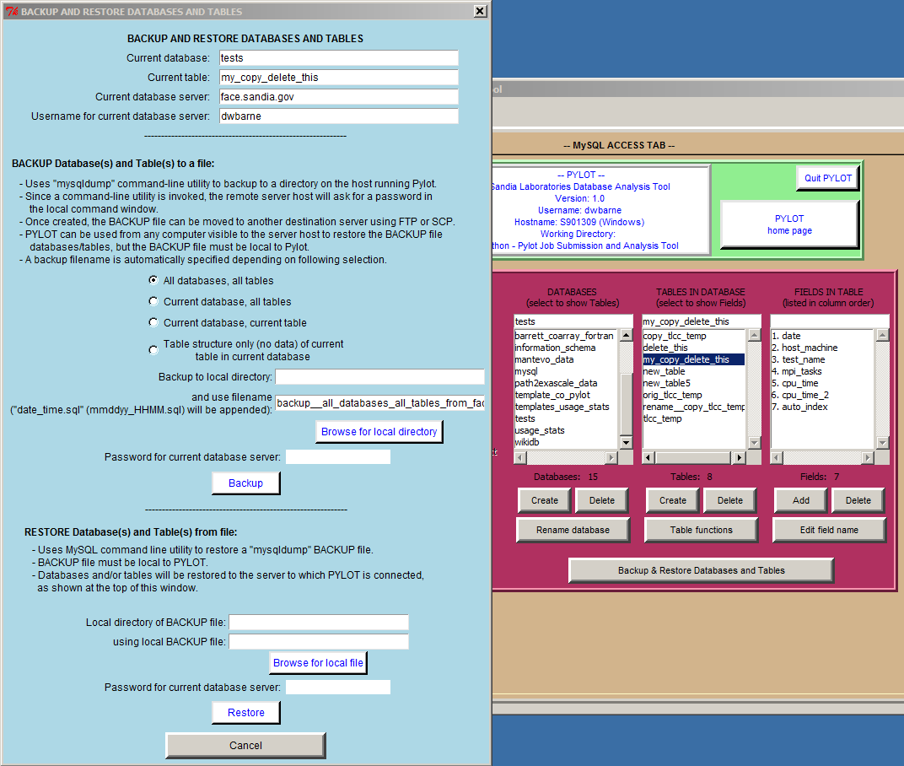

Pylot's backup uses the 'mysqldump' built-in command-line utility running on the server to backup to a directory on the host running Pylot. This means that the user can be logged in to a database server using Pylot from a remote machine and the backup will occur on the remote machine running Pylot.

For security reasons, and since the 'mysqldump' is a command-line utility running on the server, if the user is accessing a database server on a *nix machine remotely, the server will ask for a password in the local command window to run the command. There is no Pylot pop-up for this. This is the user's login password on the database server's HOST. It is NOT the database server password. Hence, to properly execute a backup on a *nix machine, the user MUST have an account on the server's host machine.

Pylot can be used from any computer visible to the server host to restore the backup file databases and/or tables, but the backup file itself must be local to the machine on which Pylot is run. This is necessary since Pylot will use the local machine's file management system when the user is searching for the backup file to restore.

**[[BOTTOM]](http://pmatwiki.sandia.gov/pmatwiki/how-to-use-pylot?action=print#bottom)[[TOP]](http://pmatwiki.sandia.gov/pmatwiki/how-to-use-pylot?action=print#top)Backup**

Once a database and/or table from the main window is selected, this functionality allows the user to backup and restore

* All databases, all tables
* Current database, all tables within the current database
* Current database, current table within the current database
* Table structure only (no data), used for creating empty tables in other databases or on different servers

A backup filename is automatically generated depending on which option above is selected and is displayed in the window. The backup filename is editable by the user.

The user must also enter the database server's password in the given text field.

Clicking 'Backup' will then generate the text-based backup file and a pop-up will appear asking the user where to save the file.

**[[BOTTOM]](http://pmatwiki.sandia.gov/pmatwiki/how-to-use-pylot?action=print#bottom)[[TOP]](http://pmatwiki.sandia.gov/pmatwiki/how-to-use-pylot?action=print#top)Restore**

The user can restore using any backup file simply by specifying the backup file's location, entering a password for the current database server, and clicking 'Restore'. Again, a login password will be required for the server's host machine since the restore command uses the MySQL command line utility. Also, the backup file to be restored must be local to the machine on which Pylot is running. A pop-up will inform the user whether the backup was successful.

**[[BOTTOM]](http://pmatwiki.sandia.gov/pmatwiki/how-to-use-pylot?action=print#bottom)[[TOP]](http://pmatwiki.sandia.gov/pmatwiki/how-to-use-pylot?action=print#top)Other notes**

Some of the advantages to this method of backing up and restoring are

* A text-based backup file is generated which can be edited if necessary; however, the file is generally left intact.
* The file can be compressed and emailed to another collaborator to re-generate the database and/or tables owned by the user.
* Backup is always to the machine on which Pylot is being run. This means that data from remote *nix servers, for example, may be backed up to local machines. Since the files are text based, it matters not that the local machines are Windows or *nix boxes.
* It is assumed that the remote *nix machine will be backed up on a regular schedule, but the ability for the user to backup to a local machine provides another level of security for the database files, especially when the table data are changing rapidly.

**[[BOTTOM]](http://pmatwiki.sandia.gov/pmatwiki/how-to-use-pylot?action=print#bottom)[[TOP]](http://pmatwiki.sandia.gov/pmatwiki/how-to-use-pylot?action=print#top)Functions for Manipulating Fields and Data Within a Selected Table**

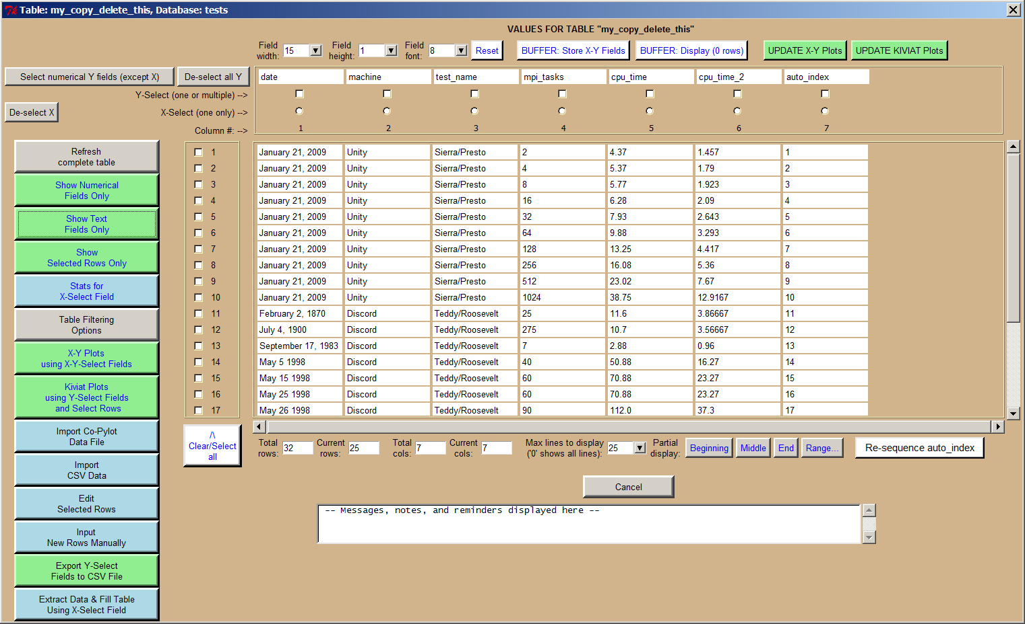

**[[BOTTOM]](http://pmatwiki.sandia.gov/pmatwiki/how-to-use-pylot?action=print#bottom)[[TOP]](http://pmatwiki.sandia.gov/pmatwiki/how-to-use-pylot?action=print#top)Main Table Functions**

**[[BOTTOM]](http://pmatwiki.sandia.gov/pmatwiki/how-to-use-pylot?action=print#bottom)[[TOP]](http://pmatwiki.sandia.gov/pmatwiki/how-to-use-pylot?action=print#top)Refresh complete table**

Refreshes table by accessing the database and extracting the most current values.

**[[BOTTOM]](http://pmatwiki.sandia.gov/pmatwiki/how-to-use-pylot?action=print#bottom)[[TOP]](http://pmatwiki.sandia.gov/pmatwiki/how-to-use-pylot?action=print#top)Show Numerical Fields Only**

Displays fields that have a numerically-based (rather than text-based) datatype. Datatypes can be checked by going to the main Pylot window and clicking 'Table functions -> Show table structure'.

**[[BOTTOM]](http://pmatwiki.sandia.gov/pmatwiki/how-to-use-pylot?action=print#bottom)[[TOP]](http://pmatwiki.sandia.gov/pmatwiki/how-to-use-pylot?action=print#top)Show Text Fields Only**

Displays fields that have a text-based (rather than numerically-based) datatype. Datatypes can be checked by going to the main Pylot window and clicking 'Table functions -> Show table structure'.

**[[BOTTOM]](http://pmatwiki.sandia.gov/pmatwiki/how-to-use-pylot?action=print#bottom)[[TOP]](http://pmatwiki.sandia.gov/pmatwiki/how-to-use-pylot?action=print#top)Show Selected Rows Only**

Allows the user to display selected rows by checking boxes under 'Column #'.

**[[BOTTOM]](http://pmatwiki.sandia.gov/pmatwiki/how-to-use-pylot?action=print#bottom)[[TOP]](http://pmatwiki.sandia.gov/pmatwiki/how-to-use-pylot?action=print#top)Stats for X-Select Field**

Displays stats for any field (column) in table, whether text- or numerically-based datatype. User selects column by clicking on one of the X-Select radio buttons (circles) under each header.

**[[BOTTOM]](http://pmatwiki.sandia.gov/pmatwiki/how-to-use-pylot?action=print#bottom)[[TOP]](http://pmatwiki.sandia.gov/pmatwiki/how-to-use-pylot?action=print#top)Table Filtering Options**

Displays the following 'SELECT & DISPLAY ORDERED FIELDS' pop-up, allowing the user to filter the data to be displayed. Either all fields (columns) can be displayed, or by selecting fields using Y-Select checkboxes only select fields are displayed after filtering. Up to 3 boolean operations can be selected to act on any field, and filtered data can be displayed with any field in ascending or descending sort order.

The filter values are imposed upon clicking 'Display'.

Note that Pylot does not filter the currently displayed data, but rather Pylot always goes to the database server to get the most current table values before filtering.

This pop-up also allows the user to delete the currently displayed rows. The user must click on 'Display' before the 'More options...' button becomes enabled. Click on the enabled 'More options...' button to display a pop-up that allows deletion of the currently displayed rows. The reason for this behavior in Pylot is that the MySQL Select command and Delete command use the same format. As a result, it is a simple matter to display the rows to be deleted if deletion is desired.

Also note that the delete window gives the user the option to re-sequence the auto_index field after the displayed rows are deleted. The user can also choose to re-sequence the auto-index field at any time from the main table display window by clicking on the 'Re-sequence auto_index' button.

**[[BOTTOM]](http://pmatwiki.sandia.gov/pmatwiki/how-to-use-pylot?action=print#bottom)[[TOP]](http://pmatwiki.sandia.gov/pmatwiki/how-to-use-pylot?action=print#top)X-Y Plots using X-Y-Select Fields**

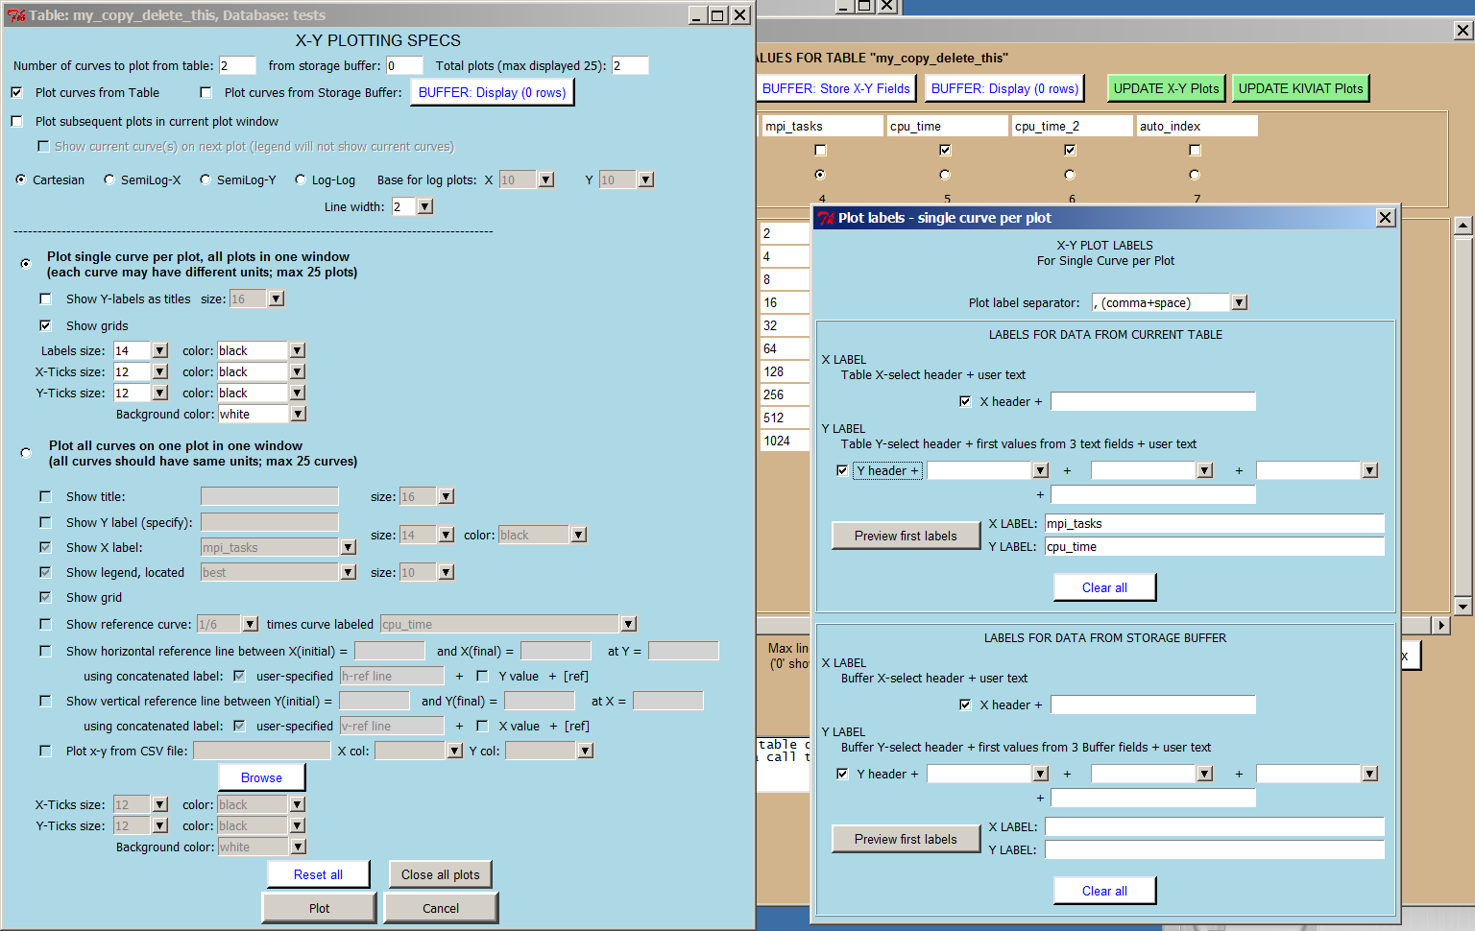

Plots are generated by the user selecting one column for X values by using the X-Select row, clicking one or more Y-Select checkboxes above each field, and then clicking on this button. The resulting pop-up displays numerous options for plots, including each selected plot displayed on a separate graph or all plots displayed on one graph. All required fields have values such that simply clicking on the 'Plot' button will display all plots on separate graphs. Sample plots are shown elsewhere under 'Plotting'.

The companion pop-up allows the user to include various fields for labels and to preview those labels before plotting.

**[[BOTTOM]](http://pmatwiki.sandia.gov/pmatwiki/how-to-use-pylot?action=print#bottom)[[TOP]](http://pmatwiki.sandia.gov/pmatwiki/how-to-use-pylot?action=print#top)Kiviat Plots using Y-Select Fields and Select Rows**

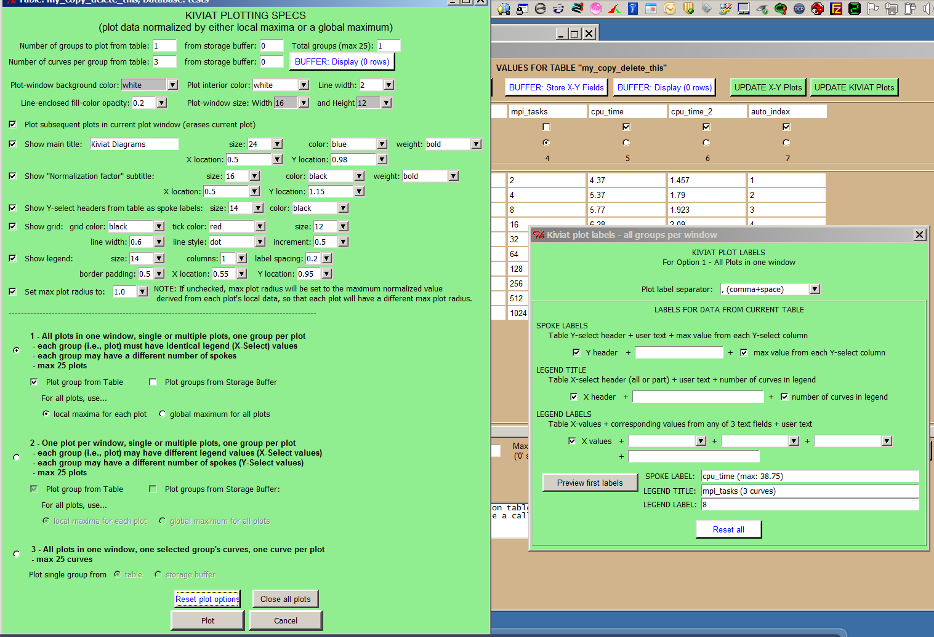

Plots are generated by the user selecting one column for X values by using the X-Select row used for legend values, clicking three or more Y-Select checkboxes above each field, selecting one or more rows of data, and then clicking on this button. The resulting pop-up displays numerous options for plots, including all plots shown in one graph, one plot per graph, or groups of curves with one group per plot, but only the first option is currently available. All required fields have values such that simply clicking on the 'Plot' button will display the associated Kiviat diagram. Sample plots are shown elsewhere under 'Plotting'.

The companion pop-up allows the user to include various fields for labels and to preview those labels before plotting.

**[[BOTTOM]](http://pmatwiki.sandia.gov/pmatwiki/how-to-use-pylot?action=print#bottom)[[TOP]](http://pmatwiki.sandia.gov/pmatwiki/how-to-use-pylot?action=print#top)Import Co-Pylot Data File**

One of the options of Pylot's companion code Co-Pylot is to output the commands to insert data into a database table to a file. This Co-Pylot option was designed to allow the user to insert data to a table even though the user has no local access to a targeted database table. The file can then be transferred to another user who can insert the data. This is beneficial especially for remote collaborations.

Once the file is available to a Pylot user, the user simply clicks here to import the data to a suitably formatted table.

**[[BOTTOM]](http://pmatwiki.sandia.gov/pmatwiki/how-to-use-pylot?action=print#bottom)[[TOP]](http://pmatwiki.sandia.gov/pmatwiki/how-to-use-pylot?action=print#top)Import CSV Data**

Excel and other database data can usually be exported as comma-separated values, or CSV, data.

Click here to import CSV data to a suitably formatted table. If the CSV data and the table structure do not match such that certain fields are not compatible with the incoming data, for example, the user is informed via a pop-up and the data are not imported.

**[[BOTTOM]](http://pmatwiki.sandia.gov/pmatwiki/how-to-use-pylot?action=print#bottom)[[TOP]](http://pmatwiki.sandia.gov/pmatwiki/how-to-use-pylot?action=print#top)Edit Selected Rows**

Selected rows in a table may be edited one row at a time with this function.

**[[BOTTOM]](http://pmatwiki.sandia.gov/pmatwiki/how-to-use-pylot?action=print#bottom)[[TOP]](http://pmatwiki.sandia.gov/pmatwiki/how-to-use-pylot?action=print#top)Input New Rows Manually**

Add new rows to any table. New rows are appended after the last table entry. Data can then be appropriately displayed using the 'Table Filtering Options' button.

**[[BOTTOM]](http://pmatwiki.sandia.gov/pmatwiki/how-to-use-pylot?action=print#bottom)[[TOP]](http://pmatwiki.sandia.gov/pmatwiki/how-to-use-pylot?action=print#top)Export Y-Select Fields to CSV File**

Table data can be exported to a file in comma-separated values (CSV) format. One use might be that he data can then be read into any spreadsheet that accepts CSV data. Another use example might be that the CSV file can be emailed to a remote Pylot user for input into that user's database.

**[[BOTTOM]](http://pmatwiki.sandia.gov/pmatwiki/how-to-use-pylot?action=print#bottom)[[TOP]](http://pmatwiki.sandia.gov/pmatwiki/how-to-use-pylot?action=print#top)Extract Data & Fill Table Using X-Select Field**

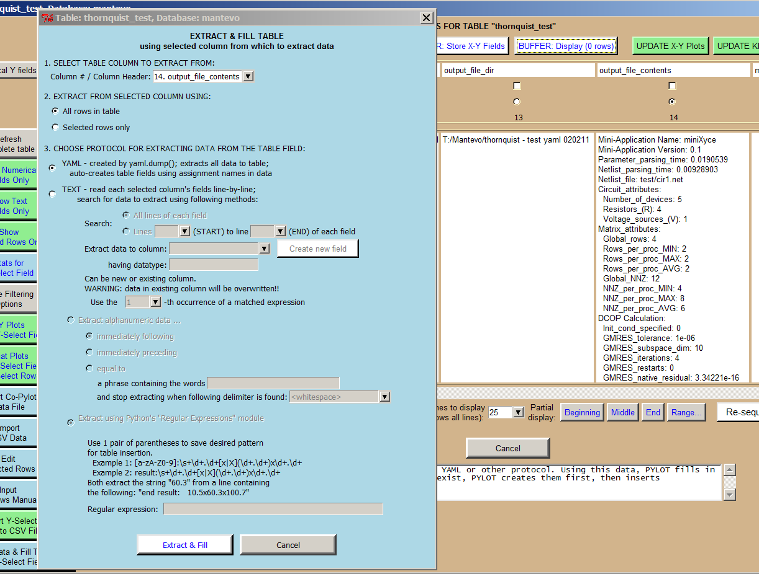

It often happens that a user sends a YAML-formatted or multi-line text field as part of the data sent to a table. These files can be performance data taken from a benchmark on a particular platform, for example. Pylot has the capability to extract either YAML-formatted or text data. Once extracted, each data value is used to automatically generate a field and the data value is then inserted into this field.

**[[BOTTOM]](http://pmatwiki.sandia.gov/pmatwiki/how-to-use-pylot?action=print#bottom)[[TOP]](http://pmatwiki.sandia.gov/pmatwiki/how-to-use-pylot?action=print#top)YAML-formatted field in table**

This is the most automated of the two extraction processes. Once the correct field is selected, click on 'Extract & Fill' button to automatically extract each data value and insert into a field generated by the name associated with the data value.

**[[BOTTOM]](http://pmatwiki.sandia.gov/pmatwiki/how-to-use-pylot?action=print#bottom)[[TOP]](http://pmatwiki.sandia.gov/pmatwiki/how-to-use-pylot?action=print#top)Text field**

Pylot also provides the user with the capability to parse any single- or multi-line text field, extract data from the field, and insert that data into a new user-generated field as well. The user is given the option to use either string searches or regular expressions for pattern matching.

**[[BOTTOM]](http://pmatwiki.sandia.gov/pmatwiki/how-to-use-pylot?action=print#bottom)[[TOP]](http://pmatwiki.sandia.gov/pmatwiki/how-to-use-pylot?action=print#top)Buffer functions**

One of the more powerful functions implemented within Pylot is the capability to store table data in a temporary storage buffer. The buffer stays intact within a Pylot session even if the user logs in and out of several databases. The field data from the tables is stored in the buffer as rows. Any or all rows can be used in X-Y plots. Also, up to 4 rows in the storage buffer data can be mathematically combined to generate a new row in case that data is not available in any one table. This ability to combine any row from any database table with other rows from different tables (whether from the same database, a different database, or a different database from another server) or the same table provides the user with a tremendous amount of flexibility to create plots not available from the table data alone.

**[[BOTTOM]](http://pmatwiki.sandia.gov/pmatwiki/how-to-use-pylot?action=print#bottom)[[TOP]](http://pmatwiki.sandia.gov/pmatwiki/how-to-use-pylot?action=print#top)BUFFER: Store X-Y Fields**

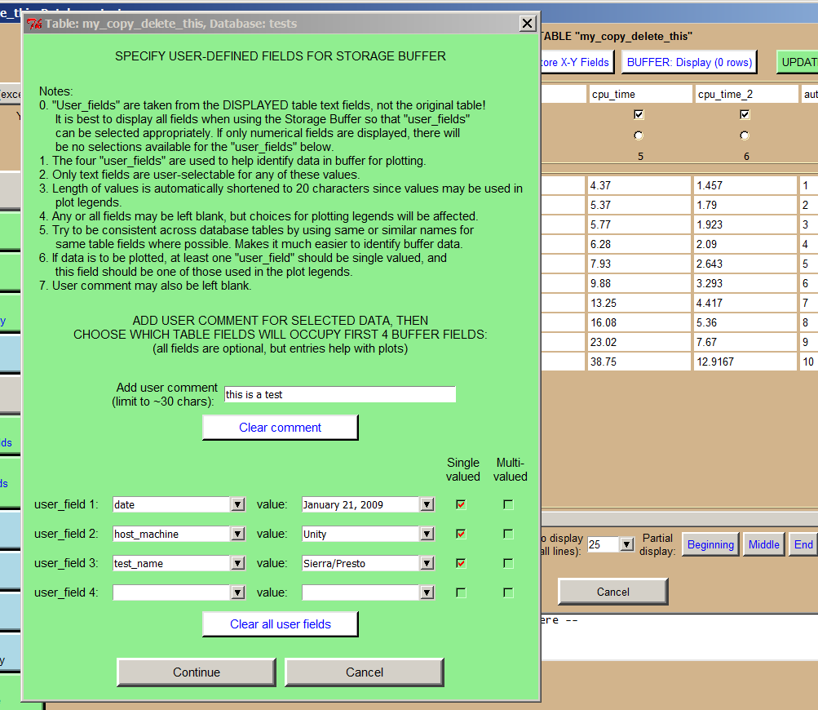

This pop-up allows the user to specify which table text field headers will be shown in user-defined fields when the storage buffer is displayed. It also allows for a user comment. The headers and comment are the same for each field selected at one time to be stored in the buffer.

**[[BOTTOM]](http://pmatwiki.sandia.gov/pmatwiki/how-to-use-pylot?action=print#bottom)[[TOP]](http://pmatwiki.sandia.gov/pmatwiki/how-to-use-pylot?action=print#top)BUFFER: Display**

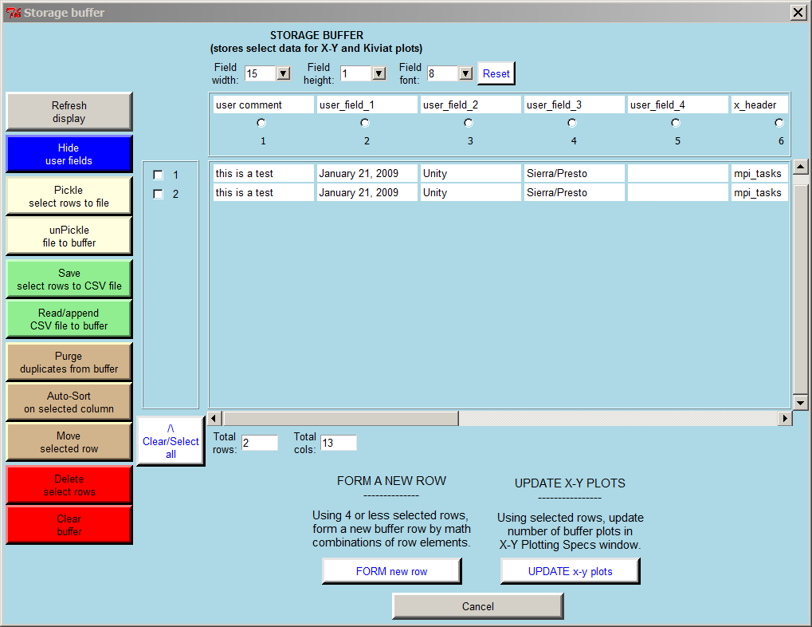

Shows the current state of the storage buffer. Displays which fields have been stored in the buffer as well as various functions related to the buffer on the left. These storage buffer functions are described below.

**[[BOTTOM]](http://pmatwiki.sandia.gov/pmatwiki/how-to-use-pylot?action=print#bottom)[[TOP]](http://pmatwiki.sandia.gov/pmatwiki/how-to-use-pylot?action=print#top)Refresh display**

Refreshes the display. This is needed when the buffer data is updated but the display has not been refreshed yet.

**[[BOTTOM]](http://pmatwiki.sandia.gov/pmatwiki/how-to-use-pylot?action=print#bottom)[[TOP]](http://pmatwiki.sandia.gov/pmatwiki/how-to-use-pylot?action=print#top)Hide user fields**

Hides the fields 'user comment' and user fields 1 thru 4.

**[[BOTTOM]](http://pmatwiki.sandia.gov/pmatwiki/how-to-use-pylot?action=print#bottom)[[TOP]](http://pmatwiki.sandia.gov/pmatwiki/how-to-use-pylot?action=print#top)Pickle select rows to file**

Saves the data in selected rows to a file using Python's pickle method.

**[[BOTTOM]](http://pmatwiki.sandia.gov/pmatwiki/how-to-use-pylot?action=print#bottom)[[TOP]](http://pmatwiki.sandia.gov/pmatwiki/how-to-use-pylot?action=print#top)unPickle file to buffer**

Restores the data to the buffer saved using the process above.

**[[BOTTOM]](http://pmatwiki.sandia.gov/pmatwiki/how-to-use-pylot?action=print#bottom)[[TOP]](http://pmatwiki.sandia.gov/pmatwiki/how-to-use-pylot?action=print#top)Save select rows to CSV file**

Saves selected rows to a file using comma-separated value (CSV) format. The data can then be read into a spreadsheet, for example.

**[[BOTTOM]](http://pmatwiki.sandia.gov/pmatwiki/how-to-use-pylot?action=print#bottom)[[TOP]](http://pmatwiki.sandia.gov/pmatwiki/how-to-use-pylot?action=print#top)Read/append CSV file to buffer**

Restore the data saved using the process above.

**[[BOTTOM]](http://pmatwiki.sandia.gov/pmatwiki/how-to-use-pylot?action=print#bottom)[[TOP]](http://pmatwiki.sandia.gov/pmatwiki/how-to-use-pylot?action=print#top)Purge duplicates from buffer**

Informs the user of exact duplicate rows and offers the option to delete all but one.

**[[BOTTOM]](http://pmatwiki.sandia.gov/pmatwiki/how-to-use-pylot?action=print#bottom)[[TOP]](http://pmatwiki.sandia.gov/pmatwiki/how-to-use-pylot?action=print#top)Auto-Sort on selected column**

Sorts the storage buffer data based on any selected field using the radiobuttons at the top of each column.

**[[BOTTOM]](http://pmatwiki.sandia.gov/pmatwiki/how-to-use-pylot?action=print#bottom)[[TOP]](http://pmatwiki.sandia.gov/pmatwiki/how-to-use-pylot?action=print#top)Move selected row**

Allows the user to move a row to a location that may better associate the data with data in its neighboring rows.

**[[BOTTOM]](http://pmatwiki.sandia.gov/pmatwiki/how-to-use-pylot?action=print#bottom)[[TOP]](http://pmatwiki.sandia.gov/pmatwiki/how-to-use-pylot?action=print#top)Delete select rows**

Deletes a selected row.

**[[BOTTOM]](http://pmatwiki.sandia.gov/pmatwiki/how-to-use-pylot?action=print#bottom)[[TOP]](http://pmatwiki.sandia.gov/pmatwiki/how-to-use-pylot?action=print#top)Clear buffer**

Empties the buffer. This function cannot be undone.

**[[BOTTOM]](http://pmatwiki.sandia.gov/pmatwiki/how-to-use-pylot?action=print#bottom)[[TOP]](http://pmatwiki.sandia.gov/pmatwiki/how-to-use-pylot?action=print#top)Additional Buffer Functions**

**[[BOTTOM]](http://pmatwiki.sandia.gov/pmatwiki/how-to-use-pylot?action=print#bottom)[[TOP]](http://pmatwiki.sandia.gov/pmatwiki/how-to-use-pylot?action=print#top)Clear/Select all**

Clicking once will select all storage buffer rows; another click will de-select all rows.

**[[BOTTOM]](http://pmatwiki.sandia.gov/pmatwiki/how-to-use-pylot?action=print#bottom)[[TOP]](http://pmatwiki.sandia.gov/pmatwiki/how-to-use-pylot?action=print#top)FORM new row**

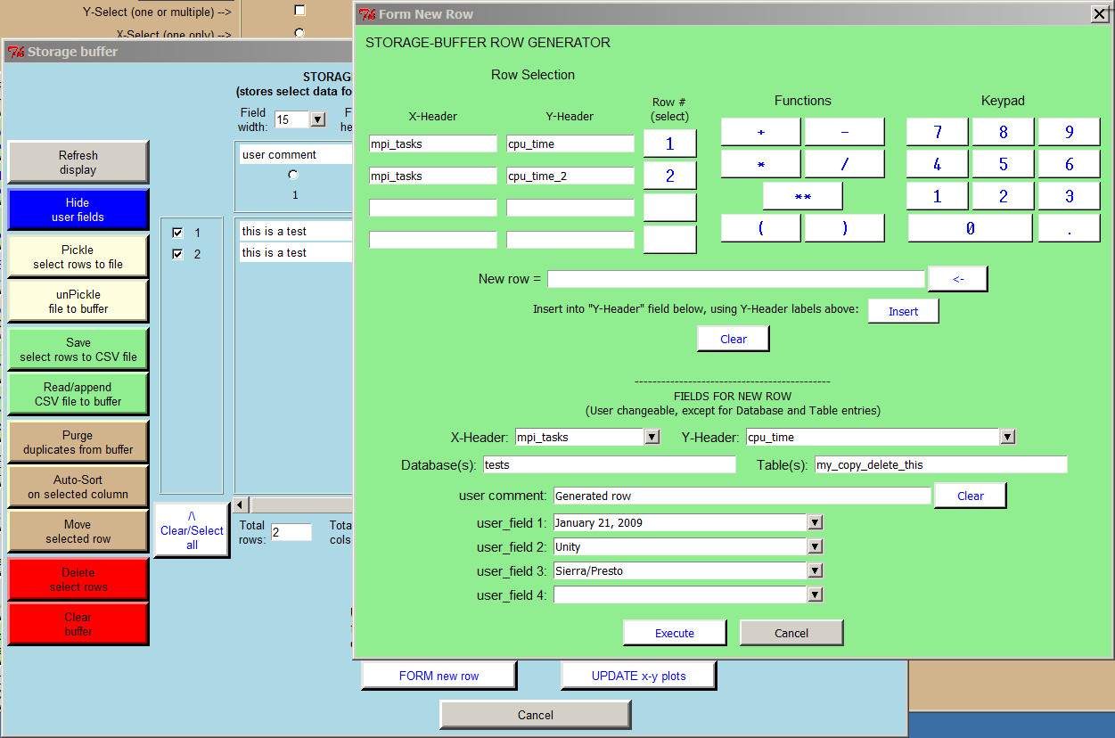

Once rows are selected from the storage buffer, the rows can be mathematically combined by clicking on 'FORM new row'. A maximum of 4 rows can be selected.

The pop-up displays the rows selected, the row number associated with each row, mathematical function buttons, and a keypad. By selecting on the row number, the formula for a new row begins to appear in the "New row =' field. For example, elements of Rows 1 and 2 can be multiplied together by first selecting row # '1', then '*' from the mathematical functions, then row # '2'. Constant factors can be entered via the keypad. Once the correct formula for the new field is shown, and the user is content with other values shown, clicking on 'Execute' creates the new row in the storage buffer. The new row is stored internally to Pylot and is not part of any database table. X-Y Plots can be updated with the new rows for plotting if desired via the 'UPDATE x-y plots' in the 'STORAGE BUFFER' window.

**[[BOTTOM]](http://pmatwiki.sandia.gov/pmatwiki/how-to-use-pylot?action=print#bottom)[[TOP]](http://pmatwiki.sandia.gov/pmatwiki/how-to-use-pylot?action=print#top)UPDATE x-y plots (from Storage Buffer)**

Updates the current X-Y plot data so that the storage buffer data can be included in plots.

**[[BOTTOM]](http://pmatwiki.sandia.gov/pmatwiki/how-to-use-pylot?action=print#bottom)[[TOP]](http://pmatwiki.sandia.gov/pmatwiki/how-to-use-pylot?action=print#top)Update plot functions**

Plot functions can be supplemented with additional plots at any time by selecting X-Select and Y-Select values and clicking on the appropriate UPDATE button.

**[[BOTTOM]](http://pmatwiki.sandia.gov/pmatwiki/how-to-use-pylot?action=print#bottom)[[TOP]](http://pmatwiki.sandia.gov/pmatwiki/how-to-use-pylot?action=print#top)UPDATE X-Y Plots**

Updates the current X-Y plot data with the currently selected X-Select and Y-Select values.

**[[BOTTOM]](http://pmatwiki.sandia.gov/pmatwiki/how-to-use-pylot?action=print#bottom)[[TOP]](http://pmatwiki.sandia.gov/pmatwiki/how-to-use-pylot?action=print#top)UPDATE KIVIAT Plots**

Updates the current Kiviat plot data with the currently selected X-Select, Y-Select, and row values.

**[[BOTTOM]](http://pmatwiki.sandia.gov/pmatwiki/how-to-use-pylot?action=print#bottom)[[TOP]](http://pmatwiki.sandia.gov/pmatwiki/how-to-use-pylot?action=print#top)Select/De-Select Field Functions**

**[[BOTTOM]](http://pmatwiki.sandia.gov/pmatwiki/how-to-use-pylot?action=print#bottom)[[TOP]](http://pmatwiki.sandia.gov/pmatwiki/how-to-use-pylot?action=print#top)Select numerical Y Fields (except X)**

Selects all fields whose dataype is numerically-based, rather than text-based. This is useful for generating plots and the table contains a large number of fields.

**[[BOTTOM]](http://pmatwiki.sandia.gov/pmatwiki/how-to-use-pylot?action=print#bottom)[[TOP]](http://pmatwiki.sandia.gov/pmatwiki/how-to-use-pylot?action=print#top)De-select all Y**

De-selects any Y-Select fields that have previously been selected.

**[[BOTTOM]](http://pmatwiki.sandia.gov/pmatwiki/how-to-use-pylot?action=print#bottom)[[TOP]](http://pmatwiki.sandia.gov/pmatwiki/how-to-use-pylot?action=print#top)De-select X**

De-selects any X-Select field that has previously been selected.

**[[BOTTOM]](http://pmatwiki.sandia.gov/pmatwiki/how-to-use-pylot?action=print#bottom)[[TOP]](http://pmatwiki.sandia.gov/pmatwiki/how-to-use-pylot?action=print#top)Partial display functions**

**[[BOTTOM]](http://pmatwiki.sandia.gov/pmatwiki/how-to-use-pylot?action=print#bottom)[[TOP]](http://pmatwiki.sandia.gov/pmatwiki/how-to-use-pylot?action=print#top)Max lines to display**

Limits the maximum number of lines to be displayed to the number shown. Prevents large tables from taking long times to display.

**[[BOTTOM]](http://pmatwiki.sandia.gov/pmatwiki/how-to-use-pylot?action=print#bottom)[[TOP]](http://pmatwiki.sandia.gov/pmatwiki/how-to-use-pylot?action=print#top)Beginning**

Displays the beginning lines of the table, limited to the number of lines shown in 'Max lines to display'.

**[[BOTTOM]](http://pmatwiki.sandia.gov/pmatwiki/how-to-use-pylot?action=print#bottom)[[TOP]](http://pmatwiki.sandia.gov/pmatwiki/how-to-use-pylot?action=print#top)Middle**

Displays the middle lines of the table, limited to the number of lines shown in 'Max lines to display'.

**[[BOTTOM]](http://pmatwiki.sandia.gov/pmatwiki/how-to-use-pylot?action=print#bottom)[[TOP]](http://pmatwiki.sandia.gov/pmatwiki/how-to-use-pylot?action=print#top)End**

Displays the last lines of the table, limited to the number of lines shown in 'Max lines to display'.

**[[BOTTOM]](http://pmatwiki.sandia.gov/pmatwiki/how-to-use-pylot?action=print#bottom)[[TOP]](http://pmatwiki.sandia.gov/pmatwiki/how-to-use-pylot?action=print#top)Range...**

Displays a range of lines of the table, with beginning and end rows to be determined by the user.

**[[BOTTOM]](http://pmatwiki.sandia.gov/pmatwiki/how-to-use-pylot?action=print#bottom)[[TOP]](http://pmatwiki.sandia.gov/pmatwiki/how-to-use-pylot?action=print#top)Re-sequence auto_index**

Re-sequences that 'auto_index' field.

**[[BOTTOM]](http://pmatwiki.sandia.gov/pmatwiki/how-to-use-pylot?action=print#bottom)[[TOP]](http://pmatwiki.sandia.gov/pmatwiki/how-to-use-pylot?action=print#top)Clear/Select all**

Click to clear all checkboxes; click again to select all checkboxes.

**[[BOTTOM]](http://pmatwiki.sandia.gov/pmatwiki/how-to-use-pylot?action=print#bottom)[[TOP]](http://pmatwiki.sandia.gov/pmatwiki/how-to-use-pylot?action=print#top)Cancel**

Click 'Cancel' to cancel the current operation and close the window.

**[[BOTTOM]](http://pmatwiki.sandia.gov/pmatwiki/how-to-use-pylot?action=print#bottom)[[TOP]](http://pmatwiki.sandia.gov/pmatwiki/how-to-use-pylot?action=print#top)Plotting**

**[[BOTTOM]](http://pmatwiki.sandia.gov/pmatwiki/how-to-use-pylot?action=print#bottom)[[TOP]](http://pmatwiki.sandia.gov/pmatwiki/how-to-use-pylot?action=print#top)Bar and Pie Charts**

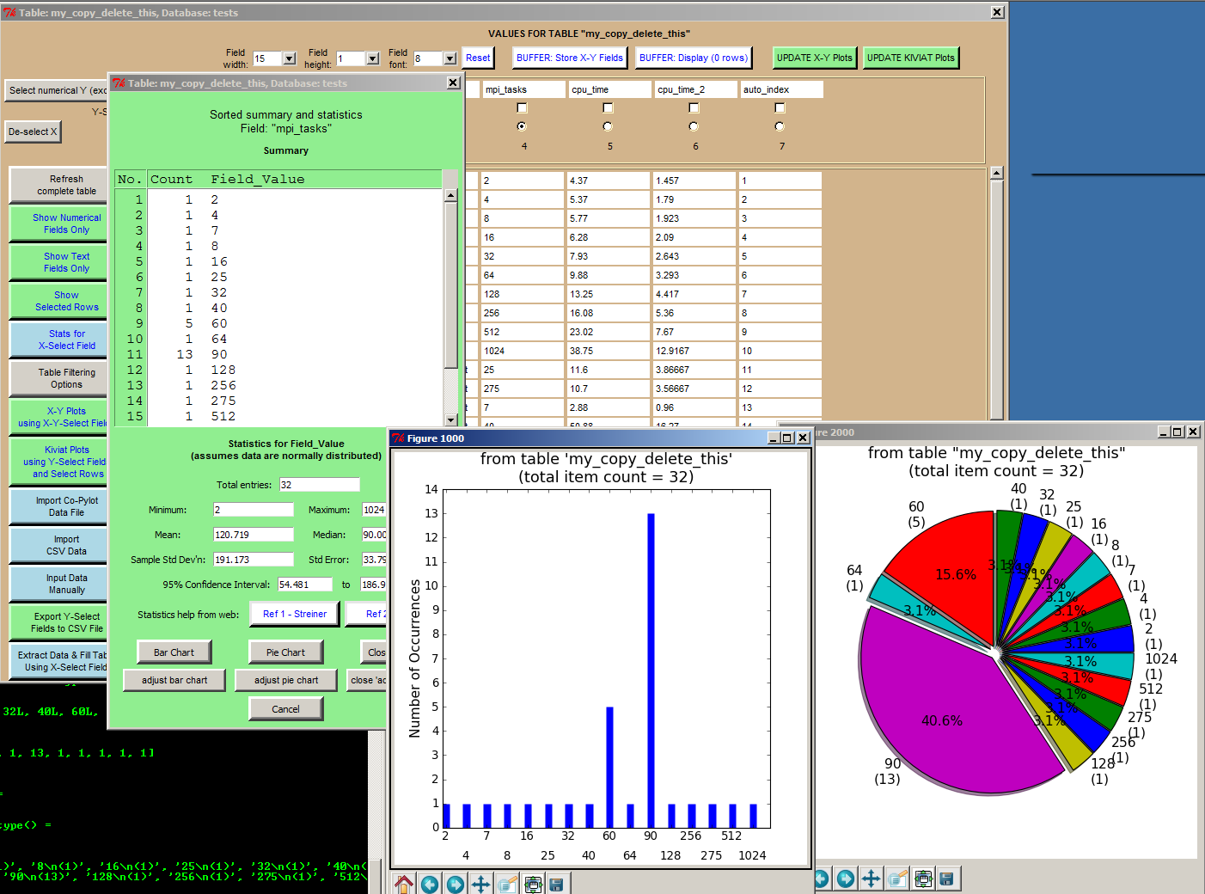

**[[BOTTOM]](http://pmatwiki.sandia.gov/pmatwiki/how-to-use-pylot?action=print#bottom)[[TOP]](http://pmatwiki.sandia.gov/pmatwiki/how-to-use-pylot?action=print#top)Cartesian Plots**

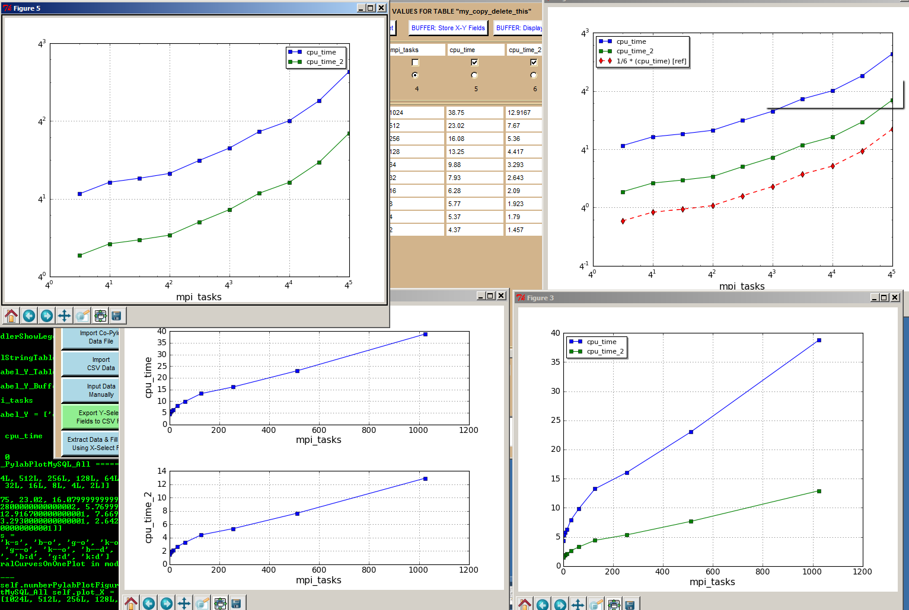

**[[BOTTOM]](http://pmatwiki.sandia.gov/pmatwiki/how-to-use-pylot?action=print#bottom)[[TOP]](http://pmatwiki.sandia.gov/pmatwiki/how-to-use-pylot?action=print#top)Semi-Log Plots**

< under construction >

**[[BOTTOM]](http://pmatwiki.sandia.gov/pmatwiki/how-to-use-pylot?action=print#bottom)[[TOP]](http://pmatwiki.sandia.gov/pmatwiki/how-to-use-pylot?action=print#top)Log-Log Plots**

< under construction >

**[[BOTTOM]](http://pmatwiki.sandia.gov/pmatwiki/how-to-use-pylot?action=print#bottom)[[TOP]](http://pmatwiki.sandia.gov/pmatwiki/how-to-use-pylot?action=print#top)Kiviat (Radar) Plots for Multi-Variate data**

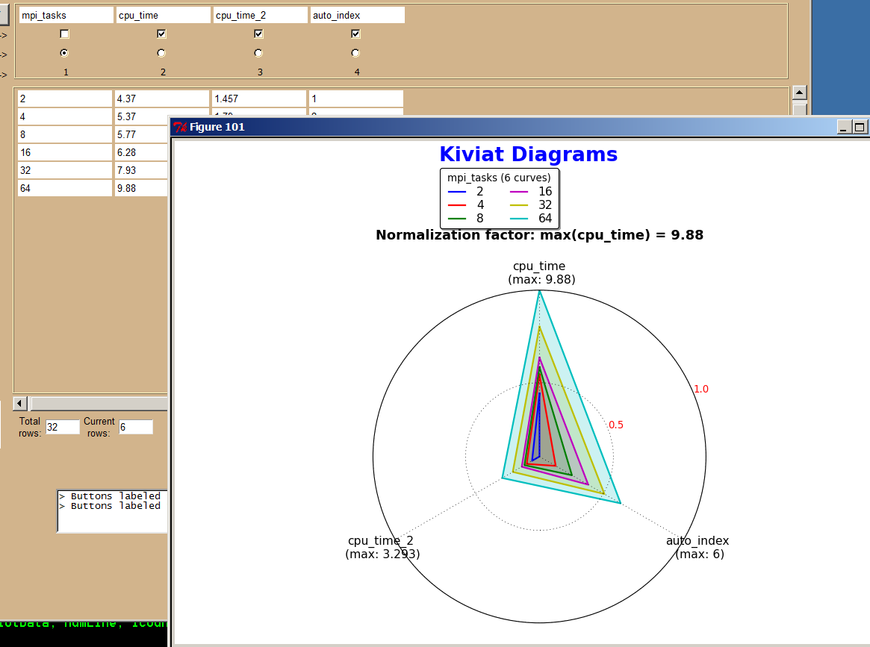

Kiviat charts display multi-variate data in an easy-to-read format. A Kiviat chart resembles a bicycle wheel where the spokes correspond to selected fields and the rings going around the plot correspond to selected rows from a database table. If done correctly, it becomes easy to see which fields begin to dominate as some relevant value increases. Pylot allows the user to easily create Kiviat diagrams from a displayed table by selected an X-Select value for legend values, at least 3 Y-Select fields for the spokes, and at least one row for the rings in the plot.

**[[BOTTOM]](http://pmatwiki.sandia.gov/pmatwiki/how-to-use-pylot?action=print#bottom)[[TOP]](http://pmatwiki.sandia.gov/pmatwiki/how-to-use-pylot?action=print#top)References**

1. D. W. Barnette, M. A. Heroux, J. W. Shipman, "Supercomputer and Cluster Application Performance Analysis Using Python," presented at the US PyCon 2011 Python Users Conference, Atlanta, GA, March 2011.  
Talk can be seen [here](http://blip.tv/file/4878753?filename=Pycon-PyCon2011SupercomputerAndClusterApplicationPerformanceAna194.m4v).  
Click [here](http://pmatwiki.sandia.gov/pmatwiki/how-to-use-pylot?action=AttachFile&do=view&target=pycon-2011-pylot-slides.pptx) to download slides used in presentation.

2. D. W. Barnette, J. W. Shipman, “Capture, Store, Analyze, and Compare Supercomputer Performance Metrics with Python and MySQL,” poster presentation, US PyCon 2011 Python Users Conference, Atlanta, GA, March 2011.  
Click [here](http://pmatwiki.sandia.gov/pmatwiki/how-to-use-pylot?action=AttachFile&do=view&target=pycon-2011-poster-slides.pptx) to download 2 slides of poster presentation.