Bacterial diversity in groundwater samples

Pierre-Yves Dupont

July 27, 2018

Table of Contents

## Libraries

library(phyloseq); packageVersion("phyloseq")

## [1] '1.26.1'

library(tidyverse)  
library(caching); packageVersion("caching")

## [1] '0.1.9'

library(cowplot)  
library(assertthat)  
library(ggplot2)  
library(RColorBrewer)  
library(colorRamps)  
library(ggrepel)  
require(car)  
library(ggpubr)

## Loading data

The objects computed using DADA2 have been saved using the caching library and can be loaded using the same library. Here we can load the phyloseq object ps and the data.frame extracted from it taxa.dt.

ps <- load.object("psc")$orig  
if(object.cached("taxa.dt")){  
 taxa.dt <- load.object("taxa.dt")  
} else{  
 taxa.dt <- psmelt(ps)  
 save.object(taxa.dt)  
}

## Loading Metadata

metadata <- read_tsv("samples-metadata.tsv")  
metadata.df <- as.data.frame(metadata)  
rownames(metadata.df) <- metadata$SampleID  
sample_data(ps) <- metadata.df  
if(!exists("taxa.dt")){  
 taxa.dt <- psmelt(ps)  
 save.object(taxa.dt)  
}

## Separate UC samples

uc_samples <- c("GW180247","GW180419","GW180420","GW180421","GW180422","GW180423","GW180424","GW180425","GW180426","GW180427","GW180428", "GW1801011A", "GW180248")  
ps_uc <- prune_samples(sample_data(ps)$SampleID %in% uc_samples, ps)

## Diversity plots

### Filter low abundance taxa.

aggregation.level <- 'Genus'  
  
dt <- taxa.dt %>% filter(Blank == "No", SampleID %in% uc_samples)  
top <- dt %>%   
 group_by(UQ(rlang::sym(aggregation.level))) %>%   
 summarise(Abundance=sum(Abundance)) %>%   
 mutate(AbundanceRel = Abundance/sum(Abundance)) %>%  
 filter(AbundanceRel >= 0.01)

## Warning: Factor `Genus` contains implicit NA, consider using  
## `forcats::fct_explicit_na`

### Compute relative abundance

dt.grouped <- dt %>%  
 filter(UQ(rlang::sym(aggregation.level)) %in% top$UQ(rlang::sym(aggregation.level))) %>%  
 mutate(UQ(rlang::sym(aggregation.level)) := factor(UQ(rlang::sym(aggregation.level)), levels=unique(UQ(rlang::sym(aggregation.level))))) %>%  
 filter(!is.na(UQ(rlang::sym(aggregation.level)))) %>% # Remove NA  
 group_by(SampleID, UQ(rlang::sym(aggregation.level))) %>%  
 summarize(Abundance = sum(Abundance)) %>%  
 mutate(Abundance = Abundance/sum(Abundance) * 100) %>%  
 filter(!is.na(UQ(rlang::sym(aggregation.level))))

### Set the palette

colourCount <- length(unique(as.character(dt.grouped[[aggregation.level]])))  
palette <- colorRampPalette(brewer.pal(10,"Paired"))(colourCount)

### Plot

#### All samples

ggplot(dt.grouped, aes(SampleID, Abundance, fill = UQ(rlang::sym(aggregation.level)))) +  
 geom_bar(stat = "identity", position = "stack") +  
 # facet_wrap(~SampleTypeAnalysed, ncol = 1, scales = "free_x") +  
 theme_minimal() +  
 scale_fill_manual(values = palette) +  
 xlab(NULL) +  
 ylab("Relative abundance") +  
 theme(axis.text.x = element_text(angle = 45, hjust = 1)) +  
 theme(panel.grid.major = element_blank(), panel.grid.minor = element_blank(), panel.background = element_blank()) +  
 theme(legend.position="bottom")

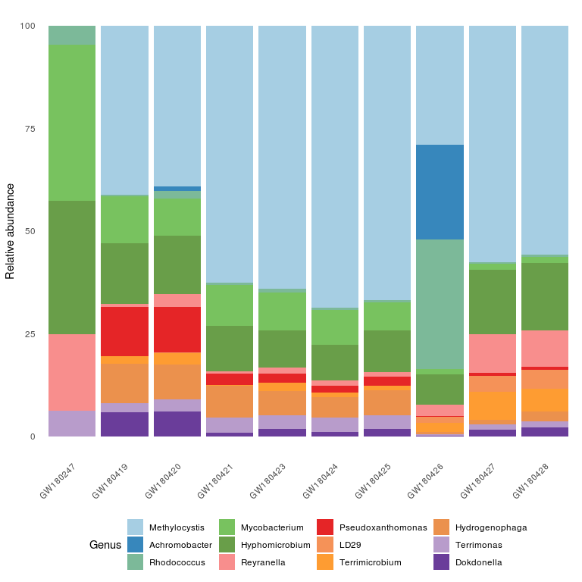

#### Only 3 samples

The following code builds a plot using the same taxa set as for the complete plot by subsetting the dt.grouped data.frame. This doesn’t change the distribution of the taxa.

dt.grouped <- dt.grouped %>% filter(SampleID %in% c("GW180247", "GW180419", "GW180421"))  
ggplot(dt.grouped, aes(SampleID, Abundance, fill = UQ(rlang::sym(aggregation.level)))) +  
 geom_bar(stat = "identity", position = "stack") +  
 # facet_wrap(~SampleTypeAnalysed, ncol = 1, scales = "free_x") +  
 theme_minimal() +  
 scale_fill_manual(values = palette) +  
 xlab(NULL) +  
 ylab("Relative abundance") +  
 theme(axis.text.x = element_text(angle = 45, hjust = 1)) +  
 theme(panel.grid.major = element_blank(), panel.grid.minor = element_blank(), panel.background = element_blank()) +  
 theme(legend.position="bottom")

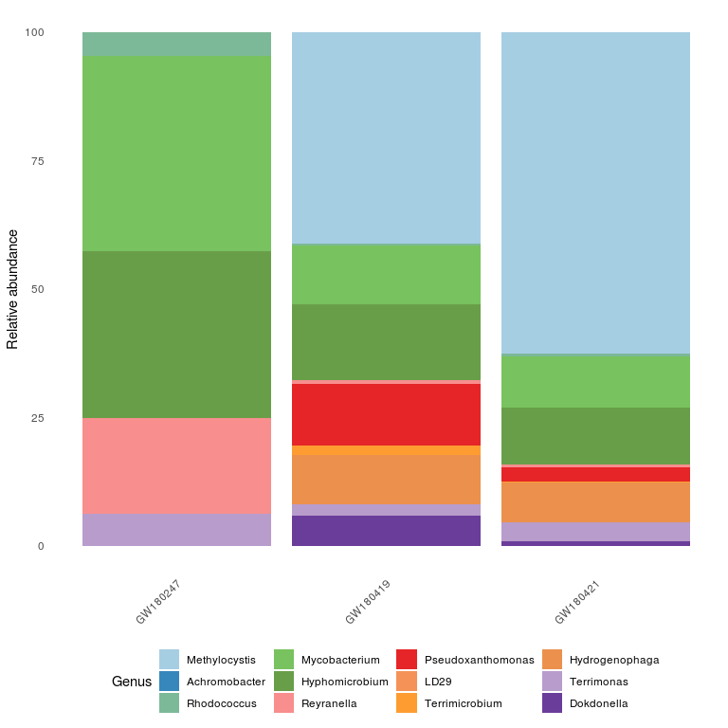

The following code first subset the data then recomputes the taxa and build the abundance plot.

dt <- taxa.dt %>%  
 filter(Blank == "No", SampleID %in% uc_samples) %>%   
 filter(SampleID %in% c("GW180247", "GW180419", "GW180421"))  
  
top <- dt %>%   
 group_by(UQ(rlang::sym(aggregation.level))) %>%   
 summarise(Abundance=sum(Abundance)) %>%   
 mutate(AbundanceRel = Abundance/sum(Abundance)) %>%  
 filter(AbundanceRel >= 0.01)

## Warning: Factor `Genus` contains implicit NA, consider using  
## `forcats::fct_explicit_na`

dt.grouped <- dt %>%  
 filter(UQ(rlang::sym(aggregation.level)) %in% top$UQ(rlang::sym(aggregation.level))) %>%  
 mutate(UQ(rlang::sym(aggregation.level)) := factor(UQ(rlang::sym(aggregation.level)), levels=unique(UQ(rlang::sym(aggregation.level))))) %>%  
 filter(!is.na(UQ(rlang::sym(aggregation.level)))) %>% # Remove NA  
 group_by(SampleID, UQ(rlang::sym(aggregation.level))) %>%  
 summarize(Abundance = sum(Abundance)) %>%  
 mutate(Abundance = Abundance/sum(Abundance) * 100) %>%  
 filter(!is.na(UQ(rlang::sym(aggregation.level))))  
  
colourCount <- length(unique(as.character(dt.grouped[[aggregation.level]])))  
palette <- colorRampPalette(brewer.pal(10,"Paired"))(colourCount)

ggplot(dt.grouped, aes(SampleID, Abundance, fill = UQ(rlang::sym(aggregation.level)))) +  
 geom_bar(stat = "identity", position = "stack") +  
 # facet_wrap(~SampleTypeAnalysed, ncol = 1, scales = "free_x") +  
 theme_minimal() +  
 scale_fill_manual(values = palette) +  
 xlab(NULL) +  
 ylab("Relative abundance") +  
 theme(axis.text.x = element_text(angle = 45, hjust = 1)) +  
 theme(panel.grid.major = element_blank(), panel.grid.minor = element_blank(), panel.background = element_blank()) +  
 theme(legend.position="bottom")

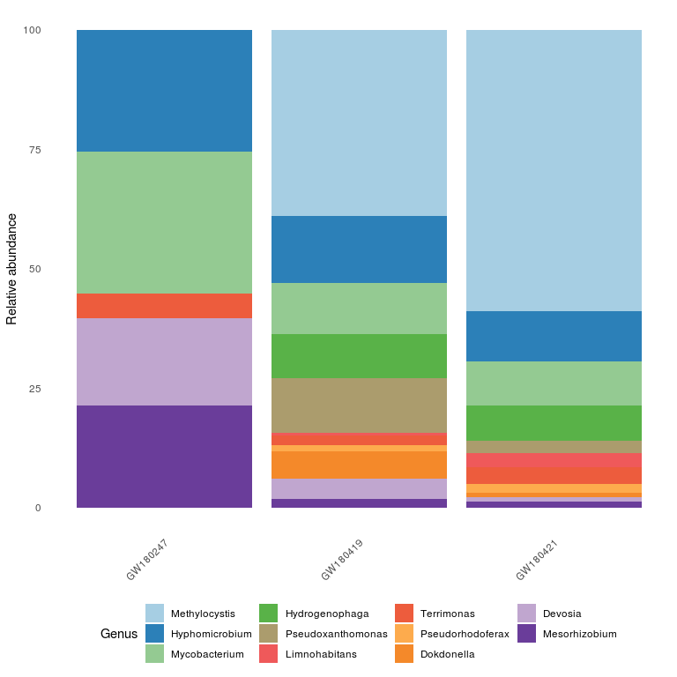

Both plots are correct. The first one corresponds to the distribution of the taxa identified as the most abundant in all the samples while the second corresponds to the distribution of the the most abundant taxa in these three samples. It is not surpising to see that you have such a large difference between the plots because your conditions (and likely your communities) are very different.