Website: www.fh-rfid.com.cn

UHF Laundry Tag
UR 3515-S

Model
UR 3515-S
RFID Standard EPC Class 1 Gen 2,1S018000-6C
Frequency
865~868MHz or 902~928MHz

Length * Width
35*15 mm(2.7*0.6 in)

Thickness
1.5 mm(0.06 in)on chip location only,Rest of tag is 0.55 mm(0.02in)
Weight 0.5g
Material
Textile
Chip Type M730/ NXP Ucode9
Memory
EPC 128-bit, User 0-bit / EPC 96-bit, User 0-bit

Data Storage
20 years

Re-write
100,000 times

Read Range(Fixed Reader)
0-5m(ERP=2W)

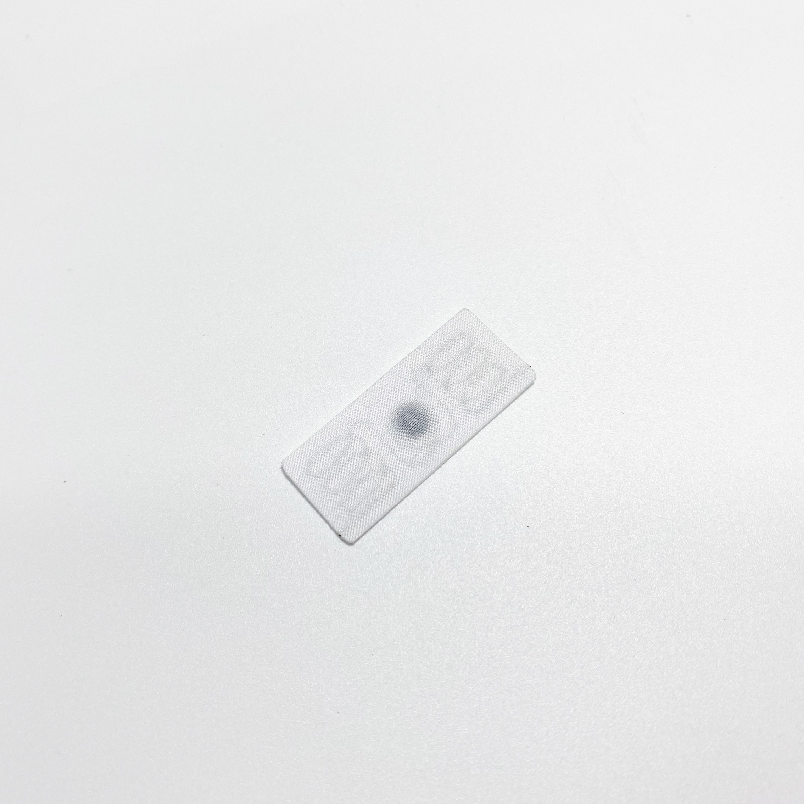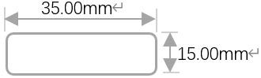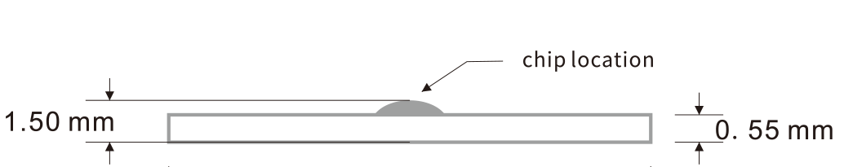
Read Range(Handheld Reader)
0-3m(Using 30dBm power)
Sew in the rolled edge or in the woven label sleeve (cannot be sewn onto metal wires or chip modules during sewing)
Warranty
200 washing cycles or 3 years, whichever comes first
Installation
Washing Method Laundry, Dry cleaning
Water Extraction pressure
60 bars
Chemical Resistance Can withstand all chemicals in the normal industrial washing
Washing Temperature
90°C(194°F)/15 minutes
Pre-drying in Tumble 180°C(356°F)/30 minutes
lroning Tempereature
180°C(356°F)/10 seconds
Sterilization Tempereature 135°C(275°F)/20 minutes
Humidity/Temperature-Operating
-20~+85°C(-4~+185°F)/8~95%RH
Personalization Serial number,LOGO printing, Encoding,Antenna design.etc

Applications
Industrial washing/Management of uniforms Medical apparel management
Military clothing management

 Application
Uniform management


Hotel linen management


Hospital linen management

Website: www.fh-rfid.com.cn
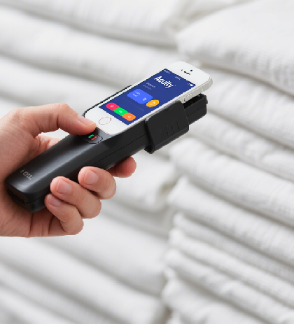 Read Range
Linen rental management
