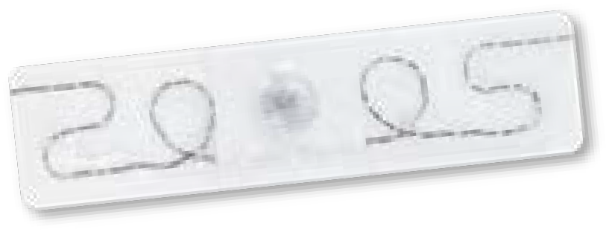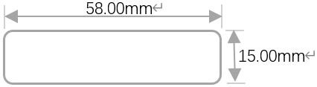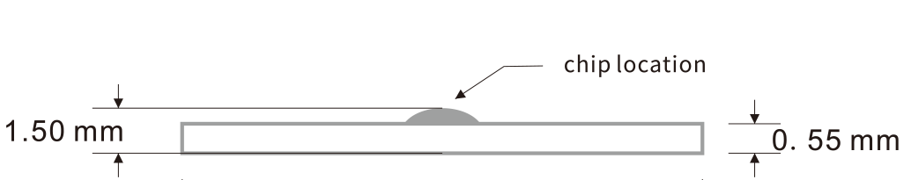
Website: www.fh-rfid.com.cn

UHF Laundry Tag
UR 5815-H

Model
UR 5815-H
RFID Standard EPC Class 1 Gen 2 , 1S018000-6C
Frequency
845-950 MHz(worldwide)
Length * Width 58*15 mm(2.7*0.6 in)
Thickness
1.5 mm(0.06 in)on chip location only,Rest of tag is 0.55 mm(0.02in)
Weight 0.6g
Material
Textile
Chip Type M730/ Impinj R6P/NXP UCODE

Memory
EPC 128-bit, User 0-bit
EPC 96-bit, User 32-bit
EPC 96-bit, User 0-bit
Data Storage 20 years
Re-write
100,000 times
Read Range(Fixed Reader) 0-10m(ERP=2W)
Read Range(Handheld Reader)
0-7m(Using ATID AT880 handheld device)
Heat-sealing:Heat-seal the tag onto the textile at 215°C and pressure greater than 0.6MPa for 15-20 seconds, or thread installation, or woven label sleeve installation
Installation
Warranty
200 washing cycles or 3 years, whichever comes first
Washing Method Laundry, Dry cleaning
Water Extraction pressure
60 bars
Chemical Resistance Can withstand all chemicals in the normal industrial washing
Washing Temperature
90°C(194°F)/15 minutes
Pre-drying in Tumble 180°C(356°F)/30 minutes
lroning Tempereature
180°C(356°F)/10 seconds
Sterilization Tempereature 135°C(275°F)/20 minutes
Humidity/Temperature-Operating
-20~+85°C(-4~+185°F)/8~95%RH
Personalization Serial number,LOGO printing, Encoding,Antenna design.etc

Applications
Industrial washing/Management of uniforms Medical apparel management
Military clothing management

 Application
Uniform management


Hotel linen management


Hospital linen management

Website: www.fh-rfid.com.cn
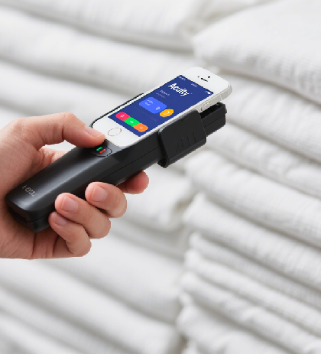 Read Range
Linen rental management
