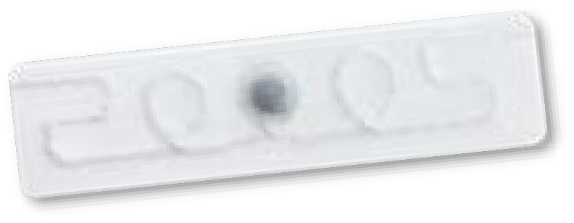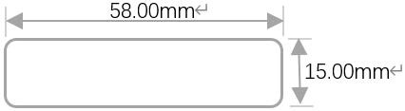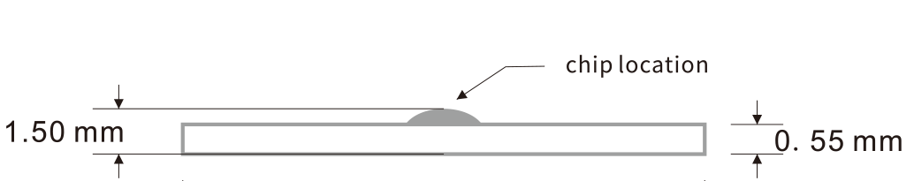
Website: www.fh-rfid.com.cn

UHF Laundry Tag
UR 5815-S

Model
UR 5815-S
RFID Standard EPC Class 1 Gen 2 , ISO18000-6C
Frequency
845MHz ~ 950MHz(worldwide)
Length * Width 58*15 mm(2.7*0.6 in)
Thickness
1.5 mm(0.06 in)on chip location only,Rest of tag is 0.55 mm(0.02in)
Weight 0.6g
Material
Textile
Chip Type M730/ Impinj R6P/NXP UCODE 9

Memory
EPC 128-bit, User 0-bit
EPC 96-bit, User 32-bit
EPC 96-bit, User 0-bit
Data Storage 20 years
Re-write
100,000 times
Read Range(Fixed Reader) 0-10m(ERP=2W)
Read Range(Handheld Reader)
0-7m(Using ATID AT880 handheld device)
Sew in the rolled edge or in the woven label sleeve (cannot be sewn onto metal wires or chip modules during sewing)
Installation
Warranty
200 washing cycles or 3 years, whichever comes first
Washing Method Laundry, Dry cleaning
Water Extraction pressure
60 bars
Chemical Resistance Can withstand all chemicals in the normal industrial washing
Washing Temperature
90°C(194°F)/15 minutes
Pre-drying in Tumble 180°C(356°F)/30 minutes
lroning Tempereature
180°C(356°F)/10 seconds
Sterilization Tempereature 135°C(275°F)/20 minutes
Humidity/Temperature-Operating
-20~+85°C(-4~+185°F)/8~95%RH
Personalization Serial number,LOGO printing, Encoding,Antenna design.etc

Applications
Industrial washing/Management of uniforms Medical apparel management
Military clothing management

 Application
Uniform management


Hotel linen management


Hospital linen management

Website: www.fh-rfid.com.cn
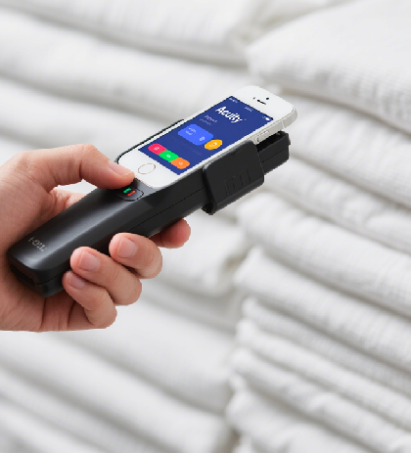 Read Range
Linen rental management
