Select the entire dataset, for ex A11 to G17

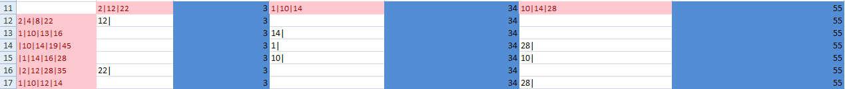

Then Hit this button on the top

