# Java安装

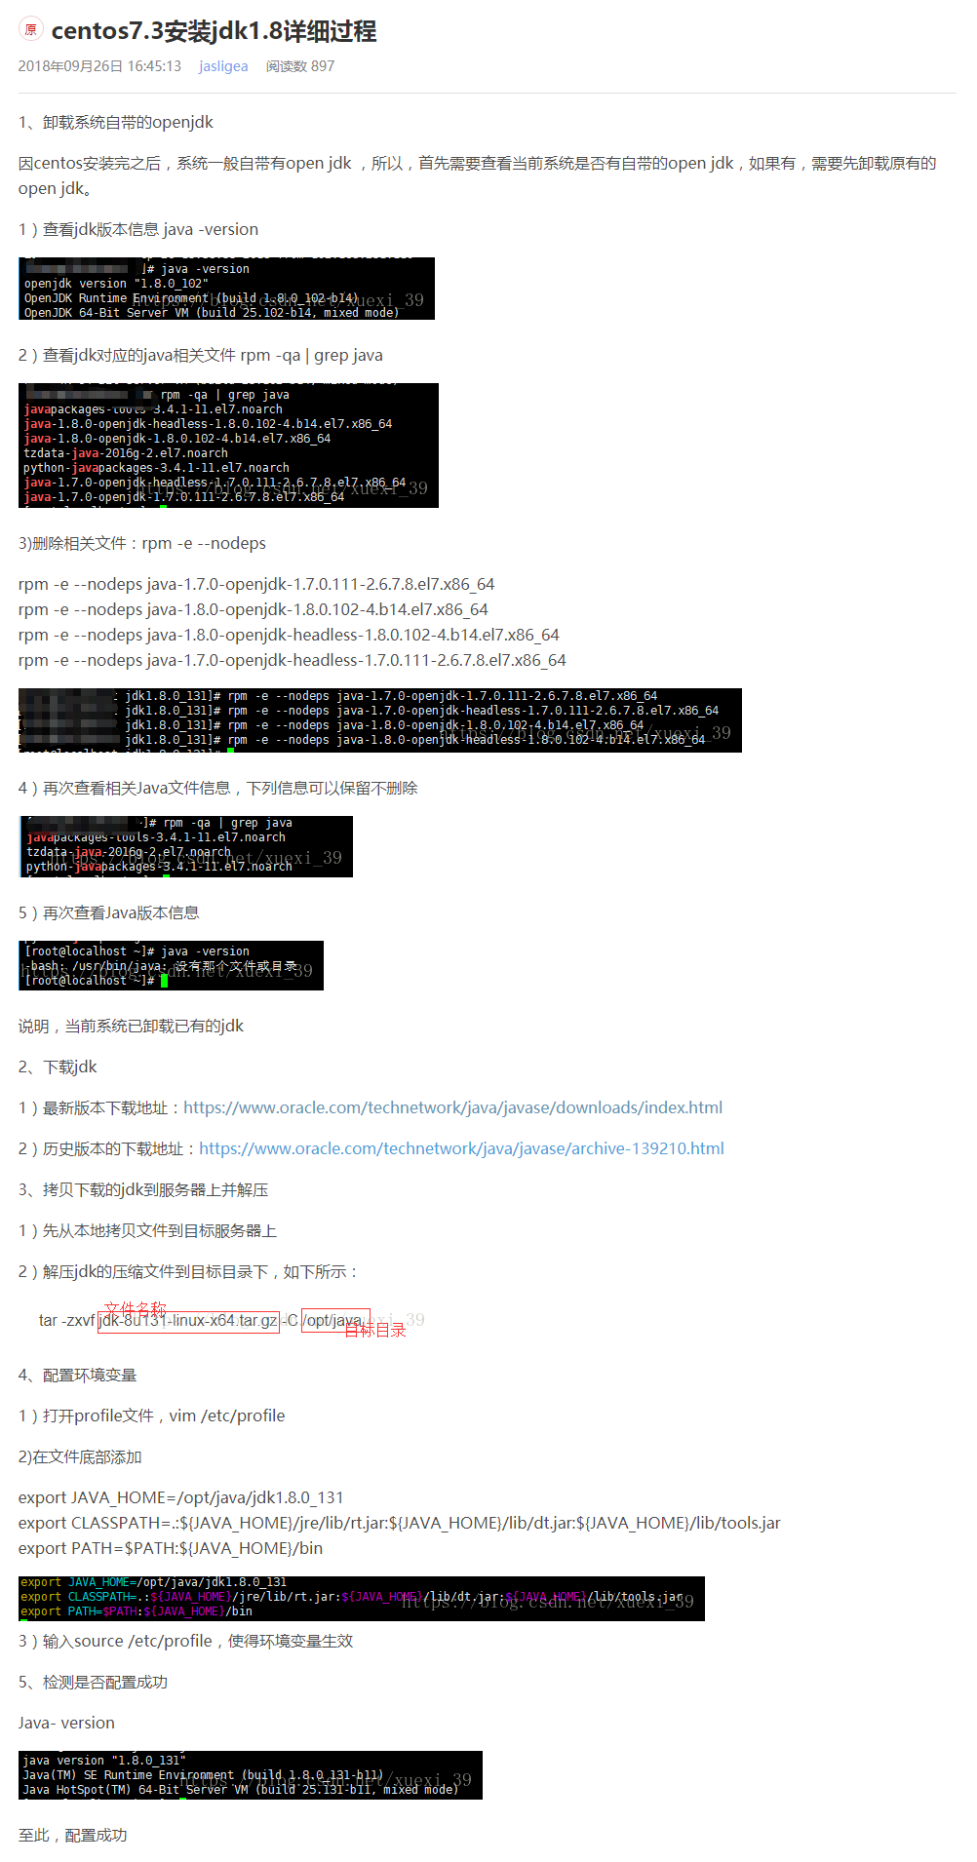

# 系统

安装必要的库：

先更新yum update

yum install zlib-devel bzip2-devel openssl-devel ncurses-devel sqlite-devel gcc python-devel

tomcat安装

1、安装jdk

解压压缩包，配置环境变量/etc/profile追加

JAVA_HOME=/usr/java/jdk1.8.0_181-amd64

JRE_HOME=/usr/java/jdk1.8.0_181-amd64/jre

PATH=$PATH:$JAVA_HOME/bin:$JRE_HOME/bin

CLASSPATH=.:$JAVA_HOME/lib/dt.jar:$JAVA_HOME/lib/tools.jar:$JRE_HOME/lib

export JAVA_HOME JRE_HOME PATH CLASSPATH

使其生效source /etc/profile

2、安装tomcat

解压压缩包，配置防火墙

firewall-cmd --zone=public --add-port=80/tcp --permanent

firewall-cmd –-reload

编辑/usr/lib/systemd/system/tomcat.service添加启动项

# Mysql安装

参照<https://www.linuxidc.com/Linux/2016-09/135288.htm>

# Redis安装

参照<https://www.cnblogs.com/zuidongfeng/p/8032505.html>

# Mongodb安装

参照<https://www.jianshu.com/p/994bc7b19b26>

# Python安装

1、安装可能用到的依赖

yum install -y openssl-devel bzip2-devel expat-devel gdbm-devel readline-devel sqlite-devel

1. 下载Python3.6.5源码

wget https://www.python.org/ftp/python/3.6.5/Python-3.6.5.tgz

3、解压到当前目录

tar -xzvf Python-3.6.5.tgz

4、进入解压后的目录

cd Python-3.6.5

5、安装到/usr/local/python目录，不用事先创建python目录

./configure --prefix=/usr/local/python3

6、编译

make

7、安装

make install

8、进入/usr/bin目录

cd /usr/bin

9、重命名python2的快捷方式

mv python python.bak

mv pip pip.bak

10、创建python3与pip3软连接

ln -s /usr/local/python/bin/python3.6 /usr/bin/python

ln -s /usr/local/python/bin/pip3.6 /usr/bin/pip

# cx_oracle安装

1. pip install cx_oracle
2. 下载对应的oracle客户端版本并解压至/usr/local /instantclient_12_2，下载地址：<http://www.oracle.com/technetwork/database/features/instant-client/index-097480.html>
3. sh -c "echo /usr/local/bin/instantclient_12_2 > /etc/ld.so.conf.d/oracle-instantclient.conf"
4. 设置环境变量，export LD_LIBRARY_PATH=/usr/local /instantclient_12_2:$LD_LIBRARY_PATH

# Nginx安装

1. 环境安装，yum install -y pcre pcre-devel，yum install -y zlib zlib-devel，yum install -y openssl openssl-devel
2. 下载稳定版nginx，下载地址：<http://nginx.org/download/nginx-1.16.1.tar.gz>
3. 编译安装，./configure，make&&make install

# 系统优化

<https://blog.csdn.net/apple9005/article/details/82556794>

# nodejs

<https://www.jianshu.com/p/657d58a149d0>

# 杀毒软件安装

<https://blog.csdn.net/weixin_41004350/article/details/80182929>