SC2002 Object-Oriented Design & Programming
Restaurant Rush
Group Assignment Report
Lab group: [LAB GROUP] Group: [GROUP NO.]
Repository: https://github.com/pyizaw/NTU_SCE1_SC2002
Video: [VIDEO LINK]
Members
[Member 1 name] - [Matric no.]
[Member 2 name] - [Matric no.]
[Member 3 name] - [Matric no.]
[Member 4 name] - [Matric no.]
[Member 5 name] - [Matric no.]
Contents
1. Overview 3
1.1 How to build and run 3
1.2 Rules we defined 3
2. UML Class Diagrams 5
2.1 Stage 1: basic restaurant operation (tag stage-1) 6
2.2 Stage 2: VIP and Critic customers (tag stage-2) 7
2.3 Stage 3: Host, ComboMeal and Happy Hour (tag stage-3, final design) 8
3. UML Sequence Diagram 9
3.1 Life cycles (supporting diagram) 12
4. Design Considerations 14
4.1 Key abstractions and responsibilities 14
4.2 Design principles reflected in the code 14
4.3 Trade-offs 15
4.4 Alternative design considered 15
4.5 How the player's choices change the result 16
5. Functional Evidence and Test Notes 17
5.1 Rule checks 17
5.2 Console screenshots 17
6. Development Process and Stage Changes 23
6.1 Stage 1 → Stage 2: 6 source files, +143 / -6 lines 23
6.2 Stage 2 → Stage 3: 11 source files, +353 / -8 lines 23
6.3 Optional window version (tag gui-extra) 24
7. Reflections 26
7.1 [Member 1 name] 26
7.2 [Member 2 name] 26
7.3 [Member 3 name] 26
7.4 [Member 4 name] 27
7.5 [Member 5 name] 27
8. Declarations and AI History 28

1. Overview
Restaurant Rush is a turn-based command-line game in Java 17 with no external libraries. The player is the manager. Every turn, the player decides what the Host, Waiter and Chef do. Customers choose their own food and the Cashier works automatically. After 18 turns the game reports Victory if all three targets are met, and Defeat otherwise:
- at least 4 customers paid;
- revenue is at least $45;
- the average satisfaction of paid customers is at least 60.
The game was built in three runnable stages, each one a single commit with its own tag. Each stage extends the saved previous stage:
- stage-1: basic operation;
- stage-2: VIP and Critic customers;
- stage-3: Host, ComboMeal and Happy Hour.
An optional window version is a separate commit after Stage 3 (tag gui-extra). It changes no rules. This report describes the final Stage 3 design and how it evolved from Stage 1.

1.1 How to build and run
- IntelliJ IDEA: open the repository folder, choose any JDK 17+ as the Project SDK, then run Play (terminal), Play (window) or a Replay_stageN_... configuration.
- Command line: javac --release 17 -d out $(find src -name "*.java") then java -cp out restaurantrush.Main.
- Replay a recorded game: java -cp out restaurantrush.Main runs/stage3-victory.txt. Commands are read from the file and echoed, and lines starting with # explain each decision. Check out the matching tag first (git checkout stage-2).
- Optional window: java -cp out restaurantrush.Main --gui (tag gui-extra).

1.2 Rules we defined
The brief leaves some rules to the group. Every rule below is shown on the welcome screen and in the README.
Rule | Our definition
Food choice | Customer number n orders the menu item at position (n - 1) mod menu size. The rule is deterministic, so every run is reproducible.
Arrivals | Turn 1 Regular, turn 4 VIP, turn 7 Critic, turns 10, 13 and 16 Regular (in Stage 1 every customer is Regular).
Critic | Order preference: the item with the most preparation units (ties go to the cheaper one). Reaction to service: if the dish sat READY for more than one turn before being served, it has gone cold and the Critic loses 20 satisfaction at once.
Combo choice | Combos are ordinary menu items placed after the three dishes, so customers #4, #5 and #6 pick the three combos by the same food rule. Price = 90% of the two components, rounded to the nearest cent; units = sum of the components.
Host | Acts before the Waiter and seats at most one queued customer per turn; the Waiter can still seat customers.
Happy Hour | Offered at the start of every turn until used (once per game). It is active on the activation turn and the next, and the remaining duration is shown. Orders taken while it is active get 20% off, applied after the VIP discount, and the price is locked in the order. At the start of each active turn, customers waiting for a table or food recover 15 satisfaction (max 100).
Seating | A customer is seated at the lowest-numbered free table.
Invalid choices | A rejected command is explained and does not use up that staff member's task; the manager is asked again.

2. UML Class Diagrams
The brief asks for one class diagram per stage, and each must match the code of its tag. To guarantee this, the members of every class (attributes and operations with visibility, static members underlined, abstract members in italics) were generated from the source of each tag. The relationships and notes were then added by hand. Simple get...() accessors are omitted to keep the diagrams readable.
All three diagrams share one colour code, and the PlantUML source and zoomable SVG versions are in docs/diagrams/.
Colour | Meaning
Blue | Boundary: view
Orange | Control: controller
Purple | Staff
Green | Domain
Yellow | Menu and pricing
Grey | Enums
Bright green fill (Stages 2 and 3) | Class is new in that stage
Orange fill (Stages 2 and 3) | Existing class changed in that stage

The packages follow the entity / control / boundary split:
- view holds the boundary classes;
- controller holds the control classes;
- model, staff and enums hold the entities and the domain logic.
The notes on the diagrams point out the main OO ideas:
- Encapsulation. Customer keeps every field private. Its state only changes through seatAt, placeOrder, serve, pay and leave, and each of these checks the current CustomerState first. Staff.perform() enforces "one task per turn", and a failed task does not use up the turn. Order locks its price when it is created.
- Polymorphism. The controller and Restaurant only hold Customer references, while RegularCustomer, VIPCustomer and CriticCustomer override getSatisfactionLossPerTurn(), billFor(), chooseDish() and reactToService(). Likewise, GameController calls staff.carryOut(command, ...) for every directed role, and each Staff subclass decides in handle() which commands it accepts and in availableTasks() which options it offers.
- Composition. Restaurant creates and owns its Tables. GameController creates and owns the staff, menu, Happy Hour and restaurant of one game. A ComboMeal is a MenuItem built from two existing MenuItems (shown as aggregation because the components also belong to the menu).
- Inheritance: Staff → Host, Waiter, Chef, Cashier; Customer → RegularCustomer, VIPCustomer, CriticCustomer; MenuItem → ComboMeal.
- Multiplicities:
  - 2 tables per restaurant;
  - 0..1 customer per table and 0..1 order per customer;
  - exactly 1 menu item per order;
  - 2 components per combo;
  - 6 scheduled arrivals;
  - 2 directed staff in Stages 1-2 and 3 in Stage 3 ({ordered}, the order in which they act).

2.1 Stage 1: basic restaurant operation (tag stage-1)
Stage 1 already contains the extension points that later stages use: the abstract Customer, the abstract Staff with its template method carryOut(), the CustomerFactory arrival schedule and the GameView interface. No Stage 2 or 3 class is present, as checked on the tag.
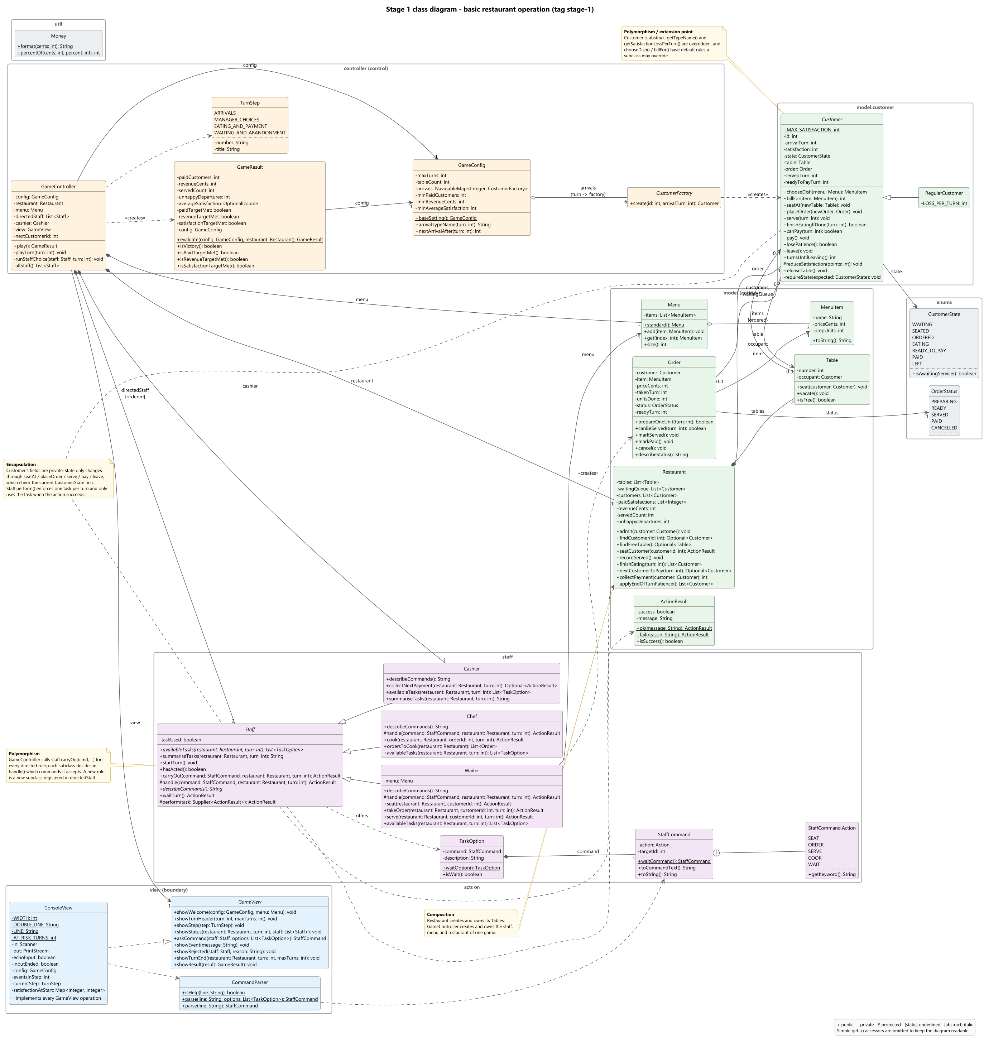
Figure 1. Stage 1 class diagram (matches tag stage-1).

2.2 Stage 2: VIP and Critic customers (tag stage-2)
The changes in this stage are colour-coded:
- New (bright green): VIPCustomer and CriticCustomer.
- Changed (orange): Customer (the reactToService() hook), Waiter (reports the reaction), GameConfig (the schedule) and ConsoleView (explains the customer types).
- Untouched: the controller, restaurant, orders, Chef and Cashier.
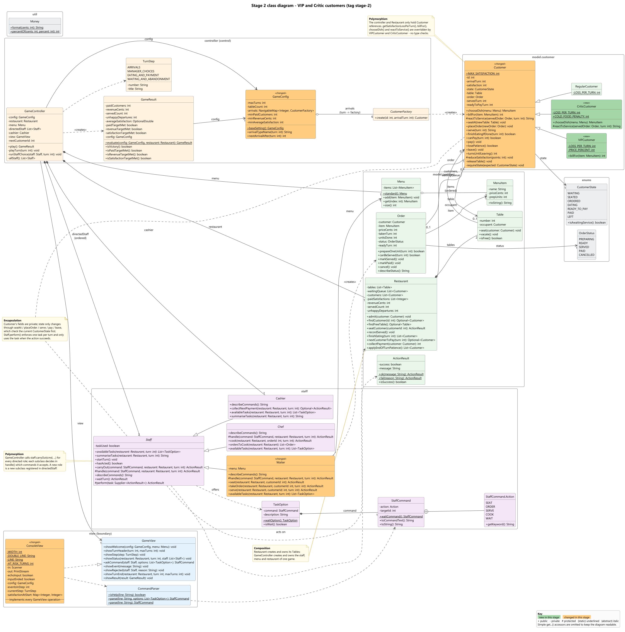
Figure 2. Stage 2 class diagram (matches tag stage-2).

2.3 Stage 3: Host, ComboMeal and Happy Hour (tag stage-3, final design)
The changes in this stage are colour-coded:
- New: Host, ComboMeal, HappyHour and PriceCalculator.
- Changed: GameController, Menu, Restaurant, Customer, Waiter, GameView and ConsoleView. The reason for each change is given in Section 6.
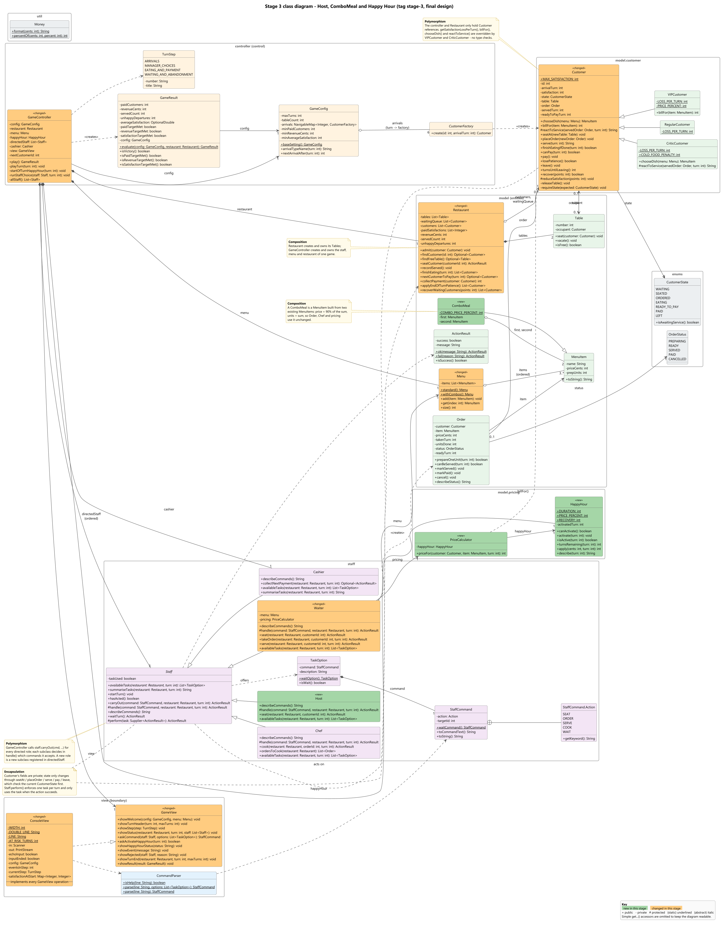
Figure 3. Stage 3 class diagram, the final design (matches tag stage-3). SwingView from gui-extra is not part of the stage and is not drawn.

3. UML Sequence Diagram
Item | Description
Use case | The manager uses Happy Hour and Waiter priority so that late customer #5 still pays before the game ends.
Stage | Stage 3 (tag stage-3). Reproducible with runs/stage3-victory.txt, turns 13 to 18.
Starting conditions | Start of turn 13: revenue $46.80, 3 paid, average satisfaction 83.7. Table 1 is free. Table 2 holds customer #4 (Regular) whose Salad + Burger Combo is already READY. Happy Hour is unused. Customer #5 (Regular) is scheduled to arrive on turn 13.
Manager choices | Turn 13: switch on Happy Hour (y); the Host seats #5; the Waiter takes #5's order instead of serving #4 (a constrained choice, since the Waiter has one task); the Chef starts #5's 3-unit combo. Turns 14-15: the Chef finishes it. Turn 16: the Waiter serves #5.
Outcome | #5 eats on turn 17 and pays $19.44 on turn 18, giving VICTORY: 5 paid, $87.84, average 86.6. If the Waiter had served #4 first on turn 13, #5's combo would only be READY on turn 16 and served on turn 17, so #5 could not pay within 18 turns: 4 paid and $68.40.

The scenario covers every element the brief asks for:
- customer arrival and order;
- Host, Waiter and Chef assignments;
- READY, then SERVED, then eating, then payment;
- the result check;
- a Stage 3 behaviour (Happy Hour pricing and recovery) with a manager choice that changes the outcome.
To stay readable, the diagram is split into two parts with continuous message numbers:
- part 1 is turn 13 (messages 1-43);
- part 2 is turns 14-18 and the result (messages 44-76).

How the interactions implement the use case
- Loops. All messages run inside GameController.play(), which loops over turns 1..18. Within a turn, the controller loops over directedStaff = [Host, Waiter, Chef]. Each staff prompt is itself a loop: askCommand() is repeated until the staff member has acted, because a rejected command (showRejected) does not use up the task.
- Polymorphic dispatch. The controller sends the same message, carryOut(command, restaurant, turn), to every role. carryOut() is a final template method in Staff: it handles wait itself and otherwise calls the subclass's handle(). The Host turns it into seat(), the Waiter into takeOrder() or serve() and the Chef into prepareOneUnit(). The controller never checks which role it is talking to.
- Pricing (Stage 3 behaviour). The Waiter asks PriceCalculator.priceFor() for the bill. The calculator first asks the customer for its own price (billFor(), which VIPs override with 10% off) and then applies HappyHour.apply(). This gives 2430 → 1944 cents, which is locked into the new Order.
- Guards. opt [happyHour.canActivate()] offers Happy Hour; opt [happyHour.isActive(13)] applies recovery. alt frames show the valid and invalid branches of seating and serving: canBeServed() only allows a dish that became READY on an earlier turn (readyTurn 15 < 16). The final alt shows the three victory targets.
- Food and payment flow:
  - Order moves PREPARING → READY (turn 15) → SERVED (turn 16).
  - finishEatingIfDone(17) makes #5 READY_TO_PAY.
  - On turn 18 the automatic Cashier asks Restaurant.nextCustomerToPay() (oldest first, at most one per turn) and collectPayment() adds the bill, records satisfaction 84, and marks the customer and order PAID.
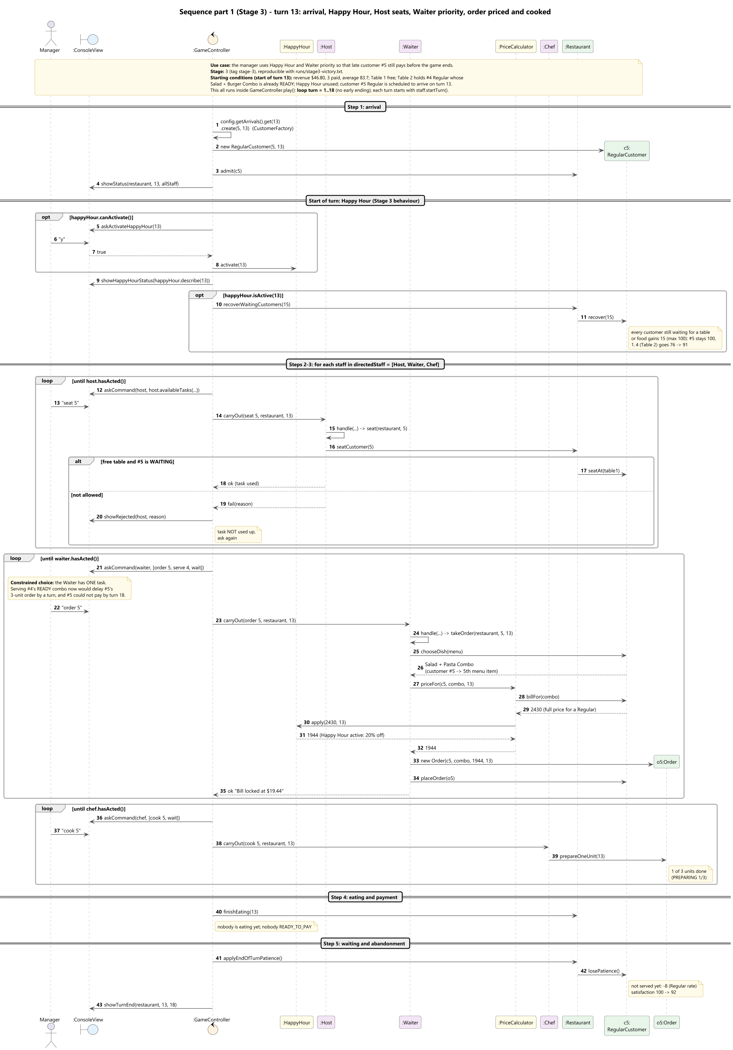
Figure 4a. Sequence part 1 - turn 13: arrival, Happy Hour, Host seats, Waiter priority, order priced and cooked.
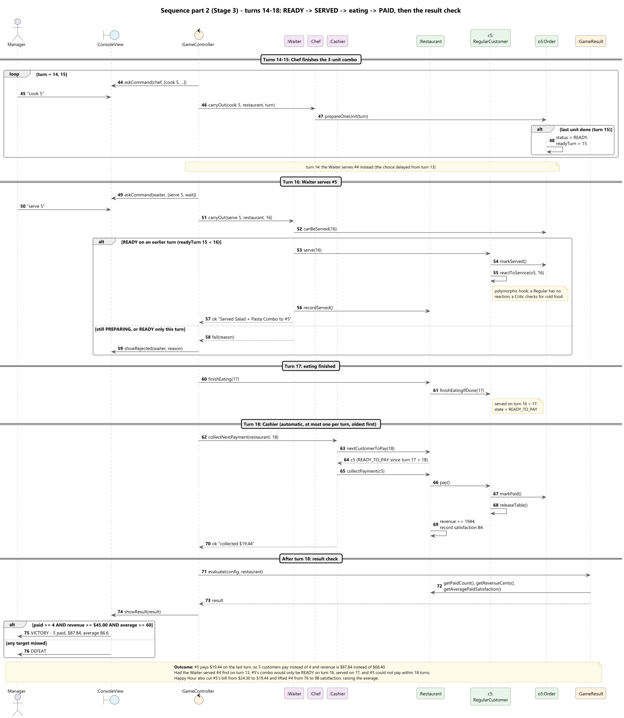
Figure 4b. Sequence part 2 - turns 14 to 18: READY, SERVED, eating, PAID, then the result check.

3.1 Life cycles (supporting diagram)
This state diagram summarises the rules that the sequence relies on: which method moves a customer or an order to its next state, and under which guard. It matches the checks inside Customer and Order.
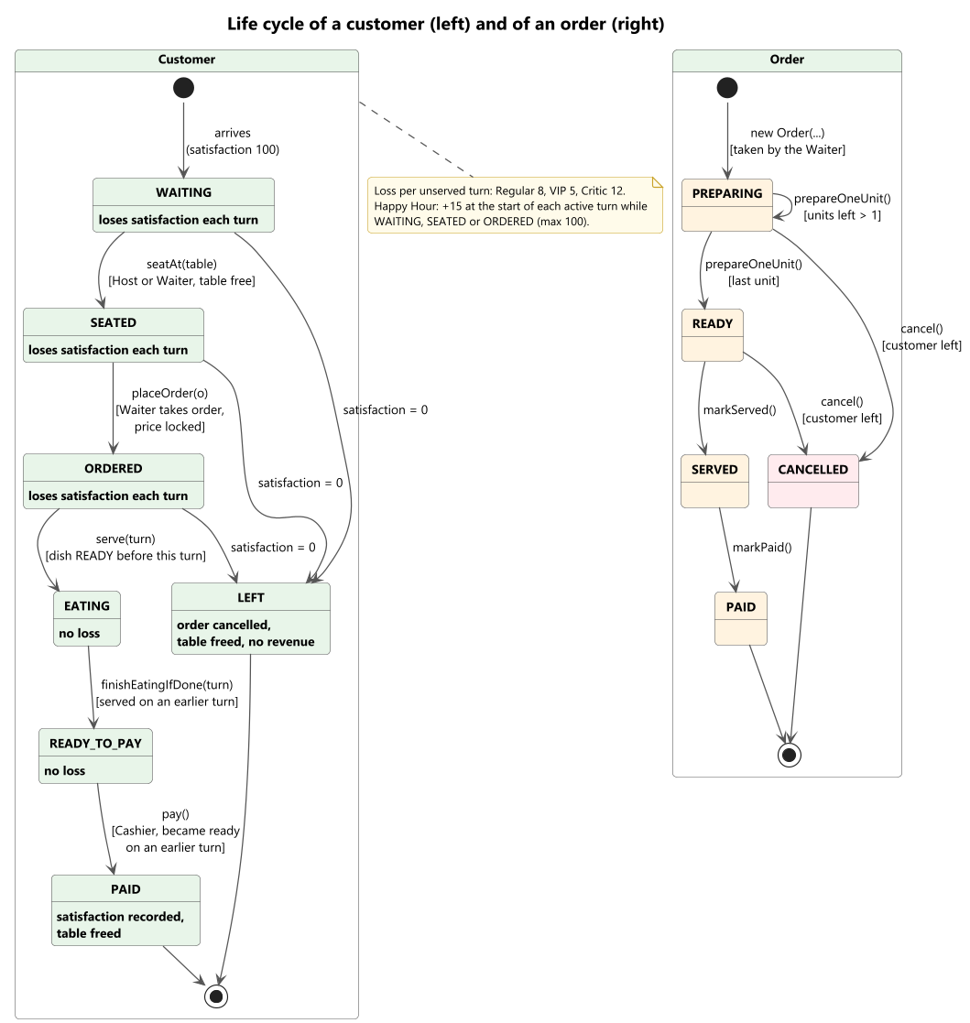
Figure 5. Customer and order life cycles.

4. Design Considerations

4.1 Key abstractions and responsibilities
Class | Responsibility
GameController | Runs the turn steps in order for 18 turns (labelled by the TurnStep enum). Hands each manager command to the staff member through carryOut() and asks again when a command is rejected. Holds no game rules itself.
GameConfig / CustomerFactory | Base setting: turns, tables, the arrival schedule (turn → CustomerFactory, e.g. VIPCustomer::new) and the victory targets.
GameResult | Judges the final restaurant state against the three targets.
GameView / ConsoleView / CommandParser | Boundary. Shows the state and the numbered task options, and turns typed text into a StaffCommand (syntax only, in CommandParser). Never decides whether a move is legal.
Restaurant | Holds the tables, waiting queue, all customers and the results (revenue, satisfaction at payment, departures). Shared rules: seating, finding who may pay, end-of-turn patience, Happy Hour recovery.
Customer (+ Regular, VIP, Critic) | Owns its life cycle and satisfaction. Subclasses decide patience loss, billing, food choice and reaction to service.
Staff (+ Host, Waiter, Chef, Cashier) | One task per turn (perform()). carryOut() is the common entry point; each subclass accepts only its own commands in handle() and lists what it can do now in availableTasks() as TaskOptions.
StaffCommand / TaskOption / ActionResult | Value objects: a requested task, an option shown to the manager, and the success or failure of an action with the reason.
Order | Locked price, preparation progress and legal status changes (PREPARING → READY → SERVED → PAID, or CANCELLED).
Menu, MenuItem, ComboMeal | What can be ordered. A ComboMeal derives its price and units from its two components.
PriceCalculator, HappyHour | The bill at order time: the customer's own price, then Happy Hour. HappyHour tracks its single use, two-turn duration, discount and recovery.

4.2 Design principles reflected in the code
Single Responsibility (SRP). Rules, flow and display are kept apart:
- ConsoleView only prints and reads, and CommandParser only parses.
- GameController only sequences the turn.
- Each rule lives in one place:
  - "can this be served?" in Order.canBeServed();
  - "who pays next?" in Restaurant.nextCustomerToPay();
  - the one-task limit in Staff.perform();
  - pricing in PriceCalculator;
  - money formatting and rounding in Money.
Open/Closed (OCP). Stage 2 added two customer types without touching GameController, Restaurant, Order, Chef or Cashier: the new behaviour is in the new subclasses, and the schedule only registers VIPCustomer::new and CriticCustomer::new. Stage 3 added the Host as a new Staff subclass. Because staff are dispatched polymorphically through carryOut(), the controller only had to register it in directedStaff; it gained no Host-specific method. Combos are a new MenuItem subclass, so orders, the Chef and pricing handle them unchanged. The one place we had to open a stable class was Customer, to add the reactToService() hook (Section 6).
Liskov Substitution (LSP). Any Customer subclass can be used wherever a Customer is expected. The subclasses only change values and choices, never the life-cycle rules, because the state-changing methods are not overridden. A ComboMeal behaves exactly like a MenuItem (positive price, at least one preparation unit). We deliberately did not make Host a subclass of Waiter: a Host cannot take orders, so it could not stand in for a Waiter. Both extend Staff and share the seating rule through Restaurant.seatCustomer().
Dependency Inversion (DIP). GameController depends on the GameView interface, not on ConsoleView, Scanner or System.out. This let us add the script-replay mode (the same view reads from a file) without touching the controller. It was tested for real by the optional window: SwingView implements GameView, and the gui-extra commit changes no controller, staff or model file. The arrival schedule depends on the CustomerFactory abstraction rather than concrete customer classes.
Interface Segregation (ISP). This principle is only weakly reflected. CustomerFactory is a minimal one-method interface. GameView is a single interface because both user interfaces need every method; we chose not to split it just to tick the principle.

4.3 Trade-offs
- Inheritance for customer types keeps each type small and readable and gives clear polymorphism. However, a customer cannot change type at run time, and a new behaviour mix (e.g. a "VIP critic") would need another subclass.
- Template method in Staff. carryOut() is final, so every role gets the same wait handling and one-task rule, and the controller has no switch on roles. The cost is that a role learns about commands it does not support: the default handle() rejects them with a message listing what the role can do.
- Commands as text with customer numbers (seat 2, cook 3) make the game fast to play and easy to script for reproducible runs. We compensate for the weaker guidance with numbered options for every staff member, so the player can type 1 instead of remembering the syntax.
- Rules inside entities (e.g. Customer.pay() checks its own state) mean some validation is repeated: staff check first to give a friendly message, and entities check again and throw if misused. We accepted this duplication because it makes illegal states impossible even if a future caller forgets a check.

4.4 Alternative design considered
We considered the Strategy pattern for customer behaviour: a single Customer class holding a PatiencePolicy, a BillingPolicy and a DishChoicePolicy. It would allow mixing behaviours and changing them at run time. We chose inheritance because the brief defines exactly three fixed customer types, each with a few small differences. Three subclasses are simpler to read, to draw in UML and to explain, and they still dispatch behaviour through the customer object. If more types or combinations were needed, we would move to strategies.
We also considered the State pattern for the customer life cycle (one class per state). With only seven states and simple transitions, an enum plus guarded methods was clearer and kept all life-cycle rules in one file.
For staff, an earlier version had one controller method per role (hostTask, waiterTask, chefTask) with a switch on the command. We replaced it with polymorphic carryOut()/handle() so that adding the Stage 3 Host needed no new controller method.

4.5 How the player's choices change the result
- Waiter priority under constraint. On turn 13 of stage3-victory, the Waiter takes #5's 3-unit combo before serving #4. #4 waits one more turn, but #5 can then pay on turn 18, giving 5 paid customers instead of 4 (Section 3).
- Kitchen priority. In stage3-defeat, the Chef idles and then cooks the newer 2-unit combo before the Critic's 3-unit combo. The Critic (-12 per turn) reaches 0 and leaves on turn 15, so only 3 customers pay ($41.40): Defeat. In stage3-victory, the Chef finishes the Critic's combo first and it is served hot.
- Serving the Critic on time. In stage2-victory, the Waiter serves the Critic's Pasta the turn after it became READY ("arrived hot"). In stage2-defeat it is never served, and the Critic walks out.
- Happy Hour timing. Using it on turns 13-14 (victory run) discounts #5's combo to $19.44 and lifts #4 from 76 to 98 satisfaction. Using it on turn 4 when nobody is waiting (defeat run) only saves the VIP $2.70 and wastes the recovery.
- Using the Host. In the victory run the Host seats while the Waiter takes an order in the same turn, which earns $87.84. The defeat run never uses the Host, and the queue backs up.

5. Functional Evidence and Test Notes
All runs use the base setting and can be replayed exactly with the scripts in runs/ (check out the matching tag first). Each script contains comments explaining the decisions. Every result below was re-checked by building each tag from a clean checkout and replaying both of its scripts.
Run (tag) | Result | Paid | Revenue | Avg satisfaction / notes
stage1-victory (stage-1) | Victory | 5 | $66.00 | 79.2. Includes a rejected early "serve 3" on turn 9 (Figure 7).
stage1-defeat (stage-1) | Defeat | 3 | $42.00 | 38.7. Chef idle for many turns; "seat" rejected when no table is free.
stage2-victory (stage-2) | Victory | 5 | $64.50 | 78.0. VIP Burger $13.50; Critic served hot.
stage2-defeat (stage-2) | Defeat | 3 | $31.50 | 86.0. Critic left unserved and walks out (unhappy departure).
stage3-victory (stage-3) | Victory | 5 | $87.84 | 86.6. Host and Waiter in the same turn; Happy Hour turns 13-14; combos.
stage3-defeat (stage-3) | Defeat | 3 | $41.40 | 85.0. VIP + Happy Hour Burger $10.80; Critic walks out; cooking the CANCELLED order is rejected.

5.1 Rule checks
Rule from the brief | Where it is shown
Worked example (Pasta: 92, 84, 76, served, pays at 76) | stage1-victory, customer #3: seated at 92, then 84, then 76, served on turn 10, READY_TO_PAY on turn 11, paid on turn 12 with 76.
A dish finished this turn is served next turn at the earliest | Order.canBeServed() requires readyTurn < turn; stage1-victory turn 9 "serve 3" is rejected.
READY_TO_PAY this turn pays next turn at the earliest; one payment per turn, oldest first | Customer.canPay(), Restaurant.nextCustomerToPay(), Cashier.collectNextPayment(); stage3-victory #4 and #5 pay on turns 16 and 18.
Invalid choice explained, task not used up | Staff.perform() only marks the task used on success; the console shows "Choose again - the Waiter's task has not been used up".
Customer at 0 leaves: order cancelled, table freed, no revenue | stage2-defeat and stage3-defeat (Critic). Cooking the cancelled order is then rejected.
Arrival on turn 16 cannot pay | Customer #6 never pays in any run (at most 5 payers).
VIP, then Happy Hour, price locked | stage3-defeat: Burger $15 x 0.9 x 0.8 = $10.80.
Combo price and units | Salad + Pasta Combo = $24.30, 3 units; Salad + Burger = $21.60, 2; Burger + Pasta = $29.70, 3.
Average satisfaction N/A before anyone pays | Status and end-of-turn lines show "N/A" until the first payment.
Robust input | Unknown commands, missing or non-numeric numbers, option numbers out of range, blank lines and end of input are handled (end of input = wait).

5.2 Console screenshots
The terminal is organised by the turn steps of the brief. Each turn shows:
- a turn header with the turns left;
- a status board (queue, tables, orders, patience and each staff member's available tasks);
- one heading per step;
- numbered options for every choice;
- an end-of-turn summary with each customer's change in satisfaction.
The colours below are added for the report only: events are green, rejected choices red and Happy Hour yellow.
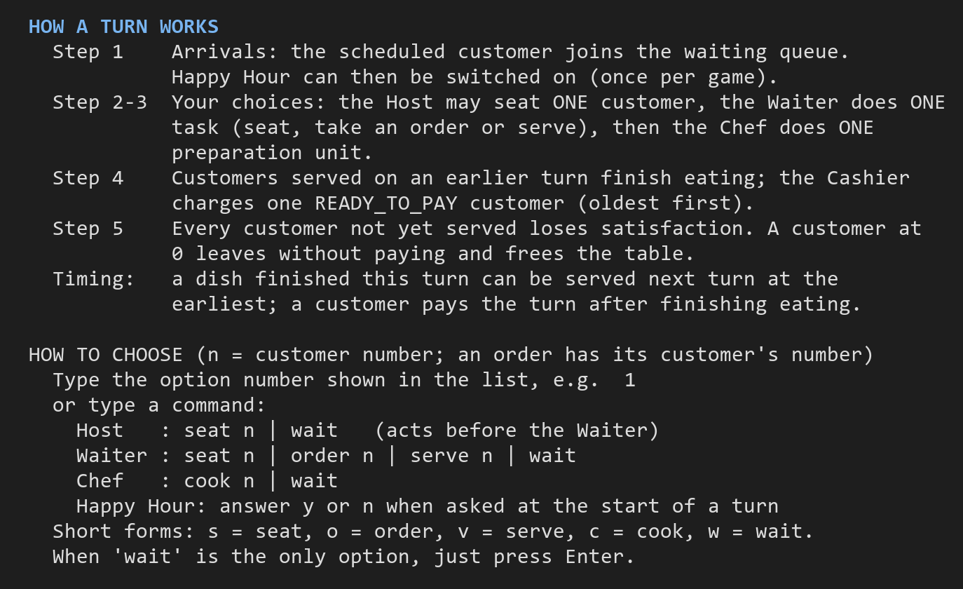
Figure 6. Welcome screen: how a turn works and how to choose (stage3-victory).
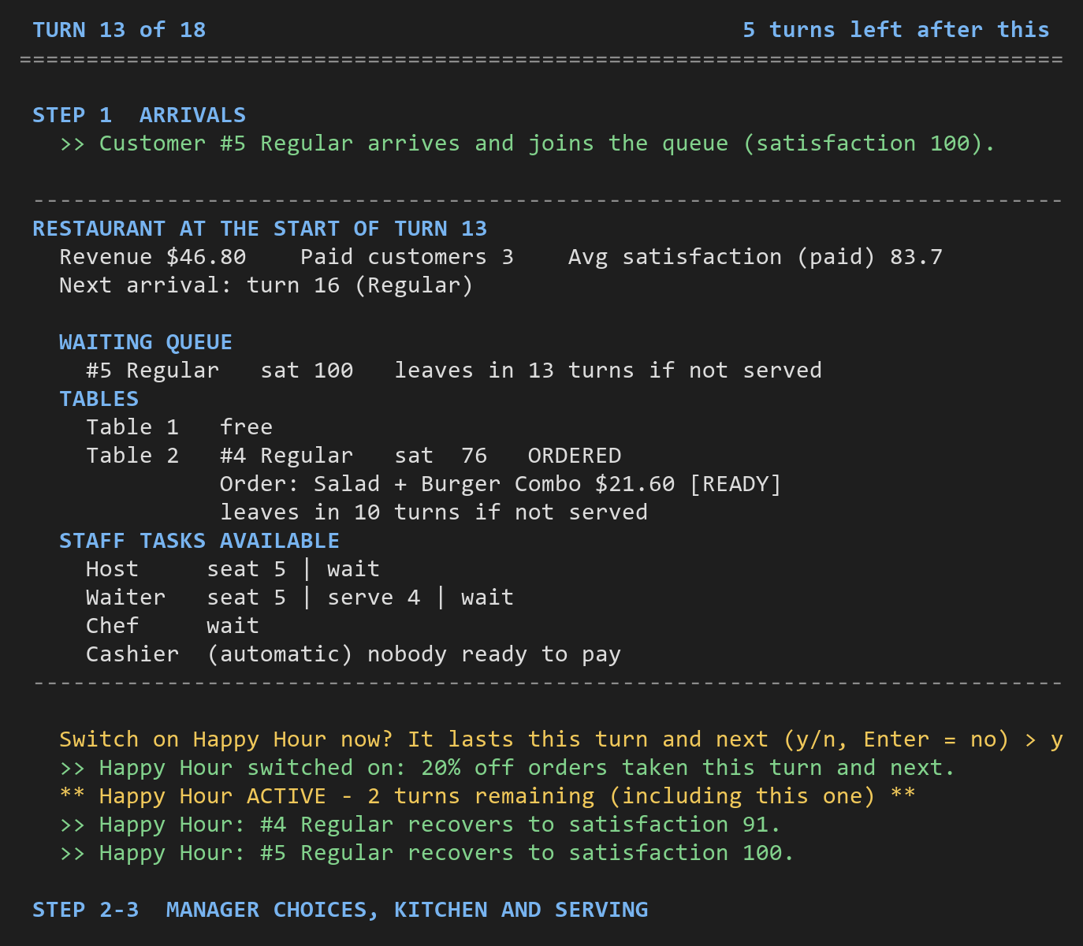
Figure 7a. Start-of-turn board on turn 13 of stage3-victory (the sequence diagram's starting conditions).
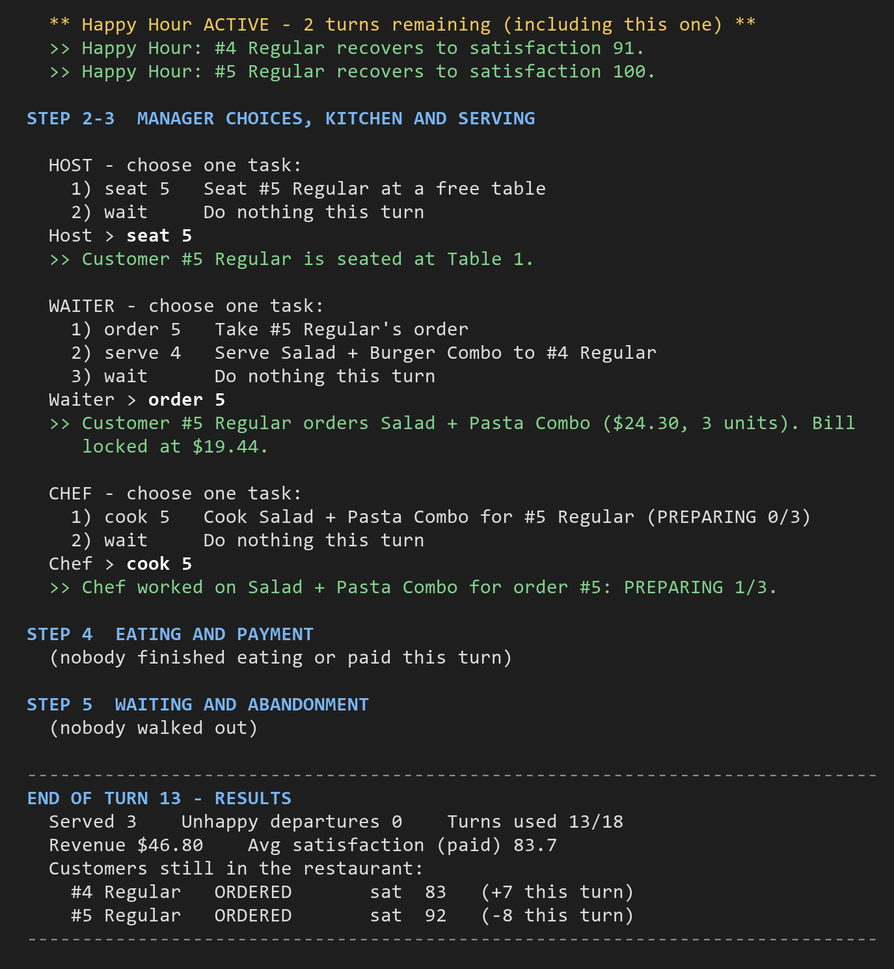
Figure 7b. Turn 13 choices: Happy Hour, Host seats #5, Waiter takes #5's order at $19.44 instead of serving #4, Chef cooks.
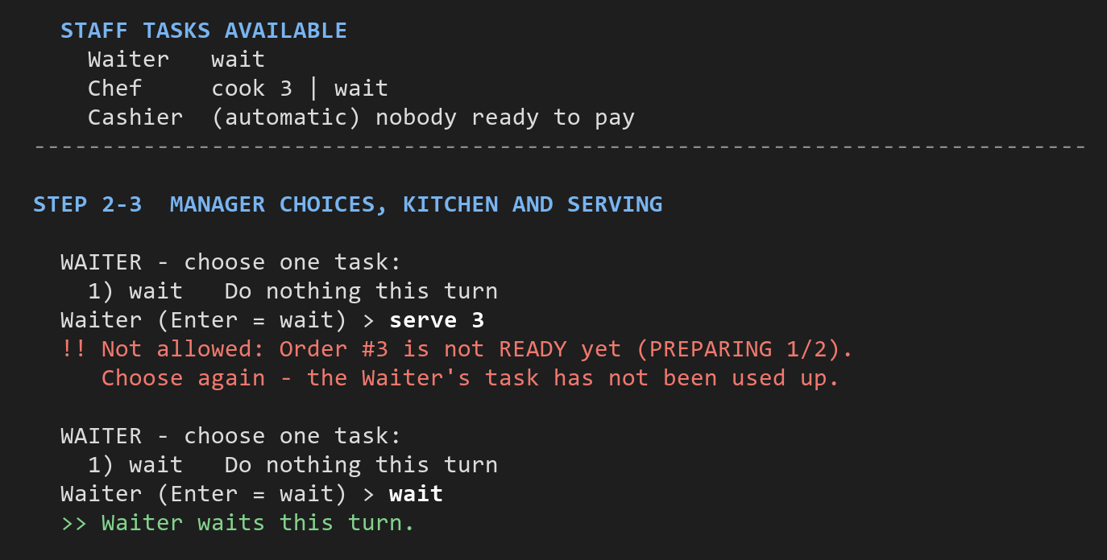
Figure 8. A rejected choice is explained and the task is not used up (stage1-victory, turn 9).
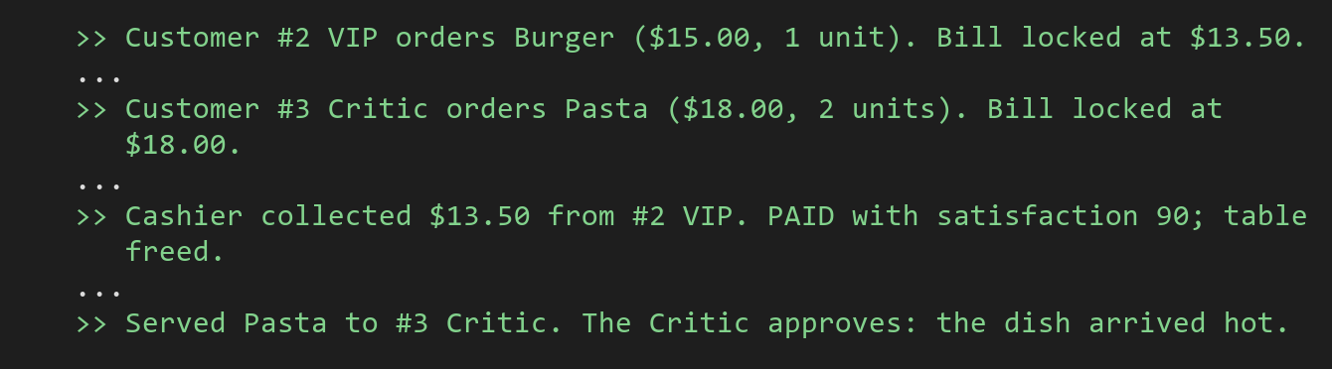
Figure 9. Stage 2 behaviours: VIP discount ($13.50) and the Critic's reaction to a hot dish (stage2-victory).
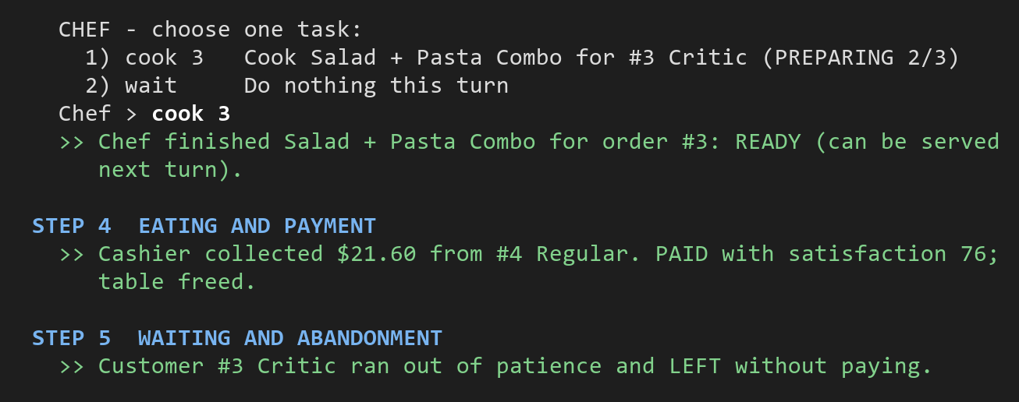
Figure 10. The Critic runs out of patience and leaves without paying (stage3-defeat, turn 15).
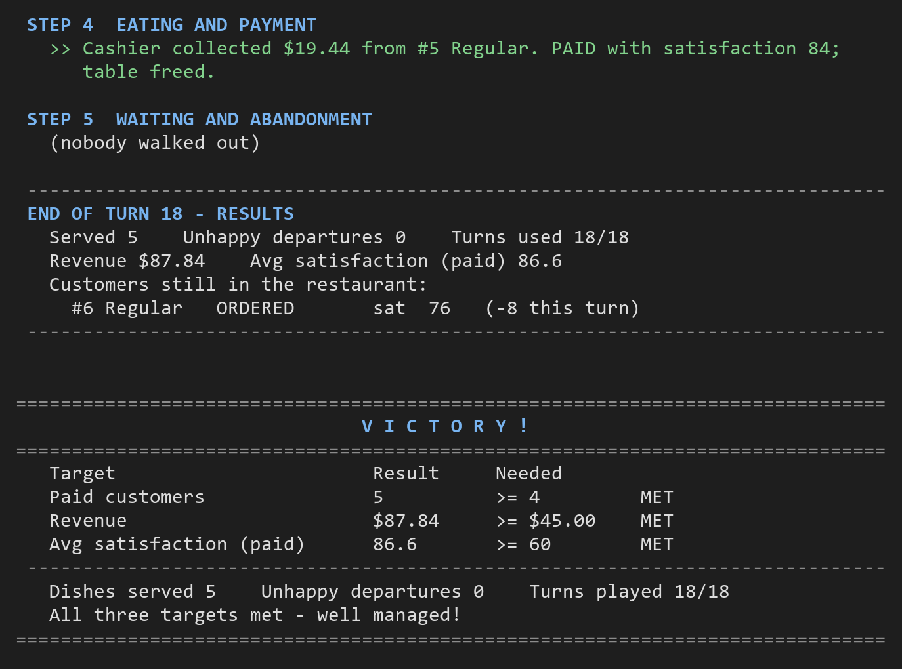
Figure 11. Turn 18 payment and the VICTORY screen (stage3-victory).
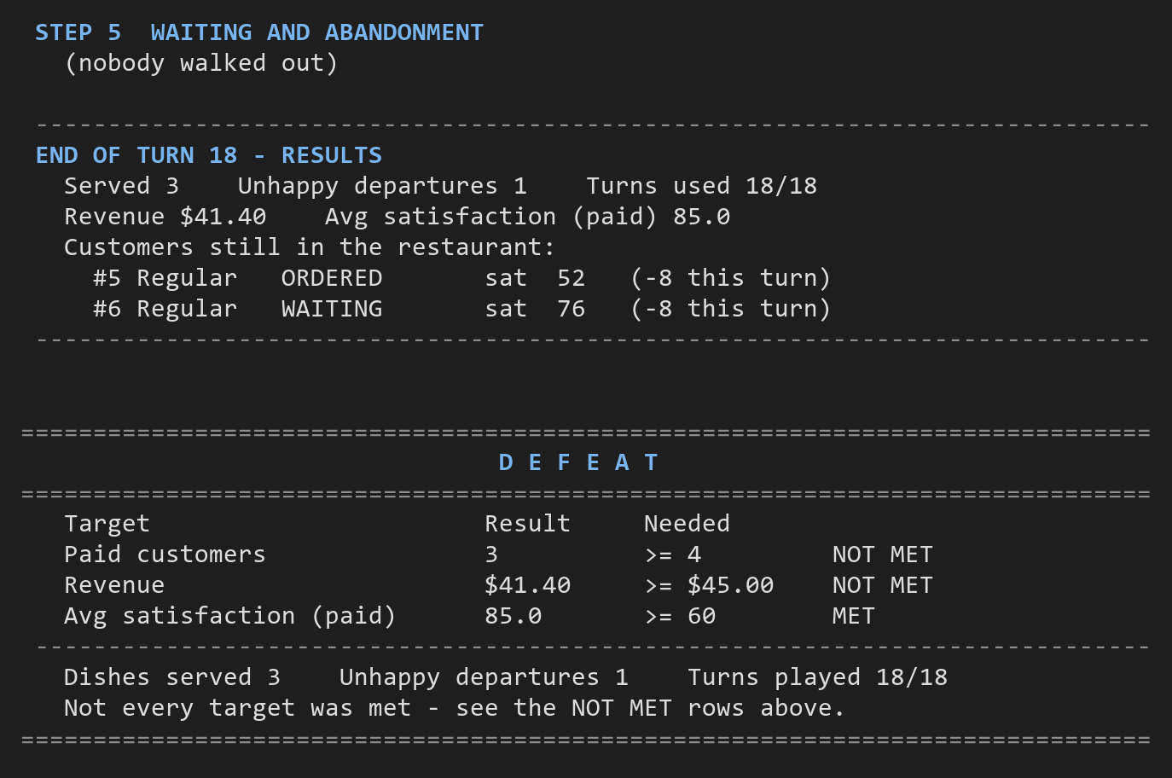
Figure 12. The DEFEAT screen with the targets that were not met (stage3-defeat).

6. Development Process and Stage Changes
Each stage is one commit on the tagged history, and each extends the saved previous stage. The source code itself shows the real stages: for example, stage-1 contains no VIP, Critic, Host, Happy Hour or combo code, and stage-2 contains no Stage 3 class.
Tag | Commit | Contents
stage-1 | f461480 | Regular customers, menu, Waiter, Chef, automatic Cashier, 2 tables, queue, full turn sequence, victory and defeat, two replay scripts.
stage-2 | 9ce66f8 | + VIPCustomer, CriticCustomer, two replay scripts.
stage-3 | 87683ee | + Host, ComboMeal, HappyHour, PriceCalculator, two replay scripts.
gui-extra | d9672e8 | + SwingView (optional window). No rule changes.

Compare links (README): https://github.com/pyizaw/NTU_SCE1_SC2002/compare/stage-1...stage-2 and .../compare/stage-2...stage-3.

6.1 Stage 1 → Stage 2: 6 source files, +143 / -6 lines
File | Change | Reason and effect on the design
customer/VIPCustomer | added | Overrides getSatisfactionLossPerTurn() (5) and billFor() (10% off).
customer/CriticCustomer | added | Loss 12; overrides chooseDish() (most demanding item) and reactToService() (cold-food penalty).
customer/Customer | modified | Gained the protected hook reactToService() (default: no reaction), and serve() now returns the reaction text. Without the hook, the Waiter would need to check "is this a Critic?" to apply the cold-food rule, which the brief forbids.
staff/Waiter | modified | Adds the reaction to the "Served ..." message (3 lines).
controller/GameConfig | modified | Registration only: turn 4 → VIPCustomer::new, turn 7 → CriticCustomer::new.
view/ConsoleView | modified | The welcome screen explains the customer types.
(deleted) | none | The new types plug into the existing hierarchy.

What still works: GameController, Restaurant, Order, Chef and Cashier are unchanged, which shows that the Stage 1 design was open to new customer types. The turn order, timing and payment rules are the same, and the Regular customers in the Stage 2 runs follow the same 92 / 84 / 76 patience pattern as in Stage 1.

6.2 Stage 2 → Stage 3: 11 source files, +353 / -8 lines
File | Change | Reason and effect on the design
staff/Host | added | A new Staff subclass: handle() accepts seat, and availableTasks() offers the queued customers.
model/ComboMeal | added | A MenuItem composed of two MenuItems; Order, Chef and pricing use it unchanged.
pricing/HappyHour | added | Single use, two-turn duration, 20% discount and the recovery rule.
pricing/PriceCalculator | added | Customer price (VIP discount) then Happy Hour, so neither class knows about the other.
controller/GameController | modified (+31) | Registers the Host in directedStaff, creates the HappyHour and PriceCalculator, and offers Happy Hour at the start of each turn. No new per-role method, because staff are dispatched polymorphically.
staff/Waiter | modified | Asks PriceCalculator.priceFor() for the bill instead of customer.billFor(), so Happy Hour is applied after the customer's own discount and locked into the order.
model/Menu | modified | Menu.withCombos() adds the three combos after the dishes.
model/Restaurant, customer/Customer | modified | recoverWaitingCustomers() and Customer.recover() implement the Happy Hour recovery; only customers who are still waiting recover.
view/GameView, view/ConsoleView | modified | Happy Hour prompt and status line, and the combo menu on the welcome screen.
(deleted) | none | -

What still works: the six-step turn order, the VIP and Critic rules, Chef cooking, Cashier payment and the result check are unchanged. The Stage 3 runs reuse them, for example the VIP discount applied before Happy Hour ($10.80) and the Critic walking out in stage3-defeat. The Stage 1 and Stage 2 scripts still give the same results at their own tags.

6.3 Optional window version (tag gui-extra)
A GUI earns no marks by itself, so it was added as an extra commit after stage-3, and the terminal game remains the main interface. Its value for the design is evidence of DIP:
- SwingView is a second implementation of GameView.
- The commit only adds SwingView and changes Main (the --gui option). No controller, staff or model file changes.
- Playing the Stage 3 victory script through the window gives the same result: $87.84, 5 paid, average 86.6.
Usability features of the window:
- progress towards each target, shown in green once met;
- an arrival preview;
- numbered task buttons (keys 1-9);
- automatic skipping of staff whose only option is "wait";
- a "leaves in N turns" warning on every waiting customer, computed by the domain query Customer.turnsUntilLeaving().
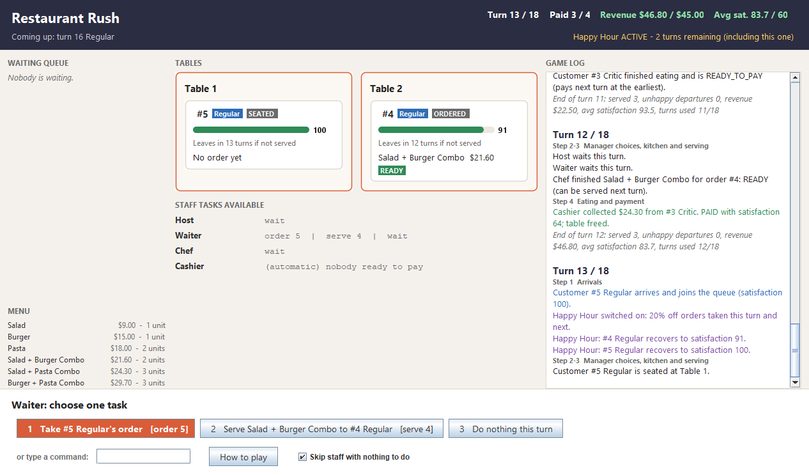
Figure 13. Window version, turn 13 of the Stage 3 victory run.

7. Reflections
Group reflection.
- What went well: keeping the rules inside the domain objects meant each stage was mostly additive. The deterministic food rule and the script-replay mode made it easy to reproduce runs and to check the numbers by hand.
- What we would improve: a unit-test suite (e.g. JUnit) for the pricing and timing rules, a configurable difficulty setting, and possibly strategies instead of subclasses if more customer types were added.
Each member answers the four questions below under their own name, using examples from their own work (classes, commits or diagrams).

7.1 [Member 1 name]
Contribution: [the stages, classes, diagrams or report sections you worked on]
What did you learn?
[Describe a specific gain in knowledge or skill.]
How did you apply it?
[Connect a course concept to a real project decision.]
What challenged you?
[Explain the hardest part and why it was difficult.]
How did you solve it?
[Describe your attempts, your solution and what you learned.]

7.2 [Member 2 name]
Contribution: [the stages, classes, diagrams or report sections you worked on]
What did you learn?
[Describe a specific gain in knowledge or skill.]
How did you apply it?
[Connect a course concept to a real project decision.]
What challenged you?
[Explain the hardest part and why it was difficult.]
How did you solve it?
[Describe your attempts, your solution and what you learned.]

7.3 [Member 3 name]
Contribution: [the stages, classes, diagrams or report sections you worked on]
What did you learn?
[Describe a specific gain in knowledge or skill.]
How did you apply it?
[Connect a course concept to a real project decision.]
What challenged you?
[Explain the hardest part and why it was difficult.]
How did you solve it?
[Describe your attempts, your solution and what you learned.]

7.4 [Member 4 name]
Contribution: [the stages, classes, diagrams or report sections you worked on]
What did you learn?
[Describe a specific gain in knowledge or skill.]
How did you apply it?
[Connect a course concept to a real project decision.]
What challenged you?
[Explain the hardest part and why it was difficult.]
How did you solve it?
[Describe your attempts, your solution and what you learned.]

7.5 [Member 5 name]
Contribution: [the stages, classes, diagrams or report sections you worked on]
What did you learn?
[Describe a specific gain in knowledge or skill.]
How did you apply it?
[Connect a course concept to a real project decision.]
What challenged you?
[Explain the hardest part and why it was difficult.]
How did you solve it?
[Describe your attempts, your solution and what you learned.]

8. Declarations and AI History
The signed Declaration of Original Work and each member's Declaration on Use of GAI Assistance (course forms) are included in the submission archive.
[Attach the signed declarations.]
AI assistance was used in this project and is declared on the GAI forms. As the brief requires, each member's full AI conversation history (prompts, replies and follow-ups, in order) is on their own branch of the group repository, in ai-history/stage-1/chat-01.md, ai-history/stage-2/chat-01.md and ai-history/stage-3/chat-01.md. The README links to each member's branch.
Member | AI history branch
[Member 1 name] | [branch link]
[Member 2 name] | [branch link]
[Member 3 name] | [branch link]
[Member 4 name] | [branch link]
[Member 5 name] | [branch link]

