MCU : STM32F405RG

1. Clock 설정(RCC)

HSE : Crystal/Ceramic Resonator

25MHz, crystal (5, 6번 핀 사용)

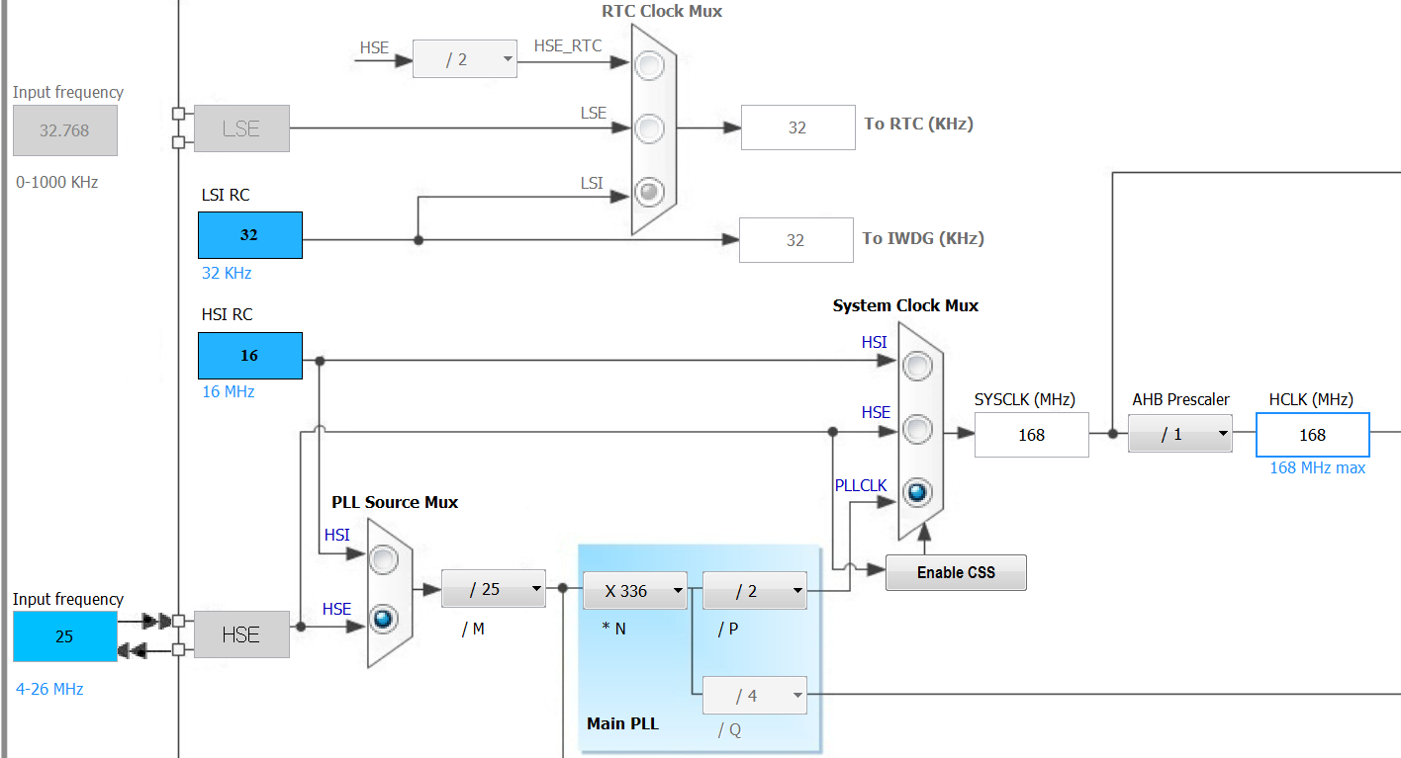

1. LD0/LD1/LD2/LD3

|  |  |  |  |  |  |  |  |  |
| --- | --- | --- | --- | --- | --- | --- | --- | --- |
| 신호 | 핀 | GPIO/AF | Reset | P.P./O.D. | PU/PD | Speed | LED제어 | 전류mA |
| LD1 | PC2 | GPIO_Output | Reset-Off | P.P. | NO | Low | Low - On | <=20 |
| LD2 | PC3 | GPIO_Output | Reset-Off | P.P. | NO | Low | Low - On |  |
| LD3 | PC4 | GPIO_Output | Reset-On | P.P. | NO | Low | Low - On |  |
| LD4 | PC5 | GPIO_Output | Reset-On | P.P. | NO | Low | Low - On |  |

*Speed 전류가 크면 Low…

1. LED1/LED2

|  |  |  |  |  |  |  |  |  |
| --- | --- | --- | --- | --- | --- | --- | --- | --- |
| 신호 | 핀 | GPIO/AF | 초기상태 | P.P./O.D. | PU/PD | Speed | LED제어 | 전류mA |
| LED1 | PA2 | GPIO_Output | LED Off | P.P. | NO | Low | H - On | <=20 |
| LED2 | PA3 | GPIO_Output | LED Off | P.P. | NO | Low | H - On |  |

*스위치를 LED 위치로 변경.



1. S1/S2/S3 Switch

|  |  |  |  |  |  |
| --- | --- | --- | --- | --- | --- |
| 신호 | 핀 | GPIO/AF | PU/PD | 동작 |  |
| S1 | PA8 | GPIO_Input | NO | 누름-High |  |
| S2 | PA11 | GPIO_Input | NO | 누름-High |  |
| S3 | PA12 | GPIO_Input | NO | 누름-High |  |

1. Motor(GPIO 모드)

|  |  |  |  |  |  |  |  |  |
| --- | --- | --- | --- | --- | --- | --- | --- | --- |
| 신호 | 핀 | GPIO/AF | Reset | P.P./O.D. | PU/PD | Speed |  |  |
| M_P | PB6 | GPIO_Output | Low | P.P. | NO | Low |  |  |
| M_N | PB7 | GPIO_Output | Low | P.P. | NO | Low |  |  |
| M_PWM | PA6 | GPIO_Output | Low | P.P. | NO | Low |  |  |



|  |  |  |  |
| --- | --- | --- | --- |
| M_P(PB6) | M_N(PB7) | M_PWM(PA6) | 동작 |
| H | L | H | 모터 On |
| L | L | H | 모터 Off |

*in1 – M_P, in2 – M_N, PWM – M-PWM, STBY – High로 고정

6. JOG

|  |  |  |  |  |  |
| --- | --- | --- | --- | --- | --- |
| 신호 | 핀 | GPIO/AF | PU/PD | 동작 |  |
| J_UP | PB0 | GPIO_EXTI0 | NO | 누름-High |  |
| J_DN | PB1 | GPIO_EXTI1 | NO | 누름-High |  |
| J_RT | PB13 | GPIO_EXTI13 | NO | 누름-High |  |
| J_LT | PB12 | GPIO_EXTI12 | NO | 누름-High |  |
| J_CN | PB2 | GPIO_EXTI2 | NO | 누름-High | Interrupt-Rising Edge |