- LCD
LMC16213A-YTDSYW
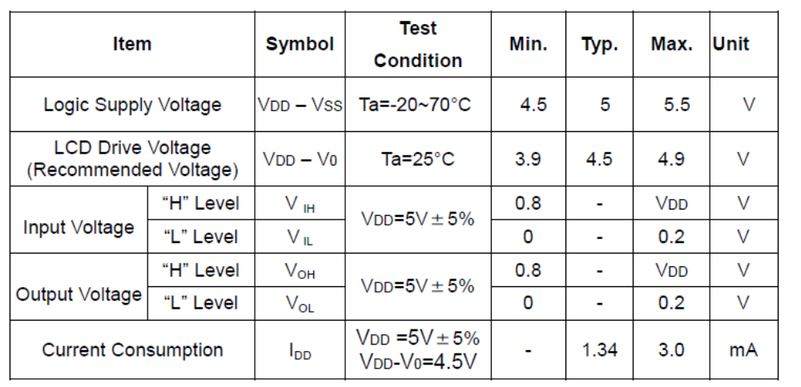
3.3V – 5V 변환 필요 : 74LVX4245MTC

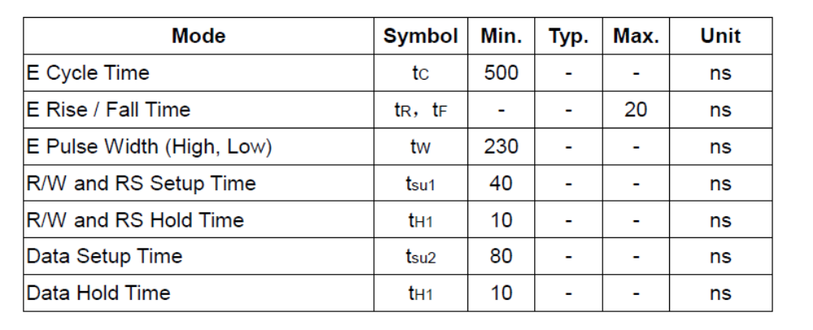
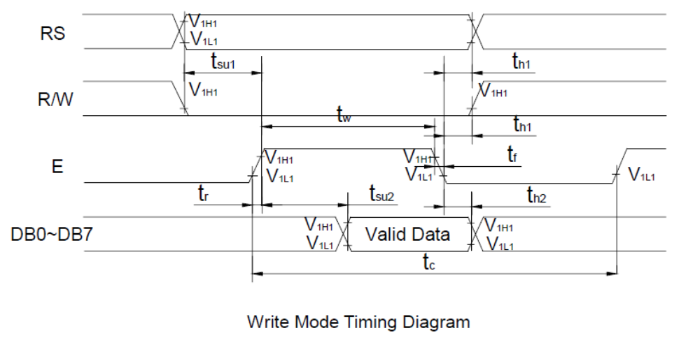

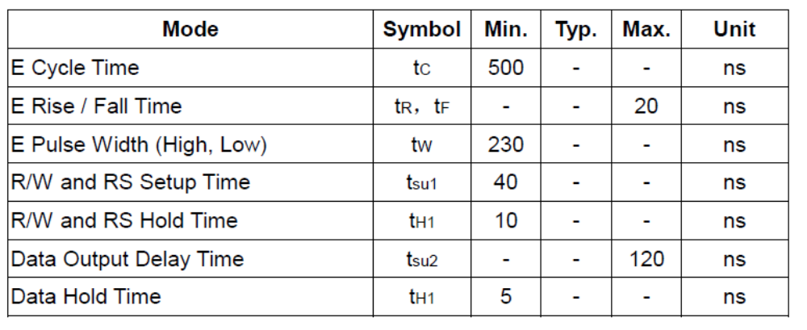
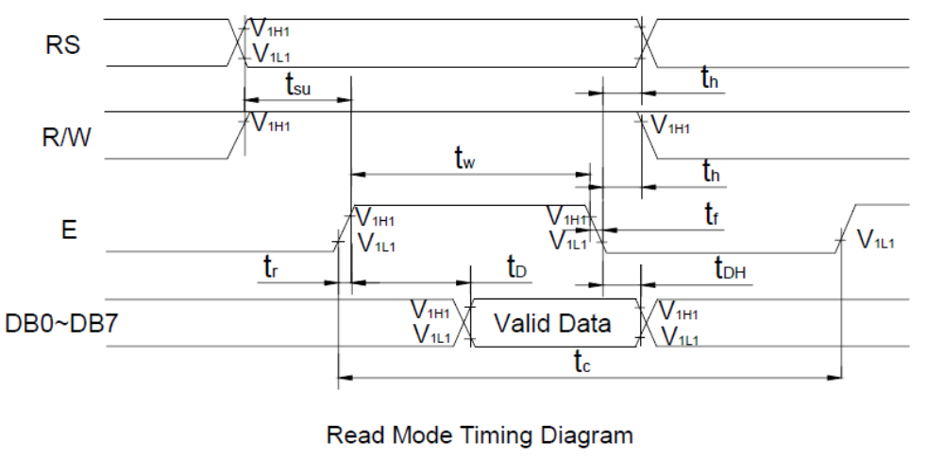

- Motor
59 | PB7 | DC_MOTOR_N (IN2)
58 | PB6 | DC_MOTOR_P (IN1)
22 | TIM3_CH1 | DCMOTOR_PWM

