Assignment: Dojo Fruit Store

**Welcome to another Core assignment!** Some students like to explore the assignments before they're finished reading through the lessons, and that's okay! It can be good for your brain to have a preview of what your future challenges might be. However, before you begin this assignment, it's important that you've first:

* Completed the preceding lesson modules
* Taken the knowledge checks to confirm your understanding
* Viewed lecture material related to the assignment topics
* Completed and submitted your practice assignments

Now, the Assignment:

Start by cloning the repo found here: <https://github.com/mchoidojo/dojo_fruit_store>

For this assignment, you'll be building a small web app as illustrated below:

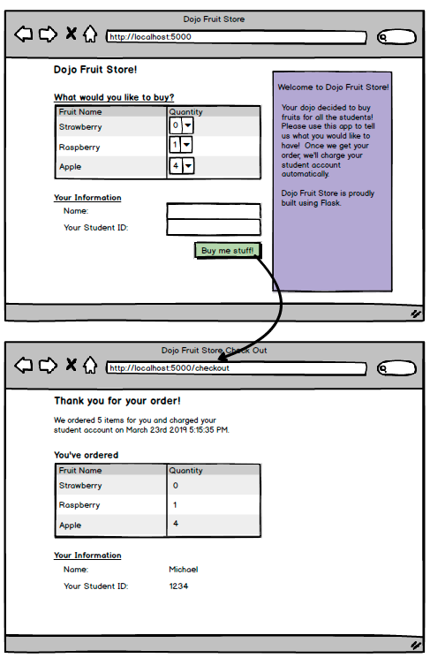

Note that the template allows you to use simple if statements and for loops, but is not really a place to do much more than that. If you're wanting to do any calculations, you would want to do this in the routing file (server.py).

Also, remember that all form inputs are received as strings. If you want to work with them as numbers, use the int() method to convert a string to an integer. For example:

"1"+"2"+"3" # returns 123

int("1")+int("2")+int("3") # returns 6

**Note for Mac Users:**

To get this code to run, you may have to add the following shebang to the top of your file to specify which version of Python to run on.

#!/usr/bin/env python3

You can read about shebangs and how they work [here](https://en.wikipedia.org/wiki/Shebang_(Unix)).

Top of Form

¨ Display all the provided images of fruit on the fruits.html page

¨ When the Checkout button is clicked, have the correct information display on the checkout.html page

¨ In the checkout method, add a print statement to display in the terminal that says "Charging [customer's name here] for [count] fruits". For example, if the user's name is Sam and they ordered 5 fruits, the print statement would read: "Charging Sam for 5 fruits"

¨ While on the checkout screen, hit the refresh button in your browser. Then check your terminal--what do you notice?

Bottom of Form