TINYWALL LOCALIZATION INSTRUCTIONS

This file contains instruction on localizing (translating) TinyWall into various spoken languages. Please follow the instructions carefully.

CONTENT

TOOLS NEEDED
GENERAL NOTES
BASIC TRANSLATION
QUALITY CONTROL AND GUI CUSTOMIZATIONS

TOOLS NEEDED

1. TinyWall installed
2. Zeta Resource Editor
3. (optional) WinRes.exe from the Microsoft Windows SDK

GENERAL NOTES

TinyWall's language resources are grouped into several XML files. Each file in the "Forms" directory contains the localized strings of one specific window TinyWall can show. For example, ConnectionsForm.resx (and all its language variants) contain the strings (texts) that the user can read when opening the Connections window of TinyWall. In addition to the "form" files, additional text can also be found in Exceptions.resx and Messages.resx. Exceptions.resx contains localized names of firewall exceptions, while Messages.resx contains all kinds of miscellaneous text.

When creating a new language, each file must be named in a specific way: a language code is added between the base file name and the resx extension. For example, if the original (untranslated) file is Messages.resx, the German variant must be called Messages.de.resx. Replace "de" by the 2-letter country code of your language. For a list of valid country codes, see the „Culture Name“ column in http://msdn.microsoft.com/en-us/goglobal/bb896001.aspx .

Please do not use sub-languages. Select a generic variant of your language without a country specialization. For example, do not use "de-AT", just use simply "de". Also, please note that Right-To-Left languages are not supported by TinyWall.

If a translation for a string does not exist in a specific language, TinyWall will automatically load and use the default (English) version of the string. That is, even if a translation misses some text, something will always be shown to the user.

BASIC TRANSLATION

1. Download and install the Zeta Resource Editor. You can get it for free (it is a freeware) from www.zeta-resource-editor.com . If you prefer not to install anything, an install-less portable version can also be downloaded from the same website.

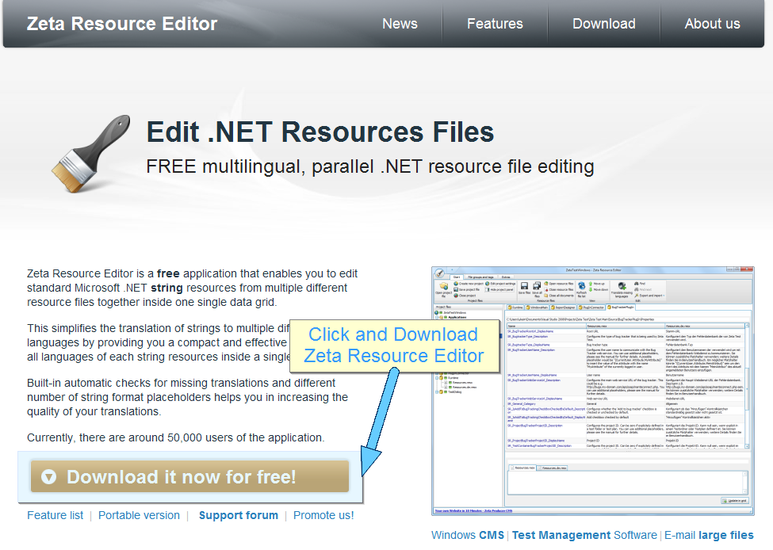
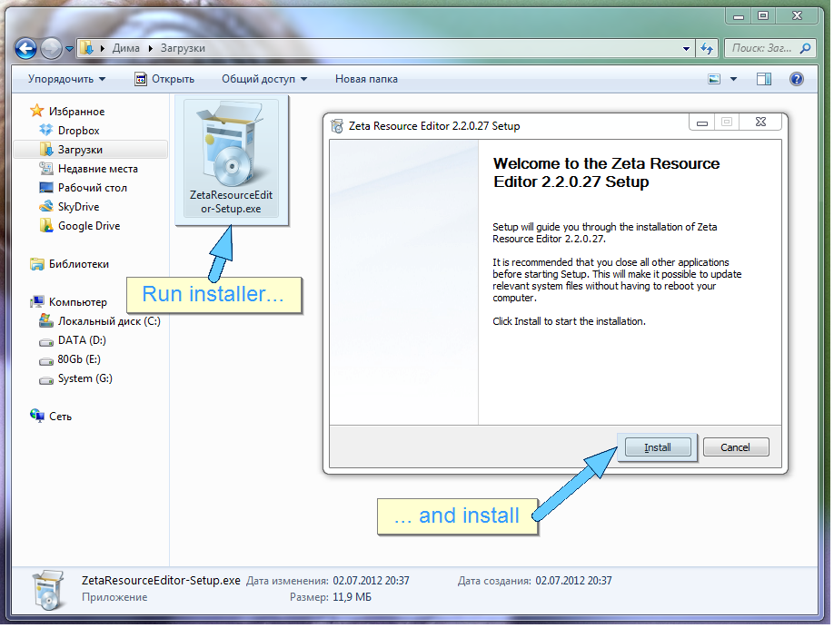

2. Start the resource editor you've just downloaded.

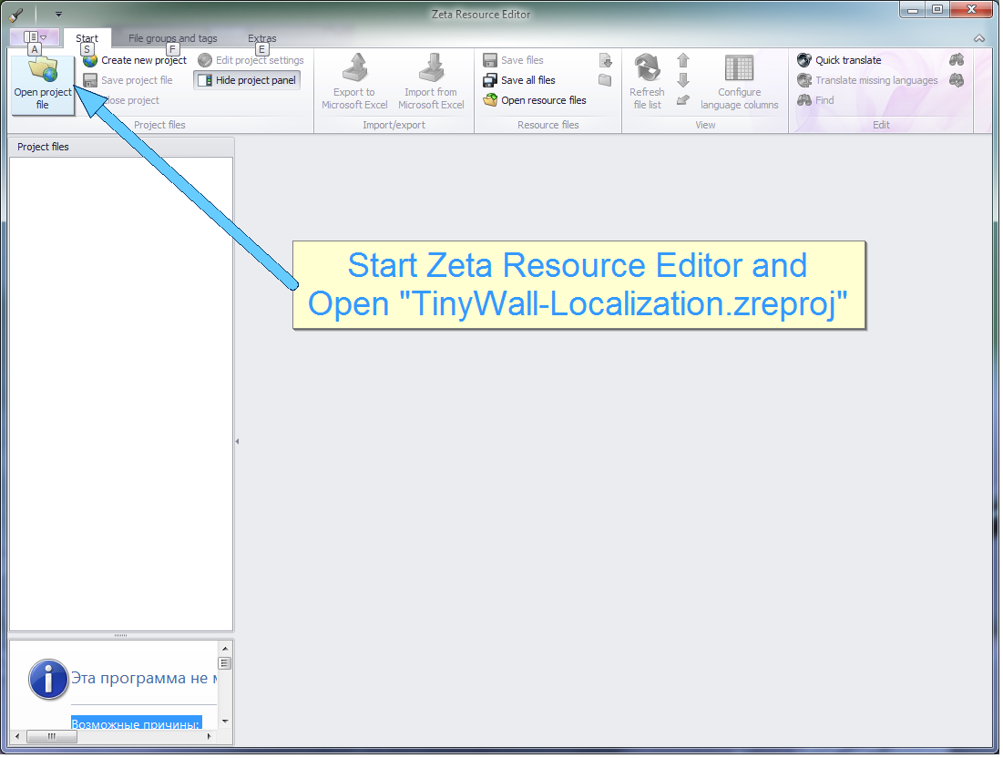

3. Open the pre-made project file "TinyWall-Localization.zreproj" in the Resources folder of TinyWall's localization pack. The left pane will show each resource file with all the language variants grouped into a single node. Double click a node and the left pane will show the strings in multiple columns, one language in each column.

4. Leave the project open, but close all opened language/resource file tabs in the right pane.

5. Right click the first resource file in the left pane, and select "Create new file for language". In the new dialog, leave the "Reference language" at English and set your new language in the "New language" field. Confirm with OK.
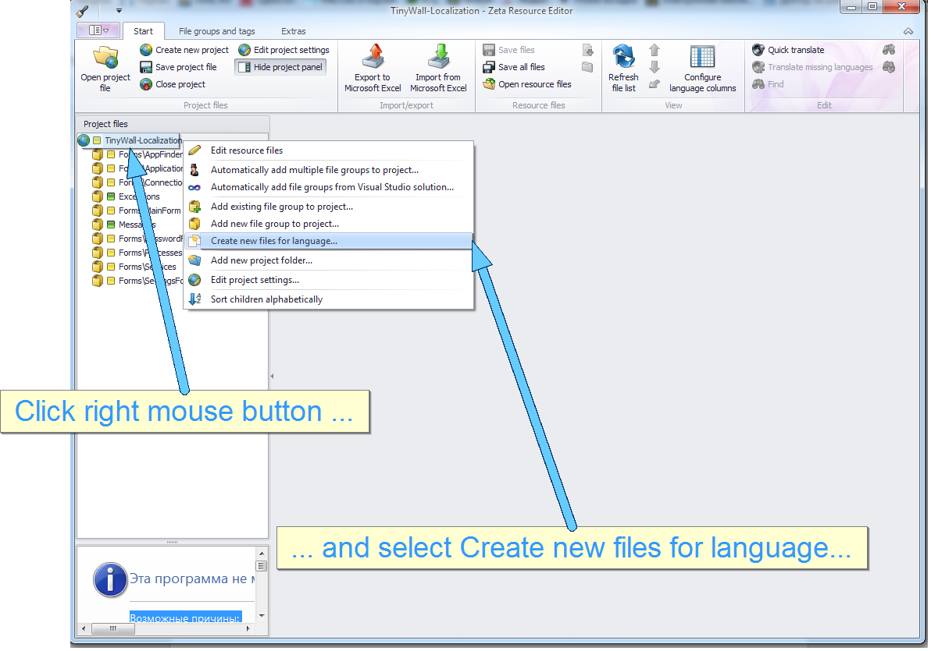

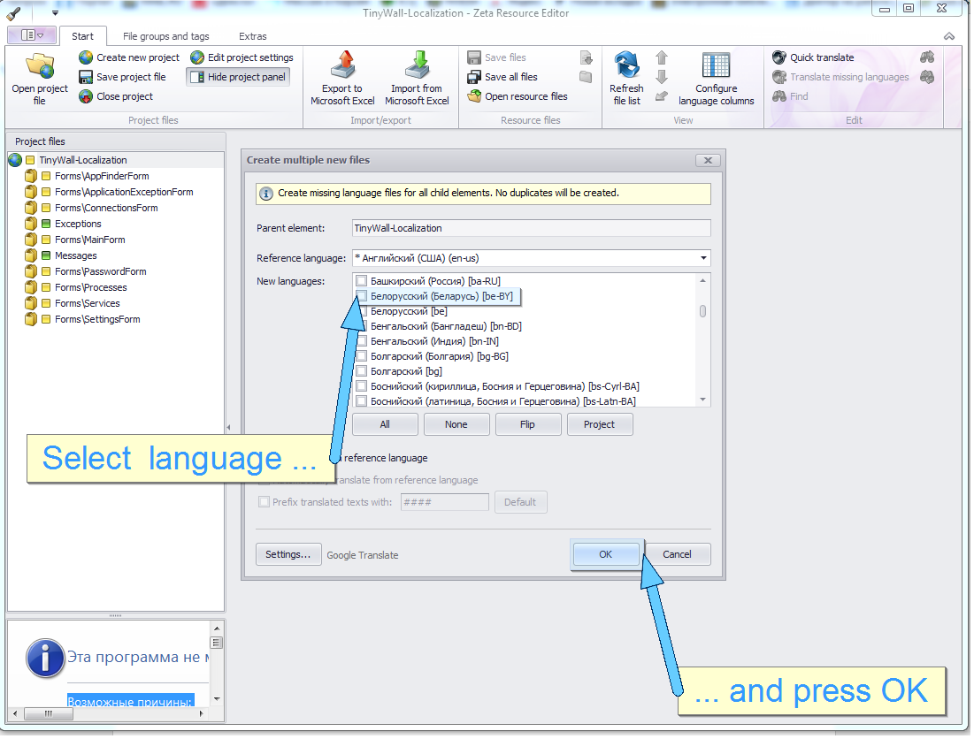

6. Open the resource file by double-clicking and translate all strings. Save.

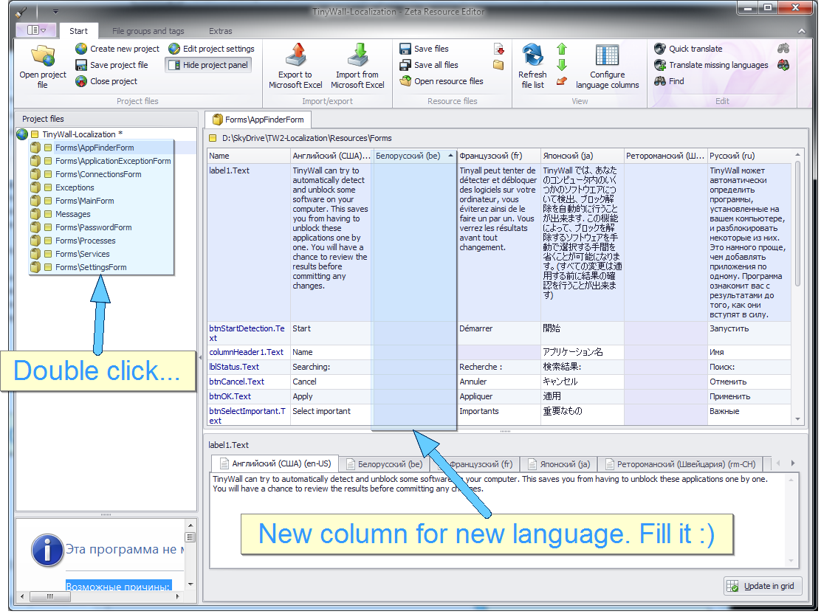

7. Repeat steps 4-6 for all other resource files.

QUALITY CONTROL AND GUI CUSTOMIZATIONS

Basically, you are done with the translation. However, you might want to check some of your results and make slight modifications in the GUI. The most probable reason is that because translated strings often have a different length than the original English version, some text might not fit onto the spaces, boxes and buttons of TinyWall. Customizing the GUI allows you to make slight adjustments, like correcting a button's size and position so that the new text fits perfectly.

1. At this point, make sure TinyWall is installed. If it is not, then install it.

2. Download the "Microsoft Windows SDK for Windows 7 and .NET Framework 4" installer. This is an online installer that will download components on the go. It accesses the internet using a temporarily extracted executable, so set TinyWall to its "Allow outgoing" mode for the duration of the setup.

3. When prompted for the components to install, the only one you need is .NET Development -> Tools.

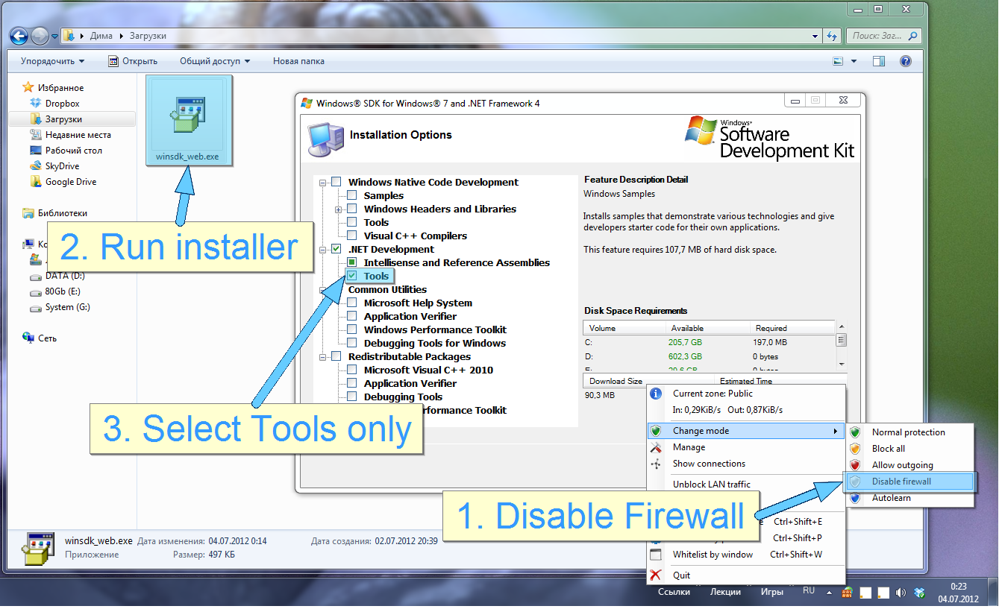

4. When installation finishes, launch WinRes.exe. Look for it in a subfolder of "C:\Program Files (x86)\Microsoft SDKs\Windows\" (for example "C:\Program Files (x86)\Microsoft SDKs\Windows\v7.0A\Bin" or "C:\Program Files\Microsoft SDKs\Windows\v7.0A\Bin").

5. Open a .resx file located in Resources\Forms. This will show you a simplified view of the selected TinyWall window. Check that the translations are correct and that all text fit correctly. If necessary, change size and position of controls. Text can also be updated here by editing the "Text" properties. Please do not make unnecessary changes to size and positions. If possible, it is preferable to alter the text slightly to fit the available space instead of changing position and size.
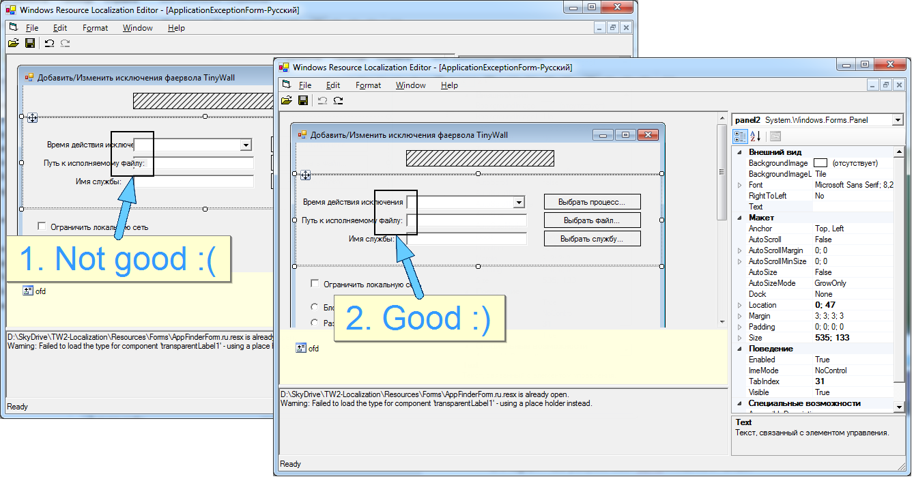

6. When saving, in the language selection window, select a generic variant of your language without a country specialization. For example, do not select "German (Austria)", but select
the generic "German" language. In File Mode, make sure the "Visual Studio File Mode-VSFM" is selected.

7. Repeat steps 5-6 for all other forms in Resources\Forms.

When all is done, zip up and send me all the files to tinywallpados.hu.

THANK YOU FOR YOUR TRANSLATION!

