Exercise Week 4_2
When you source the EmployeesDatabase.sql file, you would be in a database called employee, with two tables, employees and departments.
Use SQL to do the following. Use JOINS if possible.
1. List employee names and their department names; only include employees who are currently assigned to a department.
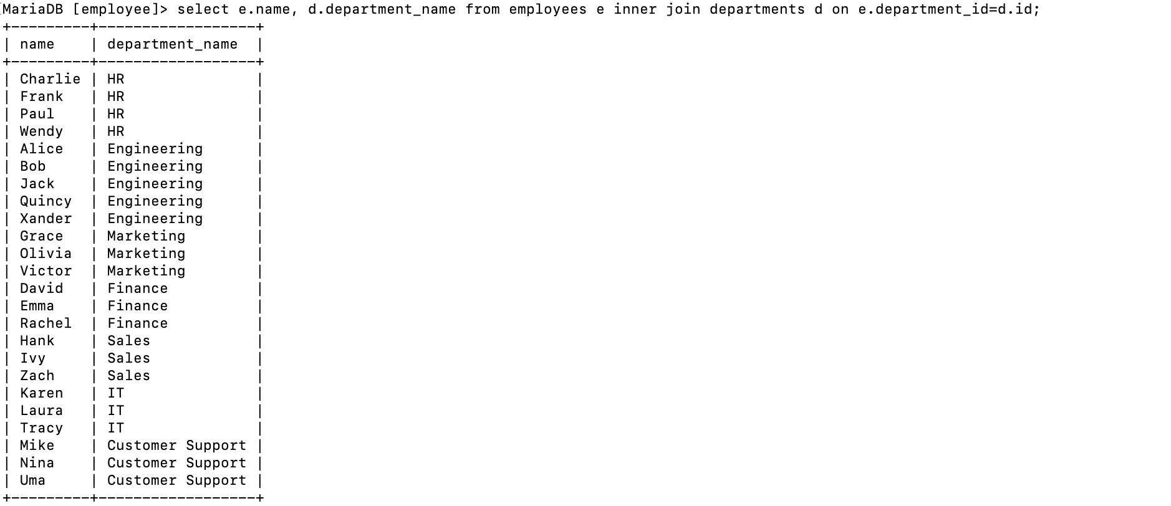
2. List employee names and their department names including those who are not assigned a department.
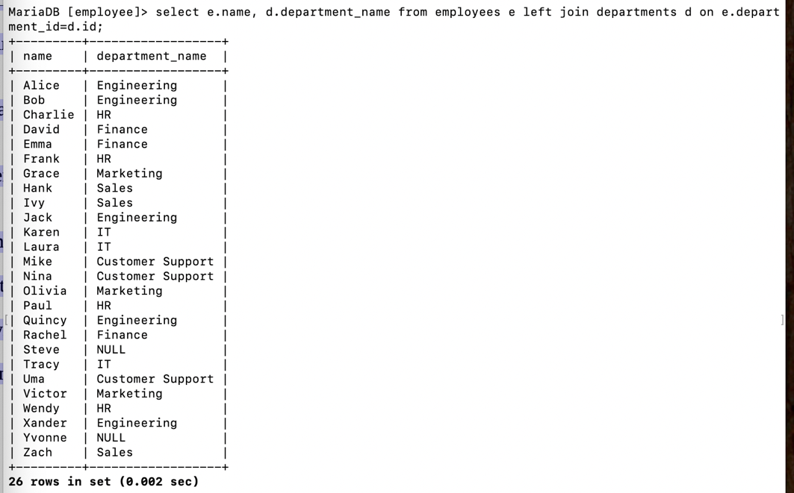
3. List all department names and the employees assigned to them. List all departments, even if they have no employees assigned to them.
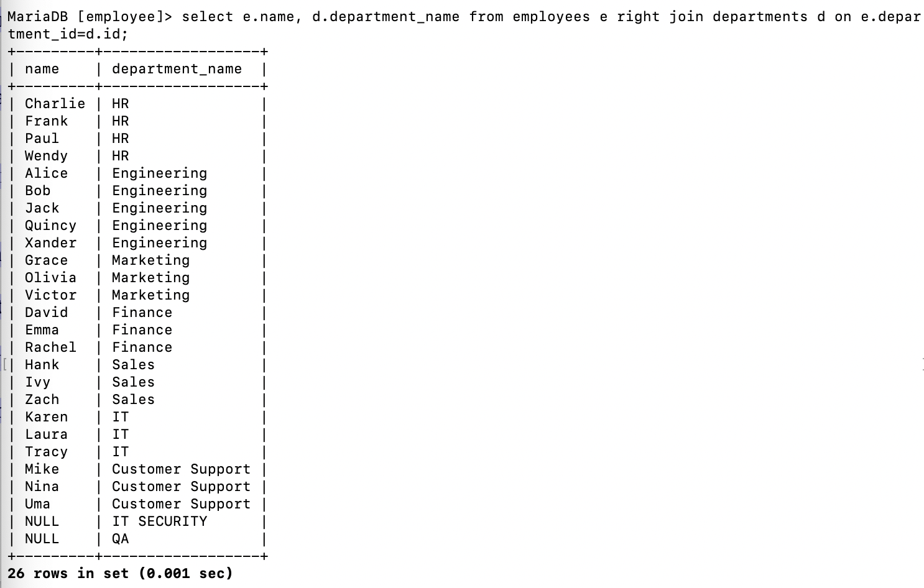
4. List all employee names and their manager’s names. List only those employees who have a manager.
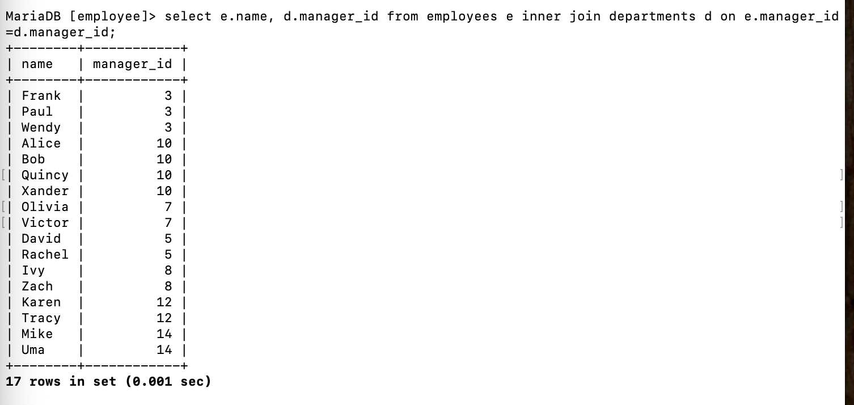
5. List employees and their department names
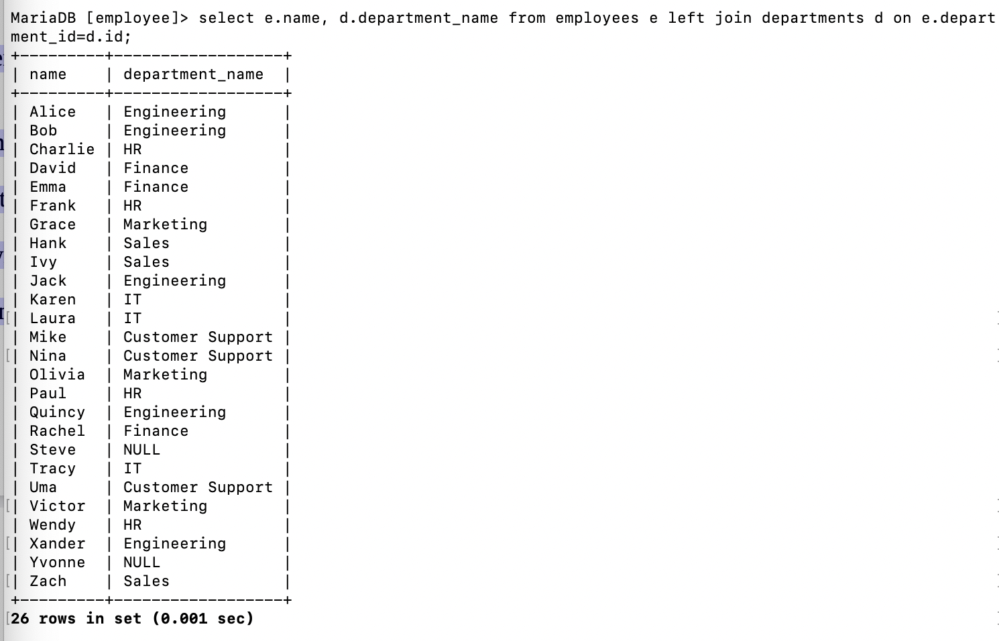
6. List name and salary of employee with highest salary
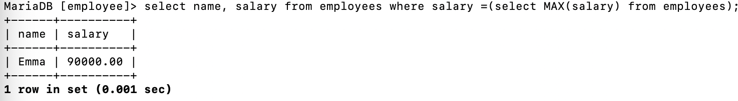
7. List name, department_name and and salary of employee with highest salary.
