Week 4_Exercises Pylypiv
- If you haven’t already done so, make sure you have both the vets table in your database.
Replace your States table, if you already have it from class, with the data in the States_Territories.csv file (given). This file includes Territories like GUAM, Northern Marinara Islands etc.
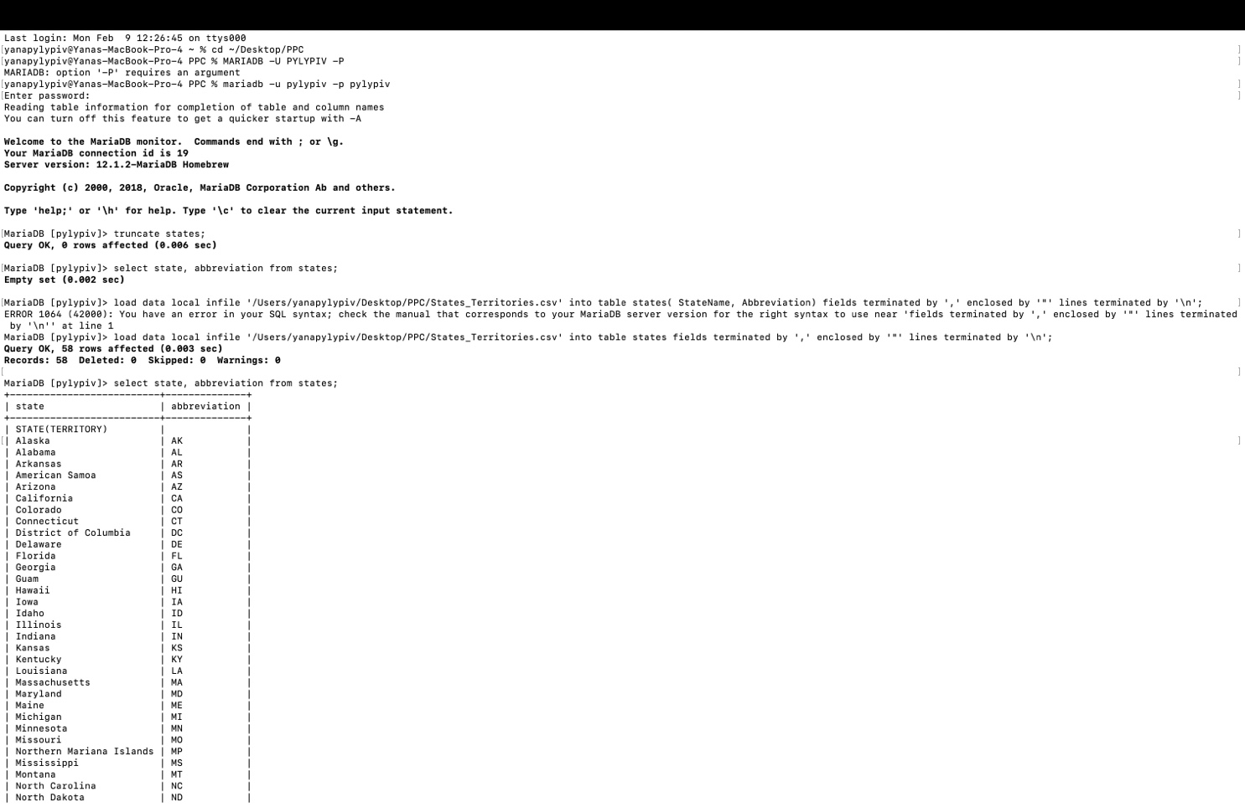
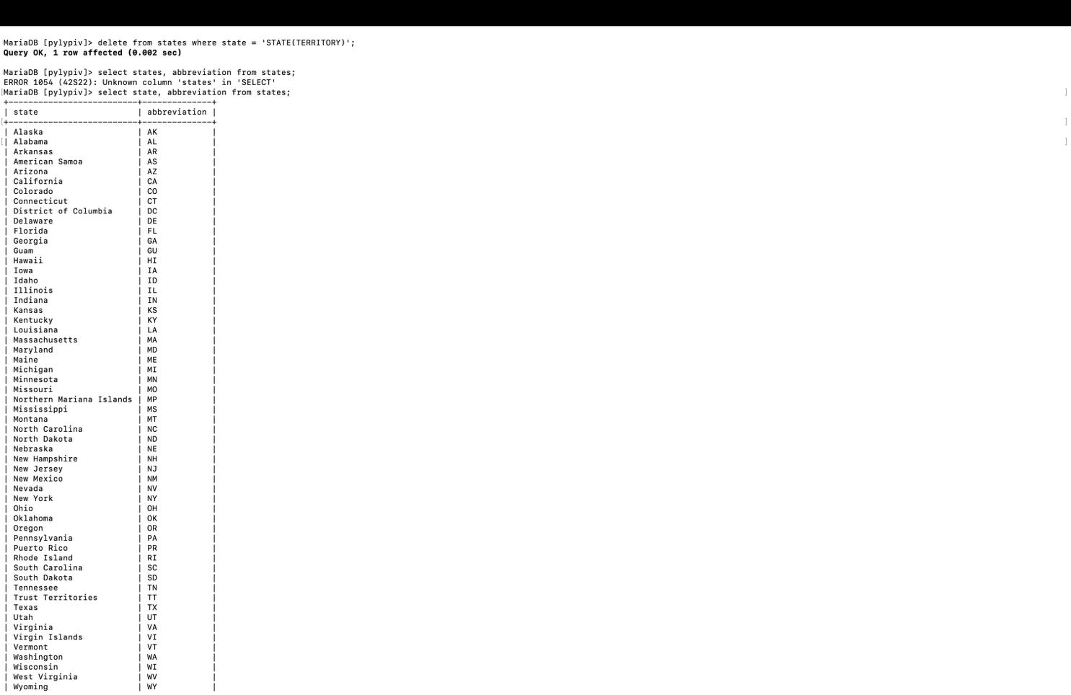
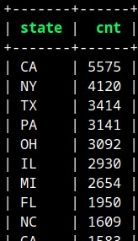
- Use SQL to obtain a count of vets from each state, ordered in descending order, as shown here:

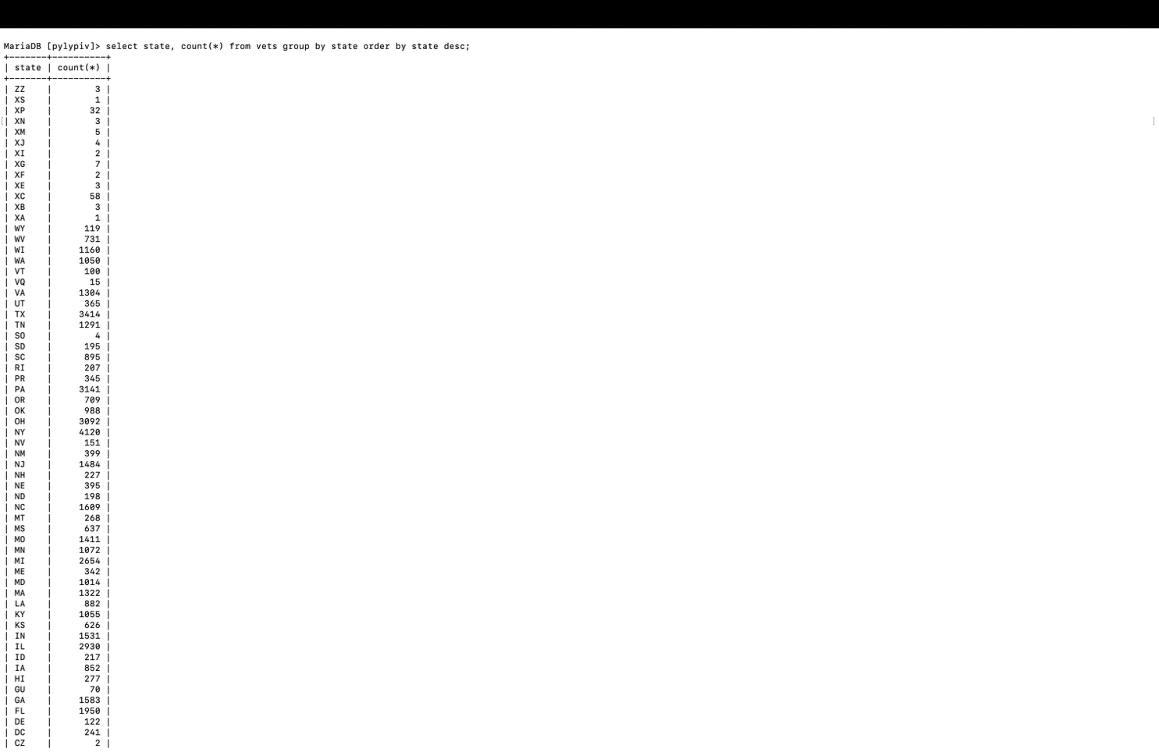
- Get (use SQL) a list of states in vets table that are not listed in the States table loaded in #1. This question involves two tables, vets and States.
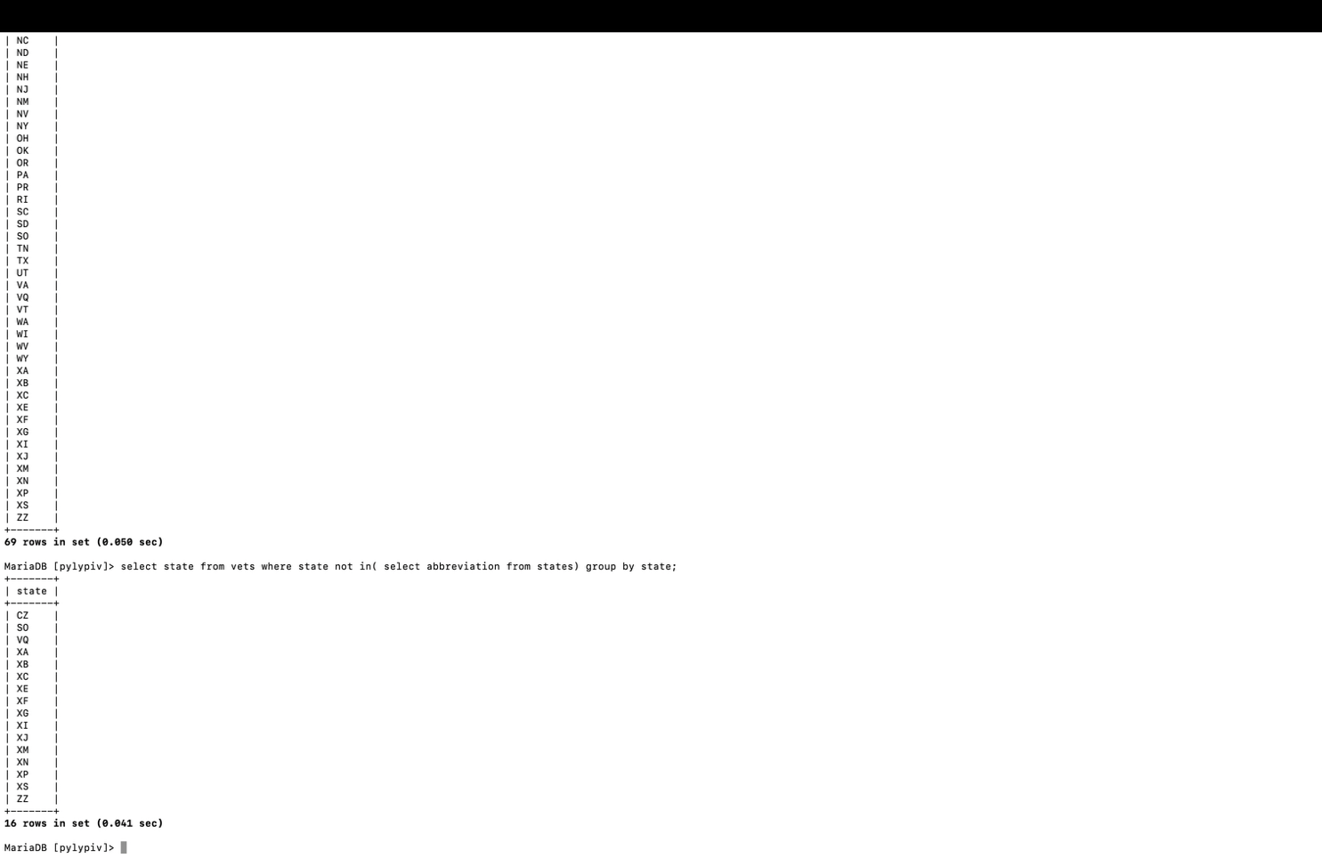
- Source the StudentExample.sql and EmployeesDatabse.sql files. What are the new databases and new tables created ? The new database created is mynewpaltz with tables EnrollmentTable, CourseTable, StudentTable. The new tables in my database: departments and employees.
