Practice SQLs – nation database.
The below questions can be answered with SQLs.
List # of regions in each continent.
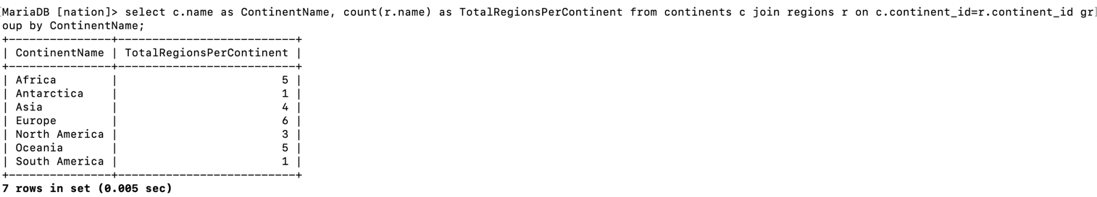
List continents and the regions each continent contains
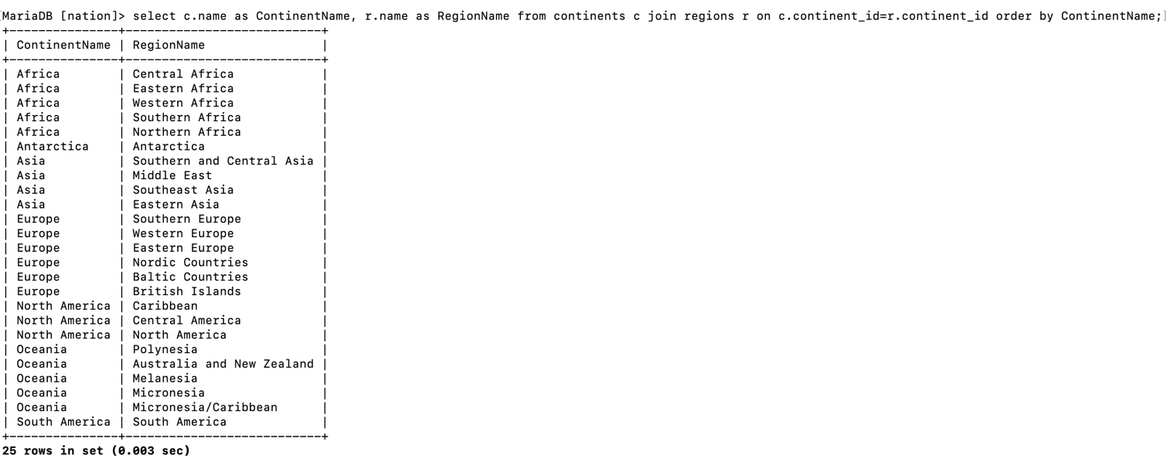

Are there regions that span more than one continent?
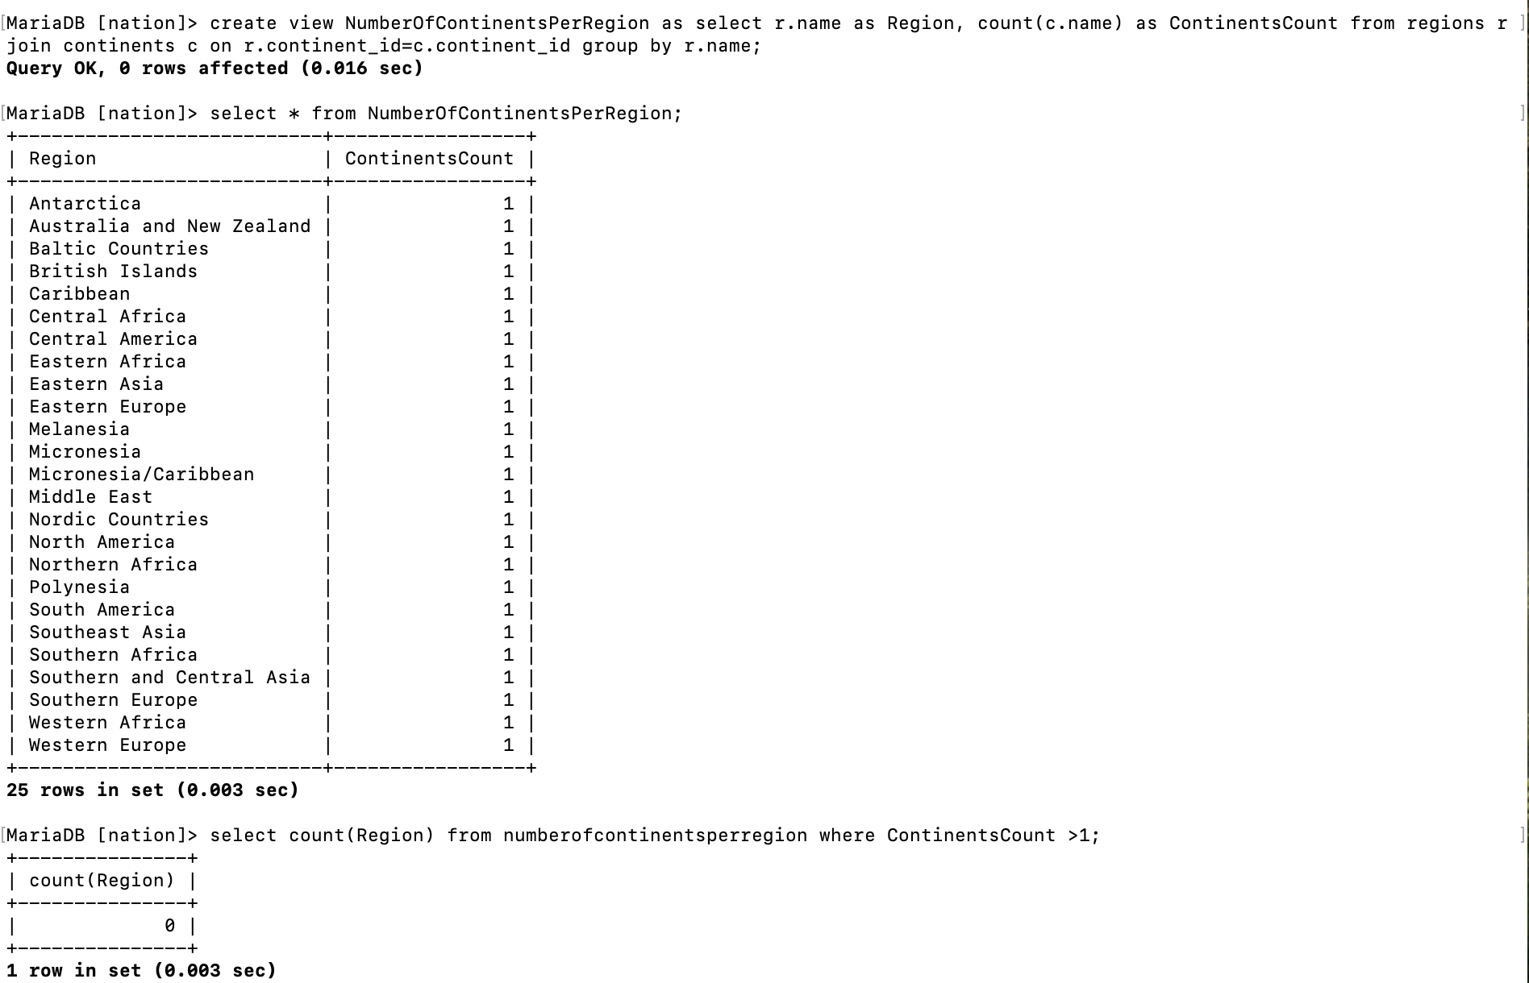
Create a view called ContriesAndContinents that lists countries and the continents they are in by name, ordered by country names alphabetically.

