Exercise on JDBC connector
Read the document (Week 7) of Java Connector, JDBC driver. This allows a Java program to query a mariadb database and retrieve information.
Write a Java Program, DisplayCountries that allows user to put in a language name as a String and have the program display a list of countries in the nation database where that language is either an official or an unofficial language.
The Code:
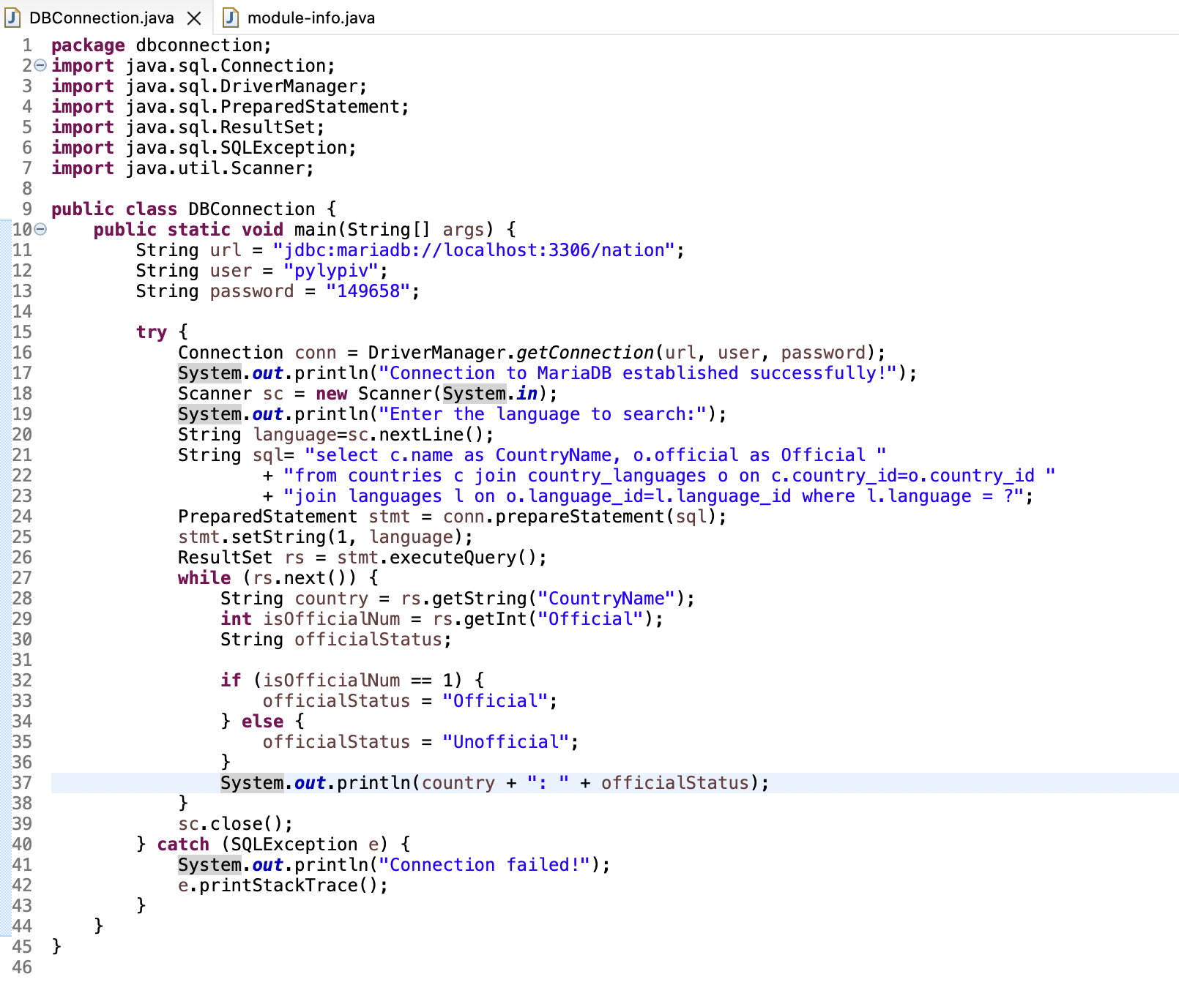

The Output:
