The dump file of a database in given in a file employee_dump_20260223.sql
Load it into a database “employee”. (If you already have tables in employee database, save them and drop them first). When you load the dump file, you will have two tables employees and departments.
- List employees and their managers
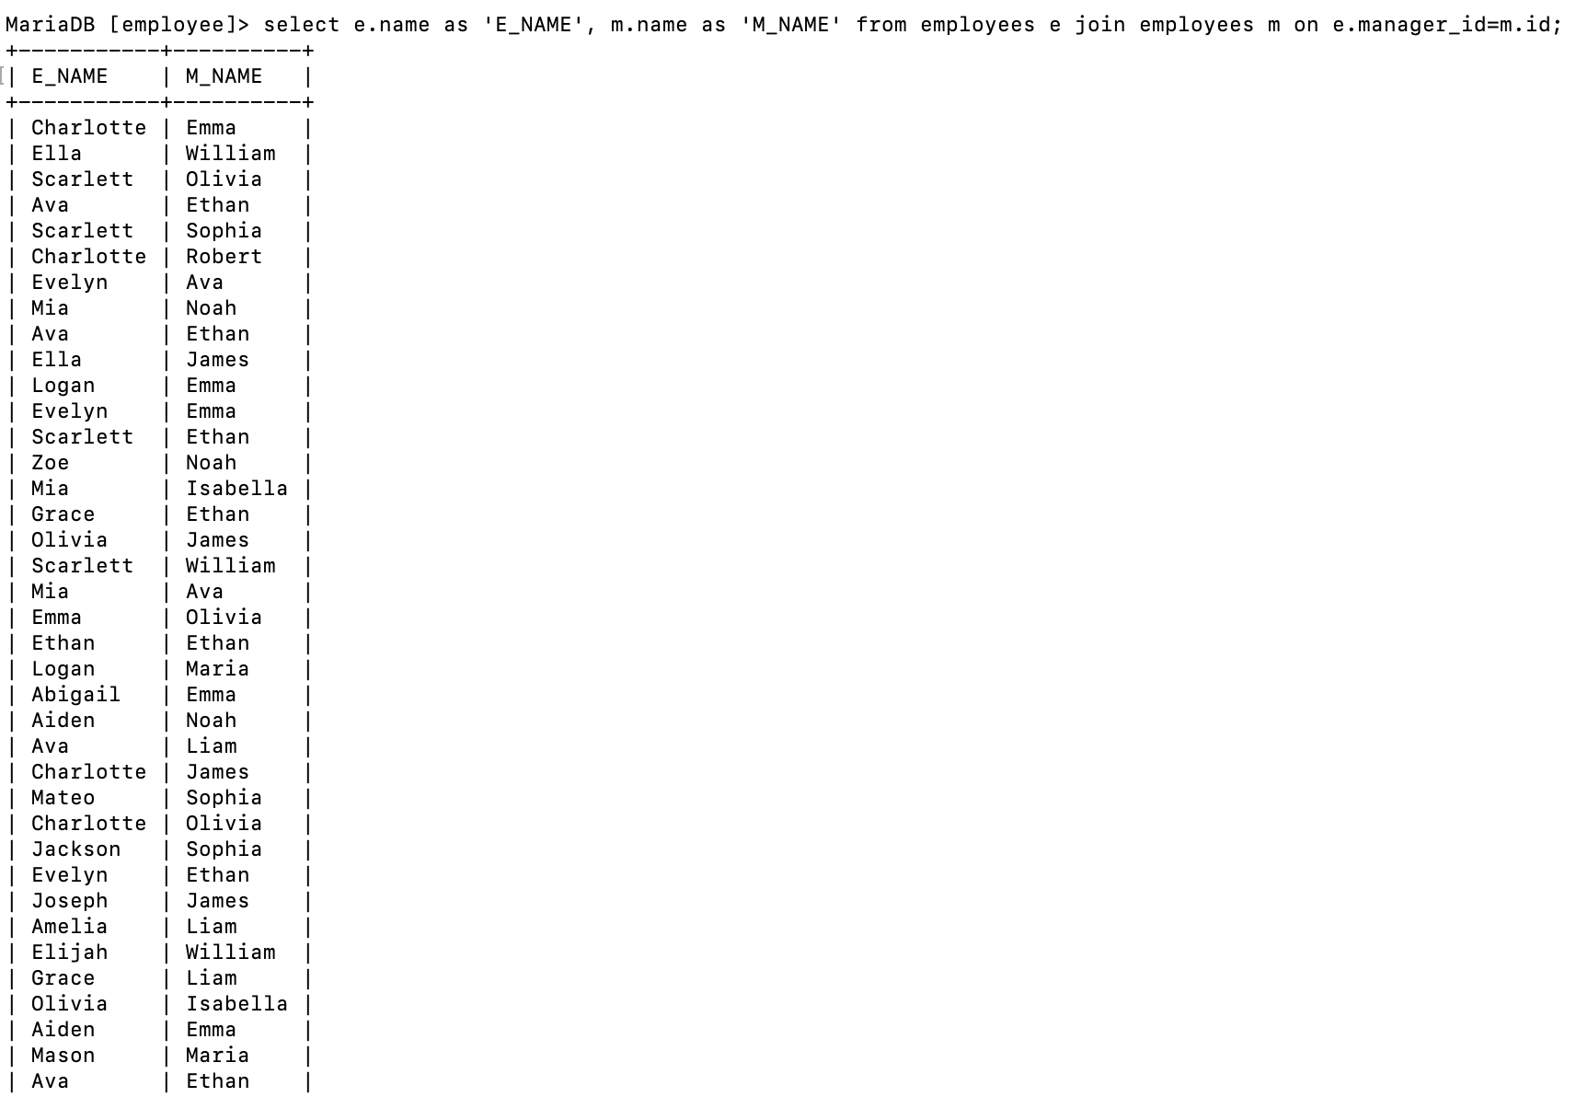
- List departments and their managers
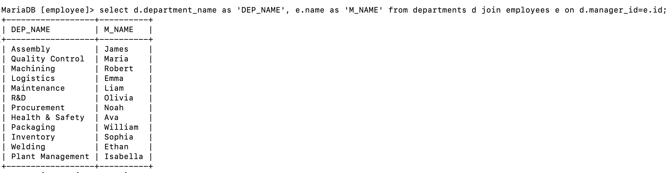
- List the department each person works in
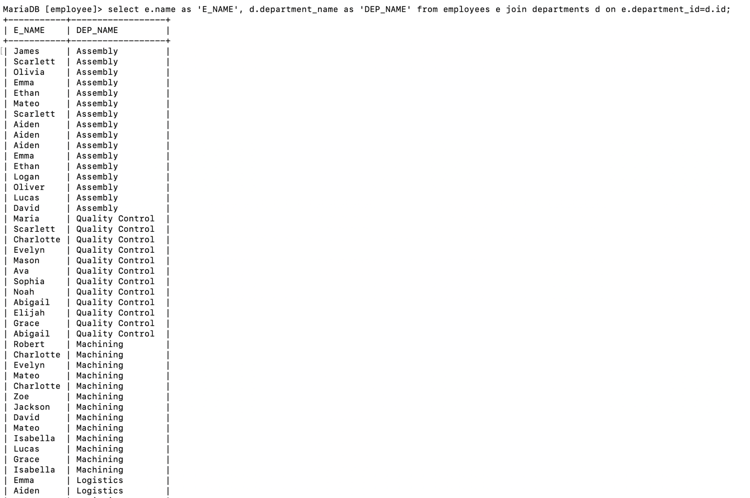
- Find employees who have no manager
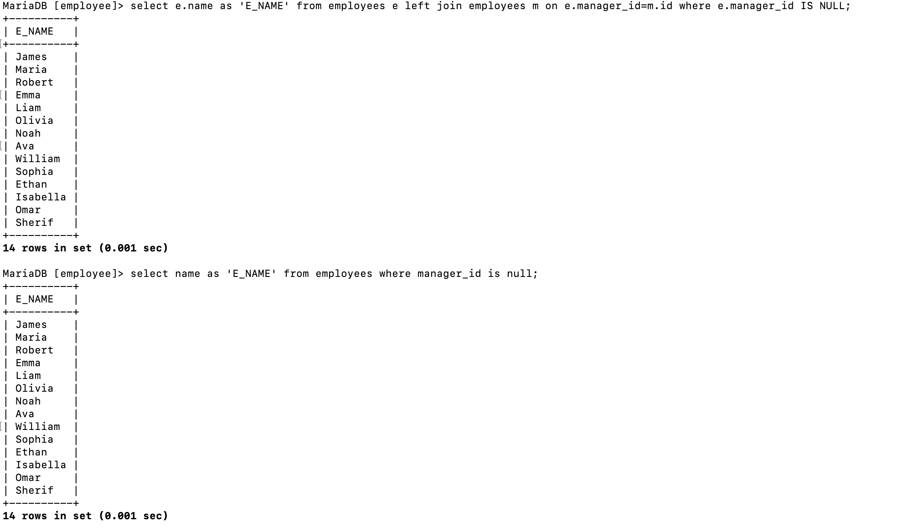
- Find employees who have no departments
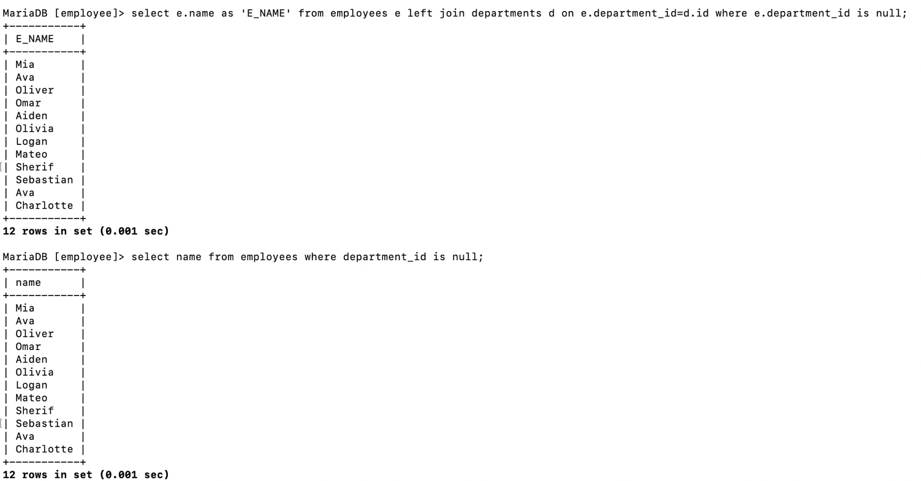
- Show a count of employees in each department, including those who have no departments.
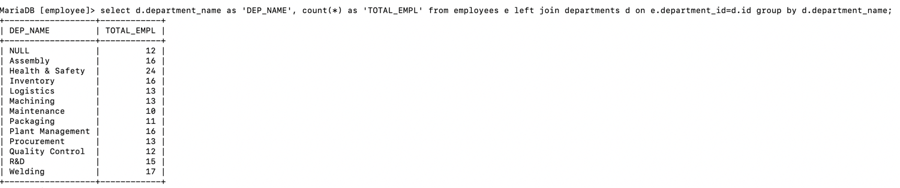
- List name, salary, and department name of managers (those who have a department but no manager).
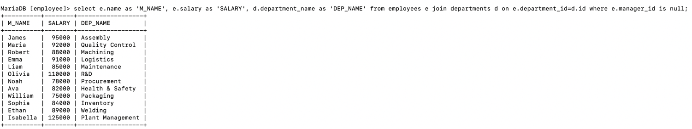
- List employees whose salaries are higher than their manager’s salaries.
