SHAPE \* MERGEFORMAT
Employment Base Diversity (EBD) Index (based on the Herfindahl-Hirschman Index or HHI).
This code includes:
- Simulated Data: Two hypothetical suburbs (City Central and Mining Town A) are created to demonstrate a diversified versus a concentrated economy.
- Function: A reusable Python function calculate_ebd_index using Pandas to perform the HHI calculation.
- Visualization: A basic Matplotlib bar chart to visually compare the resilience scores.

SHAPE \* MERGEFORMAT 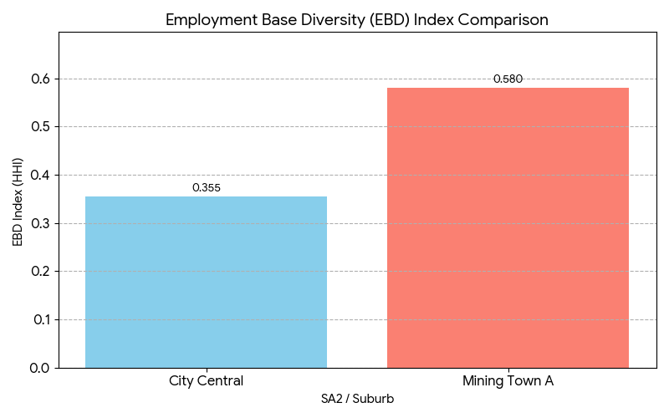

The lower score for City Central indicates a more resilient employment base, which aligns with lower investment risk and more stable long-term growth. The higher score for Mining Town A signals higher risk due to its economic concentration.
The comparison is visually represented in the generated bar chart: Employment Base Diversity (EBD) Index Comparison.

