EC2 Auto Stop/Start Schedule In AWS

This Section has 5 part of component.
1. Elastic IP for EC2
2. Associate an Elastic IP address
3. IAM Policy and Role
4. Lambda Function
5. Cloudwatch Event

1. Creating Elastic IP

1.1 Goto EC2 dashboard
1.2 In the navigation pane, choose Network & Security, Elastic IPs.
1.3 Choose Allocate Elastic IP address.
1.4 For Public IPv4 address pool, choose one of the following:
- Amazon's pool of IPv4 addresses—If you want an IPv4 address to be allocated from Amazon's pool of IPv4 addresses.
- Public IPv4 address that you bring to your AWS account—If you want to allocate an IPv4 address from an IP address pool that you have brought to your AWS account. This option is disabled if you do not have any IP address pools.
- Customer owned pool of IPv4 addresses—If you want to allocate an IPv4 address from a pool created from your on-premises network for use with an AWS Outpost. This option is disabled if you do not have an AWS Outpost.
1.5 (Optional) Add or remove a tag.
[Add a tag] Choose Add new tag and do the following:
- For Key, enter the key name.
- For Value, enter the key value.
[Remove a tag] Choose Remove to the right of the tag’s Key and Value.
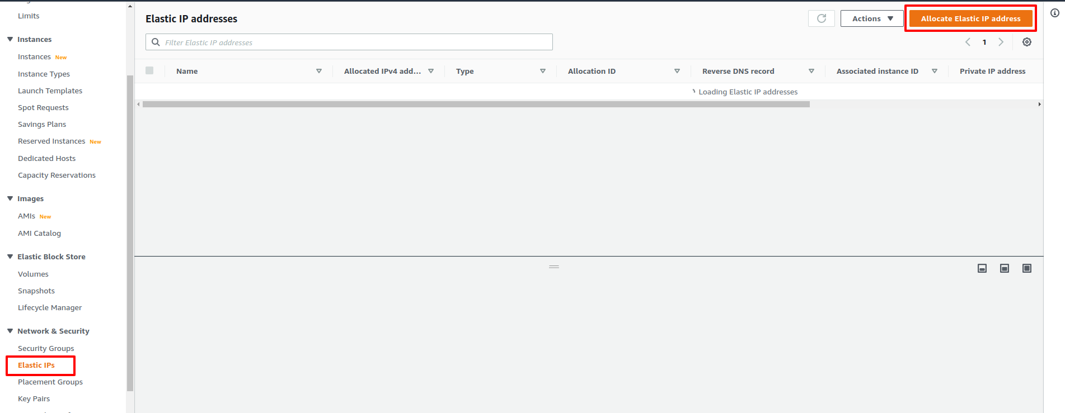
1.6 Choose Allocate.

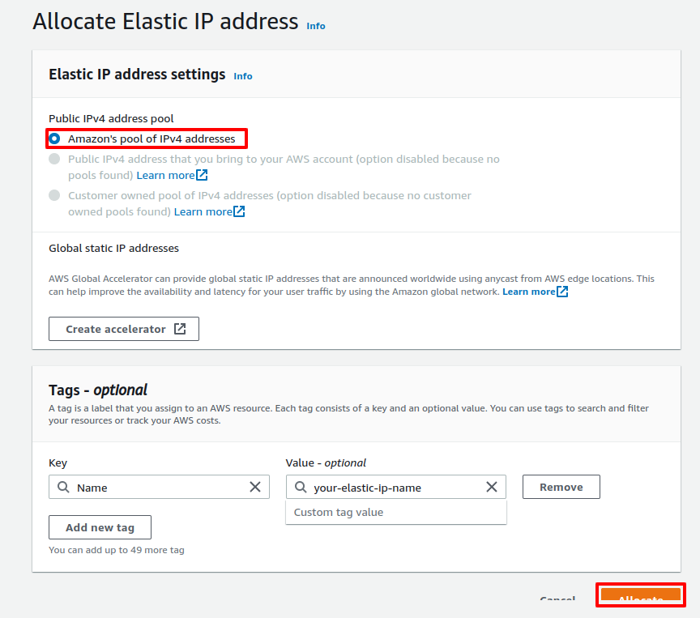

2.Associate an Elastic IP address

2.1 Open the Amazon EC2 Dashboard
2.2 In the navigation pane, choose Elastic IPs.
2.3 Select the Elastic IP address to associate and choose Actions, Associate Elastic IP address.
2.4 For Resource type, choose Instance.
2.5 For instance, choose the instance with which to associate the Elastic IP address. You can also enter text to search for a specific instance.
2.6 (Optional) For Private IP address, specify a private IP address with which to associate the Elastic IP address.
2.7 Choose Associate.

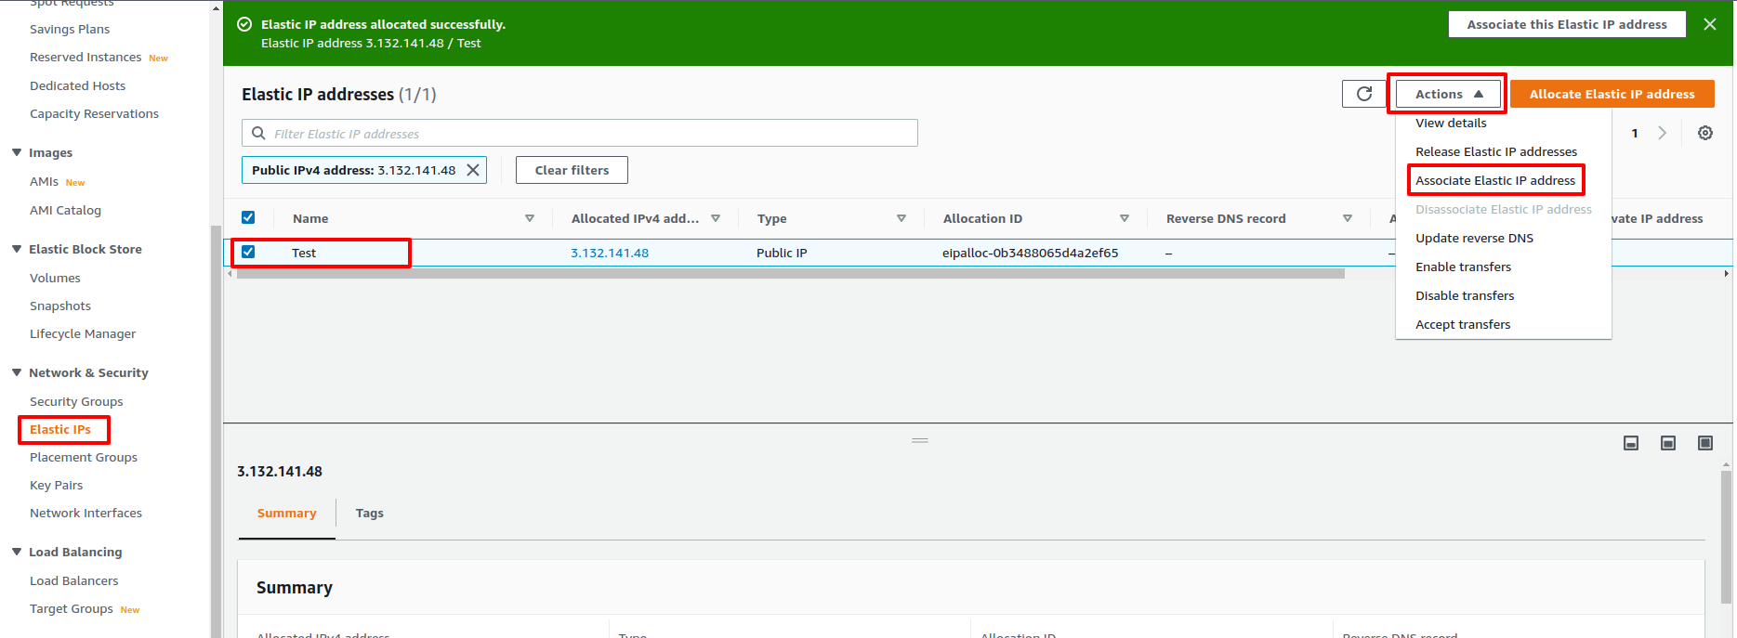
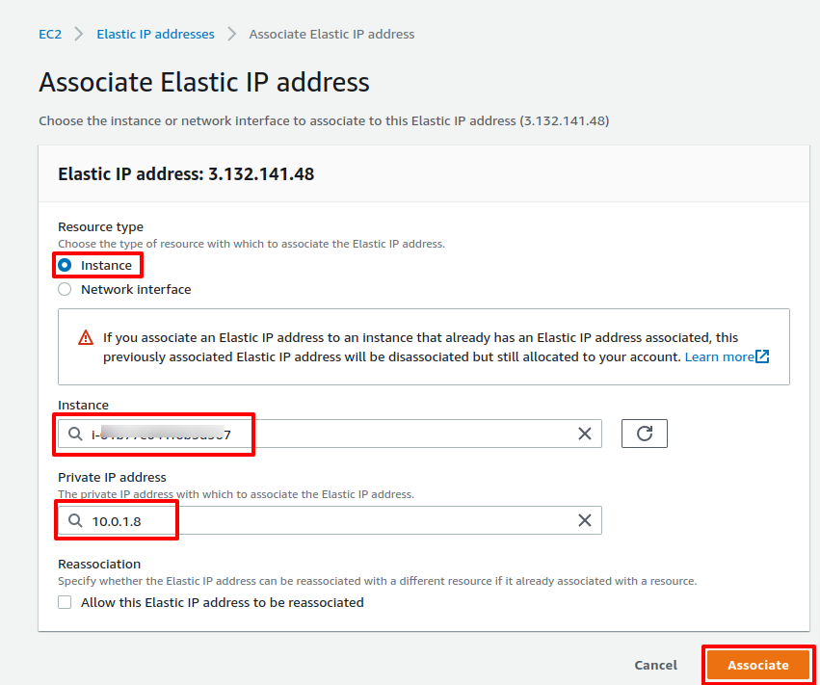

3. IAM Policy and Role

3.1 Goto IAM Console
3.2 Choose Policies and Click Create policy
3.3 Create Policy
- Service > Choose a service > Search EC2 and Choose EC2> drop down write> select StartInstances and StopInstances
- Choose Resources > Click Add ARN form instance > Fill Region and Instance id
- Choose Next: Tags
- Choose Next: Review
3.4 Add Name and Description in Review Policy and Click Create policy

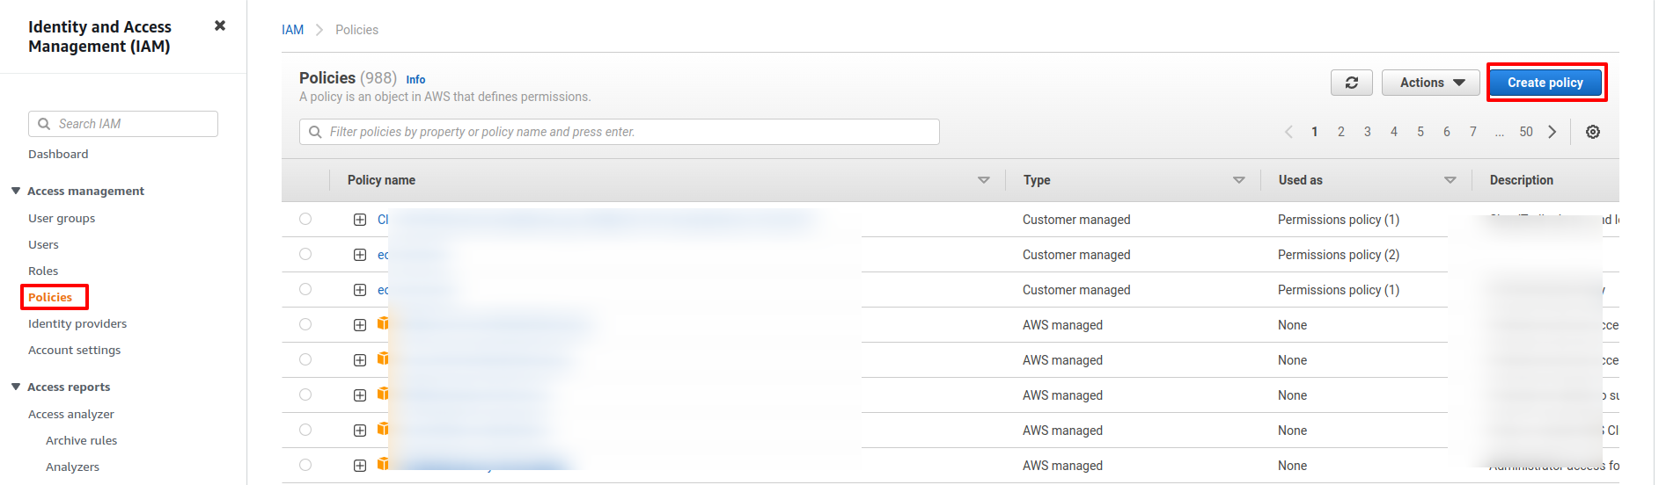
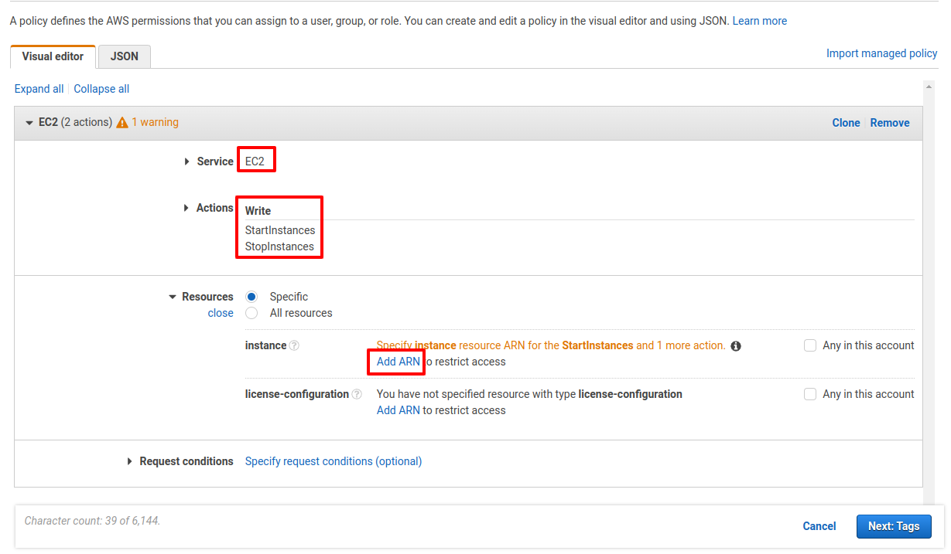

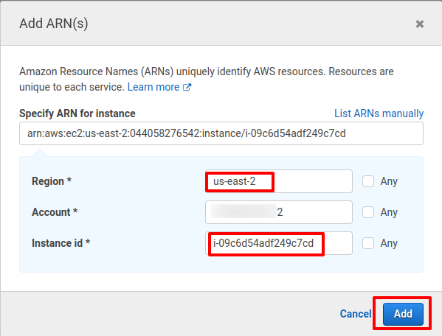

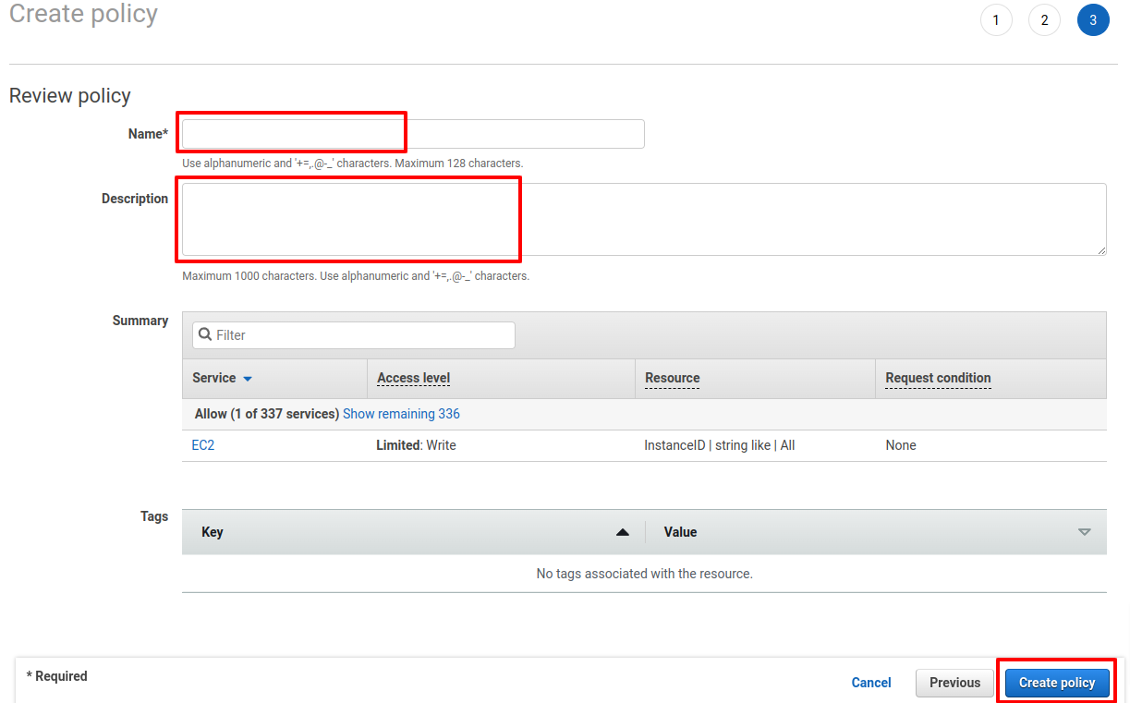

3.5 Choose Roles and Create role
3.6 Choose AWS Service, Lambda and Next
3.7 Secarch your-policy, choose this policy and click Next
3.8 Add Role Name, Description and Click Create role.

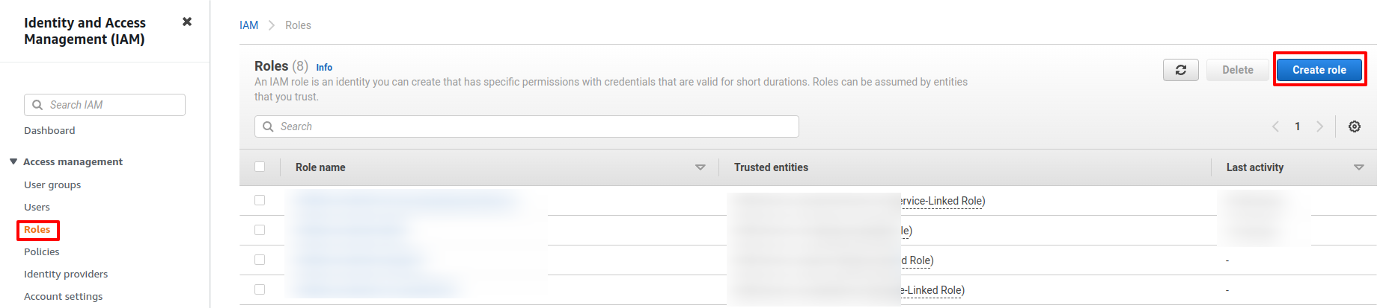

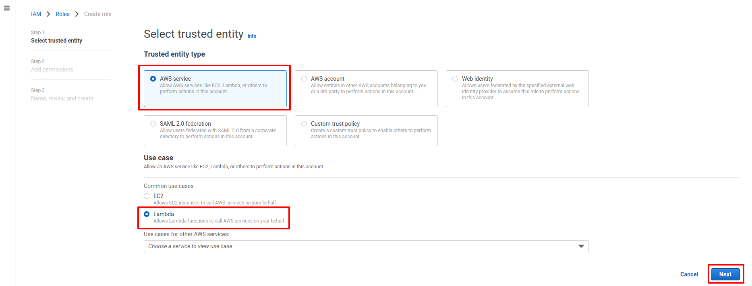
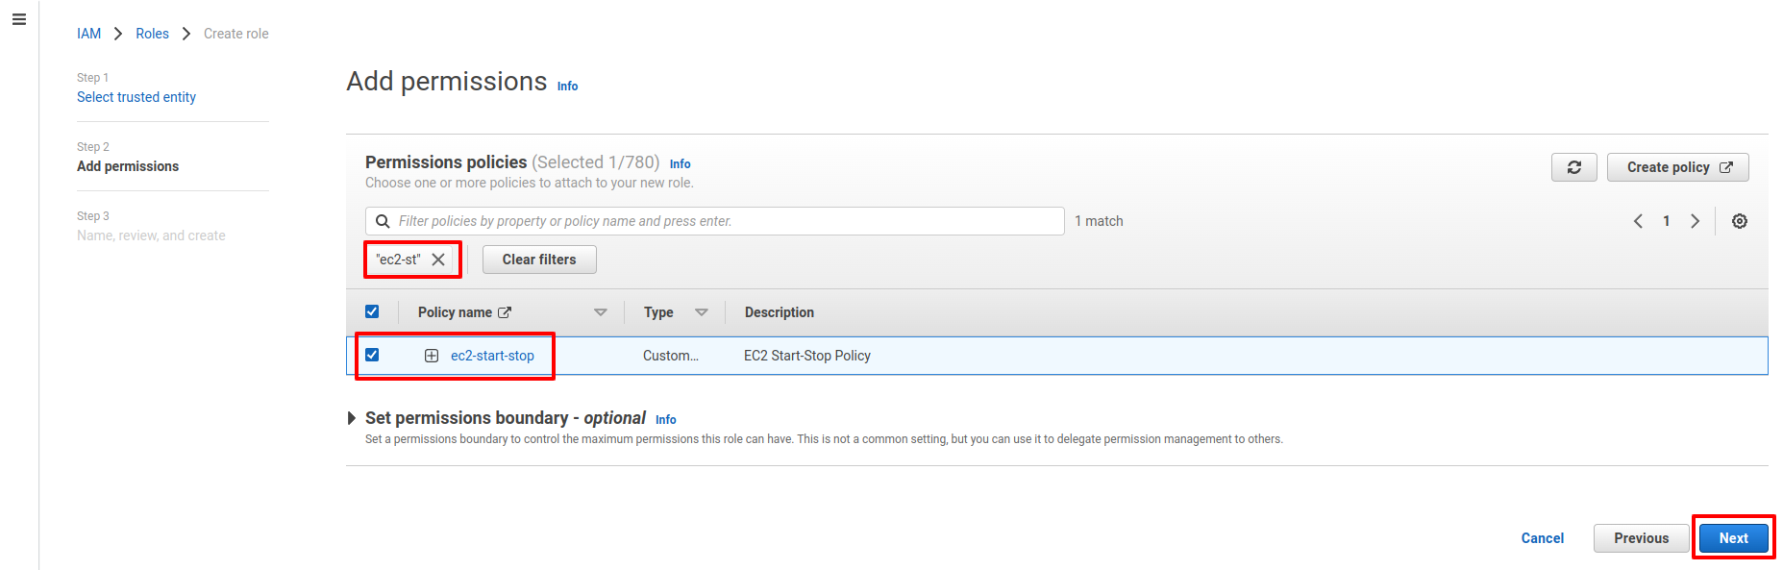

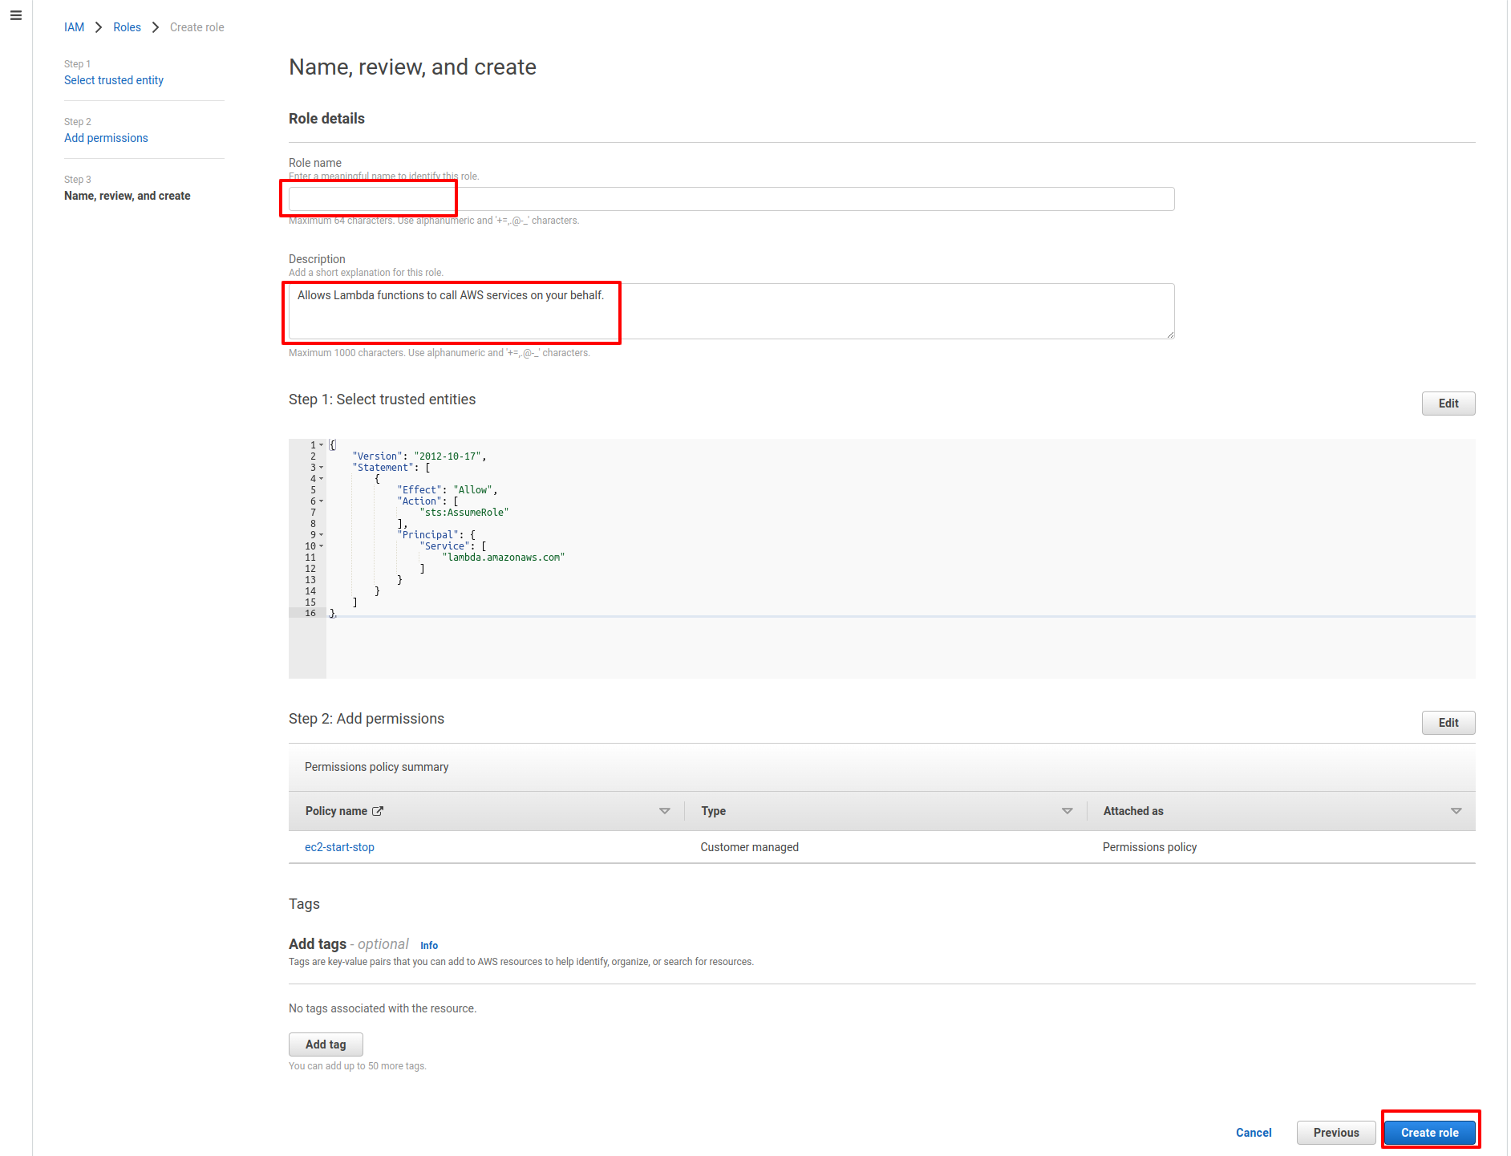

4. Lambda Function

4.1 Goto Lambda Console
4.2 Choose Author from scrath, Fill Name, Choose Python3.9 from Runtime, Choose Use an existing role and Create function.
4.3 Add Lambda function (Note: Choose your instance id), choose Deploy and Test.
4.4 Add Event name and Save.
4.5 Click Test again.

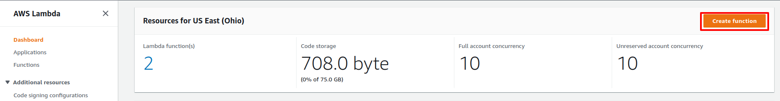

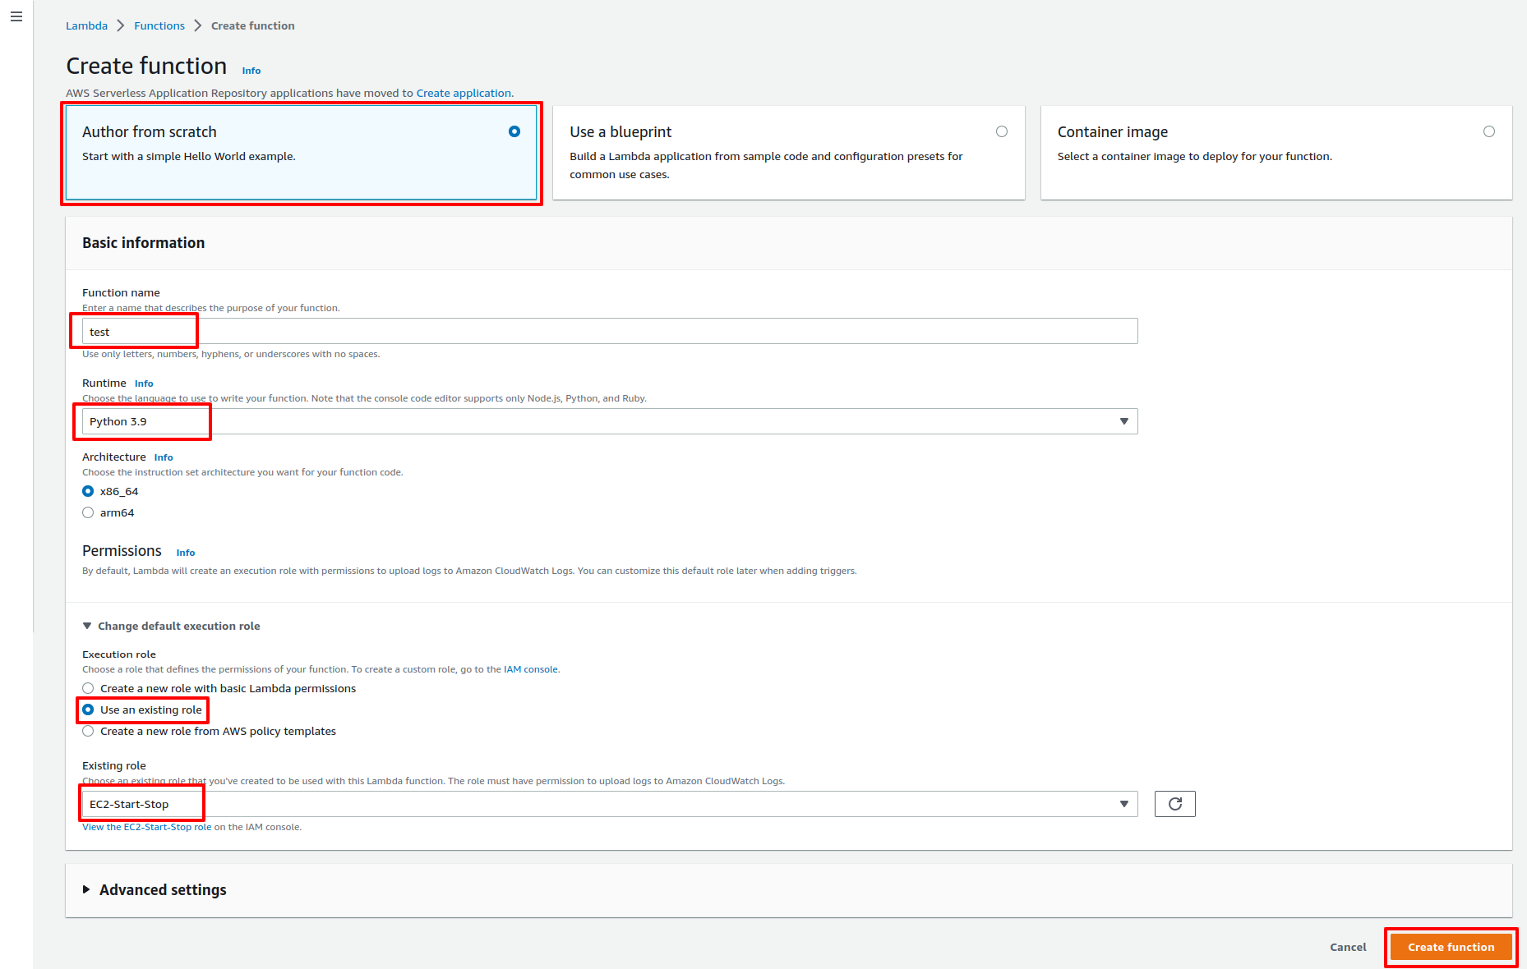

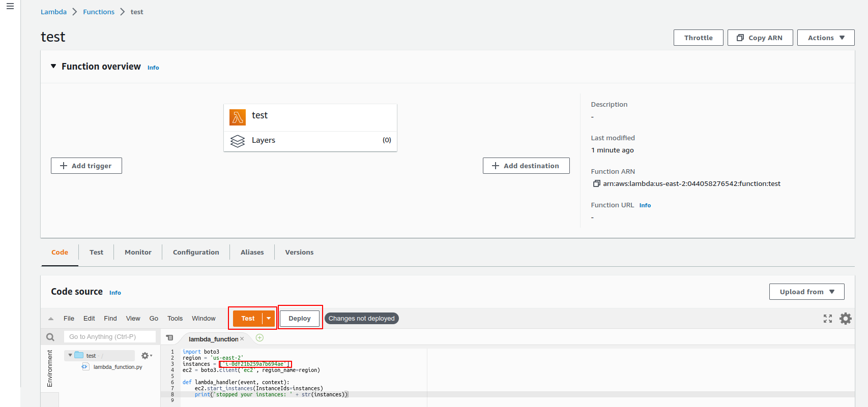

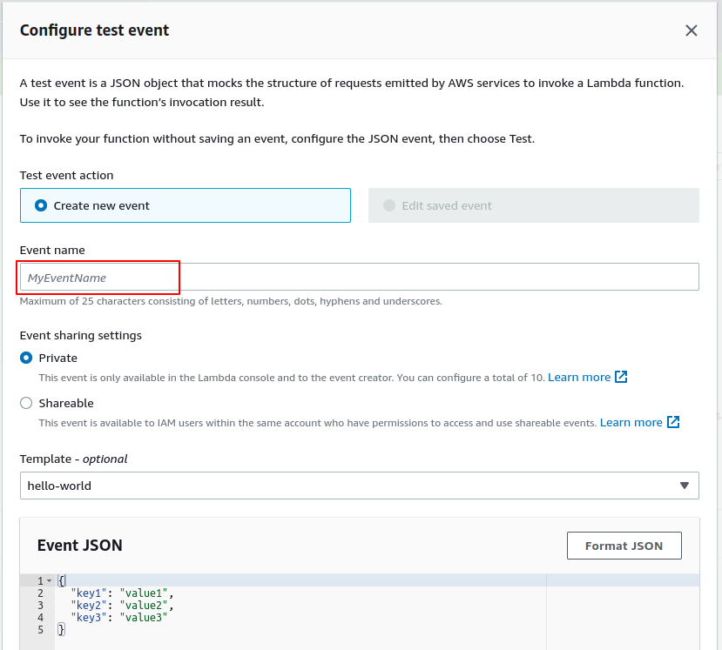
Note: Lamda Function

EC2-stop function

import boto3
region = 'us-east-2'
instances = ['Instance-ID', 'Instance-ID']
ec2 = boto3.client('ec2', region_name=region)

def lambda_handler(event, context):
ec2.stop_instances(InstanceIds=instances)
print('stopped your instances: ' + str(instances))

EC2-start function

import boto3
region = 'us-east-2'
instances = ['Instance-ID', 'Instance-ID']
ec2 = boto3.client('ec2', region_name=region)

def lambda_handler(event, context):
ec2.start_instances(InstanceIds=instances)
print('stopped your instances: ' + str(instances))

5.Cloudwatch Event

5.1 Goto Cloudwatch
5.2 Choose Rules form Events and Click Create rule
5.3 Add Name, Description, Choose Schedule and Click Next
5.4 Choose “A fine-grained …”, Create Cron schedule and click Next
[Note: Every Sunday to Friday 1:30 am run this job
Cron format for AWS =>
Minute Hour Day-of-Month Month Day-of-week Year
30 1 ? * MON-FRI *
]
5.5 Choose AWS service, Lambda function from select a target and choose your-lambda function. Click Next.
5.6 Click next form Tags.
5.7 Click Create rule.

