Ryan Chau, Philip Kwan

EE114

Computer Assignment 5

Abstract

Tasks:

1. Display the ca5_image.tif file in Matlab:

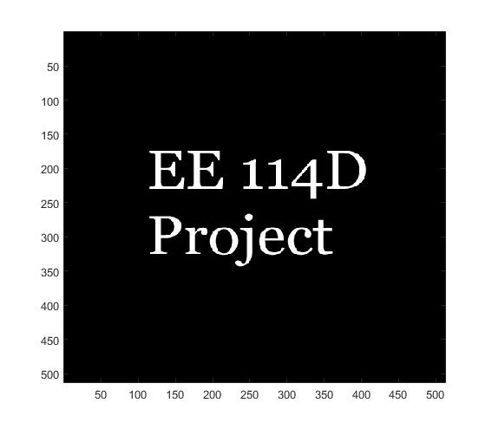

2. Generate a 2-D Gaussian distribution matrix, $λ=5$

gauss = zeros(41,41);

sum = 0;

for i = -20:1:20

for j = -20:1:20

sum = sum + exp(-(i^2+j^2)/5);

end

end

* Sum is 15.7080, so $C=\frac{1}{15.7080}$

C = 1/sum;

for i = -20:1:20

for j = -20:1:20

gauss(i + 21, j+21) = 1/sum*exp(-(i^2+j^2)/5);

end

end

3. Convolve the image with the Gaussian matrix

delta = zeros(40,40);

delta(21,21) = 1;

z = conv2(delta,image);

g = conv2(z,gauss);

imagesc(g); colormap(gray);

The new image looks just like the original, but the sharpness of the edges between the white and black are much smoother. It almost looks as if the image became dimmer. The spatial frequency around these areas must have spread out in intensity or have been attenuated.

