Ryan Chau, Philip Kwan

EE114

CA7

**Abstract**:

In this assignment, we will be looking at how various types of noise, such as Gaussian and salt-and-pepper noise, affect the appearance of an image. We’ll also be looking at techniques that intentionally modify an image to understand how they improve on characteristics affected by the noise, such as high-pass filtering, histogram equalization, low-pass filtering, and median filtering.

1. High-pass filtering

We’ll be applying this high-pass filter to the original image:

$$h_{H}=\frac{1}{7}\left[\begin{matrix}-1 & -2 & -1 \\ -2 & 19 & -2 \\ -1 & -2 & -1\end{matrix}\right]$$

Original image:

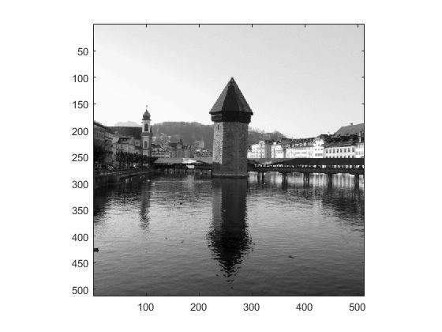

Applying the high-pass filter: 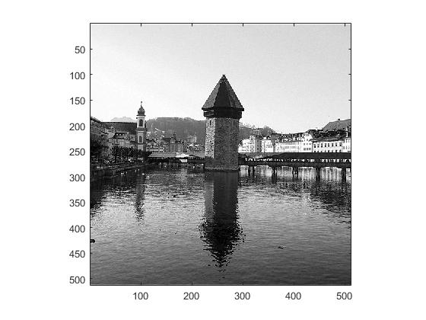

Because the high-pass filter passes high spatial frequencies and attenuates lower frequencies, improving the contrast in the image and making certain edges, such as those of the buildings, look sharper.

2. Histogram equalization

We’ll apply histogram equalization to modify certain values based on desiring a linear cumulative histogram model.

Original image is the same as in 1.

Here is the histogram-equalized version:

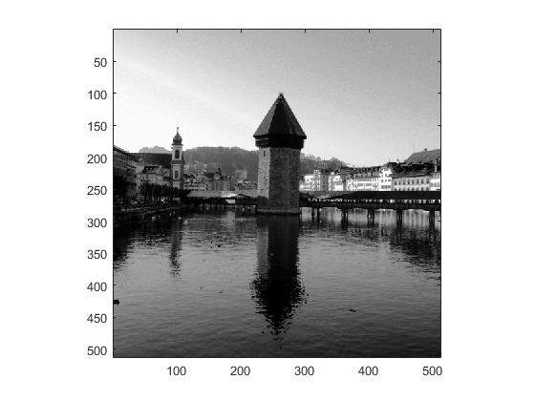

Compared to the original image, this one looks darker than the original because the contrast has increased. The sharpness did not change much as opposed to 1.

3. Low-pass filtering

Now, we’ll look at ways to improve an image affected by Gaussian noise, which is noise modeled by the Gaussian distribution. We’ll use a low-pass filter, modeled by

$$h_{L}=\frac{1}{10}\left[\begin{matrix}1 & 1 & 1 \\ 1 & 2 & 1 \\ 1 & 1 & 1\end{matrix}\right]$$

Here’s the original image affected by Gaussian noise:

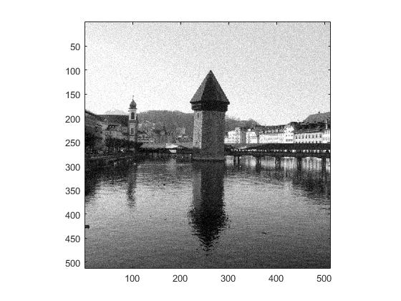

Here’s the new image, after applying the low-pass filter:

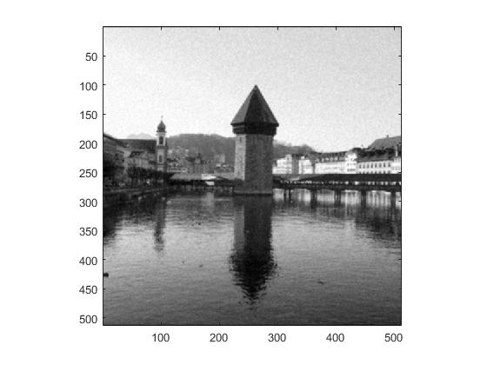

It looks as if the darker specks of noise (as well as the rest of the image) have been smoothed out, leaving noise that isn’t as sharp as before. Some detail is lost because the image has been blurred.

4. Median filtering

We will use median filtering, which utilizes a window and replaces outliers (with respect to intensity) with the median intensity of all pixels in that window. This is to target salt-and-pepper noise, which may be caused by random bit flips.

Original image with salt-and-pepper noise:

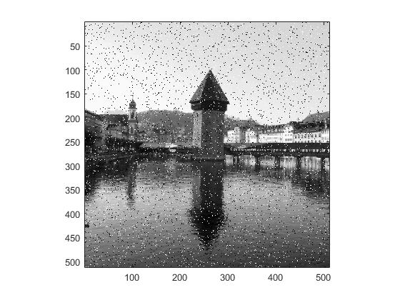

Image after median filtering:

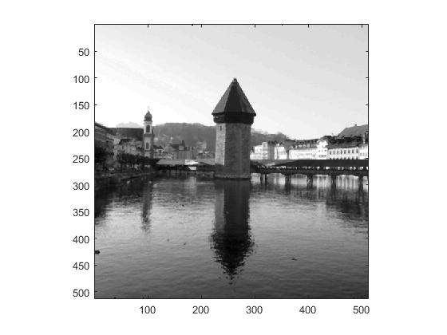

Comparing the two images, it’s easy to see that all the random specks of salt-and-pepper noise have been removed from the image, looking very much like the original image. After comparing this filtered image to the original image (unaffected by Gaussian or salt-and-pepper noise) it looks like some details of the image, like the windows or the texture of the buildings, have been smoothed out.